3. Setup
Run this once. It:
- creates the API client
- creates output_images/ in the images folder.
- adds a small helper to save base64 images
Put any reference images used for edits into input_images/ (or update the paths in the examples).
import os
import base64
from openai import OpenAI

client = OpenAI()

os.makedirs("../../images/input_images", exist_ok=True)
os.makedirs("../../images/output_images", exist_ok=True)

def save_image(result, filename: str) -> None:
"""
Saves the first returned image to the given filename inside the output_images folder.
"""
image_base64 = result.data[0].b64_json
out_path = os.path.join("../../images/output_images", filename)
with open(out_path, "wb") as f:
f.write(base64.b64decode(image_base64))

from IPython.display import HTML, Image, display

def display_image_grid(items, width=240):
cards = []
for item in items:
title = item.get("title", "")
label = f'<div style="font-weight:600;margin-bottom:8px">{title}</div>' if title else ""
cards.append(
'<div style="text-align:center">'
+ label
+ f'<img src="{item["path"]}" width="{width}" style="max-width:100%;height:auto;" />'
+ '</div>'
)
display(HTML('<div style="display:flex;flex-wrap:wrap;gap:16px;align-items:flex-start">' + ''.join(cards) + '</div>'))
The examples below uses our most capable image model gpt-image-2

4. Use Cases — Generate (text → image)

4.1 Infographics
Use infographics to explain structured information for a specific audience: students, executives, customers, or the general public. Examples include explainers, posters, labeled diagrams, timelines, and “visual wiki” assets. For dense layouts or heavy in-image text, it’s recommedned to set output generation quality to “high”.
prompt = """
Create a detailed Infographic of the functioning and flow of an automatic coffee machine like a Jura.
From bean basket, to grinding, to scale, water tank, boiler, etc.
I'd like to understand technically and visually the flow.
"""

result = client.images.generate(
model="gpt-image-2",
prompt=prompt,
size="1024x1536",
quality="medium",
)

save_image(result, "infographic_coffee_machine_gpt-image-2.png")
Output Image:
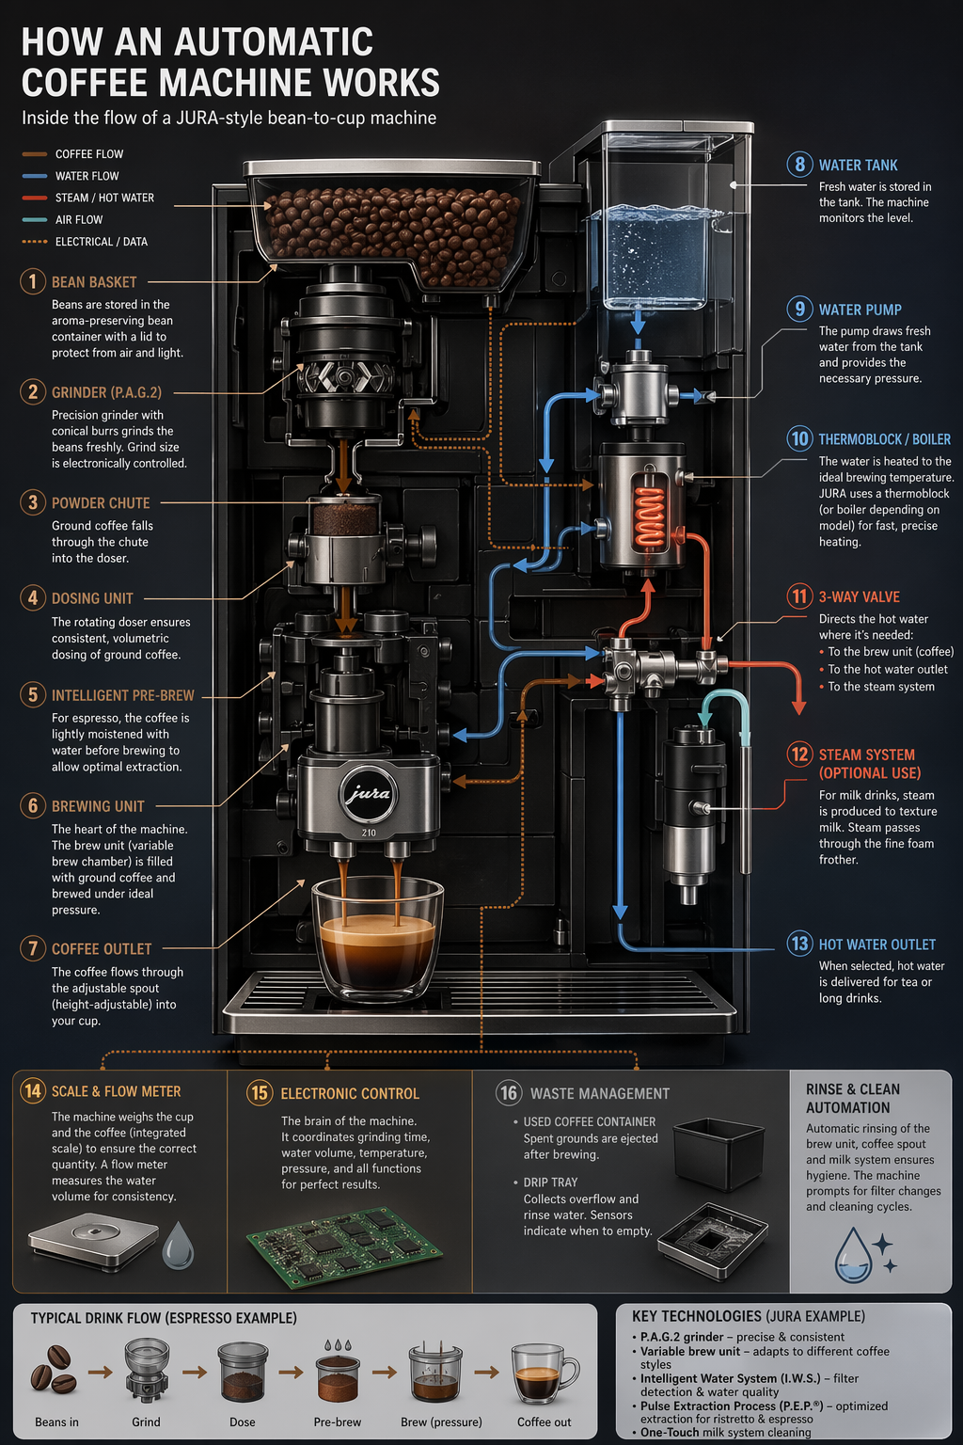

4.2 Translation in Images
Used for localizing existing designs (ads, UI screenshots, packaging, infographics) into another language without rebuilding the layout from scratch. The key is to preserve everything except the text—keep typography style, placement, spacing, and hierarchy consistent—while translating verbatim and accurately, with no extra words, no reflow unless necessary, and no unintended edits to logos, icons, or imagery.
prompt = """
Translate the text in the infographic to Spanish. Do not change any other aspect of the image.
"""

result = client.images.edit(
model="gpt-image-2",
image=[
open("../../images/output_images/infographic_coffee_machine_gpt-image-2.png", "rb"),
],
prompt=prompt,
size="1024x1536",
quality="medium",
)

save_image(result, "infographic_coffee_machine_sp_gpt-image-2.png")
Output Image:
