Screen Captures Of Application In Use

## First page. This shows when there are no documents in the collection, so that the page can load before any data are scraped.

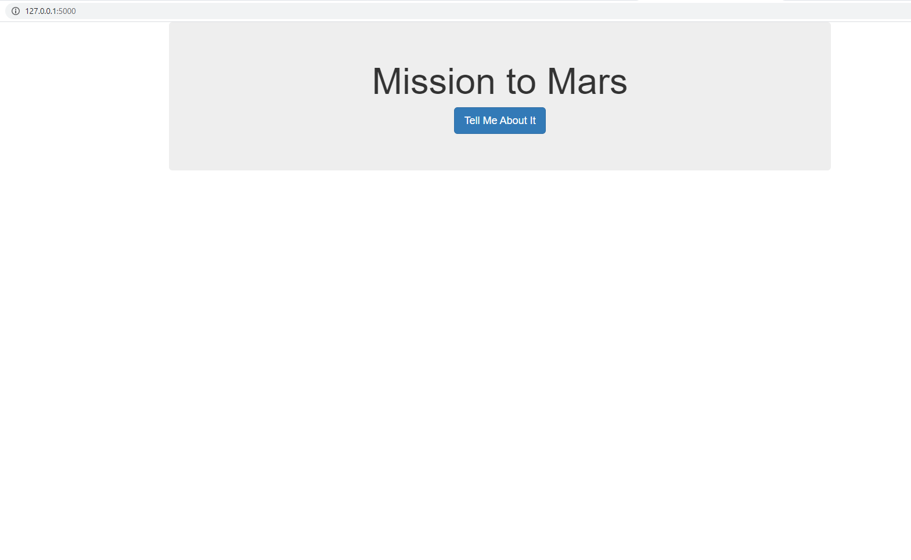

## Page where there is one document in collection. The scrape routine will drop any old records during a new scrape, so there should be at most one document. 2 images needed because of scrolling

Top half:

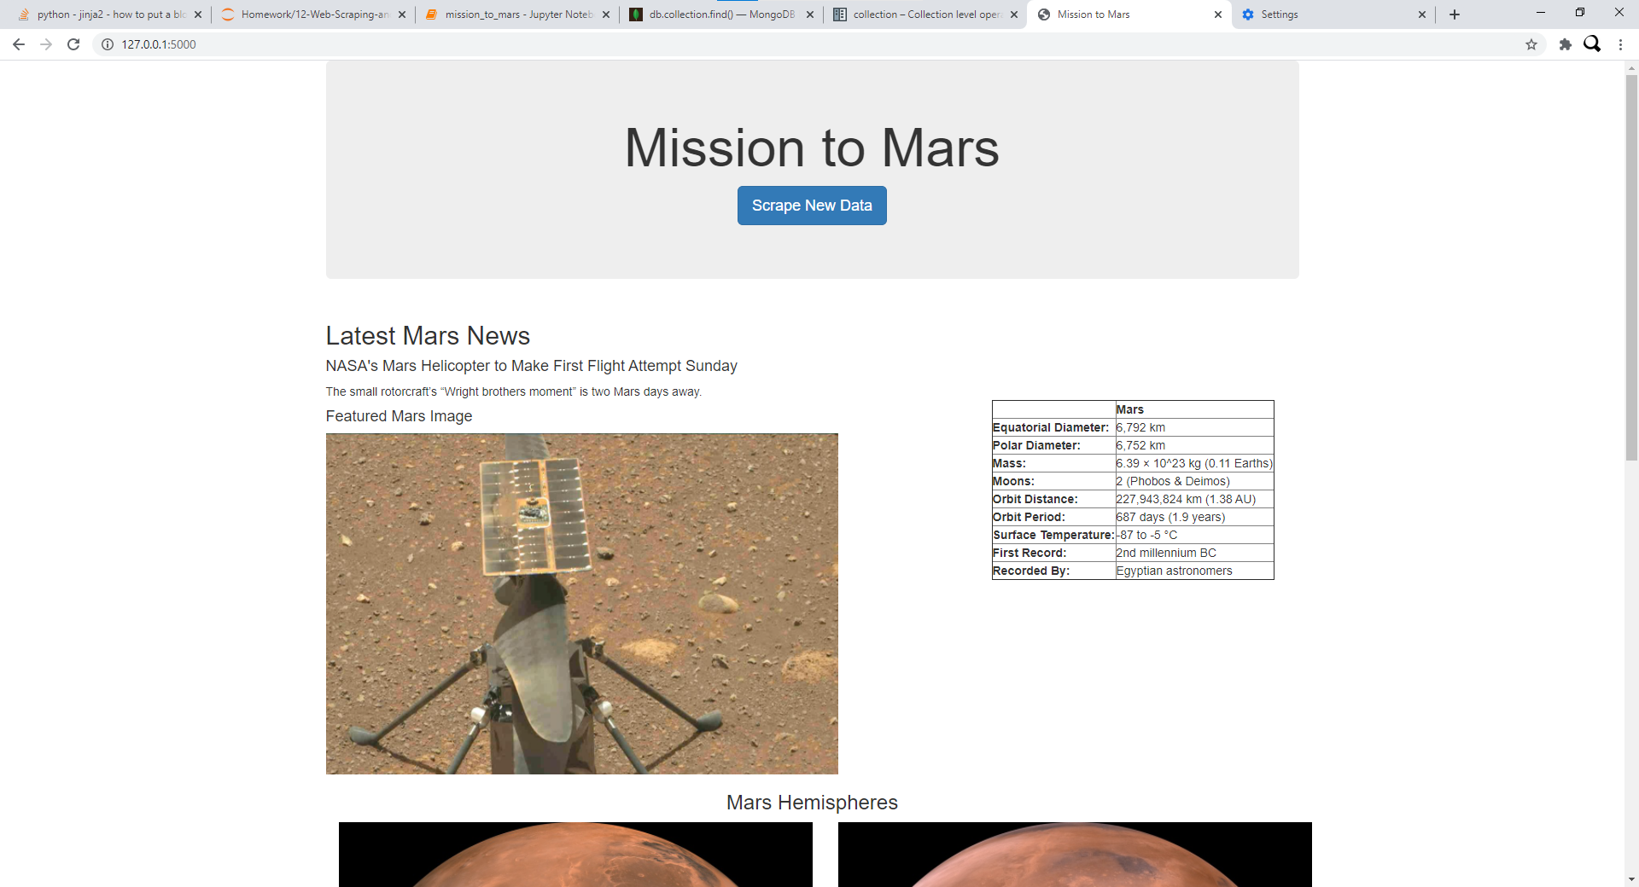

Bottom Half:

