CS4048 Project Proposal

Simon Colreavy-Donnelly, CSIS, University of Limerick

# Group Members

Please add the number (in Sulis) and the names of every member of your group below.

|  |
| --- |
| **Group** |
| David Chuntishvili |
| … |
| … |
| … |

# Main Idea

Describe in 250 words max the main idea of your app. Who are the typical users and what are the main functions they will use?

TidyTime is a productivity app designed for individuals seeking to enhance their time management skills. The app offers three core functionalities: a stopwatch, a countdown timer, and a to-do list. These features help users track time spent on tasks, set focused time periods for activities, and manage their daily responsibilities effectively.

Typical users are anyone looking to organize their daily activities and tasks. For instance, a student can use the stopwatch to measure study sessions, the timer for timed exams, and the to-do list to keep track of assignments.

TidyTime’s minimalistic and elegant design ensures a seamless experience, integrating all features into a simple navigation structure. Users can effortlessly switch between tools, set reminders, mark completed tasks. The app aims to empower users to stay productive and achieve their goals.

# User Stories

To gather the main functionality of your application, write 4 to 6 user stories (or more if necessary). If there are different types of users that achieve different goals with your app (e.g. students and teachers in Sulis), make sure to write at least one user story per type of user.

Remember to use for every user story the pattern:

**As a** <type of user>, **I want to** <perform some task> **so that I can** <achieve some goal>.

1. As a user, I want to start and stop the stopwatch so that I can measure the time spent on a task.
2. As a user, I want to set a countdown timer so that I can focus on tasks within a set time frame.
3. As a user, I want to add tasks to a to-do list so that I can organize my responsibilities.
4. As a user, I want to mark tasks as completed so that I can track my progress.
5. As a user, I want to link tasks with timers so that I can manage time more effectively.

# Technology

List any APIs and frameworks you intend to use (e.g., database, location-based functions, authentication, …)

|  |  |
| --- | --- |
| **API/framework** | **Purpose** |
| Android Room | Store to-do list items locally. |
| CountDownTimer API | Timer functionality. |
| Chronometer Class | Stopwatch functionality |
|  |  |
|  |  |

# Navigation Structure

5.1 Overview

Draw a simple overview diagram of the navigation structure. How does the user navigate through the app? At which point does the user see which information? We are not expecting that you know every detail yet (like the colour of the app logo or the number and positions of buttons in every Activity). We suggest you use online tools like Google Docs and [https://app.diagrams.net/ w](https://app.diagrams.net/)here you can share and edit documents and diagrams in your team.

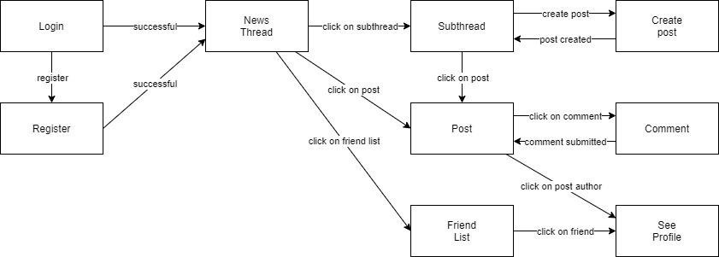

5.2 Description

Write a brief description (20 to 100 words) to every node in your diagram and explain what information is given in this particular part and which other nodes the user can reach from there.

Login – If the user is already registered, it is possible to log in from here, otherwise the user can jump to the registration from here. After a successful login, the user sees the personal news thread.

Registration – The user registers on the app here via name, email and password or the user’s Google account. After successful registration, the user sees the personal news thread.

News thread – The user sees posts from the user’s friends and sub-threads of the user’s interests ordered by newest posts first. The user reaches the sub threads, a detailed view of single posts and a list of friends from there.

Sub thread – The user sees the posts of the sub-thread ordered by newest posts first. From there the user can either create a new post or get to a detailed view of a single post.

Create post – The user can create a post with a title, description and attachments like documents or images. After posting, the user can find the post as newest post in the sub-thread.

Post – The user can see a post’s title, description, attachment and other users’ comments. The user can either click on a button to comment on the post or on the author’s name to see their profile.

Comment – The user can comment a post with a text and an attachment like documents or images. After posting the comment, the user can see their new comment in the detailed view of the post.

Friend List – The user can see a list of all added friends. By clicking on a friend’s name, the user gets to see the friend’s profile.

See Profile – The user can see another user’s profile with the user’s name, picture and a list of posts from this user. It is possible to add or remove the user as to and from the friend list there.