Name_________Benjamin Odell______ Mark _____________________/50

## Brief introduction __/3

I will be in charge of the menu / Heads up display (HUD) system as well as the audio manager in Super Vandal World. The Menu/HUD will be a must have system, as it will allow you to load into the game itself and provide your with the ability to access options or exit as you play through the game. The sound manager is a nice to have feature that nonetheless will contribute significantly to the finished game.

## Use case diagram with scenario __14

### Use Case Diagram

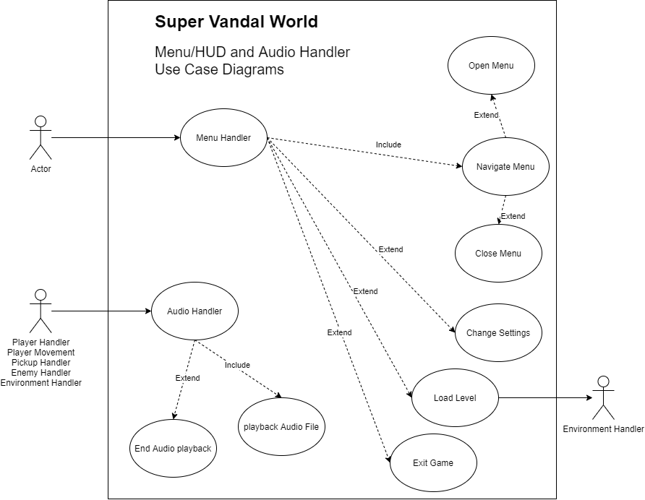

### Scenarios

**Name:** Menu

**Summary:** The player accesses the menu either by pressing the menu key or upon launching the game

**Actors:** Player

**Preconditions:** Game started.

**Basic sequence:**

**Step 1:** Pause all other game functions.

**Step 2:** Draw menu overlay on top of game.

**Step 3:** Read user input to determine menu selection.

**Step 4:** Call desired handler for menu selection.

**Exceptions:**

**Step 1:** Load level is called for a level the player has not reached yet.

**Step 2:** Player is returned to load level screen.

**Post conditions:** Control is passed on to desired subsystem.

**Priority:** 1

**ID:** 6

**Name:** Audio

**Summary:** The audio manager is used by the other system processes to ensure the appropriate sound is playing at any given time.

**Actors:** Player

**Preconditions:** Game started.

**Basic sequence:**

**Step 1:** Audio manager receives event from other process.

**Step 2:** Audio manager checks to determine it has a corresponding sound file, and begins providing that audio to the user.

**Step 3:**  Playback continues until the sound file concludes.

**Exceptions:**

**Step 1:** The audio manager receives a sound event while another sound is playing.

**Step 2:** Audio player determines the priority of these sounds and if one must be disabled.

**Step 3:** Audio manager stops audio playback where necessary and begins new sound file.

**Post conditions:** Control is passed on to desired subsystem.

**Priority:** 3

**ID:** 7

## Data Flow diagram(s) from Level 0 to process description for your feature _______14

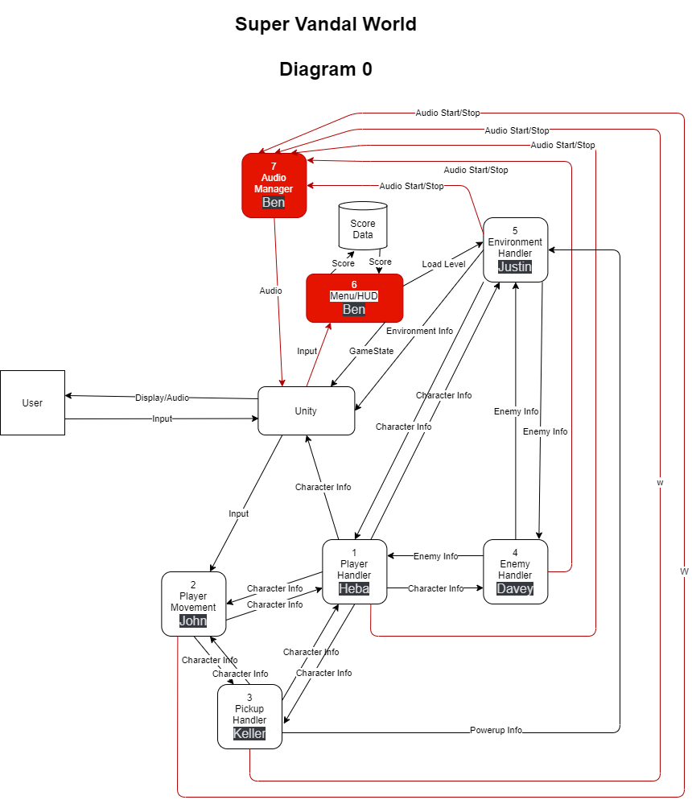

### Process Descriptions

Menu/HUD:

WHILE game running

Draw HUD overlay above game layer but under menu

IF initial startup or player input ESC

Draw menu over other layers

Use player input to select options

SWITCH(Player Choice)

CASE: Load Level  
 Calls environment handler with level to load

BREAK

CASE: Change options

Toggles various game options (volume/resolution/Dr. BC mode)

BREAK

CASE: Exit Game

Shuts down the processes

END SWITCH

END IF

END WHILE

Audio Manager:

WHILE game running

IF audio queue received from other process

IF audio layer not currently used

Play audio

ELSE

Determine audio priority, end current playback if necessary

END IF

END IF

END WHILE

## Acceptance Tests ________9

Menu

Bombard task with input while menu is opened, ensure no results occur beyond those generated by correct menu input. Ensure menu opens and closes correctly and is unaffected by spurious input.

Audio Manager

Generate extreme amounts of audio start/stop requests and ensure stability. Output may become garbled temporarily but needs to eventually resolve to normal.

## Timeline _________/10

### Work items

|  |  |  |
| --- | --- | --- |
| Task | Duration (Wks) | Predecessor Task(s) |
| 1. Requirements Collection | 2 | - |
| 2. System Breakdown | 1 | 1 |
| 3. Section Design | 2 | 2 |
| 4. Programming | 4 | 3 |
| 5. Validation | 1 | 4 |
| 6. Project Integration | 2 | 5 |
| 7. Testing | 2 | 6 |
| 8. Documentation | 1 | 4 |

### Pert diagram

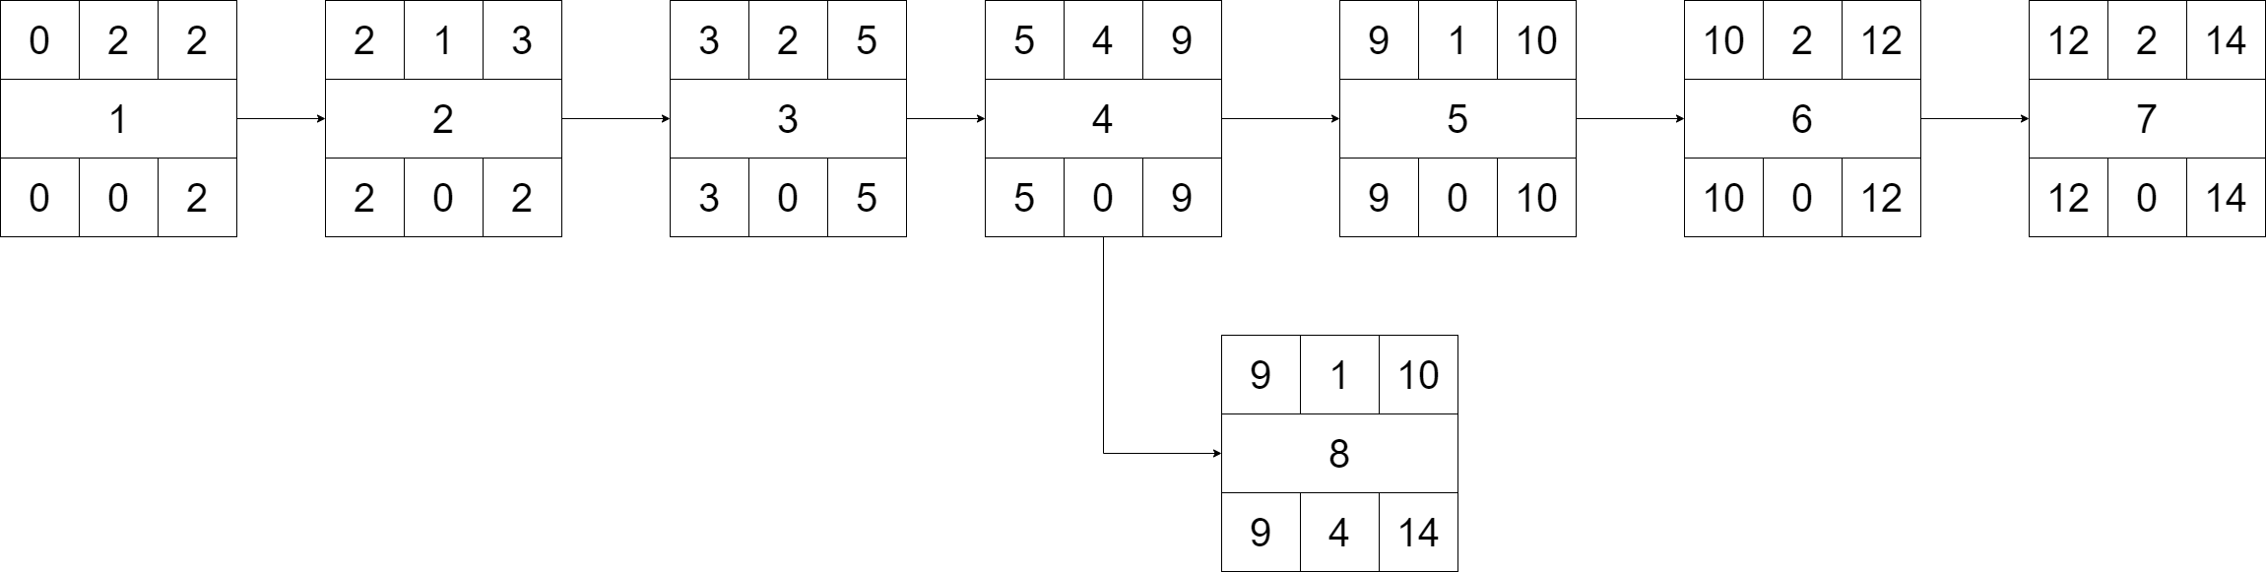

### Gantt timeline

|  |  |  |  |  |  |  |  |  |  |  |  |  |  |  |  |
| --- | --- | --- | --- | --- | --- | --- | --- | --- | --- | --- | --- | --- | --- | --- | --- |
| 1 |  |  |  |  |  |  |  |  |  |  |  |  |  |  |  |
| 2 |  |  |  |  |  |  |  |  |  |  |  |  |  |  |  |
| 3 |  |  |  |  |  |  |  |  |  |  |  |  |  |  |  |
| 4 |  |  |  |  |  |  |  |  |  |  |  |  |  |  |  |
| 5 |  |  |  |  |  |  |  |  |  |  |  |  |  |  |  |
| 6 |  |  |  |  |  |  |  |  |  |  |  |  |  |  |  |
| 7 |  |  |  |  |  |  |  |  |  |  |  |  |  |  |  |
| 8 |  |  |  |  |  |  |  |  |  |  |  |  |  |  |  |
|  | 1 | 2 | 3 | 4 | 5 | 6 | 7 | 8 | 9 | 10 | 11 | 12 | 13 | 14 | 15 |