Name___John Cambareri___________ Mark _____________________/50

[**Instructions**: Remove everything that is not a heading below and fill in with your own diagrams, etc.]

## Brief introduction __/3

[Describe your feature briefly]

This feature will describe how the player and the AI handler will be able to move the character throughout the game. It will show what the character can do, and what happens when he interacts with other objects in the game.

## Use case diagram with scenario __14

### Use Case Diagrams

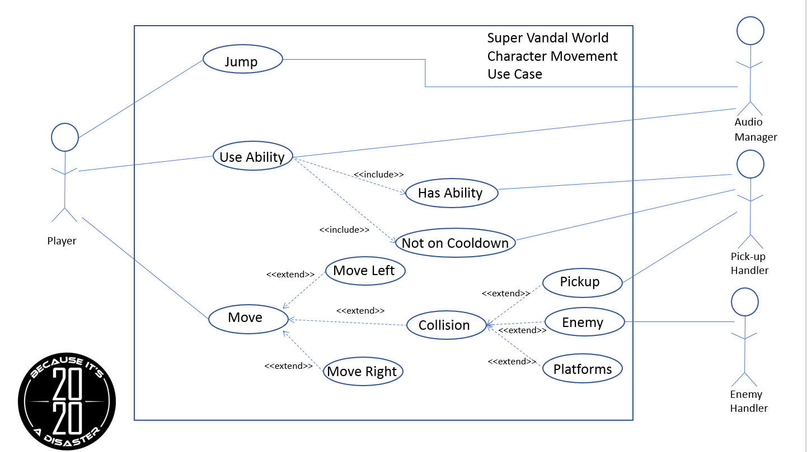

**Name:** Jump

**Summary:** The player makes the character jump.

**Actors:** Player, Audio Manager

**Preconditions:** Character has been initialized and is alive.

**Basic Sequence:**

**Step 1:** Accept input of [jump] button.

**Step 2:** Apply upward force to character.

**Step 3:** Tell Audio Manager to play a sound associated with [jump].

**Extensions:**

**Step 1a:** Game is in demo state.

**1a.1:** Accept input of jump from demo code.

**Exceptions:**

**Step 1:** Character is airborne when [jump] is pressed: ignore input

**Post Conditions:** The character has jumped into the air.

**Priority:** 2

**ID:** JC2.1

**Name:** Use Ability

**Summary:** The player attempts to use an ability of the character.

**Actors:** Player, Audio Manager, Pick-up Handler

**Preconditions:** Character has been initialized and is alive.

**Basic Sequence:**

**Step 1:** Accept input of the [ability] button.

**Step 2:** Obtain information about current ability from Pick-Up Handler

**Step 3:** Tell Audio Manager to play a sound associated with [ability].

**Step 4:** Tell Pick-Up Handler that the current ability has been used.

**Extensions:**

**Step 1a:** Game is in demo state.

**1a.1:** Accept input of jump from demo code.

**Exceptions:**

**Step 1:** The character does not have an ability: ignore input.

**Step 2:** The character has used the ability too recently: ignore input.

**Post Conditions:** The character has used an ability.

**Priority:** 3

**ID:** JC2.2

**Name:** Move

**Summary:** The player attempts to make the character move.

**Actors:** Player, Pick-Up Handler, Enemy Handler

**Preconditions:** Character has been initialized and is alive.

**Basic Sequence:**

**Step 1:** Accept input of either [move] button.

**Step 2:** Apply force to the character, depending on which [move] button was pressed.

**Extensions:**

**Step 1a:** Game is in demo state.

**1a.1:** Accept input of jump from demo code.

**Step 2a:** The character collides with an enemy.

**2a.1**: Tell the enemy handler that a collision has occurred, as well as whether the character is airborne or not.

**Step 2b:** The character collides with a pickup.

**2b.1:** Tell the pickup handler that a collision has occurred.

**Post Conditions:** The character has moved around.

**Priority:** 2

**ID:** JC2.3

## Data Flow diagram(s) from Level 0 to process description for your feature _______14

### Data Flow Diagrams

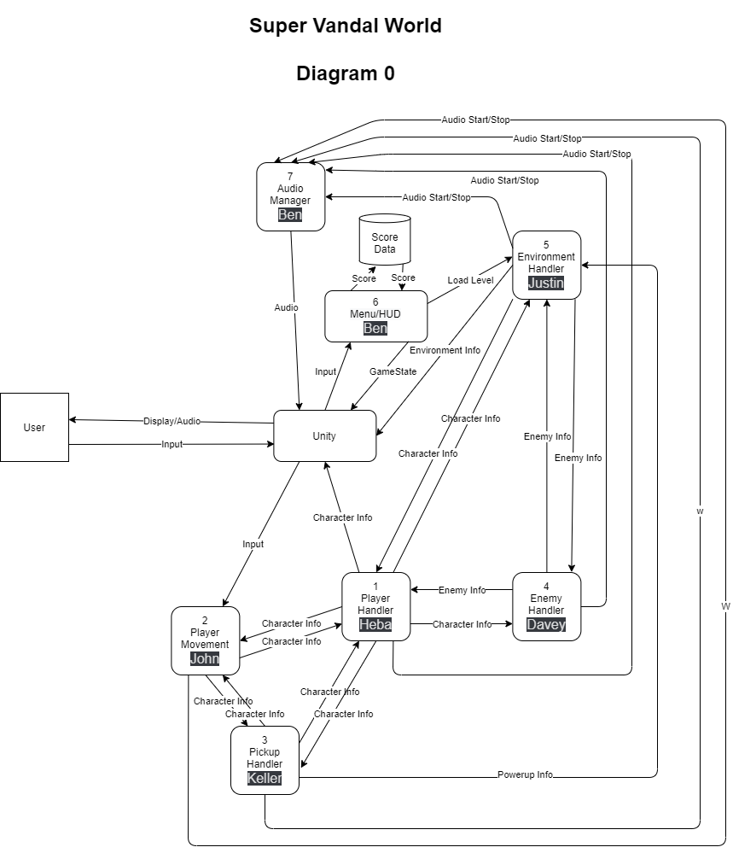

### Process Descriptions

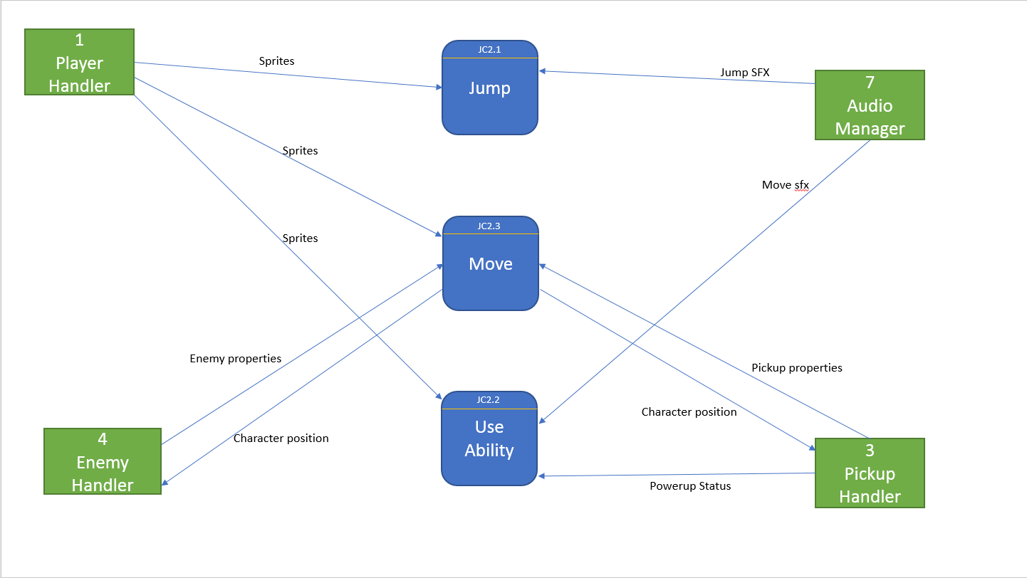

Jump:

If game is not in demo mode

If jump key is pressed

If character is not already airborne

Apply upward force to character

Else

If jump command from demo is received

If character is not already airborne

Apply upward force to character

Use Ability:

If game is not in demo mode

If ability button is pressed

If character has ability

If ability is not on cooldown

Activate ability

Else

If ability command from demo is received

If character has ability

If ability is not on cooldown

Activate ability

Move:

If game is not in demo mode

WHILE right button is held

Move character to the right

END WHILE

WHILE left button is held

Move character to the left

END WHILE

Else

WHILE right command is received from demo

Move character to the right

END WHILE

WHILE left command is received from demo

Move character to the left

END WHILE

## Acceptance Tests ________9

[Describe the inputs and outputs of the tests you will run. Ensure you cover all the boundary cases.]

Test jumping:

Test the character jumping from a variety of platforms, a minimum of 25 times, to see the following occur:

* Sound effect plays
* Player does not clip through platform
* Player does not jump when already airborne

Test using ability:

Test the character attempting to use an ability (both with and without an actual ability) a minimum of 25 times apiece, to see if the following occurs:

* Nothing happens if the player does not have an ability
* The ability activates if the player does have it
* The ability does not activate if the button is pressed multiple times in quick succession
* A sound effect plays upon activation

Test moving with player:

Test the character moving via keyboard for a minimum of 25 pressed for each input, to see if the following occurs:

* The character moves left when left is held
* The character moves right when right is held
* The character does not move when both are held
* The character moves even while airborne from a jump
* The character interacts with pickups or enemies

Test moving with demo:

Test the character moving via a demo program for a minimum of 25 times, to see if the following occurs:

* The character moves on his own
* Player input does not move the character
* The character either makes its way through all the obstacles, or dies depending on which set of instructions was rolled

## Timeline _________/10

[Figure out the tasks required to complete your feature]

Example:

### Work items

|  |  |  |
| --- | --- | --- |
| Task | Duration (PWks) | Predecessor Task(s) |
| 1. Requirements Collection | 2 | - |
| 2. Movement Design | 3 | 1 |
| 3. Pickup Implementation | 5 | 1 |
| 4. Demo Construction | 5 | 2, 3 |
| 5. Demo Programming | 15 | 4 |
| 6. Testing | 6 | 5 |
| 7. Installation | 1 | 6 |

### Pert diagram

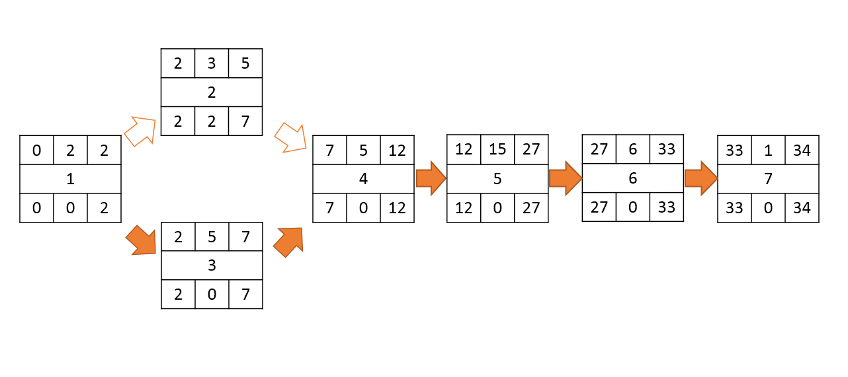

### Gantt timeline

|  |  |  |  |  |  |  |  |  |  |  |  |  |  |  |  |  |  |  |  |  |  |  |  |  |  |  |  |  |  |  |  |  |  |  |
| --- | --- | --- | --- | --- | --- | --- | --- | --- | --- | --- | --- | --- | --- | --- | --- | --- | --- | --- | --- | --- | --- | --- | --- | --- | --- | --- | --- | --- | --- | --- | --- | --- | --- | --- |
| 1 |  |  |  |  |  |  |  |  |  |  |  |  |  |  |  |  |  |  |  |  |  |  |  |  |  |  |  |  |  |  |  |  |  |  |
| 2 |  |  | 1 |  |  |  |  |  |  |  |  |  |  |  |  |  |  |  |  |  |  |  |  |  |  |  |  |  |  |  |  |  |  |  |
| 3 |  |  | 1 |  |  |  |  |  |  |  |  |  |  |  |  |  |  |  |  |  |  |  |  |  |  |  |  |  |  |  |  |  |  |  |
| 4 |  |  |  |  |  |  |  | 2 | 3 |  |  |  |  |  |  |  |  |  |  |  |  |  |  |  |  |  |  |  |  |  |  |  |  |  |
| 5 |  |  |  |  |  |  |  |  |  |  |  |  | 4 |  |  |  |  |  |  |  |  |  |  |  |  |  |  |  |  |  |  |  |  |  |
| 6 |  |  |  |  |  |  |  |  |  |  |  |  |  |  |  |  |  |  |  |  |  |  |  |  |  |  |  | 5 |  |  |  |  |  |  |
| 7 |  |  |  |  |  |  |  |  |  |  |  |  |  |  |  |  |  |  |  |  |  |  |  |  |  |  |  |  |  |  |  |  |  | 6 |
|  | 1 | 2 | 3 | 4 | 5 | 6 | 7 | 8 | 9 | 10 | 11 | 12 | 13 | 14 | 15 | 16 | 17 | 18 | 19 | 20 | 21 | 22 | 23 | 24 | 25 | 26 | 27 | 28 | 29 | 30 | 31 | 32 | 33 | 34 |