Davey Anguiano

CS 404

Assignment 6

In this assignment I created two neural networks, one which was a Fully Connected Network and the other being a Convolutional Network. Upon running the program, I noticed the time difference of execution. The CNN calculation was around 6-7 minutes on my machine to execute but the FCNN only took around 2 minutes to complete. However, faster does not mean better, for model accuracy the CNN model did better at 90.813% as compared to the 87.023% done by the FCNN. Even comparing the model performance using their epochs, the CNN seemed to take more time initializing but the FCNN took longer after each entry. Overall, this comparison indicates using a CNN model would be best for this dataset, even if it comes at a cost of speed.

* CNN Model for accuracy and performance over time using epochs
  + 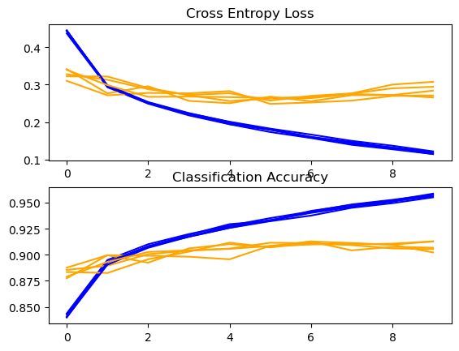
* FCNN Model for accuracy and performance over time using epochs
  + 