__________________________________________________________________

**Central Florida Regional Planning Model**

**Version 6.1**

**Final Draft SubArea Application**

__________________________________________________________________



**Prepared for the**

**Florida Department of Transportation**

**Updated By**

**HTNB**

**1276 Metropolitan Boulevard**

**Suite 304**

**Tallahassee, Fl 32312**

**July 8, 2016**

Table of Contents

1. subarea application 1

1. Catalog Keys 1

2. Design and Use of the SubArea Application in the Updated GUI 2

1. Design of the Updated GUI 2

2. Use of the SubArea Application 2

3. Application & Script Modifications 6

List of Tables

Table 1‑1: SubArea Application Catalog Key Definitions 1

Table 1‑2: MPO_DIST Catalog Key Definitions 3

Table 1‑3: UserDefinedSubarea Catalog Key Definitions 4

List of Figures

Figure 1‑1: SubArea Application Keys 1

Figure 1‑2: SubArea Application GUI Page 1 2

Figure 1‑3: Select District/Zone Option 3

Figure 1‑4: User Defined Subarea Steps 4

Figure 1‑5: User Defined Subarea Step 1 4

Figure 1‑6: User Defined Subarea Step 2 5

Figure 1‑7: User Defined Subarea Step 3 5

Figure 1‑8: User Defined Subarea Step 4 6

Figure 1‑9: DISTRIBUTION Application 6

Figure 1‑10: SubArea Application 7

Figure 1‑11: Mode Choice Application 8

List of Appendices

A. SubArea Application Scripts

List of Acronyms

CFRPM Central Florida Regional Planning Model

FDOT Florida Department of Transportation

GUI Graphical User Interface

MPO Metropolitan Planning Organization

SERPM South East Florida Regional Planning Model

TAZ Transportation analysis zone

TPO Transportation Planning Organization

# subarea application

The FDOT District 5 requested a Sub Area application be incorporated into the CFRPM v6.1 to allow users to reduce model run times. A review of models in the state found that the SERPM v6.5.4 already had a good sub area application in it therefore it was used the basis for this new application.

The following sections describe how the SubArea application was created in the CFRPM and how to use it.

## Catalog Keys

There are 3 new keys required for the SubArea application which include 2 note keys and 1 “check box” key. 2 other keys are used in the application that already exist and were documented in the Graphical User Interface & MPO Reporting Tech Memo. The existing keys are shown as the first 2 keys below. The 5 keys used in the SubArea application are described and shown in Table 1-1 and are found in the model as shown in Figure 1-1.

Table 1‑1: SubArea Application Catalog Key Definitions

|  |  |
| --- | --- |
| **Key** | **Definition** |
| MPO_DIST | Key used to designate how the user wishes the districting to be run. Setup as a drop down list to avoid errant entries in the GUI. |
| MPO NOTES | Note key used to define the districting options for selection in the MPO_DIST key in the GUI. |
| Subnote0 | New Note key used as a heading for the User-Defined Subarea/Windowed Network section of the GUI. |
| Subnote1 | New Note key used to define the steps the user must take to execute their own Subarea for selection. |
| UserDefinedSubarea | New key used to select the users Defined Windowed Subarea step in the GUI. |

Figure 1‑1: SubArea Application Keys

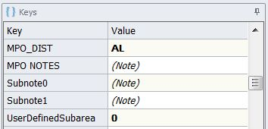

## Design and Use of the SubArea Application in the Updated GUI

In order to implement the new SubArea application, the design of the GUI needed to be updated. This section discusses those updates and explains how to use the new application.

### Design of the Updated GUI

The implementation of the 5 keys of the SubArea application immediately follow the “MODEL SETUP” note on Page 1 of the GUI and are shown in Figure 1-2.

Figure 1‑2: SubArea Application GUI Page 1

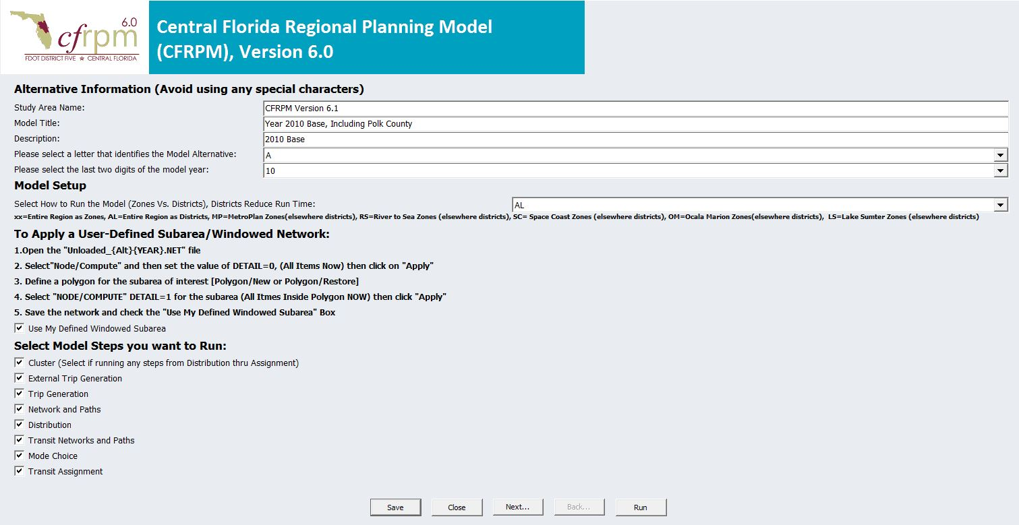

### Use of the SubArea Application

The SubArea section of the GUI allows the user to select how the districting is implemented during the model run.

The model can be run 4 different ways and is accomplished through a drop down list for the first 3 options and through a polygon procedure for the last.

1. The user can select a specific MPO/TPO area. Once selected, the MPO/TPO area is run as TAZs with the rest of the model run as districts. See Table 1-2.
2. The user can select the entire region as TAZ. Once selected, the whole model area is run as TAZs.
3. The user can select the entire region as districts. Once selected, the whole model area is run as districts.
4. The user can define their own SubArea. Once selected, the model is run with the selected SubArea as TAZs with the rest of the model run as districts.

Table 1‑2: MPO_DIST Catalog Key Definitions

|  |  |
| --- | --- |
| **Key Value** | **Definition** |
| xx | This selection runs the Entire Region as Zones. |
| AL | This selection runs the Entire Region as Districts. |
| MP | This selection runs MetroPlan as Zones and the rest of the model area as Districts. |
| RS | This selection runs River to the Sea TPO as Zones and the rest of the model area as Districts. |
| SC | This selection runs Space Coast TPO as Zones and the rest of the model area as Districts. |
| OM | This selection runs Ocala/Marion TPO as Zones and the rest of the model area as Districts. |
| LS | This selection runs Lake/Sumter MPO as Zones and the rest of the model area as Districts. |

To run the model by MPO, the entire region as DISTRICTS or TAZs the user simply selects that option from the drop down menu. As an example, Figure 1-3 below shows the selection of “AL” to run the entire model as Districts.

Figure 1‑3: Select District/Zone Option



To run the model with a user Defined Windowed SubArea the user follows the instructions located under the heading “To Apply a User-Defined Subarea/Windowed Network”. Figure 1-4 shows these steps.

Figure 1‑4: User Defined Subarea Steps

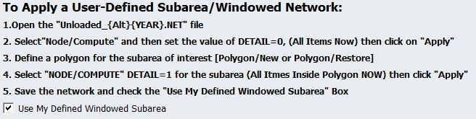

Table 1-3 shows the values for the UserDefinedSubarea Key.

Table 1‑3: UserDefinedSubarea Catalog Key Definitions

|  |  |
| --- | --- |
| **Key Value** | **Definition** |
| 0 | Does not run the User Defined Subarea scripts |
| 1 | Runs the User Defined Subarea scripts |

Figures 1-5 through 1-7 show steps 1-4.

Figure 1‑5: User Defined Subarea Step 1

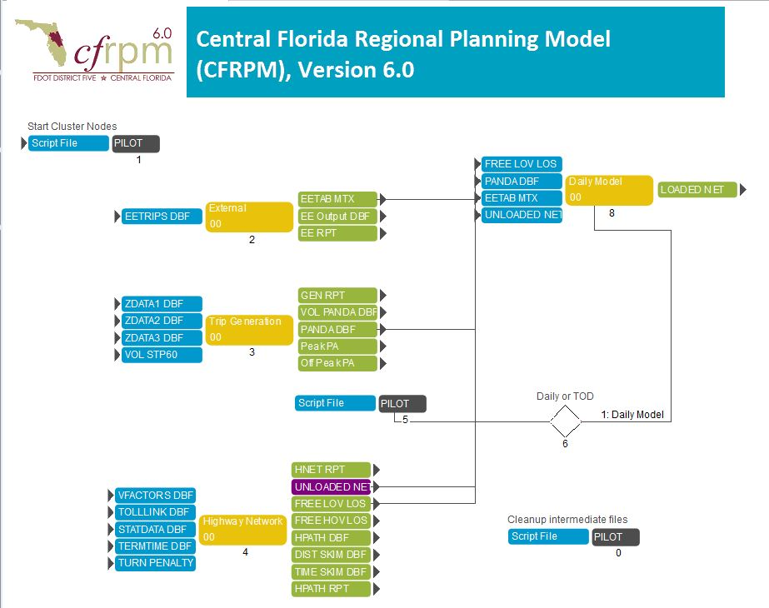

Figure 1‑6: User Defined Subarea Step 2

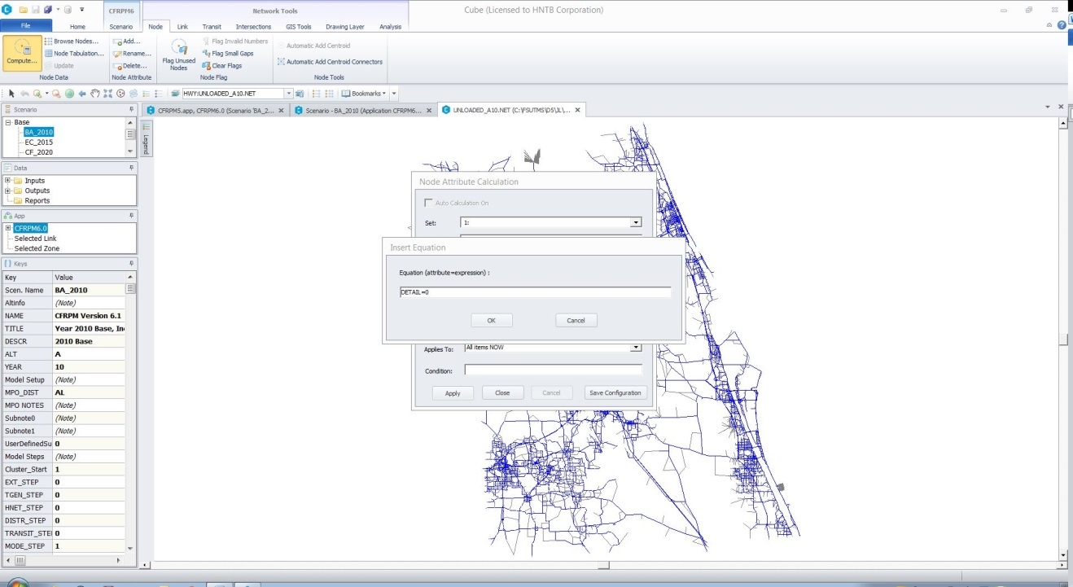

Figure 1‑7: User Defined Subarea Step 3

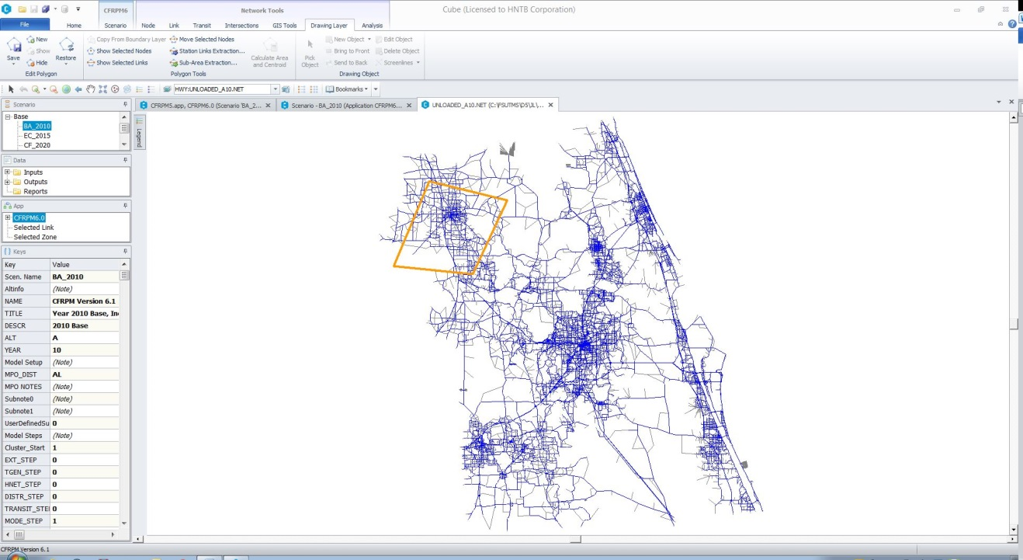

Figure 1‑8: User Defined Subarea Step 4

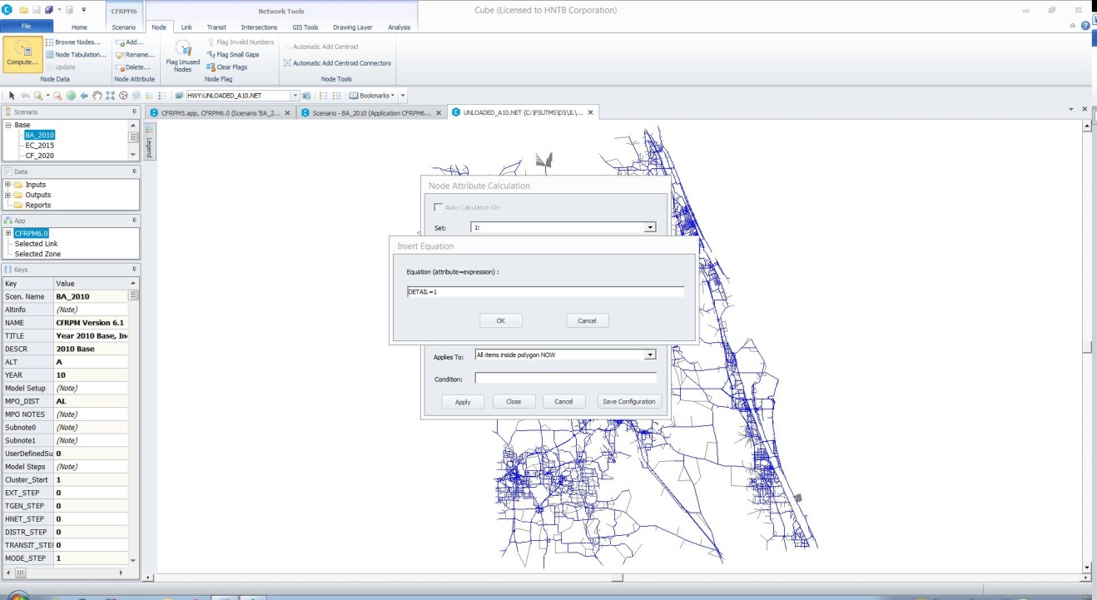

The final step is the select the “check box” for “Use My Defined Windowed Subarea” on the GUI.

## Application & Script Modifications

In order to accommodate the use of the SubArea application in the model, modifications were made to the DISTRIBUTION and MODE CHOICE applications.

Figure 1‑9: DISTRIBUTION Application

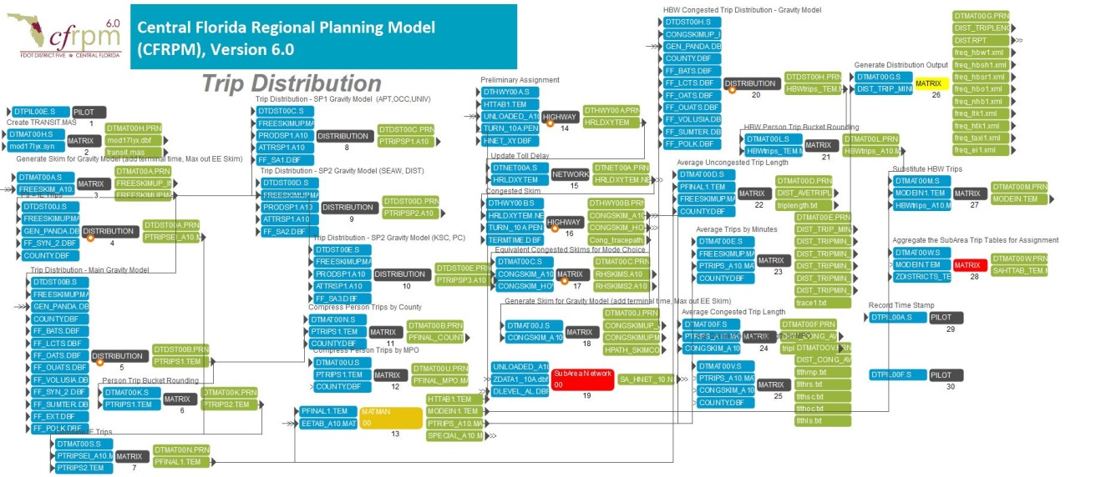

The RED boxes show the modified steps.

The SubArea application was inserted as step 19 in DISTRIBUTION. This application is where the networks are configured based on the user’s selection for SubArea windowing. See Figure 1-10 below. All scripts are contained in Appendix A.

Figure 1‑10: SubArea Application

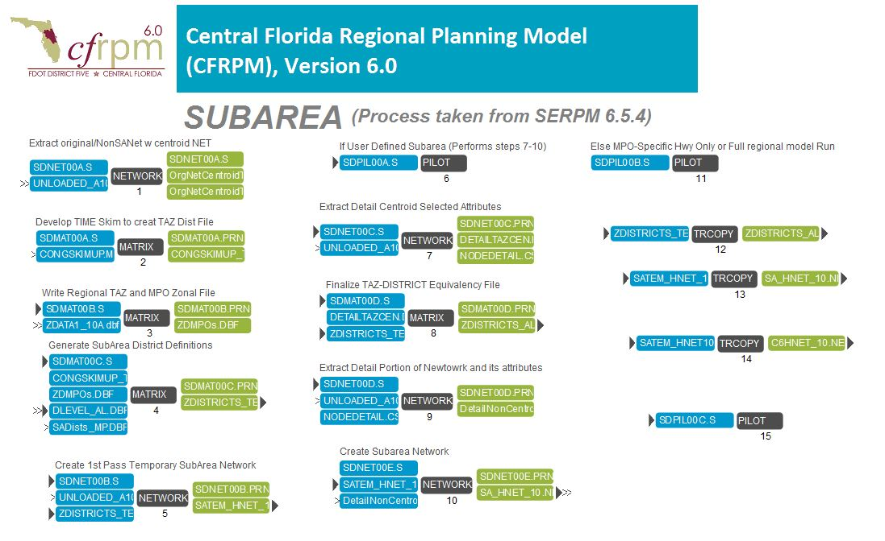

Step 28 of the DISTRIBUTION application was also added to create the SubArea trip tables for assignment. See Figure 1-9.

The final modification in is the Mode Choice Application. Step 2 was modified to sue the output trip table from the SubArea application named “SAHTTAB_TEM.MAT”. See Figure 1-11 for the Mode Choice application. The modified Script is located in Appendix A.

Figure 1‑11: Mode Choice Application

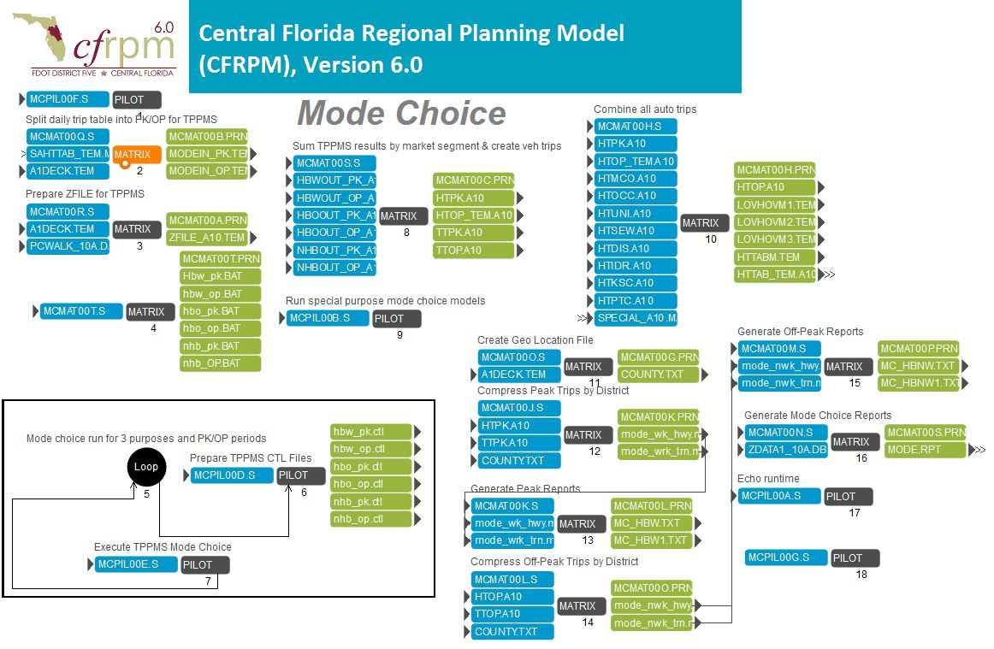

1. SubArea Application Scripts