**Summary stats 5-26**

In total we have 7 graphs for variables.

The results for the variables “abundance” and “richness” are not satisfactory. My original approach was to aggregate all the data from the state-level datasets and then match them to their corresponding FIPS codes. The data is then aggregated by FIPS code and year. Specifically, for "abundance", I summed the StopTotal values, and for "richness", I summed the SpeciesTotal values. Additionally, I calculated the number of distinct routes (StateNum_Route) within each FIPS code and year to determine the variable no_routes.

In conclusion, I have some problems when integrating the variables “abundance” and “richness”. For the rest of the variables, although I did not replicate the data exactly, the overall trends are similar and not too far apart from each other.

1. abundance

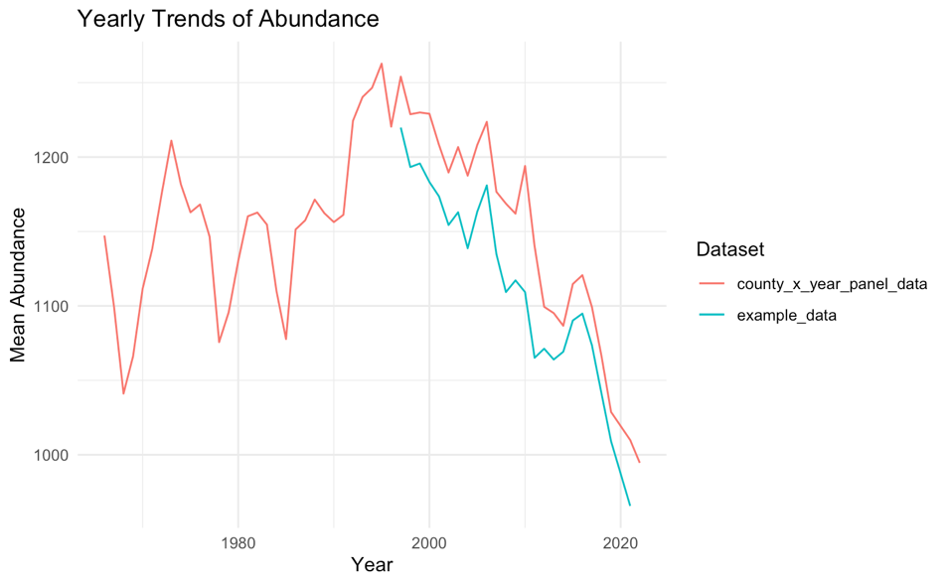

2. richness

3. no_routes

4. duration minutes

5. obsn

6. car_total

7. noise total

