Filmography Application
(Customer Name: xxxx)

System Setup and Installation
Version: 1.0.0

Release date: 01-June-2009

The contents of this document and its accompanying documents are confidential in nature and shall not be revealed to any party other than the ones it is intended for.
The purpose of this document is to provide setup and installation information to the client. Higher versions of this document shall be created as and when required.

by

Baryons Software Solutions Pvt. Ltd.
39-40, 2nd Floor, 2nd Cross, Govind Reddy Layout,
Opp MICO Arekere Layout, Bannerghatta Road,
Bangalore, India – 560076
www.baryonssoftsolutions.com

Document Information

Author | Nandha Guru A
Reviewer | Pranav Kumar
Approver
Effective Date | 01 June 2009
File | Filmography-install.doc

Overview

This document details out the System Requirements and the Installation Instructions for the Filmography Application. It has the following sections:

  - System Requirements
  - Drupal Installation Instructions
  - Customized Modules Setup.
  - Database Setup.
  - Free Base API queries & Libraries used.

System Requirements:-

For Linux: LAMP – Linux Apache, Mysql and PHP.

OS : Linux variants provided by your hosting server. (Eg. Fedora 8 or greater, Centos 5 or greater, Opensuse 10.0 or greater)

Apache: Version 2.0 or greater.

Mysql : Version 5.x.x or greater.

PHP : Version 5.2.x or greater.

For Windows: WAMP – Windows Apache, Mysql and PHP.

WAMP : Version 2.0 or greater.

Apache: Version 2.2.x or greater.

Mysql : Version 5.2.x or greater.

PHP : Version 5.2.x or greater.

Drupal Installation Instructions:

In order to install the Drupal CMS application, please follow the step-by-step instructions below:

Step 1: Download the Drupal installation file (drupal-6.10.tar.gz or drupal-6.10.zip) from http://drupal.org/ by choosing the stable version 6.10 and clicking on the Download link next to the package. Download link - http://ftp.drupal.org/files/projects/drupal-6.10.tar.gz

Step 2: Upload the downloaded drupal archive file (.tar.gz or .zip) into public_html folder of your hosting account File Manager folder. You can do that through an FTP client like FileZilla or via cPanel -> File Manager -> Upload file(s). Once upload is successful you can find your drupal archive file in your public_html folder (I.e) nothing but a root folder of your website.

Step 3: Now navigate to the uploaded file ,select it and extract it by clicking on the 'Extract' link (or) 'Unarchive' link provided in the 'File Manger'. This will create a subfolder: drupal-x.x.x., where instead of x.x.x. is the current version. So you can move the files one level up in the desired directory. (I.e) from you Drupal directory to root directory (public_html).
The other option is to extract the file in your computer and then to upload the content in the desired folder via FTP.

Step 4: Once the files are extracted in the desired folder, you should create a MySQL database for Drupal. You can do that from cPanel -> MySQL Databases (or) through phpMyAdmin Panel. There you should create a database and add a user to it.

Step 5: Once the database is created, navigate to the URL of your Drupal site (http://domain.com) It will show a screen like this :

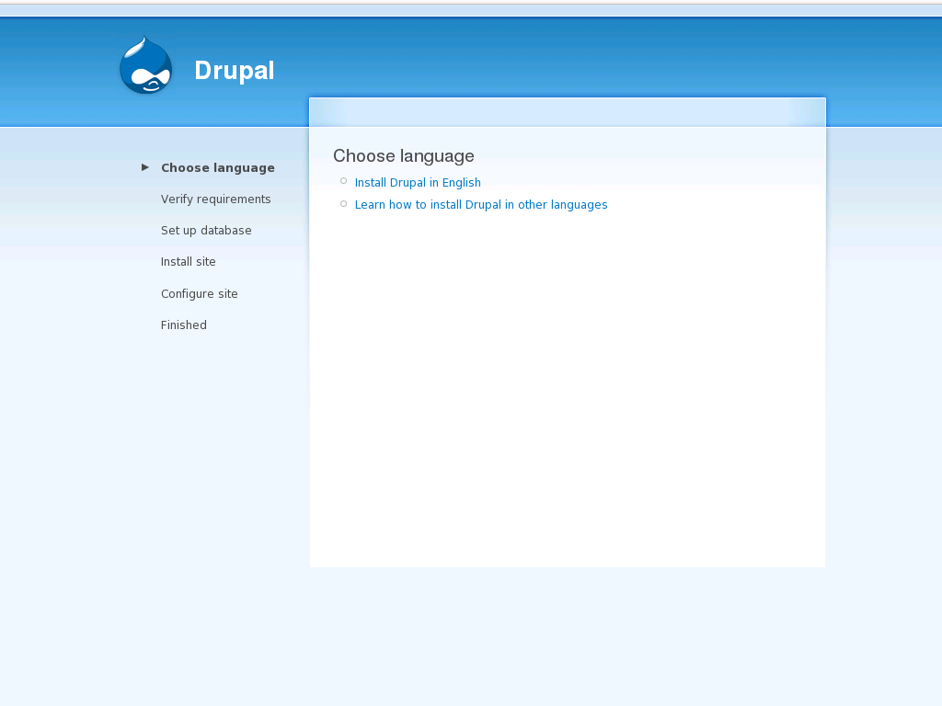

Step 6: Pick the default language for the Drupal web site (English) and proceed further .

Step 7: Copy the /sites/default/default.settings.php file to /sites/default/settings.php. This can be done through cPanel -> File Manager. Also through the same tool you can grant write permissions
(I.e to 777) to the file settings.php and folders default,sites.

Step 8: Enter the database details for the database which you have created in Step 4. Click on the "Save configuration" button to continue. Following is the screen which will be shown up for database detail entries.

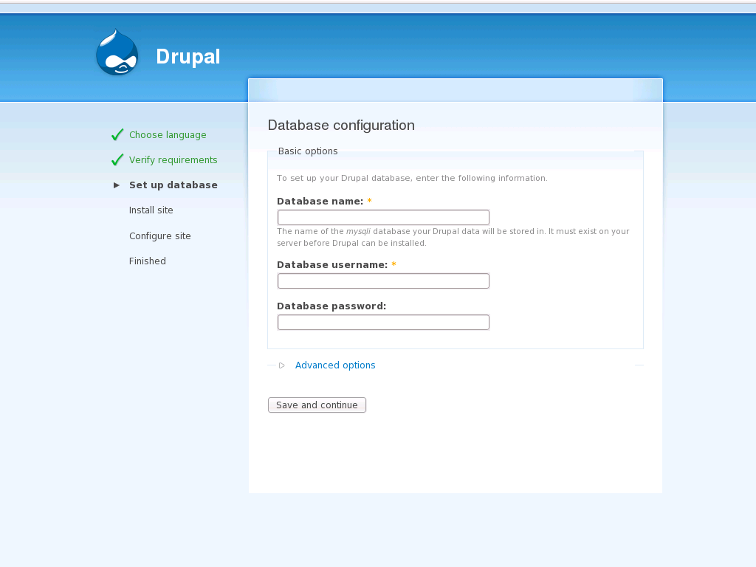

Step 9: Alter back the file permissions (i.e to 755) for the file settings.php and folder default and enter the site information along with the admin account's details. Also enable the Clean URLs and click on the Save and Continue button.

Step 10: Now you will be shown with a screen as follows this confirms your installation.

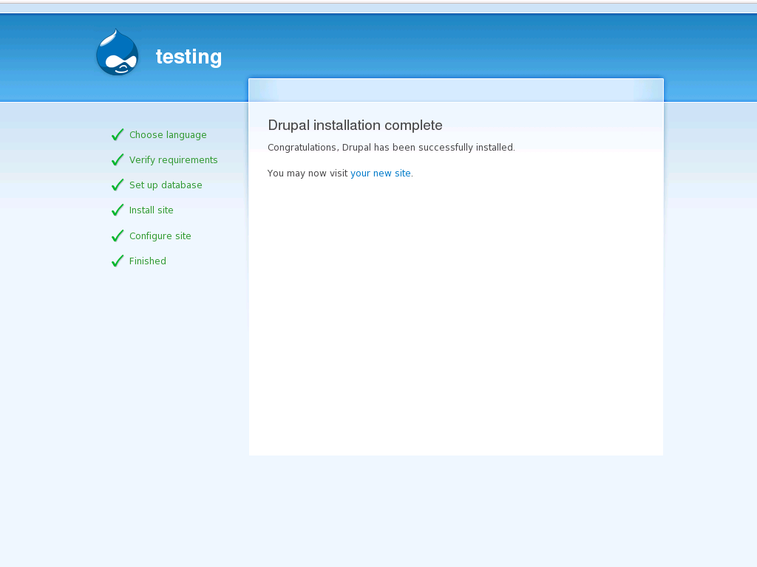

Customized Module Setup:

Step 11: After the installation is completed successfully extract the given module.zip file.
Create a folder named 'modules' under /sites/all/ folder and copy paste following folders into it,
- film_search
- fivestar
- fivestarextra
- jq
- jquery_freebase
- profiles
- voting_api

Then extract the given core.zip file and copy paste the files

- coment.module & comment.css into /modules/comment folder
- system.css in /module/system folder
- And blix folder into /themes folder.

Database Setup:

Step 12: Once the above steps are completed login to MYSQL (or) phpMyAdmin panel take a backup of your database and drop all tables in them or drop the database and create a new database with same name.
Select the created database and then Import the given database dump (film.sql) by Clicking on “Import” link in PHPMyAdmin, and also select the compatibility mode as mysql40 from drop down and then press the “Go” button, this will configure and setup your entire site.

By default the admin username and password will be changed to the following
Username: admin
Password: site52556
Now you can visit the site: http://yourdomain.com, login as admin using the above credentials.

Navigate to “Administer->Site Configuration->Site Information” to change the website information.

Navigate to “My Account” and you can edit your profile to change your administrator details.

Freebase API Queries & Libraries Used.

- Following is the function used for auto suggest search box list generation.
API libraries used in this function are
- api/service/search
- api/trans/blurb
- api/trans/image_thumb

function SuggestControl() {

fb.InputSelectControl.call(this);

this.default_options = {

width: 275, // width of list and flyout

soft: true, // if true, DO NOT auto-select first item, otherwise select first item by default

suggest_new: null, // to show suggest new option, set text to something (eg, "Create new topic")

flyout: true, // show flyout on the side of highlighted item

service_url: "http://www.freebase.com",

ac_path: "/api/service/search",

ac_param: {

type_strict: "/film/film",

start: 0,

limit: 20

},

ac_qstr: "prefix", // this will be added to the ac_param ...&prefix=str

blurb_path: "/api/trans/blurb",

blurb_param: {

maxlength: 300

},

thumbnail_path: "/api/trans/image_thumb",

thumbnail_param: {maxwidth:80, maxheight: 90},

filter: null,

transform: null,

initialize: false

};

};

- Following is the query used for fetching freebase film details.
API used for fetching film details is
- api/services/mqlread
Query Used:
var json = '{'+

' "q1":{'+

' "query":{'+

' "name" : null,'+

' "initial_release_date" : [{'+

' }],'+

' "directed_by" : [{'+

' }],'+

' "id":"'+topicId+'",'+

' "starring" : [{'+

' "*" : null'+

' }],'+

' "produced_by" : [{'+

' }],'+

' "written_by" : [{'+

' }],'+

' "story_by" : [{'+

' }],'+

' "music" : [{'+

' }],'+

' "cinematography" : [{'+

' }],'+

' "genre" : [{'+

' }],'+

' "country" : [{'+

' }],'+

' "rating" : [{'+

' }],'+

' "netflix_id" : [{'+

' }],'+

' "type" : "/film/film"'+

' }'+

' }'+

'}';

