# CHAPTER 2: LITERATURE REVIEW

## Introduction

This chapter gives an overview of the current applications, which are related to our project and it will give a brief description of the technologies that will be used to build this project in the background section.

## Related Work

Creating schedules is not considered a recent problem. It has long been a challenge for everyone who needs to create a schedule to organize some work. Therefore, it is natural that we find some devised ways to solve this problem, and universities are not excluded from this issue. Many universities have developed programs that prepare schedules. The university and schedules for students.

### Making a School Schedule from GOV.SA

An e-service provided by the Ministry of Education in KSA, enabling school administrators to create study schedules through the Noor system.[1]

Steps to make a school schedule are:

* Login to the Noor system.
* Select the school schedule.
* Select (Prepare and implement the table).
* Complete the table setting steps.
* The schedule is complete.

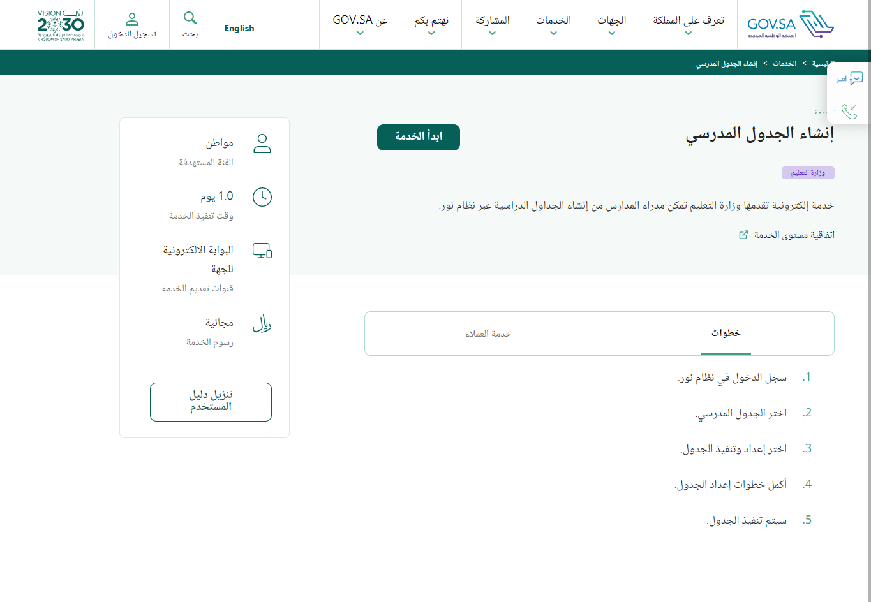

**Figure 3**: generating schedule page on manger of school account

Figure 2: School Schedule page on manger of school account

Figure1: Making Schedule School page on GOV.SA website

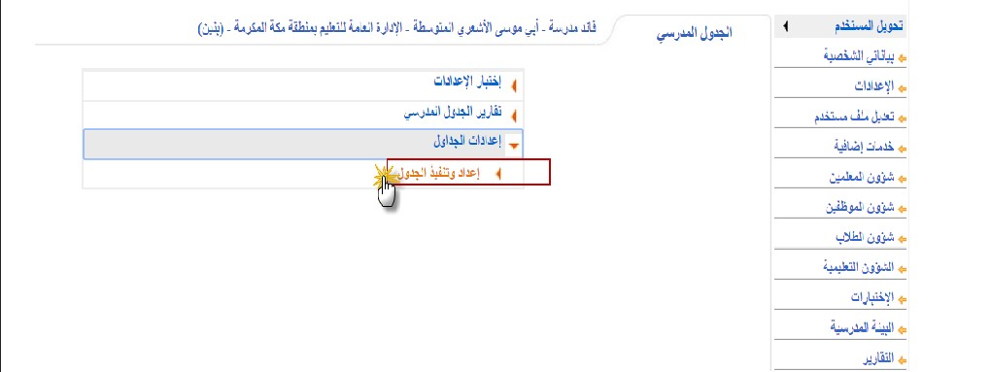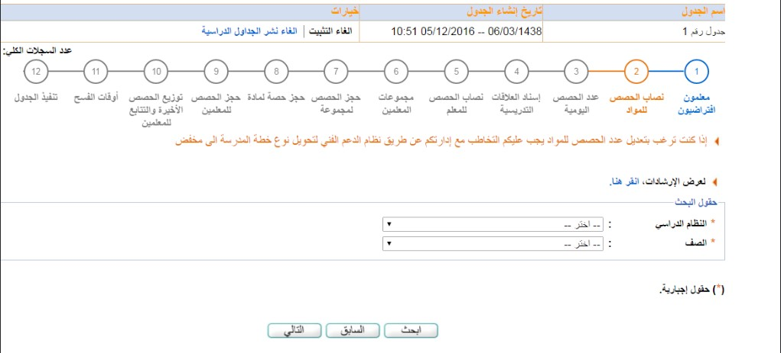

### Scheduly

The goal of the software application is to provide a possible timetable solution with the minimum number of clashes between time slots. It relieves the user of much of the hard work required for generating a timetable manually, leaving him with more time to apply the skills and judgment where they are needed to produce a timetable of the highest quality.[2]

Figure 4Dashboard

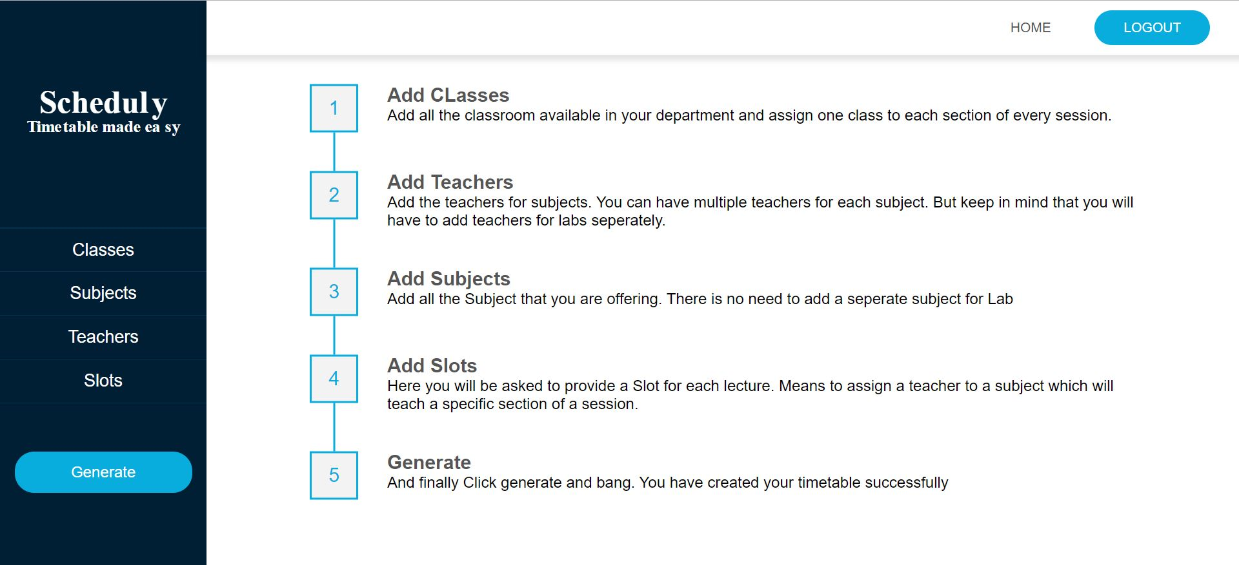

Figure 5 Output page

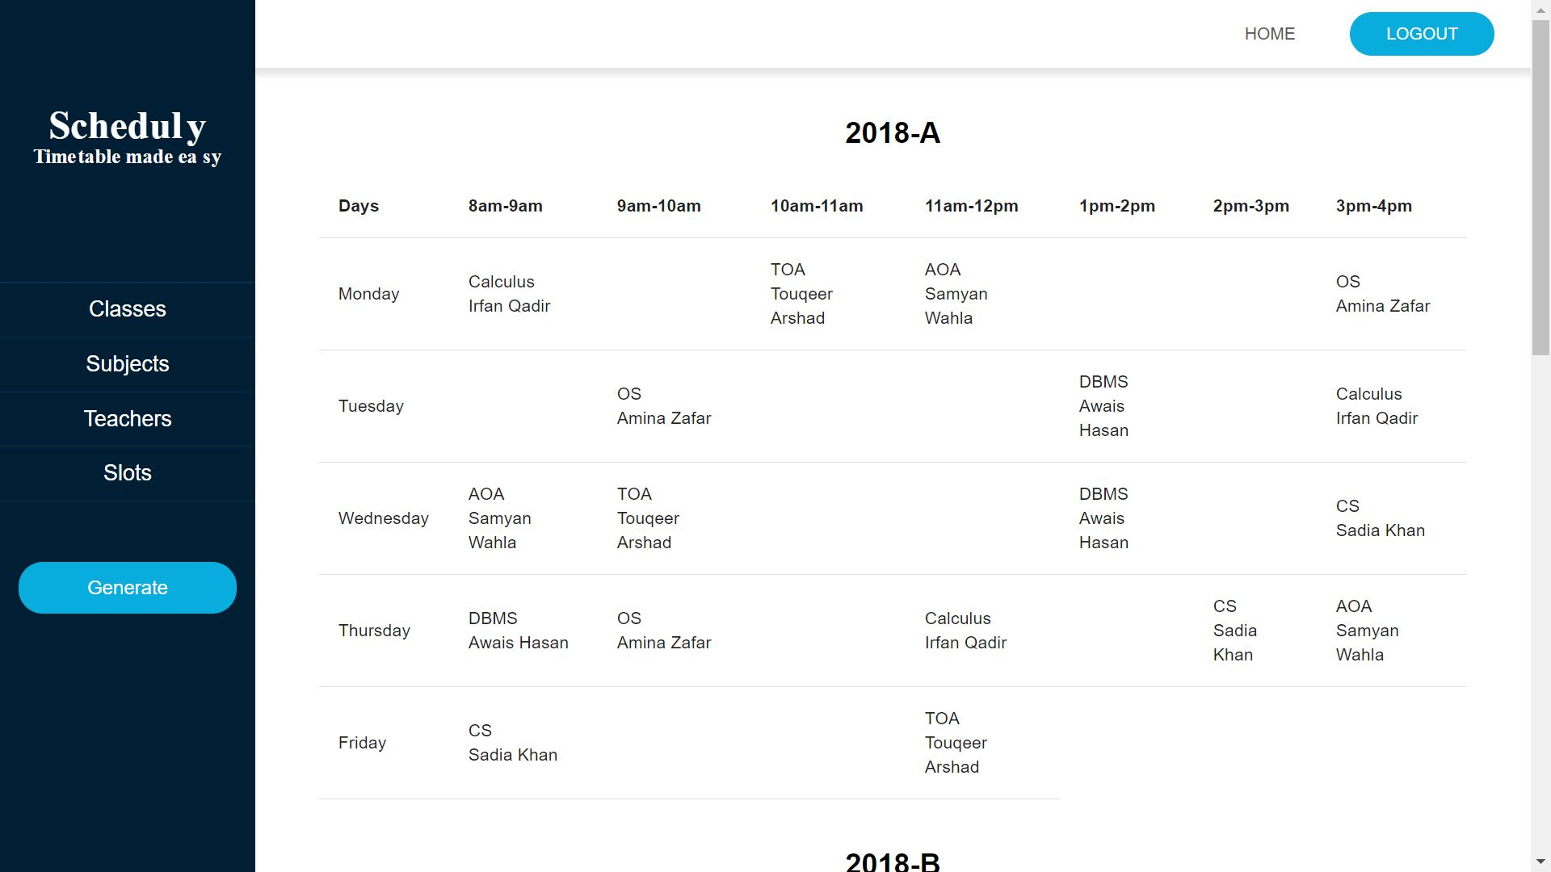

## Background

In this section we will give a brief definition of the technologies and tools we are using to build this project, mainly we are building web applications, and these applications will depend on an algorithm called a genetic algorithm. and the technologies we will use can be categorized into two main sections, Front End and Back End.

### Genetic Algorithm

A genetic algorithm is a learning computer programming heuristic search algorithm that is capable of finding the solution to computational problems which require a large pool of possible solutions, and then optimizing them based on building blocks that guide it toward the wanted solution these blocks are constrained with two types of constraints hard and soft constraints (the hard you can't violate them, where the soft to get to the optimum solution the algorithm try to stay within them). this algorithm is based on the theory of biogenetics, which is a kind of search algorithm with a high degree of randomness.[3], [4]

#### How Genetic Algorithms Work

As we mentioned previously Genetic algorithms generate initial solutions randomly and then go through multiple steps: selection, crossover, mutation, and elitism. The solution is called a chromosome that is still in the form of a symbol, a collection of chromosomes constructs a population.[5], [6]

In a genetic algorithm, a population of chromosomes consisting of a given random collection of genes is initiated according to the following steps:

1. Generating an initial population of chromosomes.
2. Evaluating the suitability of each chromosome (individual) that forms the population.
3. Selecting the chromosomes for mating based on the above results.
4. Producing offspring by mating (cross over) the selected chromosomes.
5. Mutating genes randomly.
6. Repeating steps 3-5 until a new population is generated.
7. Ending the algorithm when the best solution obtained has not changed after a preset number of generations.[7]

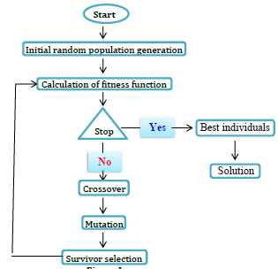

Figure 6: genetic algorithm

### Front End

The Front End of an application is the interfaces, and all that can the end user see or interact with on the screen of that application.

#### HTMLHTML

HTML stands for Hyper Text Markup Language and it is the standard markup language for creating Web pages. HTML describes the structure of a Web page; elements of HTML tell the browser how to display the content.

A start tag, some content, and an end tag define an HTML element:

<tagname> Content goes here... </tagname>

To read HTML documents and display them we need to use a browser such as Chrome or Firefox.[8]

#### CSSCSS

CSS stands for Cascading Style Sheets and describes how HTML elements are to be displayed on the screen, paper, or in other media. CSS saves a lot of work it can control the layout of multiple web pages all at once.

HTML was never intended to contain tags for formatting a web page, it was created to describe the content of a web page, when tags like <font>, and color attributes were added to the HTML 3.2 specification, it started a nightmare for web developers. Development of large websites, where fonts and color information were added to every single page, became a long process.[9]

#### D:\College\Mini Project\Our project\images\JavaScript.pngJavaScript

JavaScript is a programming language that is one of the core technologies of the World Wide Web, alongside HTML and CSS. Over 97% of websites use JavaScript on the client side for web page behavior, often incorporating third-party libraries. All major web browsers have a dedicated JavaScript engine to execute the code on users' devices. JavaScript is a high-level, often just-in-time-compiled language that conforms to the ECMAScript standard.

It has dynamic typing, prototype-based object orientation, and first-class functions. It is a multi-paradigm, supporting event-driven, functional, and imperative programming styles and it has application programming interfaces (APIs) for working with text, dates, regular expressions, standard data structures, and the Document Object Model (DOM).[10]

#### ReactReact.js

React, sometimes referred to as a frontend JavaScript framework, is a JavaScript library created by Facebook. React is a tool for building UI components.

Instead of manipulating the browser's DOM directly, react creates a virtual DOM in memory, where it does all the necessary manipulating and is found out what changes have been made, and changes only what needs to be changed, before making the changes in the browser DOM.[11]

### Back End

On the opposite side of the Front End, The Back End is all the underneath structures and data management in the background of an application that is hidden from the end user, it is responsible for storing and organizing data, and the backend communicates with the frontend, sending and receiving information to be displayed.

#### NodeNode.js

Node.js is an open-source and cross-platform JavaScript runtime environment.

Node.js runs the V8 JavaScript engine, the core of Google Chrome, outside of the browser. This allows Node.js to be very performant. A Node.js app runs in a single process, without creating a new thread for every request. Node.js provides a set of asynchronous I/O primitives in its standard library that prevent JavaScript code from blocking and generally, libraries in Node.js are written using non-blocking paradigms, making blocking behavior the exception rather than the norm.

When Node.js performs an I/O operation, like reading from the network, or accessing a database or the file system, instead of blocking the thread and wasting CPU cycles waiting, Node.js will resume the operations when the response comes back.

This allows Node.js to handle thousands of concurrent connections with a single server without introducing the burden of managing thread concurrency, which could be a significant source of bugs.

Node.js has a unique advantage because millions of frontend developers that write JavaScript for the browser are now able to write the server-side code in addition to the client-side code without the need to learn a completely different language.[12]

#### Amazon RDS for MySQL – Amazon Web Services (AWS)MySQL

MySQL is one of the most recognizable technologies in the modern big data ecosystem. Often called the most popular database and currently enjoying widespread, effective use regardless of industry, anyone involved with enterprise data or general IT should at least aim for a basic familiarity with MySQL.

MySQL is a relational database management system (RDBMS) developed by Oracle that is based on structured query language (SQL).

A database is a structured collection of data. It may be anything from a simple shopping list to a picture gallery or a place to hold vast amounts of information in a corporate network. In particular, a relational database is a digital store collecting data and organizing it according to the relational model. In this model, tables consist of rows and columns, and relationships between data elements all follow a strict logical structure. An RDBMS is simply a set of software tools used to implement, manage, and query such a database.[13]

### Development Environment

To be able to use these technologies all of them need an environment that hosts them and as we going to use the best technology, we will use the best environments.

#### VS CODEVisual Studio Code

Visual Studio Code is a source-code editor made by Microsoft for Windows, Linux, and mac OS. Features include support for debugging, syntax highlighting, intelligent code completion, snippets, code refactoring, and embedded Get. Users can change the theme, keyboard shortcuts, and preferences, and install extensions that add additional functionality.

**Features**

* Visual Studio Code is a source code editor that can be used with a variety of programming languages, including Java, Go, JavaScript, Python, and C++.
* Is based on the Electron framework, which is used to develop Node.js web applications that run on the Blink layout engine.
* Instead of a project system, it allows users to open one or more directories, which can then be saved in the workspace for future reuse.
* Visual Studio Code can be extended via extensions available through a central repository. This includes additions to the editor and language support, extending and customizing to your liking.[14]

## References

[1] “Making a School Schedule.” https://www.my.gov.sa/wps/portal/snp/servicesDirectory (accessed Dec. 14, 2022).

[2] “GitHub - ghulamghousdev/Scheduly: Activity Scheduling Tool.” https://github.com/ghulamghousdev/Scheduly (accessed Dec. 14, 2022).

[3] A. R. East, “Timetable Scheduling via Genetic Algorithm.” National University of Ireland, 2019.

[4] J. Xu, “Improved Genetic Algorithm to Solve the Scheduling Problem of College English Courses.” 1International Education School, Chifeng University, Chifeng 024000, China, Jun. 10, 2021.

[5] N G A P H Saptarini, I W Suasnawa, and P I Ciptayani, “Senior high school course scheduling using genetic algorithm.” Electrical Engineering Department, Politeknik Negeri Bali, Jalan Kampus Bukit Jimbaran, Badung - 80364, Bali, Indonesia, 2017.

[6] R Ansari and N Saubari, “Application of genetic algorithm concept on course scheduling.” Departement of Informatics Engineering, Faculty of Engineering, Universitas Muhammadiyah Banjarmasin, Banjarmasin, Indonesian, 2020.

[7] Achini Kumari Herath, “Genetic Algorithm For University Course Timetabling Problem.” University of Mississippi, 2017.

[8] “Introduction to HTML.” https://www.w3schools.com/html/html_intro.asp (accessed Dec. 14, 2022).

[9] “CSS Introduction.” https://www.w3schools.com/css/css_intro.asp (accessed Dec. 14, 2022).

[10] “JavaScript,” *Wikipedia*. Dec. 12, 2022. Accessed: Dec. 14, 2022. [Online]. Available: https://en.wikipedia.org/w/index.php?title=JavaScript&oldid=1127088475

[11] “Introduction to React.” https://www.w3schools.com/REACT/react_intro.asp (accessed Dec. 14, 2022).

[12] “Introduction to Node.js.” https://nodejs.dev/en/learn/ (accessed Dec. 14, 2022).

[13] “What is MySQL? Everything You Need to Know,” *Talend - A Leader in Data Integration & Data Integrity*. https://www.talend.com/resources/what-is-mysql/ (accessed Dec. 14, 2022).

[14] “Visual Studio Code,” *Wikipedia*. Feb. 25, 2021. Accessed: Dec. 14, 2022. [Online]. Available: https://en.wikipedia.org/w/index.php?title=Visual_Studio_Code&oldid=1008850700