# **CHAPTER 3**

# **METHODOLOGY**

## INTRODUCTION

This chapter explains the methodology used in this project with the analysis of all its aspects, how the end user will interact with all the data available to him through the application, and how data flow between each of the users and the system to get the best results in terms of timetable. Then, it will address the design of the database and how it fills the database table through which the timetable is created. Finally, the interfaces of the project and how they will be designed so that both ease of use and effectiveness for the user are taken into account, with an explanation of some of them.

## Analysis

### Creating Timetable Manually

At this stage, it is analyzed how timetables are created by the university and what steps are taken to make this process as smooth as possible. After checking with the heads of departments and the secretary in the College of Engineering and Petroleum, it was found that the university's timetable is established with the following steps:

1. Determining the study subjects Each department head determines the subjects that will be studied at each level of his department, except for the first level, where most of the subjects are the responsibility of the college secretary. These subjects are determined according to the study plan followed for each department.
2. Assign lecturers The head of the department assigns the lecturers to each of the specified subjects according to their capabilities and requests. As previously mentioned, the subjects of the first level are determined by the college secretary, so he is also the one who determines the lecturers for them. In the absence of lecturers from the department for the subject, the head of the department or the secretary of the college may have to send a request to the head of another department to give him a lecturer capable of teaching that subject.
3. Hall distribution At this stage, the halls are distributed to each group of all levels according to the number of students and the capacity of the hall. Here, the college uses a method to facilitate this process by defining a number of its halls for each department that takes priority over other departments. While keeping the large halls and allocating them to first-level students from all departments, these halls will be at the disposal of the college secretary. In the event of a conflict between the halls, or if the number of students exceeds the capacity of the hall, the head of the department or the secretary resorts to sending a request to one of the other departments to give him one of their halls, if it is. Available according to his needs, or to exchange if there is a group from the other section to fit in the hall.
4. Timing for lectures At this stage, the timetable begins to form, where the department head or secretary arranges the timetable with the day for each lecture according to the following information:

* Subject
* Duration of lecture
* Lecturer
* Hall
* Group.

1. Checking for conflicts The final stage of creating the timetable is to check for discrepancies between timetables created by all departments. This is done by a specific person, and in the event of a conflict, he reviews the sections in which the dispute occurred to try to solve the problem either by changing the timing of some lectures or changing the rooms. This process is repeated until a timetable for all departments is produced free of conflicts.
2. Distribution of the created timetables After the timetable is created then it is distributed to the college students and lecturers.

These are the steps followed in each semester by the college in creating timetables for each semester and in the following figure (figure 1) a simplification of the process to make it easier to visualize.

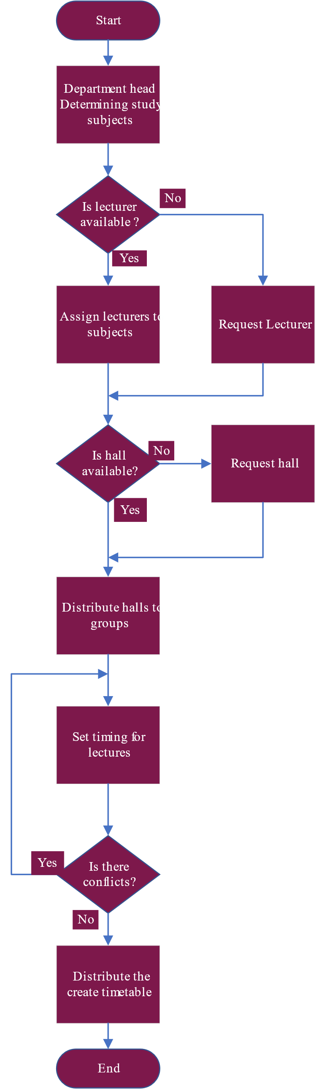

The process of finding conflicts and trying to solve them is done by a specific person.

When assigning a lecturer, take into consideration his requests and capabilities

Figure Manual way to create a timetable

### Creating Timetable Using Tabu Search

After understanding how to create the timetable, here comes the role of the Tabu search to convert this process into an automatic process to reduce the time required to produce a timetable and be free of conflicts. The steps used to get the timetable are almost the same. The department head or college secretary has to select the subjects and lecturers for each subject, after which the algorithm starts taking this data and creates the timetable according to the constraints imposed on it. Constraints are divided into two types, hard constraints, which are used to prevent any cases of conflict, and there are also soft constraints, which are used to generate schedules according to some department preferences. Here are some constraints two follow:

Hard constraints:

* The lecturer does not teach two subjects at the same time
* The hall does not contain two groups at the same time
* The group does not take two subjects at the same time

Soft constraints:

* Set the time and day that suits the lecturer
* Don't take too much free time between lectures.
* Schedule practical subjects for the same day

So, to generate a timetable using the Tabu search as mentioned earlier, the first few steps are the same as those in the manual method with the difference that the Tabu search starts to take the lead after it has the data needed to create the best timetable, and it follows these steps:

1. Determine the study subjects. (manually)
2. Assign the lecturers. (manually)
3. The algorithm distributes the hall and manages the timing for the lectures.
4. The generated timetable is distributed to the college students and lecturers.

These are the steps used to create the timetable using Tabu search and to get a good understanding of the concept of it and visualize see figure2.

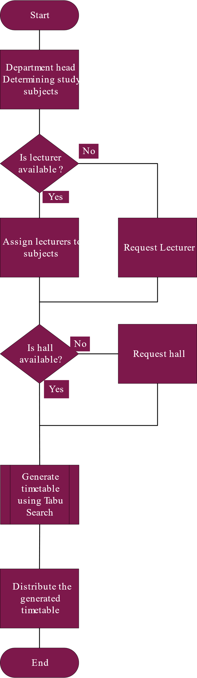

Figure flowchart to generate the timetable using the genetic algorithm

### Users of the system and their use case

From the analysis, you find that the Tabu search needs users who give it the necessary data to generate the timetables, and these users are the ones who control the results that the algorithm will give, and they are:

* Admin of the system.
* Head for the department.
* College secretary.

#### Admin of the system

The system administrator will be responsible for operating the timetable generation system within the college campus and will also be assigned to perform some other tasks. His task is noted below with some explanation and to visualize see figure3.

Table ‑ Use case of Admin

|  |  |
| --- | --- |
| Use case 1 | Add users |
| Flow | When the system is first implemented in the college the administrator's job is to give access to a few of the users that will use the system to generate the timetables. |

|  |  |
| --- | --- |
| Use case 2 | Define the structure of the college |
| Flow | When the system is first implemented in the college the administrator's job is to define the structure of the college that the system is implemented in which include the hall and their types and capacity also which building it’s located in |

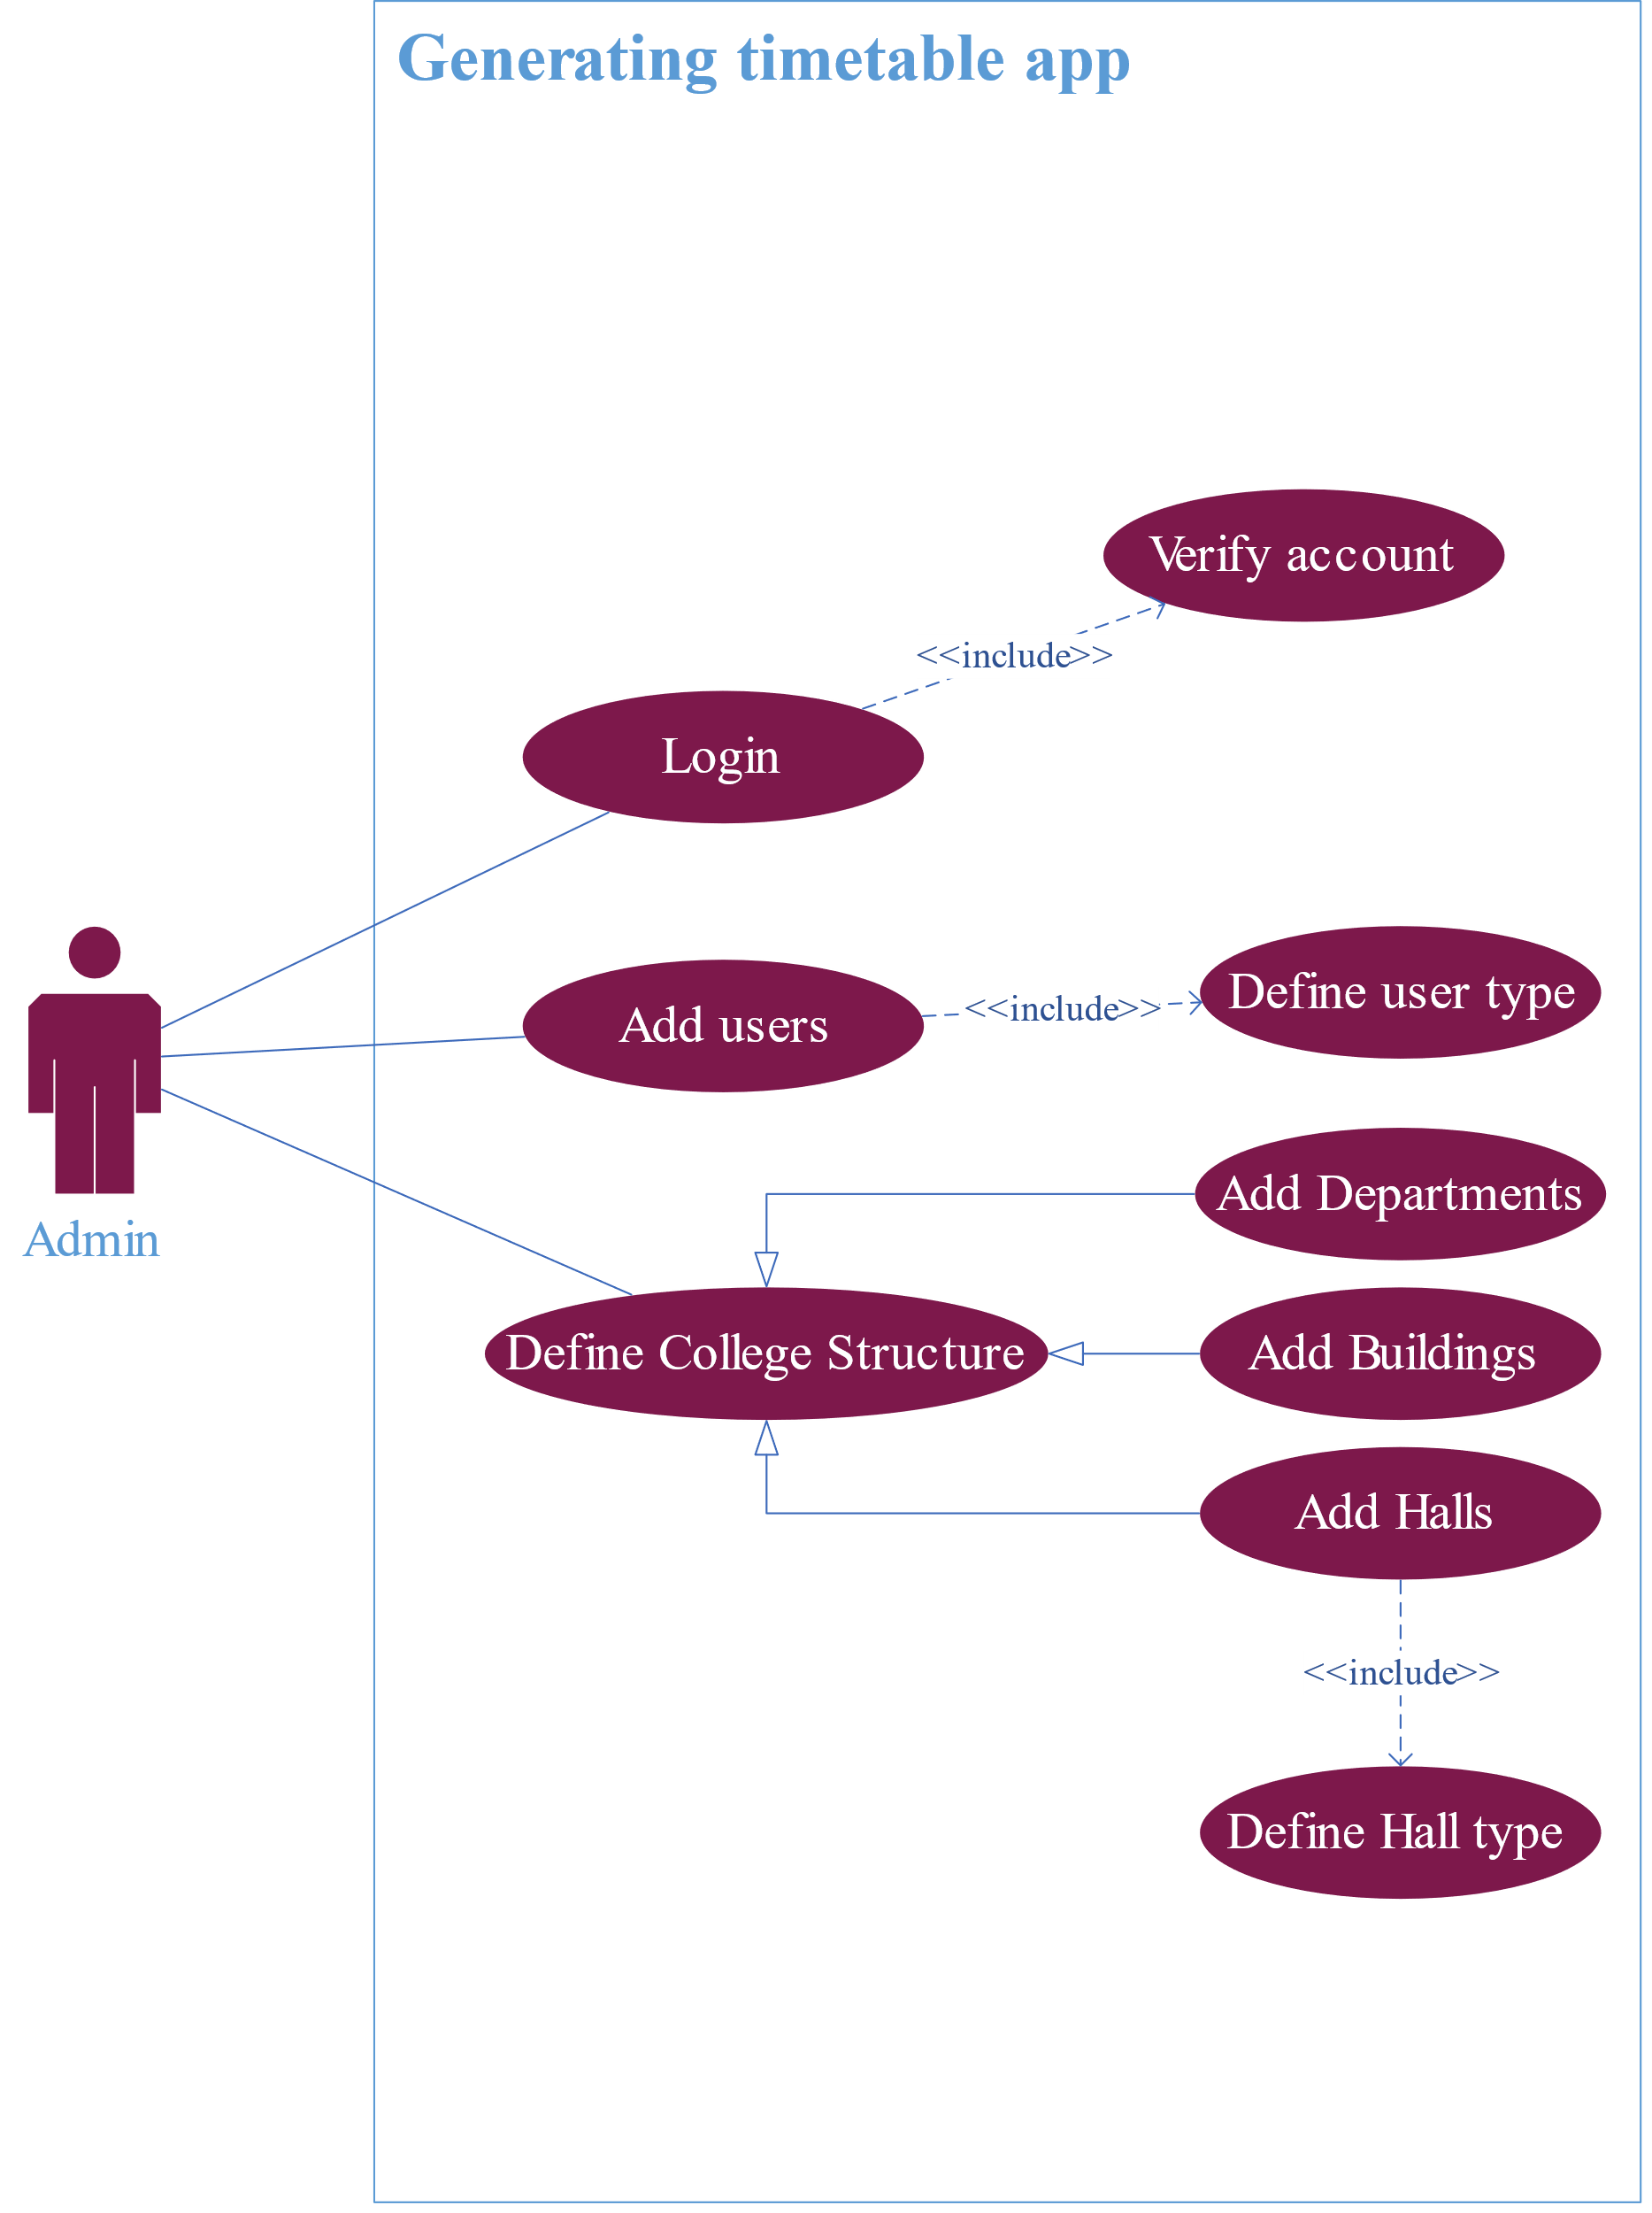

Figure administrator use case

#### Head of the department

The head of the department is one of the main users of the system, as he is responsible for entering most of the important data that make the system effective. Below is an explanation of what he does in the system, and to visualize it, see figure4.

Table ‑ Use case of Head of Department

|  |  |
| --- | --- |
| Use case 1 | Modify Courses |
| Flow | The department head is responsible for adding courses prescribed by the college to the system. He adds study subjects and their characteristics and may modify them or even remove them. |

|  |  |
| --- | --- |
| Use case 2 | Modify Groups |
| Flow | The department head is responsible for defining the groups of his department. He adds new groups and their characteristics and may modify them or even remove them. |

|  |  |
| --- | --- |
| Use case 3 | Assign lecturers |
| Flow | The department head is responsible for adding lecturers to the system with their preferences and assigning them to subjects so they teach them. Also, he can assign lecturers to requests from other users of the system. |

|  |  |
| --- | --- |
| Use case 4 | Request lecturers |
| Flow | If the department head needed a lecturer for a subject but didn’t have one available, he can request a lecturer from another user of the system. |

|  |  |
| --- | --- |
| Use case 5 | View Halls |
| Flow | The department head can view the halls if he needed to. |

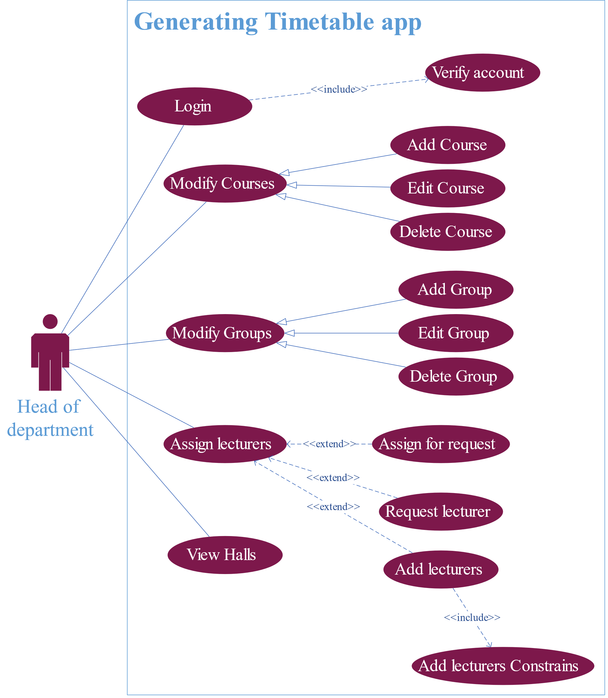

Figure Head of the department use case

#### College secretary

|  |  |
| --- | --- |
| Use case 1 | Assign lecturers |
| Flow | The college secretary is responsible for adding lecturers of the first-level students to the system with their preferences and assigning them to subjects so they teach them. Also, he can assign lecturers to requests from other users of the system. |

The college secretary is also one of the main users of the system, as he is responsible for first-level students from all departments because most of the subjects they have in common are prescribed by the college, so he is responsible for their lecturers. Also, he is the one who makes sure in the system that all of the rest of the users have added all their data so that the algorithm can work. Below is an explanation of what he does in the system, and to visualize it, see figure5.

Table ‑ Use case of college secretary

|  |  |
| --- | --- |
| Use case 2 | View Halls |
| Flow | The college secretary can view the halls if he needed to. |

|  |  |
| --- | --- |
| Use case 3 | Start generation of timetable |
| Flow | The secretary is responsible for making sure that all the users have submitted their data that allow the Tabu search to generate the timetable when everything is ready, he signals to the algorithm to start. |

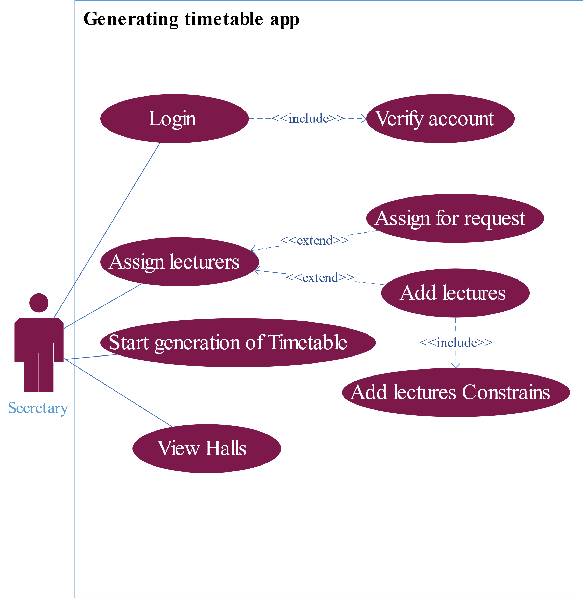

Figure College secretary use case

### The dataflow the system

After knowing how users deal with the system, the data flow begins between both users and the system. To facilitate the data visualization process, the context diagram (figure6) generally shows the context of operations between all users and the system.

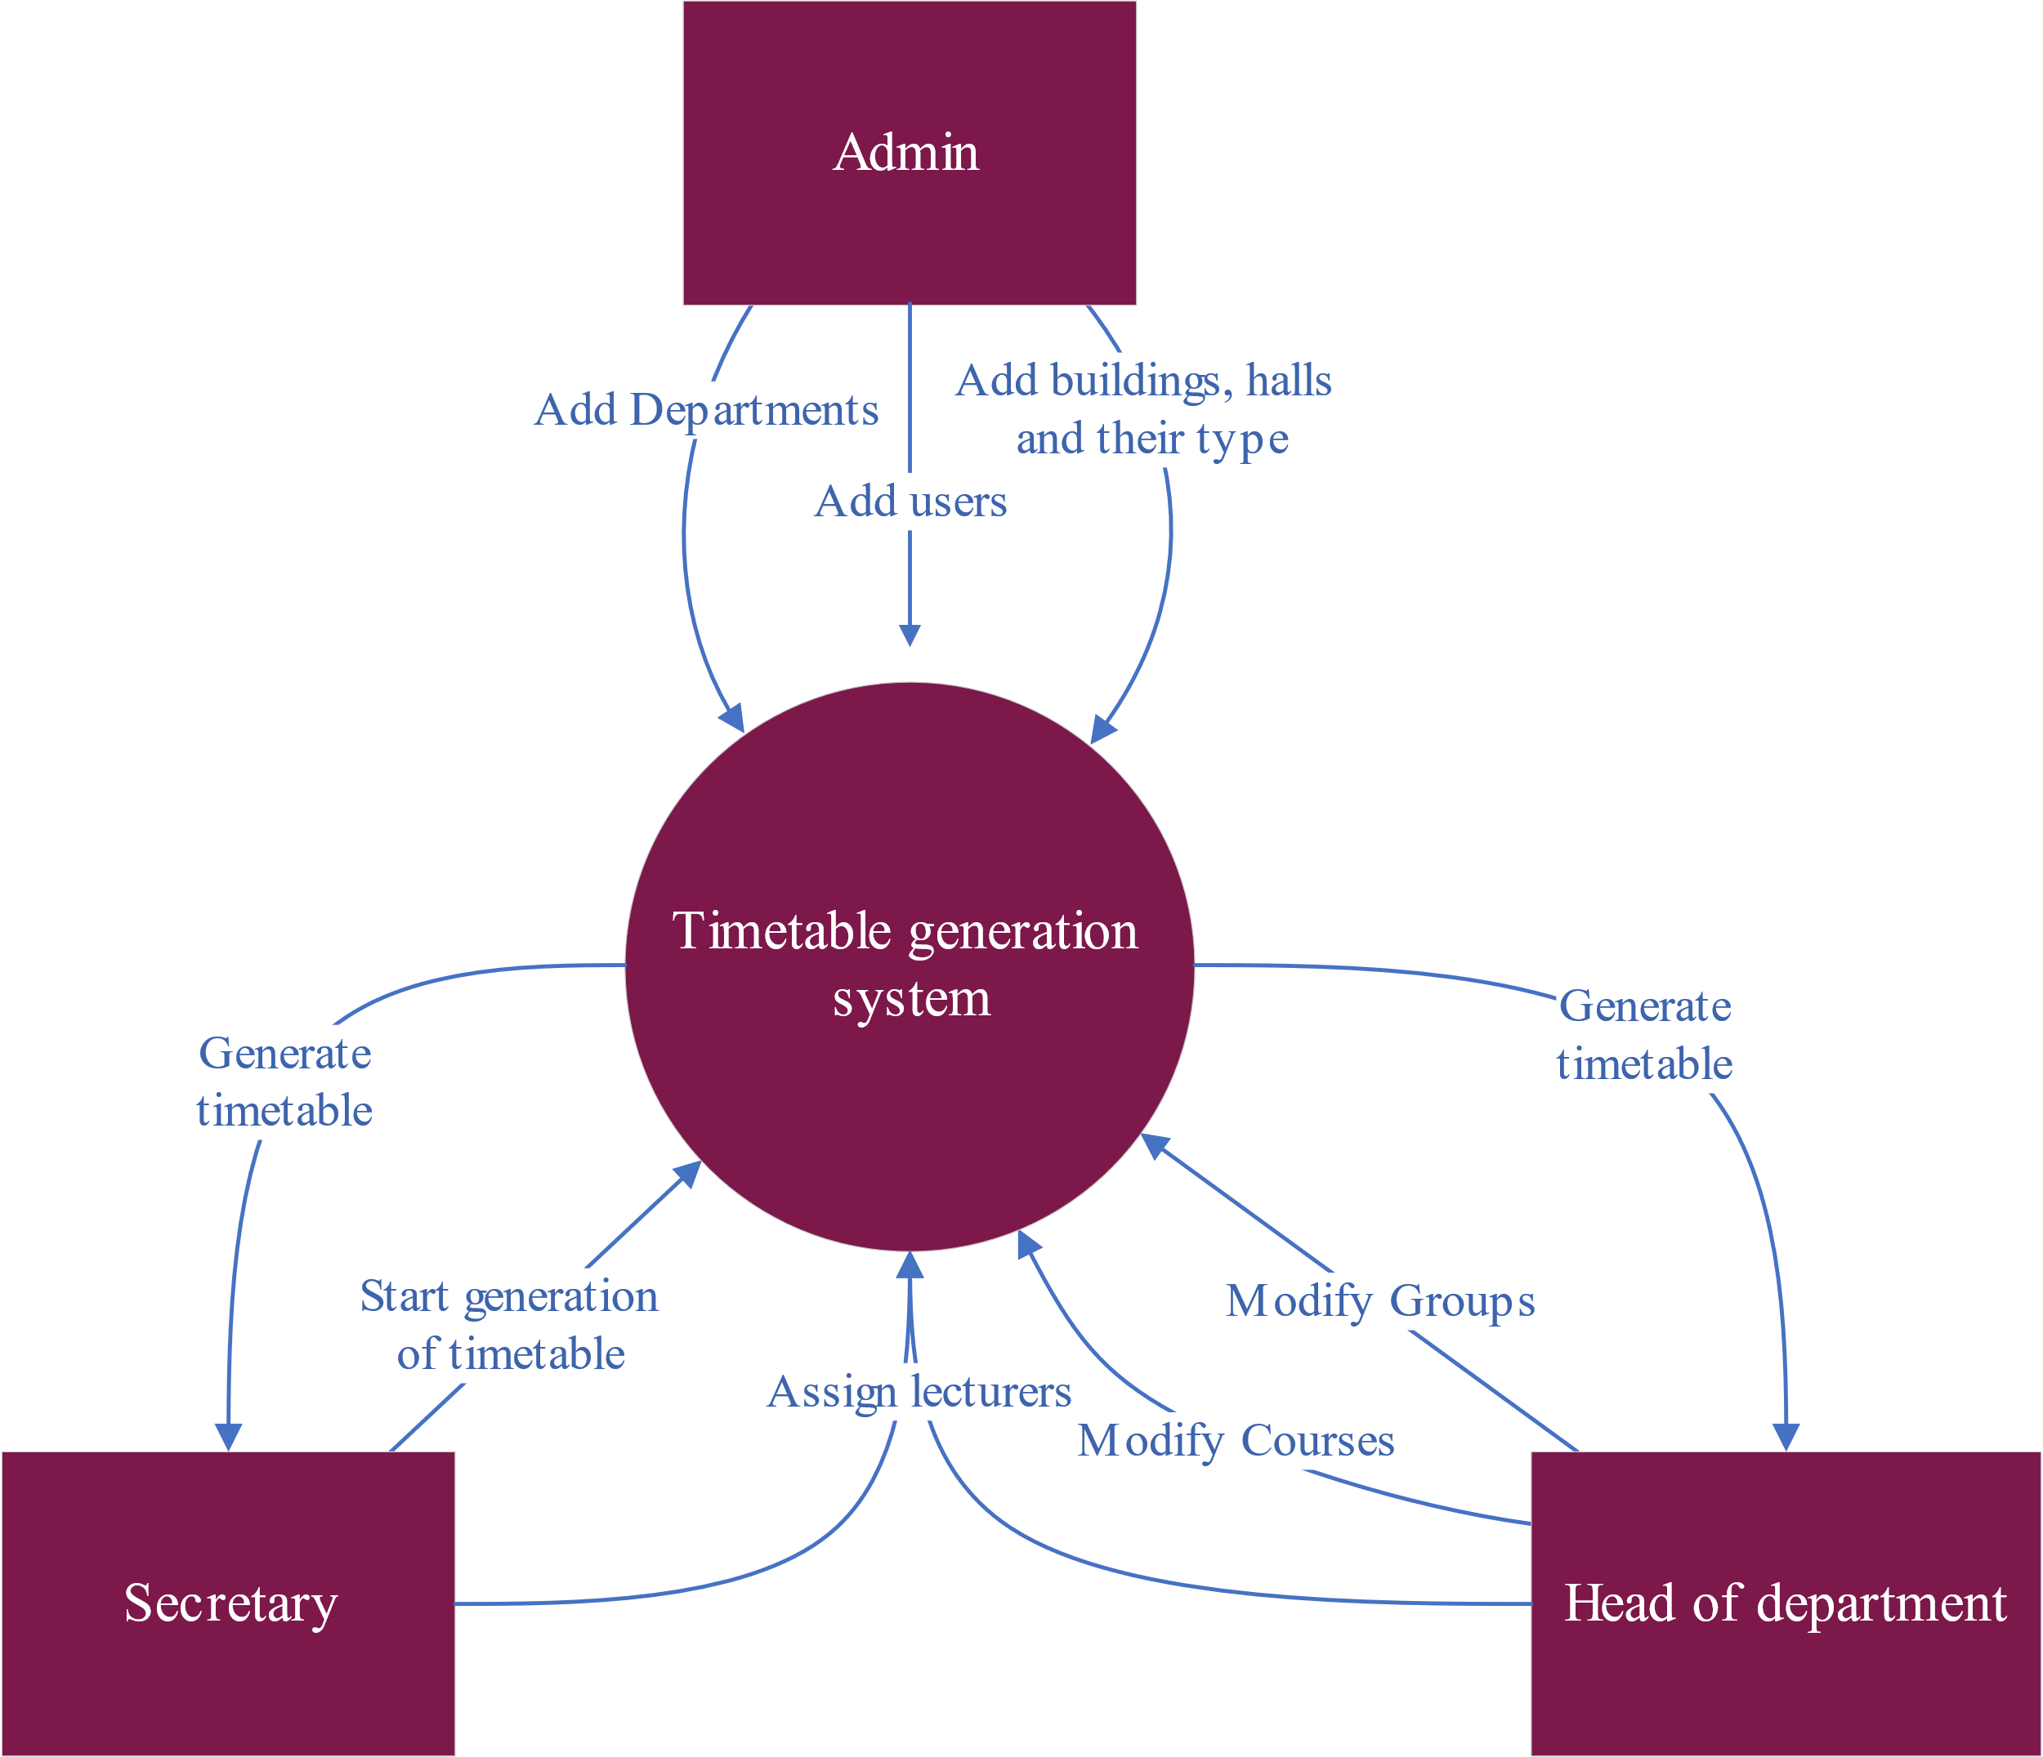

Figure Context diagram

As shown in figure6, each of the users first sends the data that the system needs to generate timetables, where the system stores it in its database and extracts what is needed to generate a timetable for each department of the college.

For a more comprehensive view of the data flow process, the data flow diagram (figure7) shows where the data comes from, where it is stored, and where it is heading.

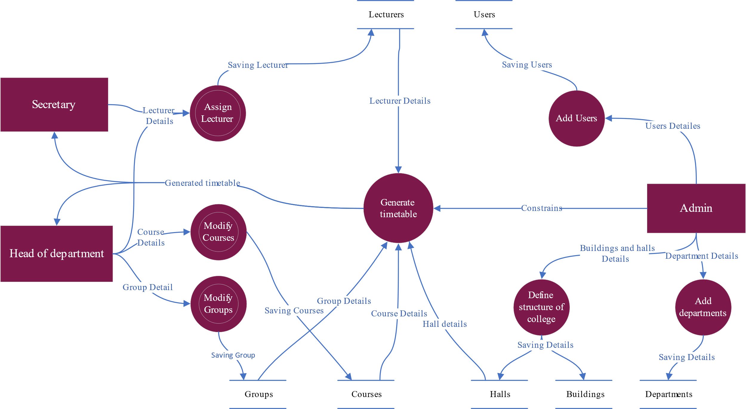

Figure Dataflow diagram

You can see in figure7 some of the processes that are symbolized by a circle with a white circle inside of it this figure indicates multiple processes, see the data flow process in the assigning of lecturers (see figure8) You will find some other processes that make up this process.

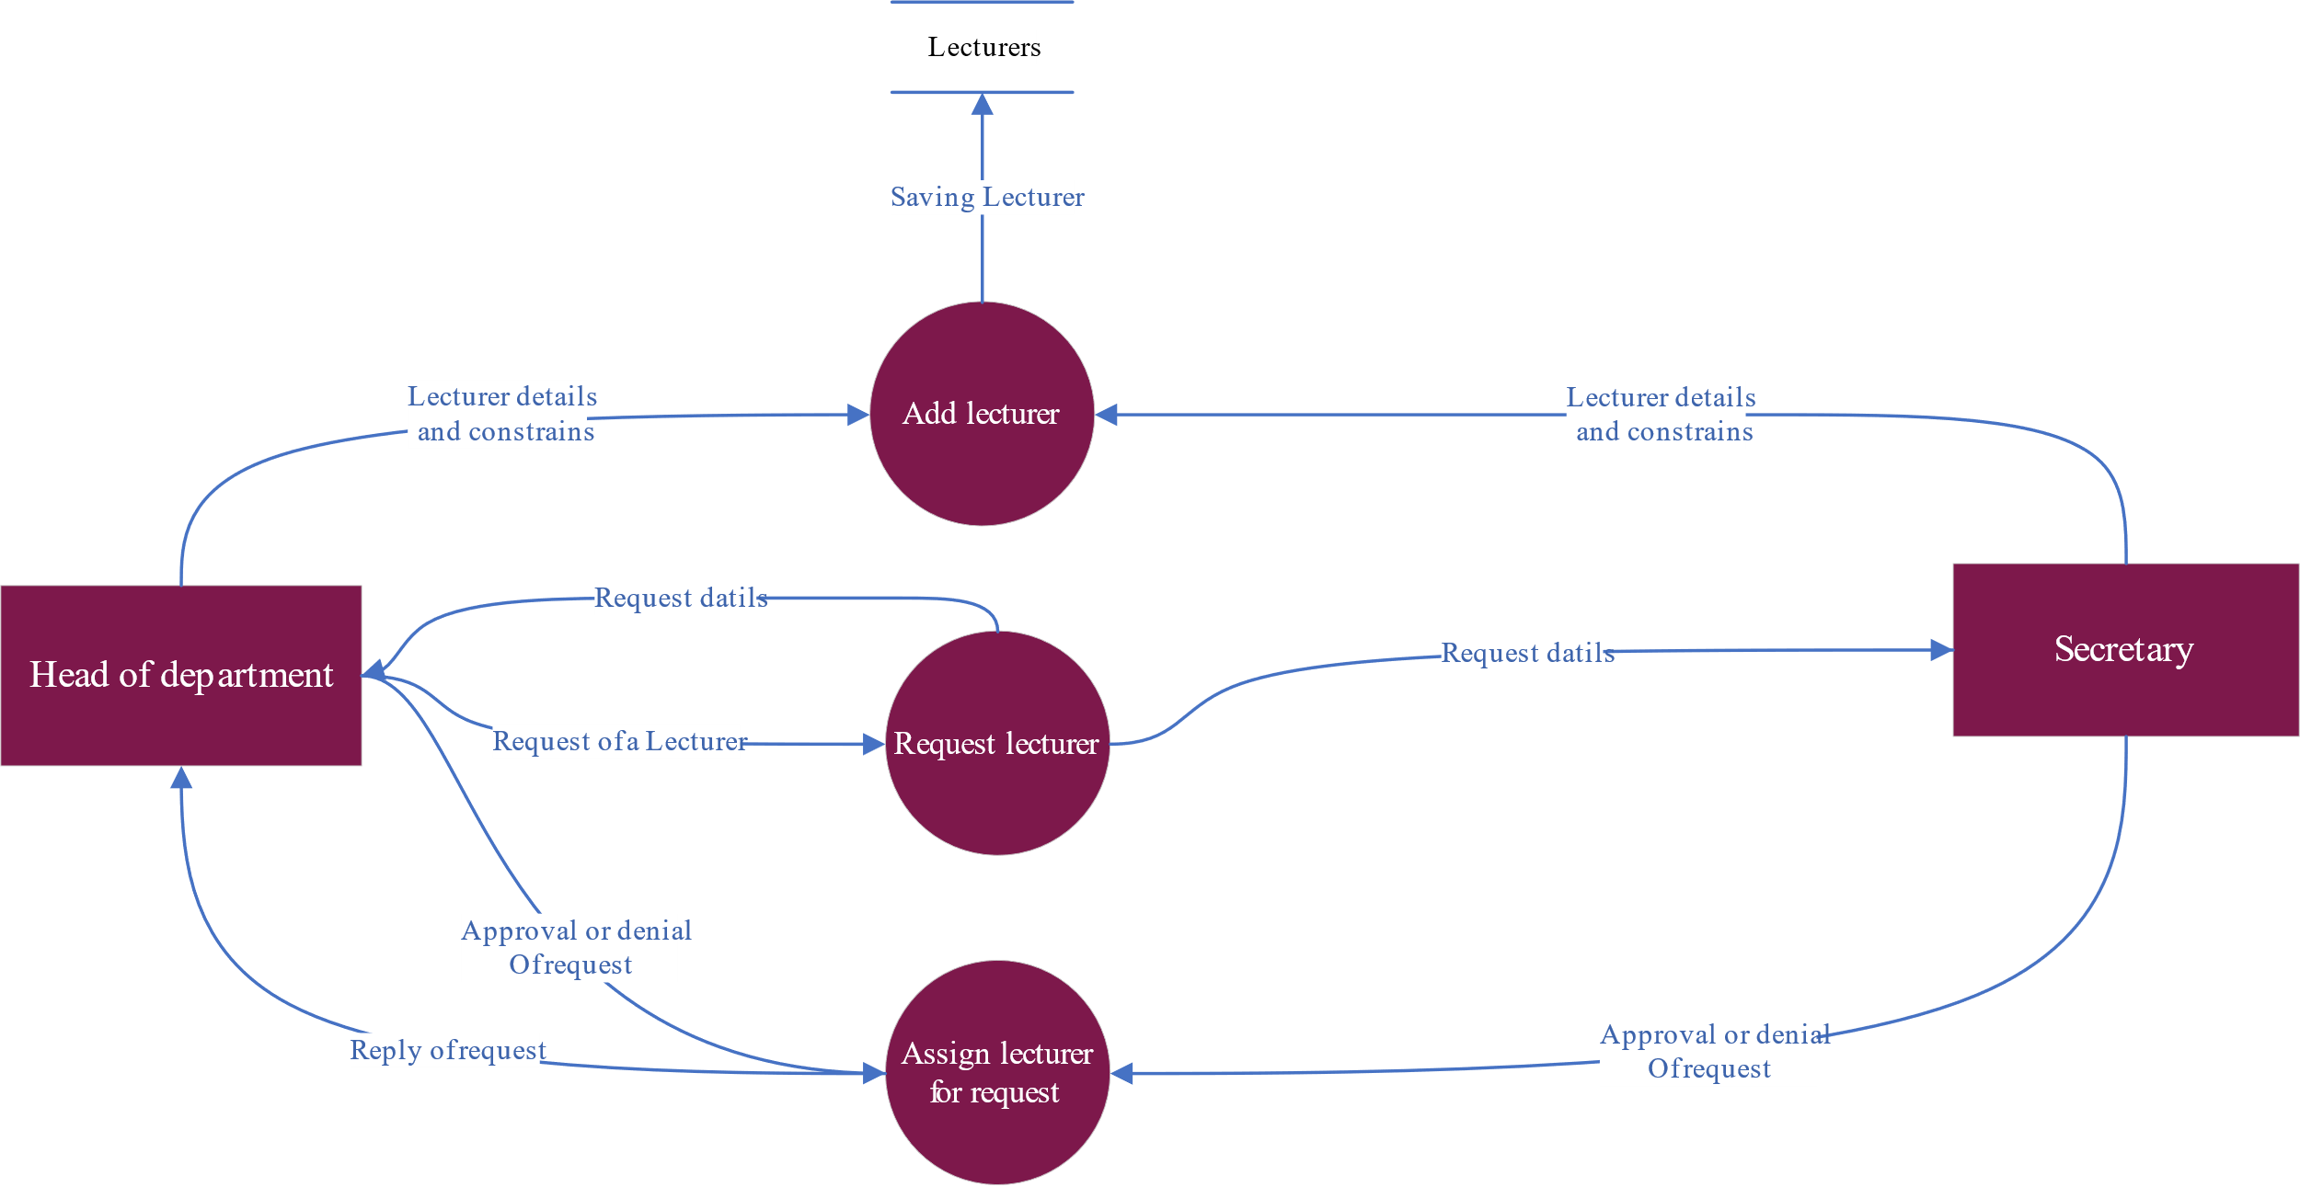

Figure dataflow diagram of multiple processes (assign lecturers)

### Database of the system

The database of the system (see Figure 9). The database consists of tables filled in by users, which are the tables that keep most of the data, and some tables are filled in automatically by the system to prepare the process of generating the timetable. In the end, the table (ETT) is the last table that the Tabu search deals with to generate the timetable.

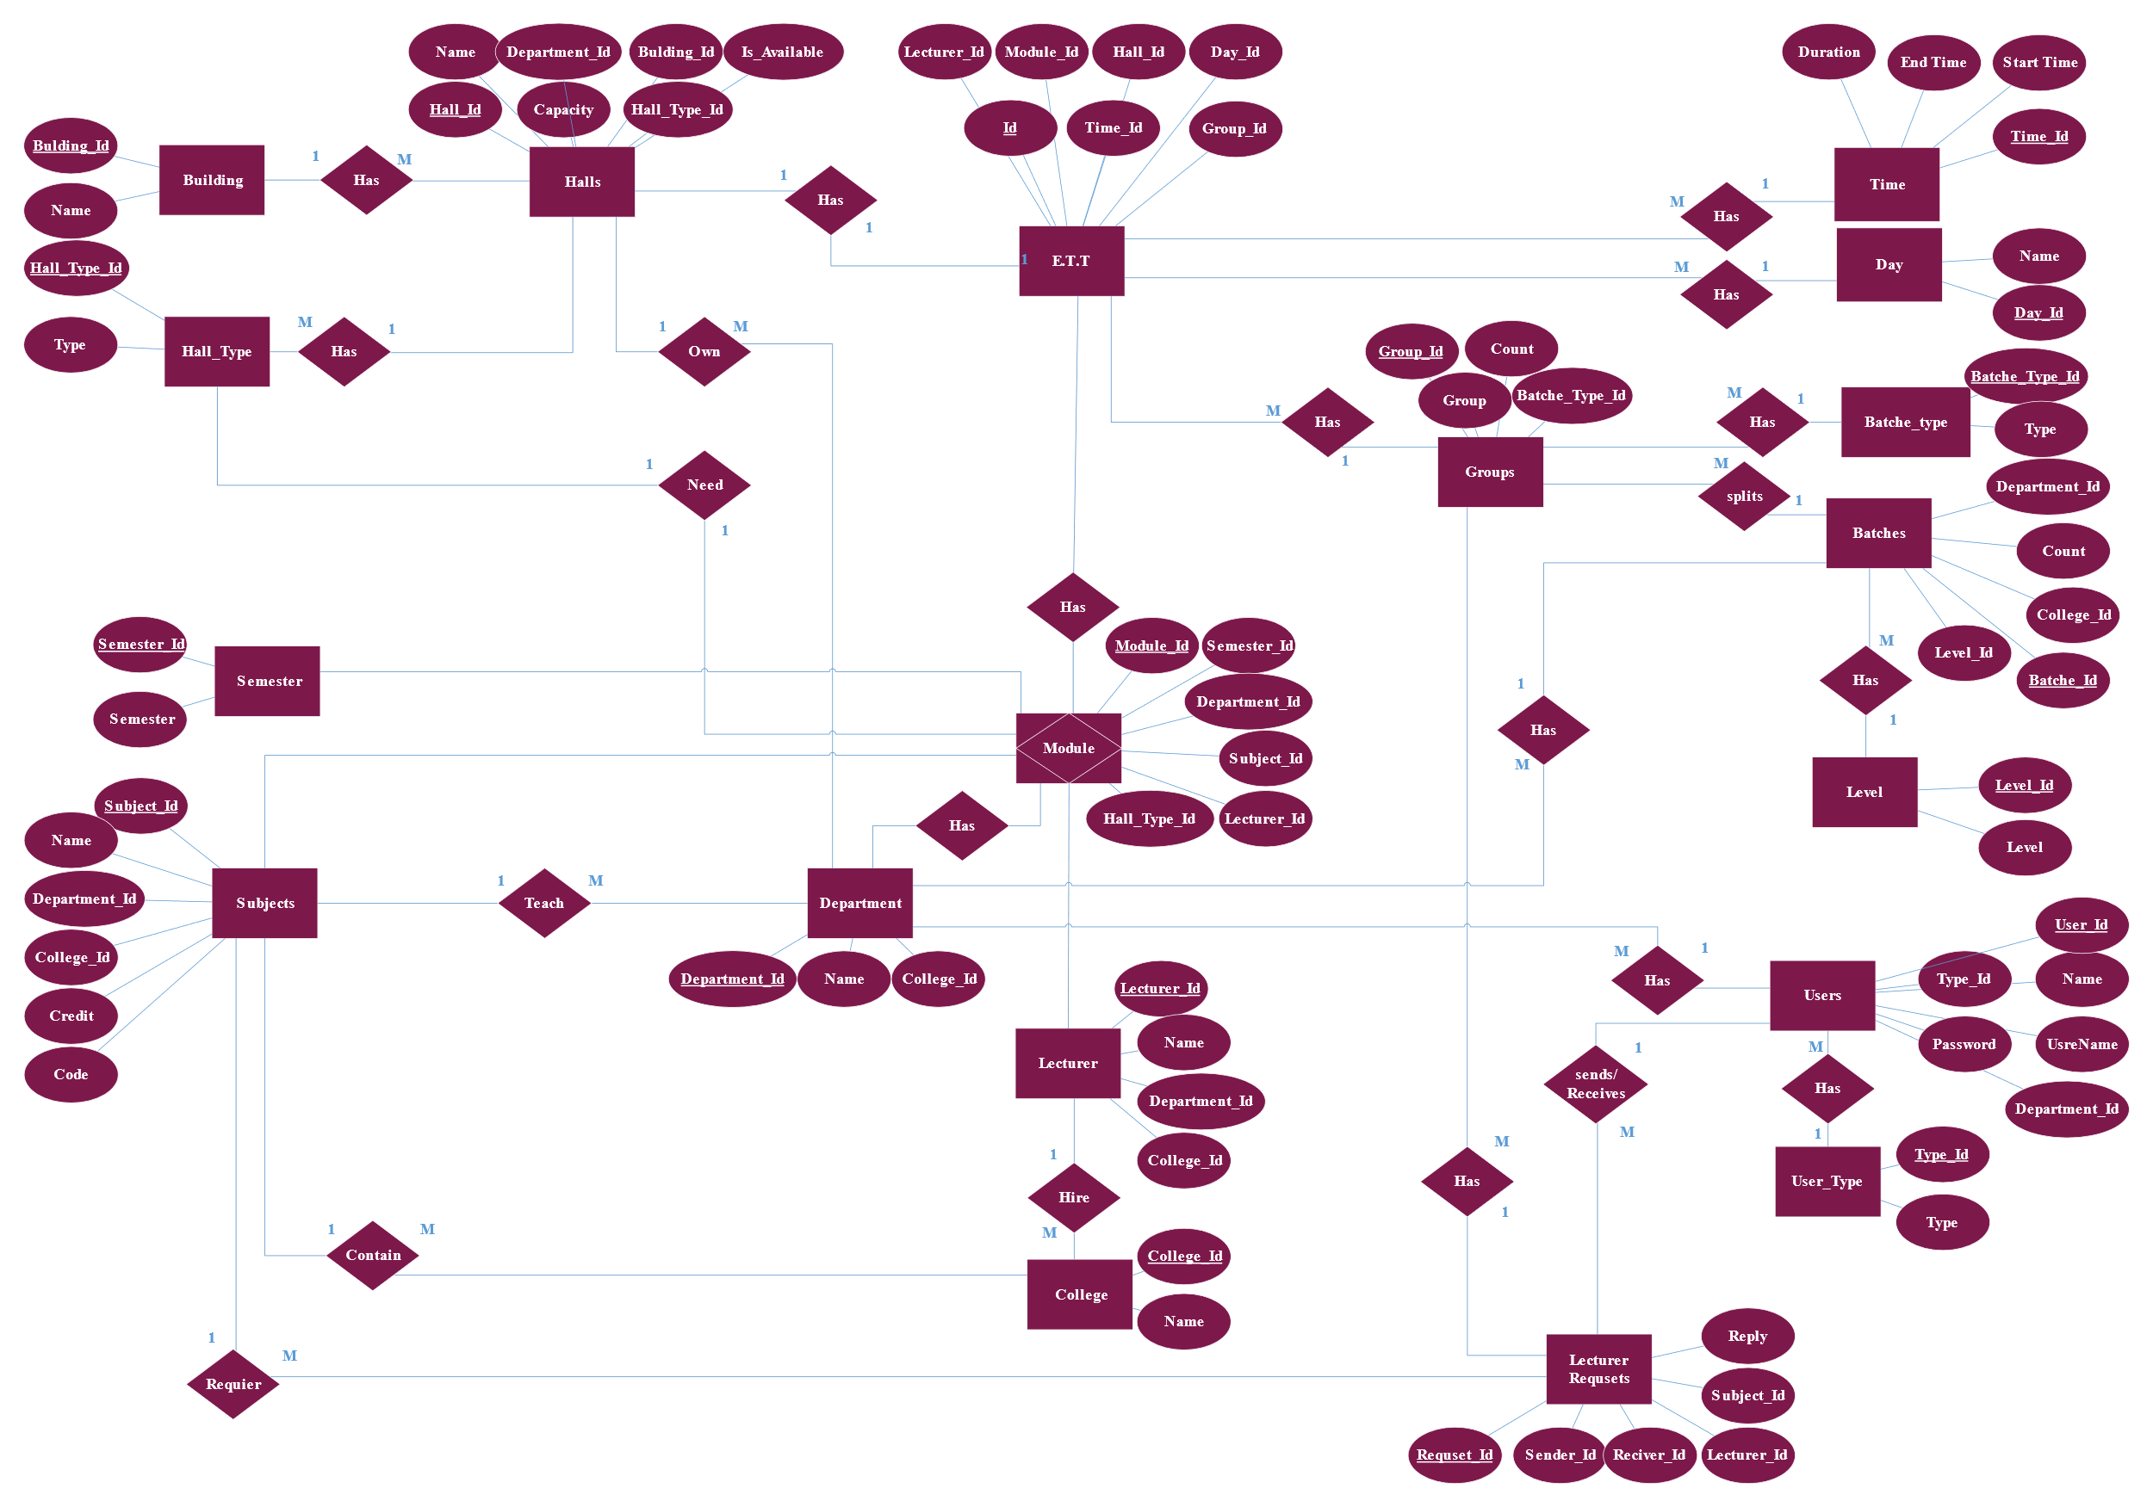

Figure Entity relationship diagram

## Implementation and result

We were able to create a user-friendly interface that allows the users to easily access and interact to achieve the services they need.

### Main Page

The main page interface of our website is designed to be user-friendly and easy to navigate. The top bar includes quick links to navigate and a log in option

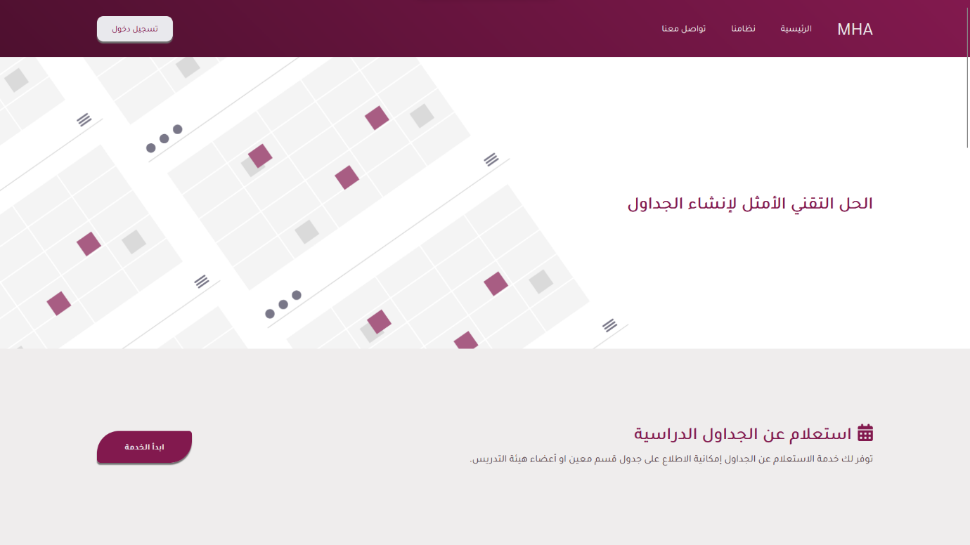

### Login Interface

The login interface of our website is simple and easy to use. The user enters their username and password and then clicks on the "تسجيل الدخول" button, our system will detect the user type and will navigate the user to the appropriate page

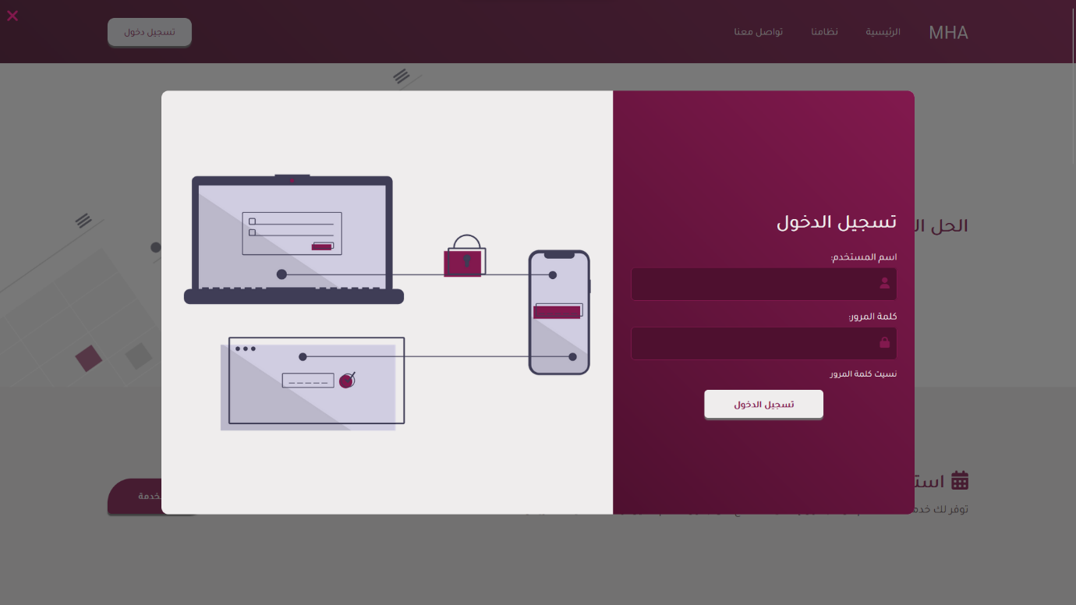

### Admin Homepage

The admin homepage contains a brief and quick view of the states of the system including the users, colleges, and number of departments

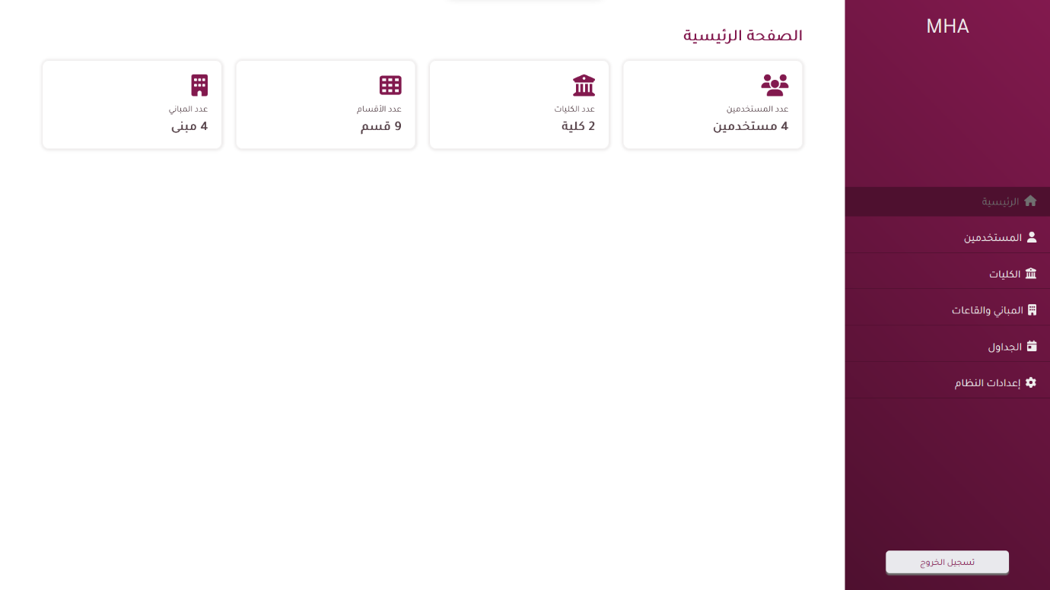

#### Admin Users Control

The user interface allows administrators to view and manage all users on the website. This includes the ability to create new users, edit existing users, and delete users.

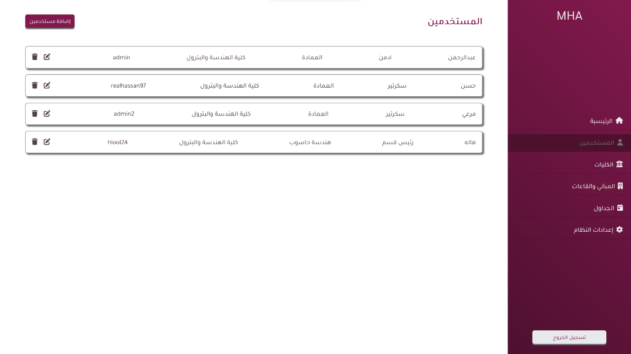

#### Admin Colleges

The college's interface allows administrators to view and manage all colleges. This includes the ability to create, edit, and delete.

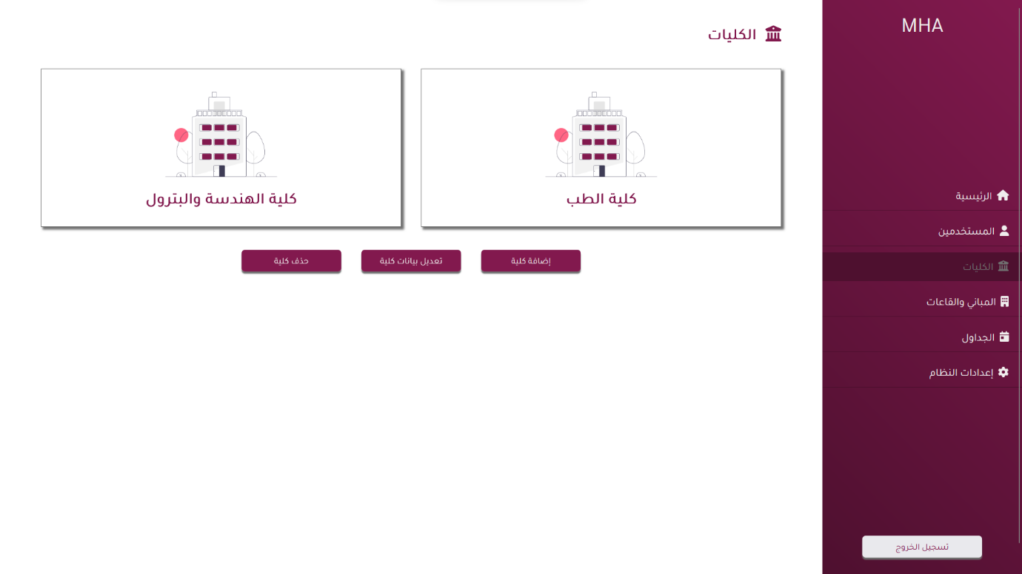

#### Admin Buildings

The building interface allows administrators to view and manage all buildings on the college campus. This includes the ability to create new buildings, edit existing buildings, and delete buildings, also the administrators can manage the types of classes those buildings will contain.

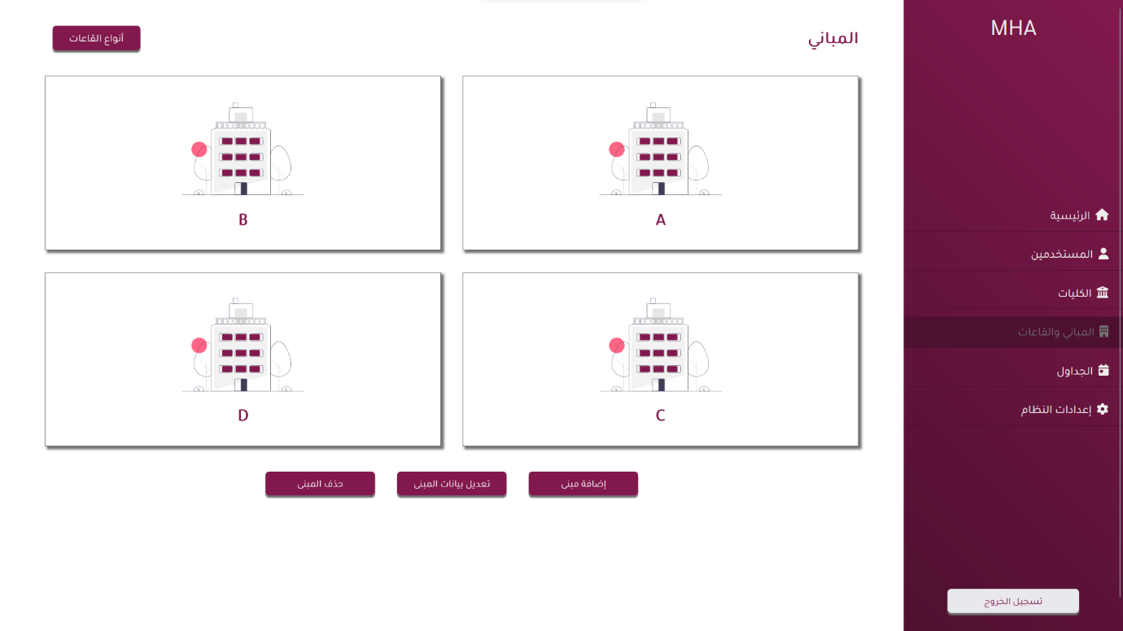

#### Admin Classes and Laps

The interface will allow the administrator to view and manage the classes and laps inside each building.

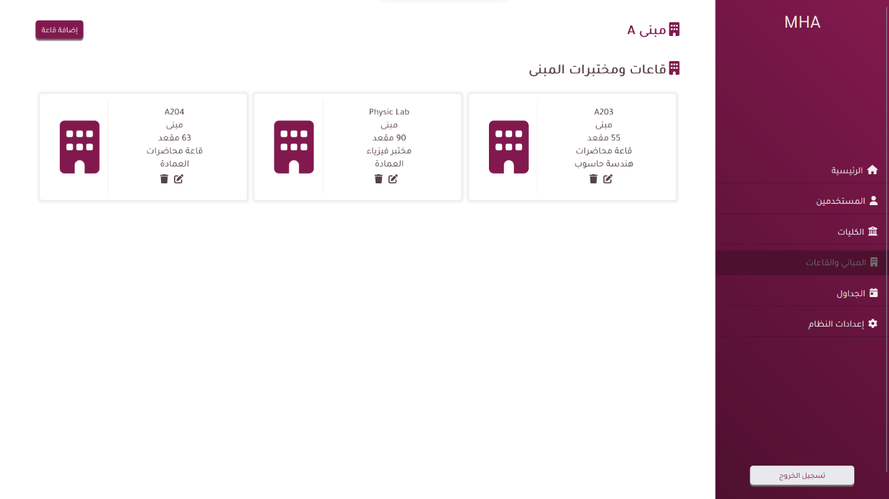

#### Admin Schedules

(template)

#### Admin Settings

The settings interface allows the administrator to manage some important system features including the year, semester, and schedule preferences.

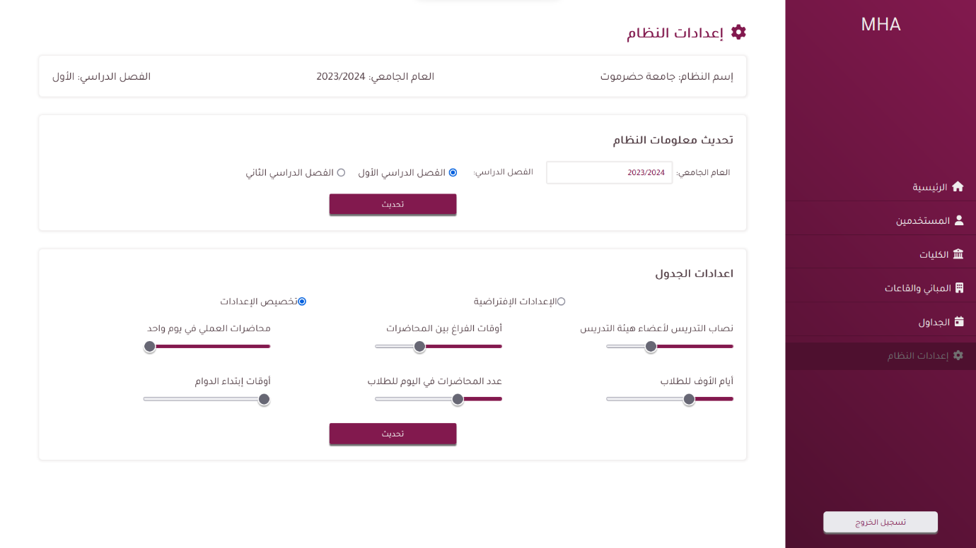

### Head of Department Homepage

The Head of the department homepage provides access to all interactions that are under his or her supervision.

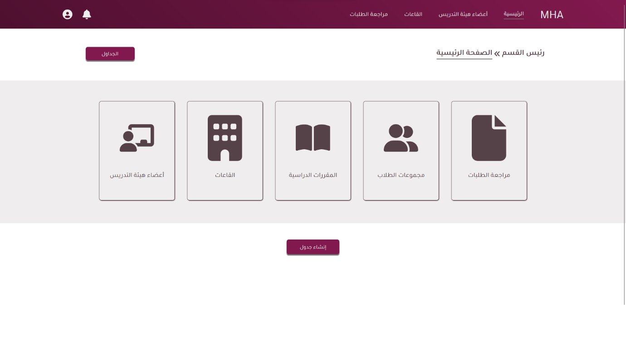

#### Head of Department Review Requests

The Request interface allows the head of the department to request to assign a class in his department with a teacher from another department.

(template)

#### Head of Department Groups

The student groups interface allows the head of the department to view and manage the groups of each batch.

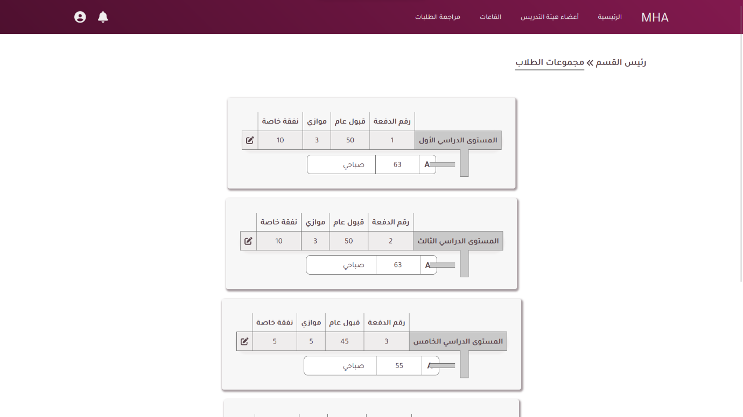

#### Head of Department Courses

The courses interface allows the head of the department to view and manage all courses for each batch that is under his or her supervision.

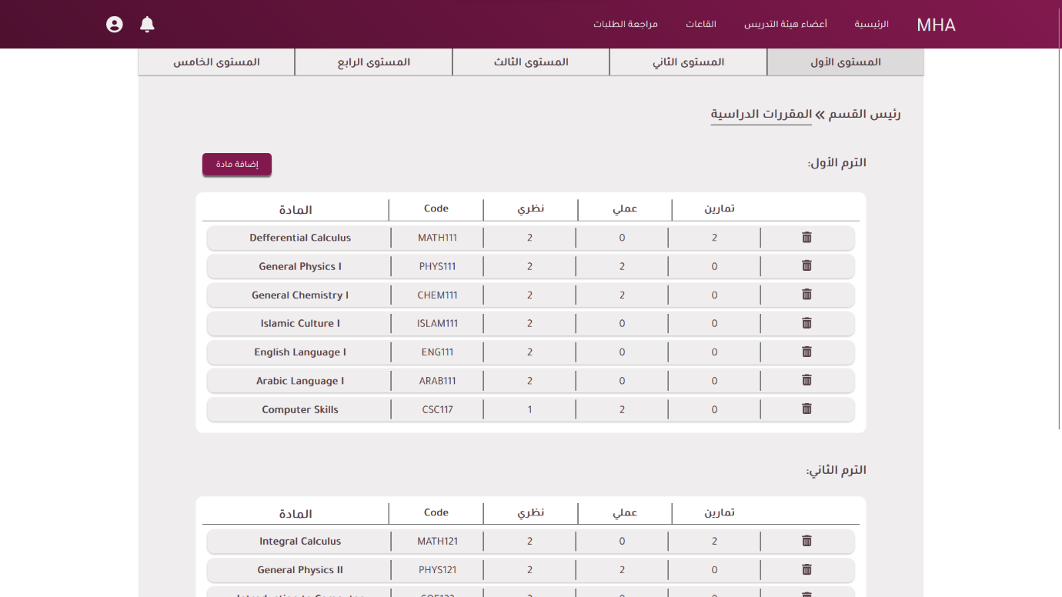

#### Head of Department Lecturers

The lecturer's interface allows the head of the department to manage all the lecturers in his department and their work days and if available or not.

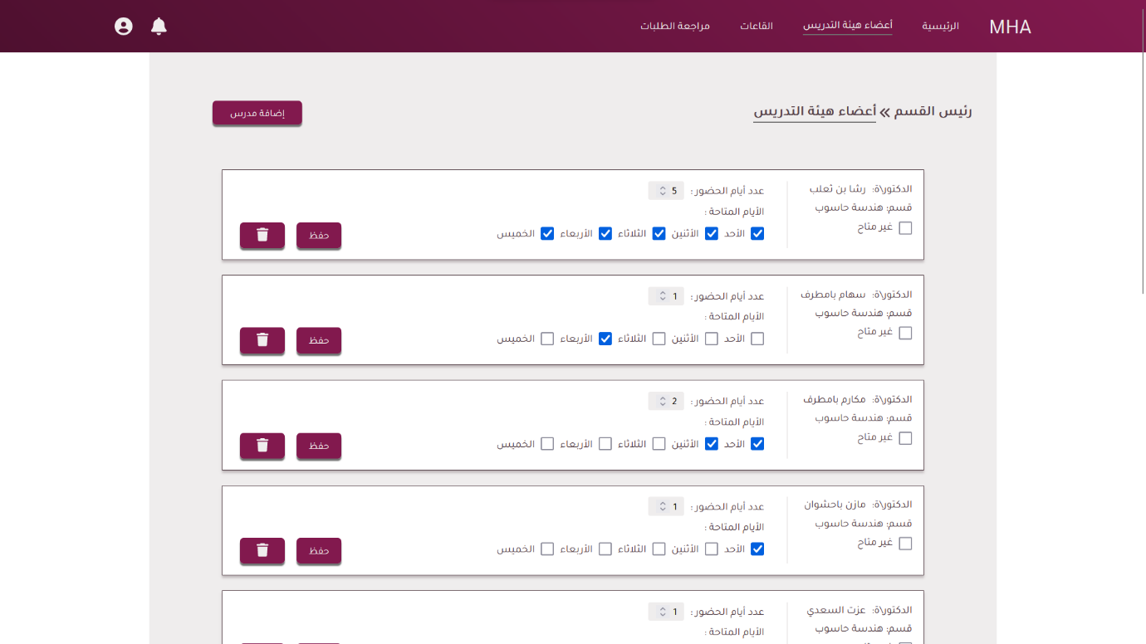

### Secretary Homepage

The secretary's homepage provides access to all interactions that are under his or her supervision.

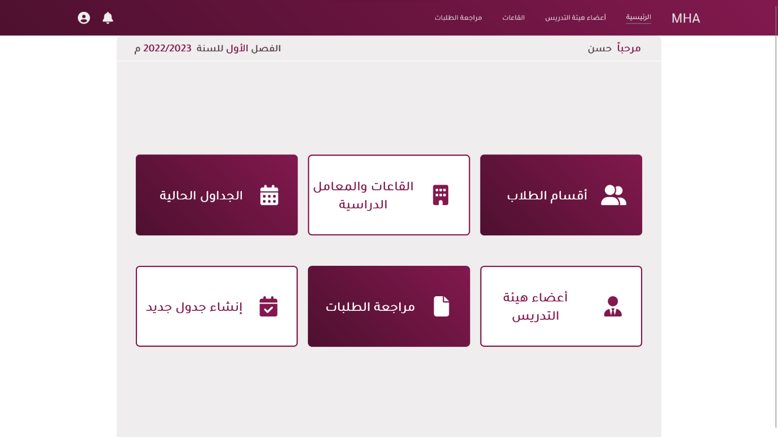

#### Secretary Lecturers

The lecturer interface allows the secretary to manage all the lecturers in the head of the departments and their work days and if available or not.

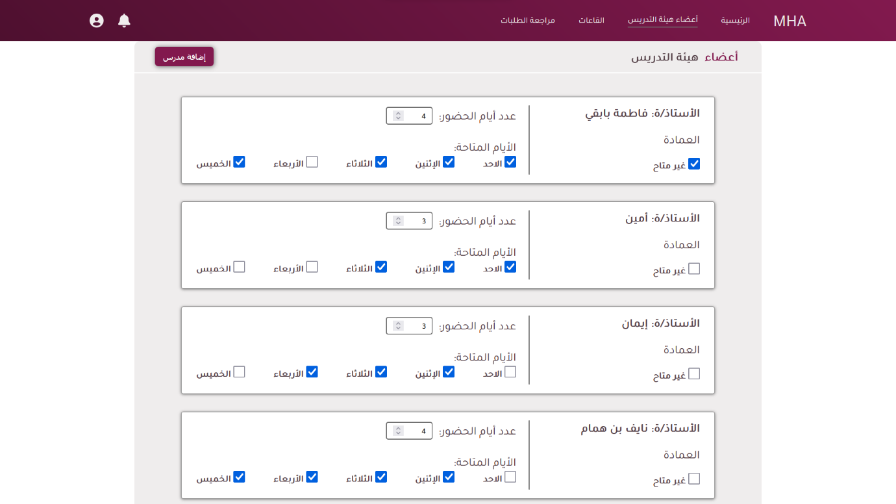

#### Secretary Current Schedules

(template)

#### Secretary Review Requests

The request interface allows the secretary to accept or decline the requests of the head department to assign a teacher from another department with a course.

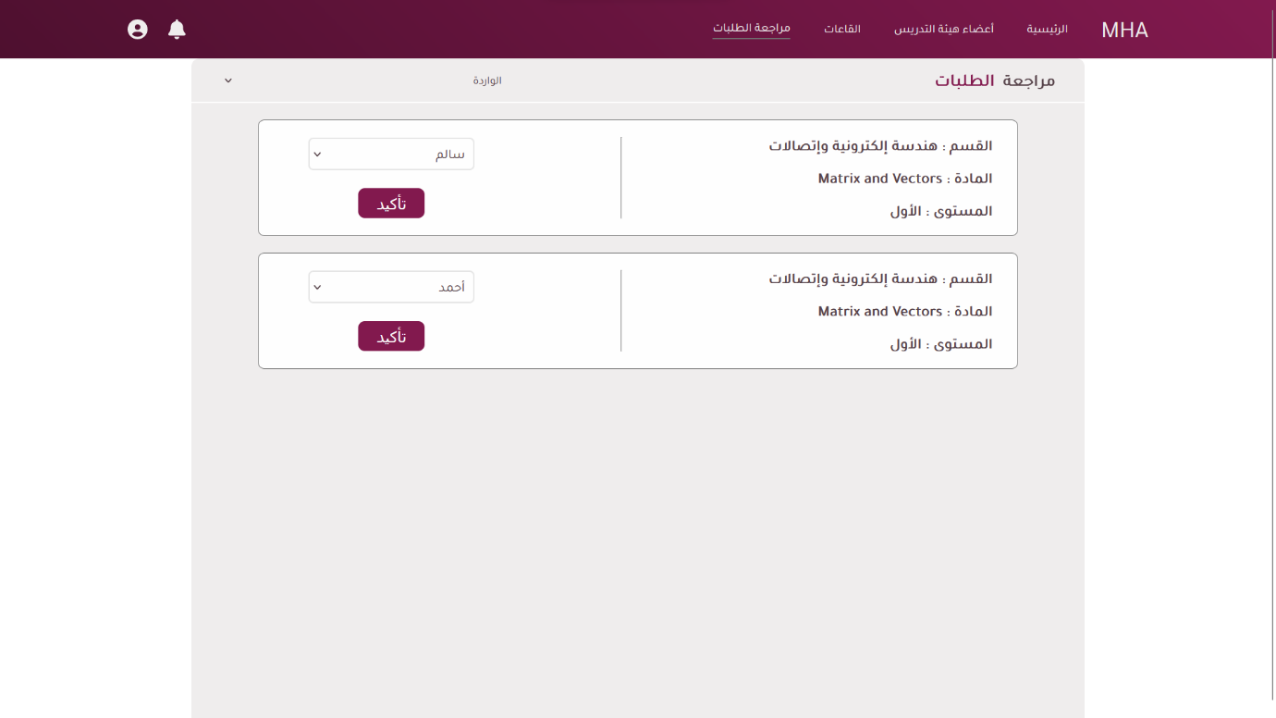

#### Secretary Schedules

The interface will allow providing to the secretary a brief view to the states of the current progress of the schedules for each department and last will allow the creation of the schedule

