**Part1:**

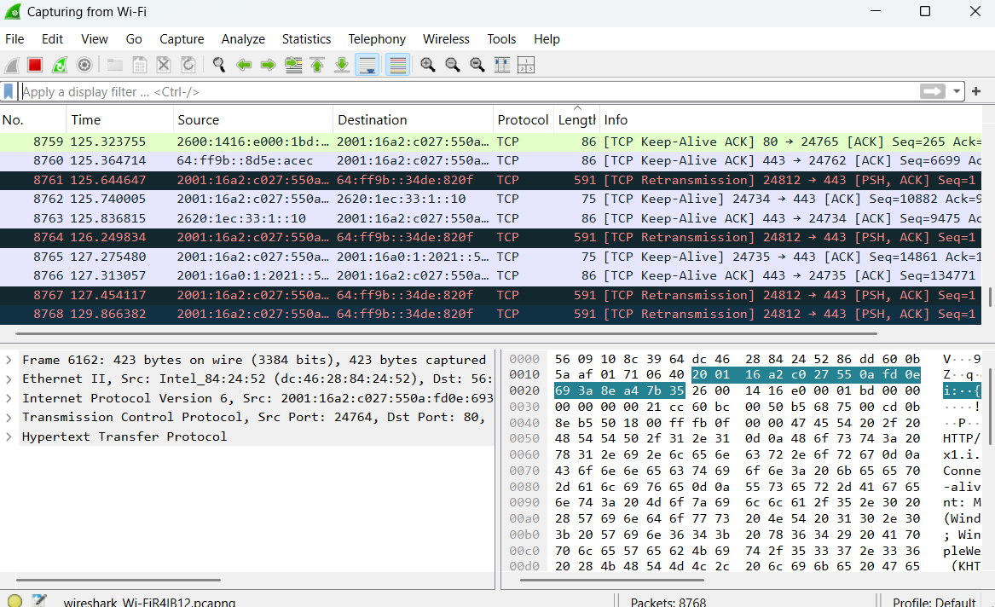

**Part2:**

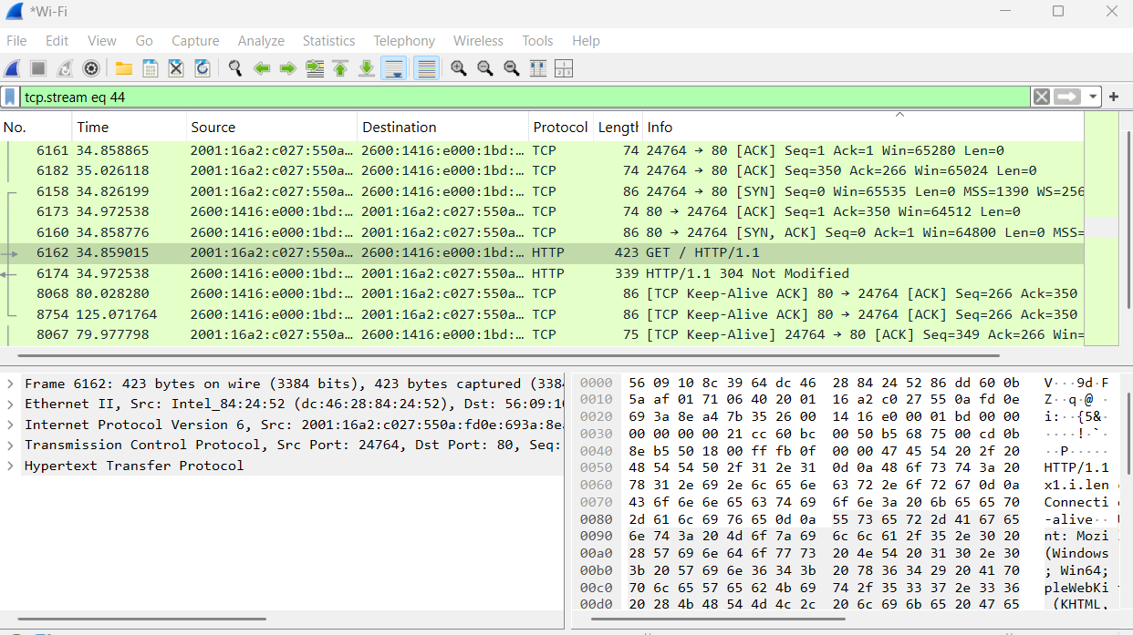

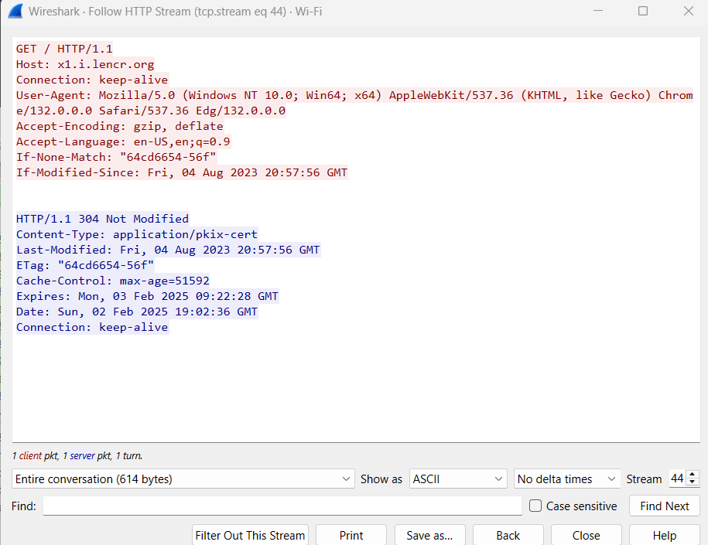

SYN:



SYN-ACK:



ACK:



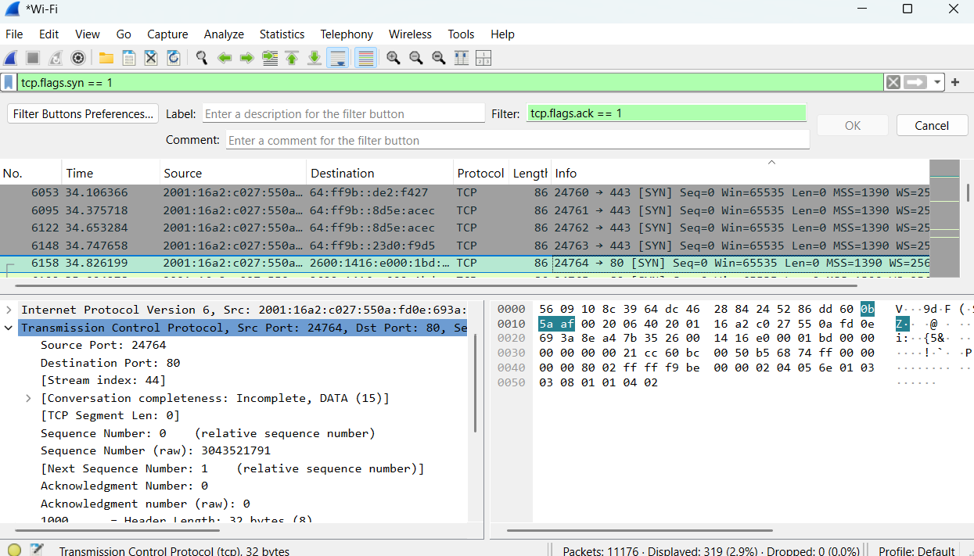

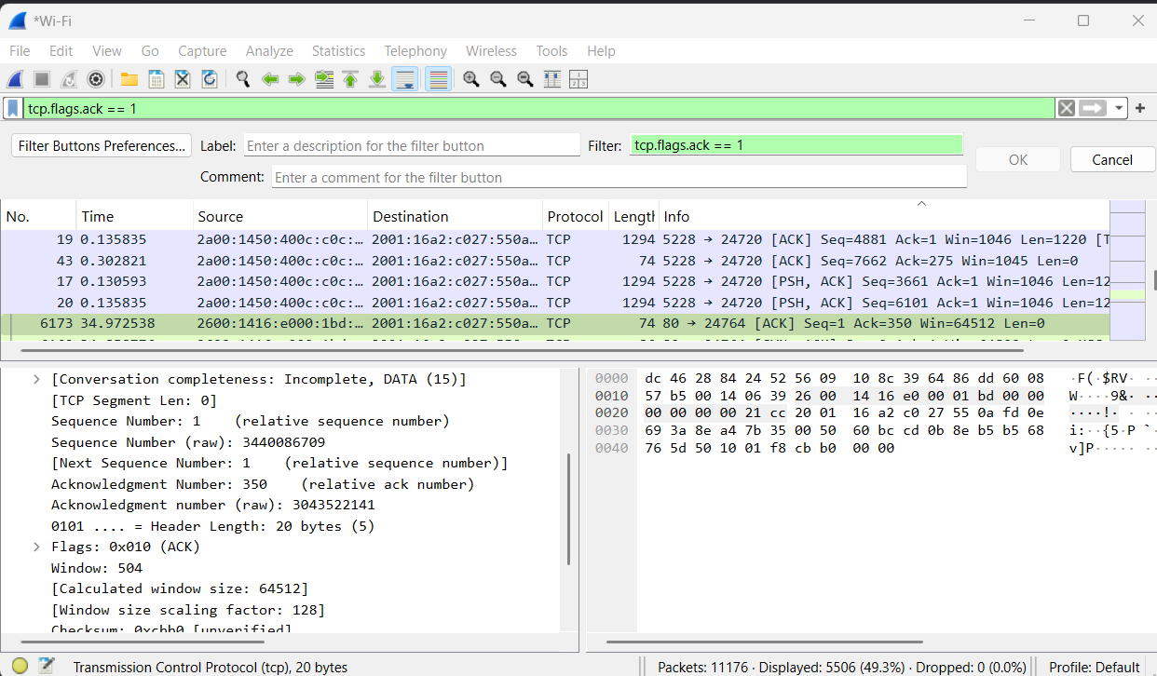



Look at the TCP termination process (FIN, ACK packets).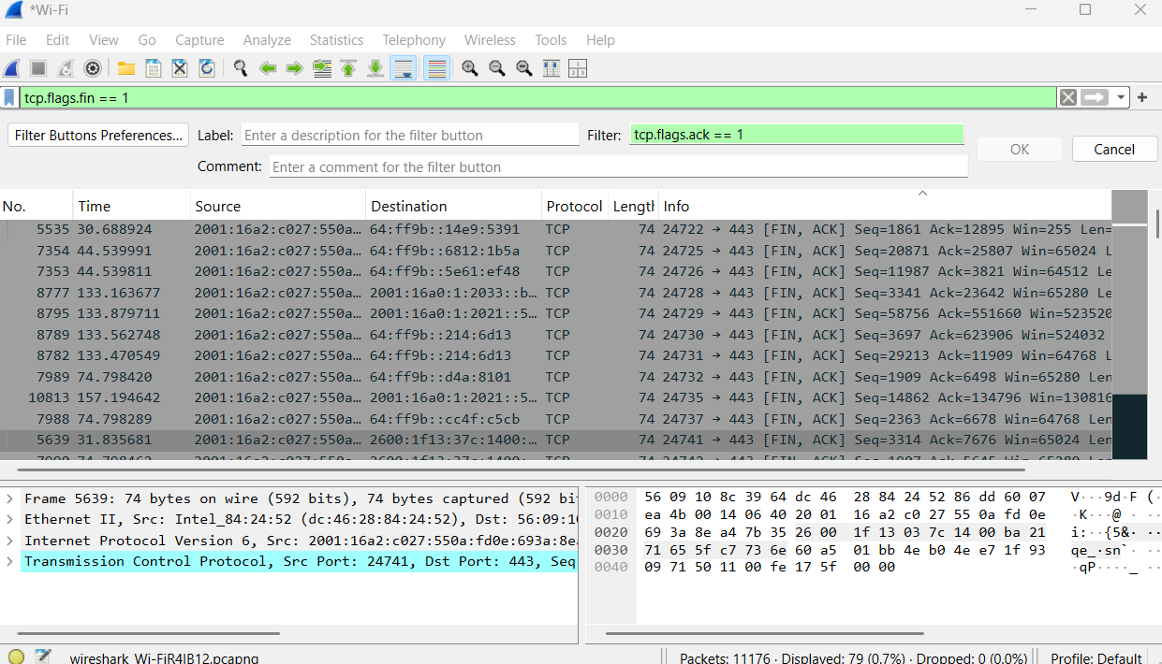

**Part3:**

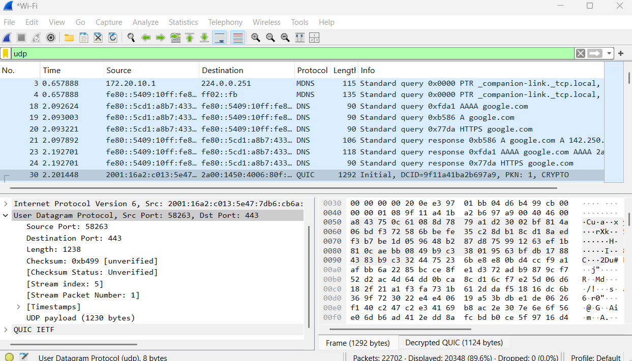

**Part4:**

|  |  |  |
| --- | --- | --- |
|  | TCP or UDP | Reasons |
| Reliability and Connection  Establishment | TCP | TCP Establishes a connection using the three-way handshake (SYN, SYN-ACK, ACK).. |
| Data Integrity and Ordering | TCP | TCP ensures that all data sent is received accurately and in the correct order |

|  |  |  |
| --- | --- | --- |
|  | TCP | UDP |
| Use cases | Web browsing, file transfers, email | Online gaming  Video streaming, VoIP |
| Performance | Connection Establishment Flow Control and Congestion Control | Connectionless  No Acknowledgments |