1. **Extended Synopsis**

# Overview and Objectives

Current theories of galaxy formation and evolution strongly suggest that central, supermassive black holes (SMBHs) have a profound effect on the galaxies that they live in [Vogelsberger et al., 2014,](#_bookmark17) [Schaye et al., 2015,](#_bookmark15) [Somerville and Davé, 2015,](#_bookmark16) [Davé et al., 2017]. This is not surprising since the potential energy associated with mass accretion onto a supermassive black hole is comparable to that generated via the nuclear fusion in the galaxy’s stars see e.g. [Fabian, 2012]. Thus when a galaxy goes through a “quasar” phase (where gas is supplied and accreted by the SMBH) there is ample energy to potentially impact the host galaxy and the surrounding intergalactic medium.

However, the details of the physical processes involved in how this energy escapes the inner most regions of the galaxy and then interacts with the gas, dust, stars and dark matter, is currently **poorly understood**, with current observational data giving more puzzles than clues on how to make progress. Significant further issues arise since startling new observations by the P.I.’s (Nicholas P. Ross; NPR) research team [MacLeod et al., 2016,](#_bookmark12) [Ross et al., 2018] show that *quasars vary significantly on timescales of weeks to months*, whereas the accretion disks (that supply ‘fuel’ for the quasar) should take thousands of years to change their optical emission; this has recently been called the “Quasar Viscosity Crisis” e.g., [Lawrence, 2018]. Thus, it is unclear if we have an understanding of a physical phenomena prevalent in many astrophysical systems: the accretion disk.

The field of observational extragalactic astrophysics is poised for a fundamental and rapid change. Starting in late 2019, a fleet of new telescopes, instruments and missions will be commissioned, start data taking, and will leap-frog the quality and quantity of data we have available today. These surveys and missions include: the fifth incarnation of the Sloan Digital Sky Survey (SDSS-V1); the Large Synoptic Survey Telescope (LSST2); the Dark Energy Spectroscopic Instrument (DESI3) survey; the 4-metre Multi-Object Spectroscopic Telescope (4MOST4) survey, and the ESA *Euclid* mission5. Even more imminent is the launch of the *James Webb Space Telescope* (JWST6).

This proposal has two broad and well-posed goals. First, we aim to elucidate in detail **how the energy directly associated with a supermassive black holes impacts the universal galaxy population.** We will gain a deep understanding into the physical mechanisms related to central engine black holes; their accretion disk physics, their dynamics on both human and galactic timescales and the role they might play in forming and regulating the galaxy population. Second, we anticipate **the discovery of brand new extragalactic phenomena.** By tapping into the massive and raw discovery space that the new experiments will open up, there is the highly likely outcome of discovering something “brand new” [Ivezic and Tyson, 2008,](#_bookmark9) [LSST Science Collaborations](#_bookmark11) [et al., 2009]. DISQoVERobjectives are:

* 1. Characterize the variable extragalactic universe and quasar population.
  2. Establish the energy transport mechanisms associated with the“quasar phase”, and explain the relation between accretion rate, black hole mass build-up with observed light curve and spectral properties.
  3. Develop and then link theoretical accretion and galaxy formation models for a fully holistic theory of active galaxies.
  4. Discover new extragalactic variable objects.

We will achieve this by leveraging several of the new, large-scale surveys that are coming online in the next few years. These critical observations are made by exploiting the large imaging and spectroscopic datasets that will be available from the SDSS-V, DESI, 4MOST, LSST and ESA *Euclid*. *Crucially, although these projects individually will deliver new state-of-the-art datasets, it is our project that will be the first to break down the associated data silos and combine these data in order to go beyond the state-of-the-art.*

1 [www.sdss.org/future/](http://www.sdss.org/future/) 2 lsst.org 3 desi.lbl.gov 4 4most.eu 5 sci.esa.int/euclid/ 6 jwst.stsci.edu

# Current State of the Art.

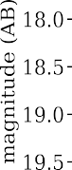The current state-of-the-art data samples have either 106 quasars with one spectral epoch, or only a few objects with repeat photometric data, i.e. light-curve information and the accompanying repeat spectra (see Figure 1). NPR has been involved in the production of both of these two types of samples [MacLeod et al.,](#_bookmark12) [2016,](#_bookmark12) [Pâris et al., 2017]. We plan to collate datasets so that the 106 sample have high-fidelity light-curves *and* ample repeat spectroscopy, and in doing so will kick start the new field of Variable Extragalactic Astrophysics.

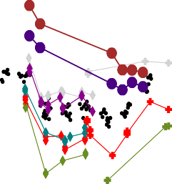

*≈*

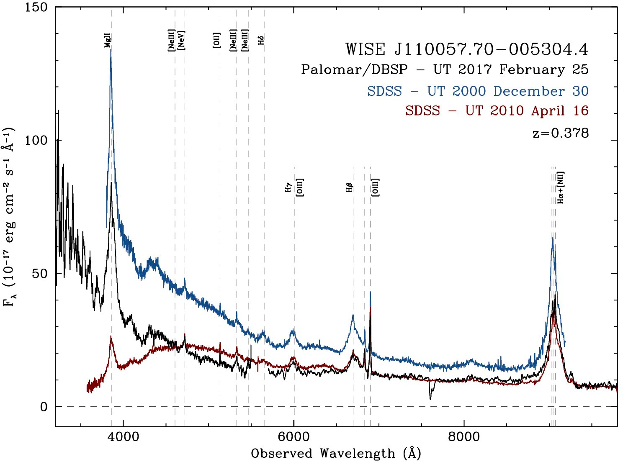

|  |  |  |  |
| --- | --- | --- | --- |
|  |  |  |  |

Figure 1: *(Left:)* The optical and infrared light-curve for the redshift *z* = 0*.*378 quasar J1100-0053 (Ross et al. 2018). Note the fall in the infrared, whereas there is a decrease, but then recovery in the optical. *(Right:)* Three epochs of spectra for J1100-0053. The spectacular downturn in the blue for the 2010 spectrum indicates a dramatic change in the accretion disk.

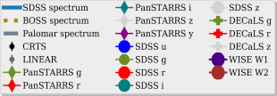During its initial phases of operation the Sloan Digital Sky Survey (SDSS) obtained spectra of 1 million galax- ies in the local Universe. This dataset has become the *de facto* standard for understanding the present day galaxy population, and sets the boundary conditions for all theoretical comparisons. The paradigm changing success of the SDSS was due to having 1,000,000 objects *with very high signal-to-noise photometry and spec- tra*, enabling multivariate analysis that is required for galaxy astrophysics investigations. **We desire the sample size and revolutionary understanding with new temporal dimension of the quasar population, as the SDSS had with the low-redshift z 0.1 galaxy population***.* Our proposal takes quasar astrophysics into the 2020s, going from single objects samples, to surveys and samples of millions of objects, with massive spectroscopic monitoring giving access to the time-domain and leveraging these very large scale next generation missions, telescopes and their datasets.



*∼*

**The timing for this proposal could not be better***.* The first of the data “firehoses” turns on in late 2019, with the full datastream from our key sources fully online by mid-2022. As such, we have the time to mature our analysis techniques, and then be in the ideal position to take advantage of the initial data releases of all these new projects. Prompt ERC Consolidator level-support is also imperative since final survey design and optimization trade-off studies are being made e.g. for DESI, SDSS-V and LSST over the next 12-18 months. Having the ability to influence these decisions to our science goals would be very powerful. Also, having the science teams and various collaborations know that the PI is embarking on this program will help attract the best personnel for the PDRAs, *who would be guaranteed “First Light” data and science.*

*∼*

The importance of this branch of astrophysics is already well establish in Europe and is a priority for the next two decades. This is demonstrated by noting that one of the two primary mission goals for the ATHENA mission is answering the question “How do black holes grow and shape the Universe?”. ATHENA is ESA’s second L-class flagship mission, due for launch in 2028.

The scope and remit of an ERC Consolidator grant will allow us to combine these data products in a manner that will not only **establish the new state-of-the-art** in variable extragalactic astrophysics, but it will also establish and **kickstart the new field** of variable extragalactic astrophysics itself.

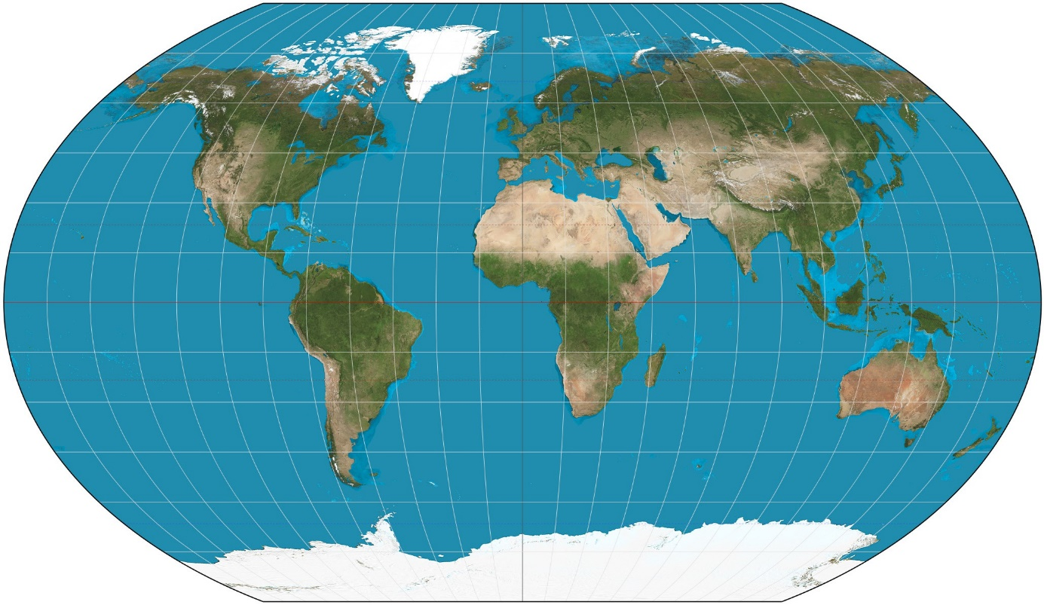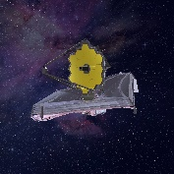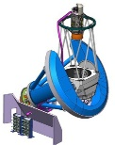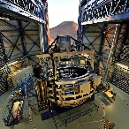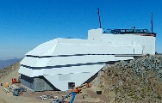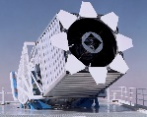

**Facilites, Timelines and Priorities**

***Euclid***

**SDSS**

**DESI**

***JWST***

**4MOST**

***LSST***

* **† *JWST:* Launch June 2019**
  + **DESI: Science Survey January 2020**
  + **SDSS-V: Sept 2020 (*Nth*), 2022 (*Sth*)**

**† ESA *Euclid*: Launch 2021**

* ***LSST*: Science Survey 2022**

**† 4MOST: First Light 2022**

* ***UK priority †EU priority***

***\*Funds requested for ‘buy-in’***

Figure 2: Facilites, Timelines and Priorities. Withe SDSS and DESI in the Northern Hemisphere and 4MOST, LSST in the South, we have full celestial sphere coverage.

# Methodology

Our proposal contains six work packages that fall into three broad and complementary categories: obser- vational studies of large numbers (millons) of objects; high-risk, very high-reward observational studies of a small number (10s) of objects; theoretical modeling investigations. Table 1 summarises our overall WP plan. Risks and mitigation strategies are present for each WP as are Key Deliverables.

We define three PDRAs, “PDRA1”, “PDRA 2”, “PDRA 3”, and one PhD student, “PhD1”. The skill set of PDRA1 would include development of the underlying tools and techniques necessary to extract meaning from large and/or complex data sets. The skill sets of PDRA2 would include expertise in time series analysis, primarily with optical data but potentially also in other wavebands. The skill set of PDRA3 would include experience with fluid mechanics modelling and/or large computer simulations. PhD1 would have a Masters or a strong 4-year undergraduate degree in Physics or Mathematics with evidence of research-level project work.

**WP1: BUILD QUASARSIEVE:** Raw events come from LSST. The UK LSST Data Access Center (DAC, based here at the University of Edinburgh) ingests this datastream and re-emits a filtered stream. In order to utilize this filtered datastream for our science goals we will build a “Stage 2 filter”, which we name *Quasar- Sieve*. This second stage filter will identify the quasars, add context, perform outburst forecasting etc. Our light-curve algorithm will sit on top of *QuasarSieve* and will trigger other telescopes to get e.g. timely spec- trum or infrared data. The heavy-industry computing infrastructure is being supplied by the LSST DAC and our task will be to build software in a timely and robust manner. This is a **novel enterprise** and a rate-limiting step in our overal programme, with the associated high-risk. We mitigate this risk with the data science and machine learning experience from PDRA1 and the P.I. (NPR). We will also mitigate risk by taking advantage of the algorithm resources and LSST DAC staff, here at the Royal Observatory, Edinburgh. We thus classify **WP1 as medium-risk, high-reward. Key Deliverables:** An open-source, well-documented software package that can interact with and return data from the LSST Data Access Center.

**WP2: QUASAR CATALOGUE GENERATION AND DEMOGRAPHIC STUDIES:** Building the quasar corpus

and cataloguing the observational data will be a vital step in beginning to pursue our science goals. This catalogue will be the glue that binds the observational projects together and will have not only the data, but also the metadata to enable the other WPs. Following on from the quasar catalogue generation, a key science output will be the study of the quasar demographics. Luminosity function, clustering and higher-order statistics will be made in order to precisely determine the census of quasars, their environments, their host galaxy preferences and their evolution. All these are vital observational tests for galaxy formation models and theory (see WP4 below). The goal of this WP is to construct a quasar catalogue and make key observational tests. Given the

P.I.s experience at these specific tasks, plus the effort level of PDRA1, PDRA2 and PhD this WP is deemed medium-risk. **WP2 is medium-risk, high-reward. Key Deliverables:** A science-enabling compendium that will be the state-of-the-art quasar dataset for the 2020s. A suite of new, beyond-the-state-of-the-art quasar demographic measurements which are the boundary conditions for theoretical models.

**WP3: LIGHT-CURVE AND SPECTRAL ANALYSES:** Another major scientific output that will originate from the quasar corpus catalogue generation will be the full and detailed light-curve and spectral analyses of the said catalogue. This will result in the discovery of light-curve trends with quasar type, new methods to measure black hole mass and the key science goal to see which quasars are “changing-look” objects. This WP will have a data science/machine learning aspect. The goal of this WP is to elucidate the physical processes that drive quasar variability. The full Light-Curve and Spectral Analyses that we envisaged will be a significant amount of work, leading to significant high-reward science. **WP3 is medium-risk, high-reward.** This level of investigation is highly novel, though we envisage no major barriers outside of our control to achieving our science goals and PDRA1, PDRA2, as well as the P.I. (NPR) and PhD1 effort will be directed towards this. As such, we deem this medium-risk. **Key Deliverables:** Measurements, for the first time of how the light-curves and spectra of quasars depend on key physical quasar properties e.g. *M*SMBH, luminosity, *λ* = log(*L/L*Edd), spin etc. These measurements will allow us to make direct comparisons to accretion disk models.

**WP4: ACCRETION DISK AND QUASAR FEEDBACK SIMULATIONS:** New accretion models are needed to fully explain the observational data of “changing look” quasars that we have examples of today and the “Quasar Viscosity Crisis”. New radiation MHD codes begin to explain the observations here, but further development is needed to gain the desired deep understanding. Cosmological-scale hydrodynamic simulations with stellar and quasar feedbasck are now also online. The **exceedingly ambitious goal** of WP5 is to develop new holistic accretion disk-to-cosmological scale simulations that explain our observational results and link them to “quasar feedback”. WP4 is thus high-risk due to its novel nature and algorithmic complexity. We also envisage ramp- up time to get our theoretical simulations to the level that will be required by our beyond-the-state-of-the-art dataset. However, we mitigate this risk first by noting this will be the lead WP and top priority for PDRA3. We further mitigate this risk by invoking collaboration with accretion disk theorist Prof. Ken Rice (WKMR; Chair of Computational Astrophysics at the IfA, University of Edinburgh) and Prof. Romeel Dave (RSD; Chair of Physics in the IfA, University of Edinburgh). Thus PDRA3, NPR, potentially PDRA2, with guidance where necessary from WKMR and RSD would collaborate on this WP. We thus classify **WP4 as medium-to-high risk, very high-reward. Key Deliverables:** New accretion disk models and theory that explain the light curve data of our beyond-the-state-of-the-art dataset. New galaxy evolution models, describing the hydrodynamics involved on galactic scales, but related to the quasar central engine.

**WP5: OBSERVATIONS OF QUASARS BY THE JAMES WEBB SPACE TELESCOPE:** What are the star-

formation properties of luminous quasars at the peak of quasar activity? We aim to answer this by looking for the presence of polycyclic aromatic hydrocarbon (PAH) spectral features in infrared bright quasars with the *James Webb Space Telescope* (JWST). **WP5 is high risk, high-reward.** This is an ideal investigation for the JWST, but we classify this as high-risk since we have to apply for the telescope time and are not guaranteed the data. We note this will be the single WP NPR would lead and does not impact in any direct way the other WPs. This would lead to very-high gain science. **Key Deliverables:** State-of-the-art data products from the JWST, with the observational evidence and physical interpretation of how “quasar feedback” regulates galaxy formation in high-redshift quasars.

**WP6: NEW OBJECT DISCOVERY:** The LSST will scan the sky repeatedly, enabling it, and us, to both dis- cover new, distant transient events and to study variable objects throughout our universe. The most interesting science to come may well be the discovery of new classes of objects. Suffice to say, this would be exception- ally high-reward. **WP6 is high risk, exceptionally high-reward.** We class this as high risk, since it is complex to class a WP with essentially unknown discovery potential as ‘low-risk’. However, we *nota bene* that a lack of any novel discovery here would be a startling null result. **Key Deliverables:** Potential discovery of new classes of astronomical objects.



|  |  |  |  |  |  |  |  |  |  |  |  |  |  |  |  |  |
| --- | --- | --- | --- | --- | --- | --- | --- | --- | --- | --- | --- | --- | --- | --- | --- | --- |
|  | **Personel** | **Year 1** | | | **Year 2** | | | **Year 3** | | | **Year 4** | | | **Year 5** | | |
| **WP1** | **PDRA1, *NPR*** | “*QuasarSieve*" | | | | | |  |  |  |  |  |  |  |  |  |
| **WP2** | **PDRA1, PDRA2, PhD1, *NPR*** |  | Quasar Catalog Generation and Demographics Stuides | | | | | | | | | | |  |  |  |
| **WP3** | **PDRA1, PDRA2, PhD1, *NPR*** |  |  |  |  |  | Light Curve+Spectral analysis | | | | | | | | | |
| **WP4** | **PDRA3, *NPR***  **(PDRA2, *WKMR*, *RSD)*** |  |  |  |  | Accretion Disk and  Cosmological Simulations | | | | | | | | | | |
| **WP5** | ***NPR*** | *James Webb Space Telescope* studies | | | | | | | | | | | | | | |
| **WP6** | ***NPR,* PDRA1, PDRA2, PDRA3, PhD1** |  |  | | |  |  | *New Object Discovery* | | | | | | | | |

Figure 3: An overview of our WPs: the personel attached to each WP and a guide to their start and duration is shown. As given be the shadings, WP1, 2 and 3 are observational studies of large numbers of objects; WP4 are theoretical modeling investigations and WP5 and 6 are high-risk, very high-reward observational studies of a small number of objects.

# Resources, Survey ‘buy-in’ and Budget

**PERSONNEL:** We request the resources and support for 100% of the time and effort for the P.I. We request the resources and support for 3 Postdoctoral Research Associates (PDRAs), for a total of 10 PDRA year equivalents (3+3+4). We request the resources and support for 1 PhD studentship.

**SURVEY BUY-IN:** We request support for the “buy-in” to two of the new surveys, SDSS-V and DESI. The costs here are e184,100 for SDSS-V and e200,100 for DESI. We ask this support to come from the “additional funds that can be made available to cover access to large facilities.” We request access to these funds as it gives our project access to telescopes and data in the North and South Hemispheres for complete coverage of the celestial sphere and delivers the crucial early spectroscopy that will be vital to train, test and build our data science and machine learning codes and algorithms. We emphasise that the science return is ‘exponentially’ dependent on the breadth of data available and heralds a brand new regime of “several-survey” or “multi- mission” astronomy. *Buy-in here would place the P.I. and the University of Edinburgh as the only group and institute in the world to be involved in SDSS-V, DESI, 4MOST, LSST and ESA Euclid and JWST*.

**COMPUTING REQUIREMENTS:** With the availability of the facilities at an institute (e.g. IfA Cullen), univer- sity (e.g. [Edinburgh Compute and Data Facility)](https://www.ed.ac.uk/information-services/research-support/research-computing/ecdf) and at a national [(The Hartree Centre)](https://www.hartree.stfc.ac.uk/Pages/home.aspx) level, the rate limiting factor will be how quickly and efficiently we can deploy our codes and analysis.

**TRAVEL:** We request support for travel for all 5 members of the group, including repeat medium-term (i.e., few weeks) travel to the US and ESO Chile to work with key collaborators at critical timings of the First Light for the new telescopes.

**References**

R. Davé, M. H. Rafieferantsoa, and R. J. Thompson. mufasa: the assembly of the red sequence. *MNRAS*, 471: 1671–1687, Oct 2017. doi: 10.1093/mnras/stx1693.

A. C. Fabian. Observational Evidence of Active Galactic Nuclei Feedback. *ARA&A*, 50:455–489, Sept 2012. doi: 10.1146/annurev-astro-081811-125521.

Z. Ivezic and J. A. for the LSST Collaboration Tyson. LSST: from Science Drivers to Reference Design and Anticipated Data Products. *ArXiv e-prints*, May 2008.

A. Lawrence. Quasar viscosity crisis. *Nature Astronomy*, 2:102–103, Jan 2018.

LSST Science Collaborations, P. A. Abell, J. Allison, S. F. Anderson, J. R. Andrew, J. R. P. Angel, L. Armus,

D. Arnett, S. J. Asztalos, T. S. Axelrod, and et al. LSST Science Book, Version 2.0. *ArXiv 0912.0201v1*, Dec 2009.

C. L. MacLeod, N. P. Ross, et al. A systematic search for changing-look quasars in SDSS. *MNRAS*, 457: 389–404, March 2016. doi: 10.1093/mnras/stv2997.

I. Pâris, P. Petitjean, N. P. Ross, et al. The Sloan Digital Sky Survey Quasar Catalog: Twelfth data release.

*Astron. & Astrophys.*, 597:A79, Jan 2017. doi: 10.1051/0004-6361/201527999.

N. P. Ross et al. A new physical interpretation of optical and infrared variability in quasars. *Nature Astronomy*, 2018.

J. Schaye et al. The EAGLE project: simulating the evolution and assembly of galaxies and their environments.

*MNRAS*, 446:521–554, Jan 2015. doi: 10.1093/mnras/stu2058.

R. S. Somerville and R. Davé. Physical Models of Galaxy Formation in a Cosmological Framework. *ARA&A*, 53:51–113, Aug 2015. doi: 10.1146/annurev-astro-082812-140951.

M. Vogelsberger, S. Genel, V. Springel, P. Torrey, D. Sijacki, D. Xu, G. Snyder, S. Bird, D. Nelson, and

L. Hernquist. Properties of galaxies reproduced by a hydrodynamic simulation. *Nat*, 509:177–182, May 2014. doi: 10.1038/nature13316.