1. **Extended Synopsis**

# Overview and Objectives

Current theories of galaxy formation and evolution strongly suggest that central, supermassive black holes (SMBHs) have a profound affect on the galaxies that they live in. This is not surprising since the potential energy associated with mass accretion onto a supermassive black hole is comparable to that generated via the nuclear fusion in the galaxy’s stars. Thus when a galaxy goes through a “quasar” phase, there is ample energy to potentially impact the host galaxy and the surrounding intergalactic medium.

However, the interaction and the details of physical processes involved in how this energy escapes the inner most regions of the galaxy and then interacts with the gas, dust, stars and dark matter, is currently poorly understood, with current observational data giving more puzzles than clues on how to make progress. Further issues arise since startling new observations (e.g. MacLeod, Ross et al. 2016; Ross et al. 2018) show that *quasars vary significantly on timescales of weeks to months*, whereas the accretion disks (that are thought to supply the ‘fuel’ for the quasar) should take thousands of years to change their optical emission (see e.g. Lawrence 2018, Nature Astronomy). Thus, it is unclear to what level we have an understanding of a prevalent astrophysical phenomena; the accretion disk.

The field of observational extragalactic astrophysics is poised for a fundamental and rapid change. Starting in late 2019, a fleet of new telescopes, instruments and missions are coming online over the next few years that will leap-frog the quality and quantity of data we have available today. Over the course of the next 5-6 years, surveys and missions including the fifth incarnation of the Sloan Digital Sky Survey (SDSS-V1), the Large Synoptic Survey Telescope (LSST2), the Dark Energy Spectroscopit Instrument (DESI3) survey, the 4-meter Multi-Object Spectroscopic Telescope (4MOST4) survey, and the ESA *Euclid* mission5, will see first light. Even more imminent is the launch of the *James Webb Space Telescope* (JWST6).

This proposal has two broad and well-posed goals. First, we aim to elucidate in detail *how the energy directly associated with a supermassive black holes impacts the universal galaxy population.* We will gain a deep understanding into the physical mechanisms related to central engine black holes; their accretion disk physics, their dynamics on both human and galactic timescales and the role they might play in forming and regulating the galaxy population. We will investigate what the observed rapid changes tell us about the SMBH and accretion discs, and does “quasar feedback” regulate galaxy formation? *Ultimately, we want to discover if there is a missing link between the activity on sub-parsec scales that impacts on the galaxy-wide kiloparsec scales.* These are among the most prescient astrophysical issues of our time, and where major breakthroughs are imminent.

Second, we will *discover brand new extragalactic phenomena.* By tapping into the massive and raw discovery space that the new experiments will open up, there is the highly likely outcome of discovering something “brand new”. The LSST will deliver a dataset so spectacularly different both in sky coverage and time-sampling coverage that the Universe would have to be an exceptionally boring place to not have brand new astronomical objects and astrophysical phenomena waiting to be discovered.

We will achieve this by leveraging several of the new, large-scale surveys that are coming online in the next few years. These critical observations are made by exploiting the large imaging and spectroscopic datasets that will have available from the SDSS-V, DESI, 4MOST, LSST and ESA *Euclid*. *Crucially, although these projects individually will deliver new state-of-the-art datasets, it is our project that will be the first to break down the associated data silos and combine these data in order to go beyond the state-of-the-art.*

# Current State of the Art.

The current state-of-the-art data samples have 106 quasars with one spectral epoch, or only a few objects with repeat spectra (e.g, MacLeod, Ross et al. 2016; Ross et al. 2018, Figure 1). We plan to collate datasets so that the 106 sample have light-curves and repeat spectra and in doing so, will kick start the new field of Variable Extragalactic Astrophysics.

*≈ ∼*

1 [www.sdss.org/future/](http://www.sdss.org/future/) 2 lsst.org 3 desi.lbl.gov 4 4most.eu 5 sci.esa.int/euclid/ 6 jwst.stsci.edu



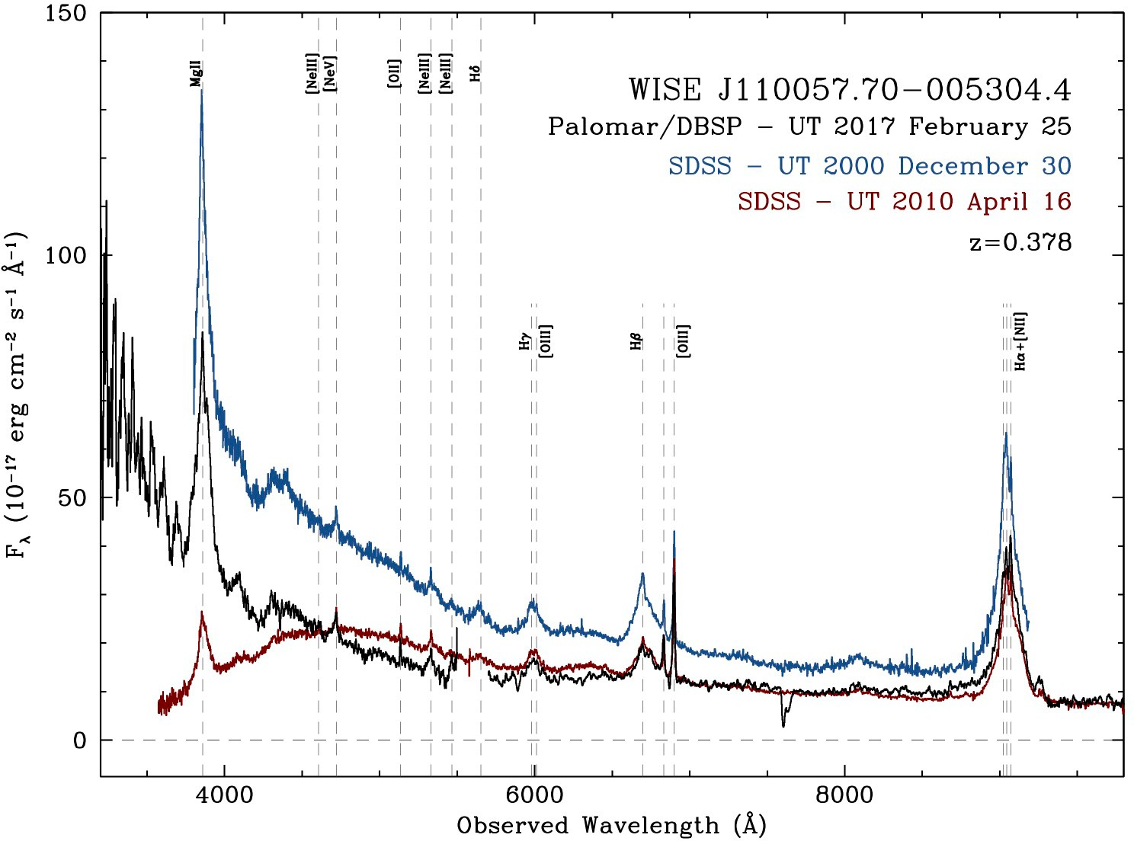

|  |  |  |  |
| --- | --- | --- | --- |
|  |  |  |  |

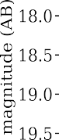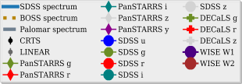Figure 1: *(Left:)* The optical and infrared light-curve for the redshift *z* = 0*.*378 quasar J1100-0053 (Ross et al. 2018). Note the fall in the infrared, whereas there is a decrease, but then recovery in the optical. *(Right:)* Three epochs of spectra for J1100-0053. The spectacular downturn in the blue for the 2010 spectrum indicates a dramatic change in the accretion disk.

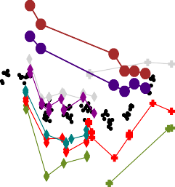

During its initial phases of operation the Sloan Digital Sky Survey (SDSS) obtained spectra of 1 million galax- ies in the local Universe. This dataset has become the *de facto* standard for understanding the present day galaxy population, and sets the boundary conditions for all theoretical comparisons. The paradigm changing success of the SDSS was due to it having 1,000,000 objects *with very high SNR photometry and spectra*, en- abling multivariate analysis that is required for galaxy astrophysics investigations. *We desire the same sample size and revolutionary understanding of the quasar population as the SDSS had with the z* 0*.*1 *galaxy pop- ulation.* Our proposal takes quasar astrophysics into the 2020s, going from single objects samples, to surveys and samples of millions of objects, *with massive spectroscopic monitoring giving access to the time-domain* and leveraging these very large scale next generation missions, telescopes and their datasets.

*∼*

*The timing for this proposal could not be better.* The first of the data “firehoses” turns on in late 2019, with the full datastream from our key sources fully online around 2022. As such, we have the time to mature our analysis techniques, and then being in the ideal position to take advantage of the initial data releases of all these new projects.

The importance of this branch of astrophysics is already well establish in Europe and is a priority for the next two decades. This is demonstrated by noting that one of the two primary mission goals for the Advanced Telescope for High-ENergy Astrophysics (ATHENA) mission is answering the question “How do black holes grow and shape the Universe?”. ATHENA is ESA’s second L-class flagship mission, due for launch in 2028.

*The scope and remit of an ERC Consolidator grant will allow us to combine these data products in a manner that will not only establish the new state-of-the-art in variable extragalactic astrophysics, but it will also establish and kickstart the new field of variable extragalactic astrophysics itself.*

# Methodology

Our proposal contains eight work packages that fall into three broad and complementary categories: obser- vational studies of large numbers (millons) of objects; high-risk, very high-reward observational studies of a small number (10s) of objects, and theoretical modeling investigations. Risks and mitigation strategies are present for each WP. Table 1 summarises our overall WP plan.

**WP1: BUILD AN EVENT BROKER:** The LSST will deliver three levels of data products and services and being in the U.K. gives us access to all three. In order to utilize the LSST data for our science needs we will need to build an *event broker*, an intermediary program module that interacts with primarily the “Level 3” data products from the LSST. **WP1 is low-risk, high-reward.** The goal of this WP is to build an Event Broker. The heavy-industry computing infrastructure is already being supplied by the LSST Data Access Center and our task will be to build software in a timely and robust manner. At the effort level, one PDRA (“PDRA 1”)

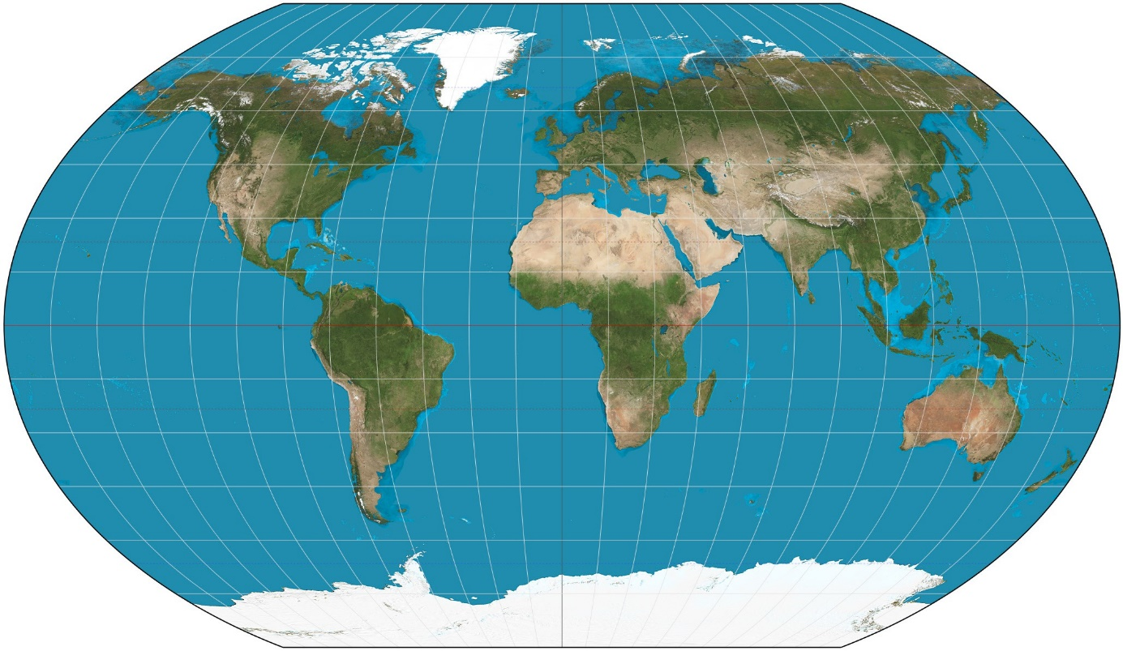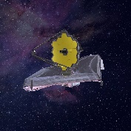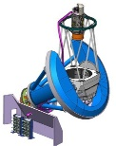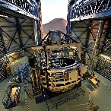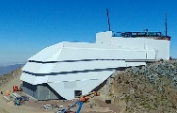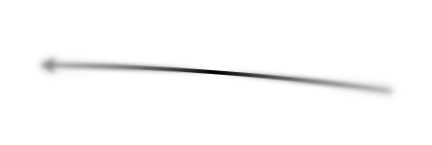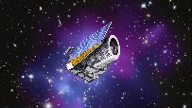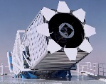

**Facilites, Timelines and Priorities**

***Euclid***

**SDSS**

**DESI**

***JWST***

**4MOST**

***LSST***

* **† *JWST:* Launch June 2019**
  + **DESI: Science Survey January 2020**
  + **SDSS-V: Sept 2020 (*Nth*), 2022 (*Sth*)**

**† ESA *Euclid*: Launch 2021**

* ***LSST*: Science Survey 2022**

**† 4MOST: First Light 2022**

* ***UK priority †EU priority***

***\*Funds requested for ‘buy-in’***

Figure 2: Facilites, Timelines and Priorities. Withe SDSS and DESI in the Northern Hemisphere and 4MOST, LSST in the South, we have full celestrial sphere coverage.

and the commitment from the P.I., along with the algorithm resources and key personnel, e.g. Prof Andy Lawrence (AL) and Prof. Bob Mann (RGM), at the Royal Observatory, Edinburgh, there is no element of this which can be deemed high-risk.

**WP2: QUASAR CATALOGUE GENERATION:** Building the quasar corpus and cataloguing the observational data will be a large, but vital step in beginning to pursue our science goals. This catalogue will be the glue that binds the observational projects together and will have not only the data, but moreover the metadata to enable the other WPs. **WP2 is low-risk, high-reward.** The goal of this WP is to construct a quasar catalogue. This is a full WP, and with the P.I.s (NPR) experience at this specific task, plus the effort level of one PDRA (“PDRA 2”) there is no element of this which can be deemed high-risk.

**WP3: LIGHT-CURVE AND SPECTRAL ANALYSES:** Following on from the quasar corpus catalogue genera- tion, one key science output will be the full and detailed light-curve and spectral analyses of the said catalogue. This will result in the discovery of light-curve trends with quasar type, new methods to measure black hole mass and the relatively easy check to see which quasars have become “changing-look” objects. This WP will have a data science/machine learning aspect. **WP3 is low-risk, high-reward.** The goal of this WP is to eluci- date the physical processes that drive quasar variability. The full Light-Curve and Spectral Analyses that we envisaged will be a significant amount of work, leading to significant high-reward science. This particular work package will be broken down into small projects and the level of two PDRAs (“PDRA 1” and “PDRA 2”), as well as the P.I. (NPR) and a PhD student (“PhD 1”) will be directed towards this. This level of investigation is highly novel, but there is no element of this which can be deemed high-risk.

**WP4: QUASAR DEMOGRAPHIC STUDIES:** Another major scientific output that will originate from the quasar corpus catalogue generation will be the study of the Quasar Demographics from our datastreams. This is different from WP3 in that these investigations won’t necessarily be tied to the time-domain aspect of our catalogue, but will be the crucial baseline that we, and the field in general, will use to compare to the time-

depedent discoveries. Luminosity function, clustering and higher-order statistics will be made in order to precisely determine the census of AGN, their environments, their host galaxy preferences and their evolution. All these are vital observational tests for galaxy formation models and theory (see WP6 below). **WP4 is low- risk, high-reward.** The goal of this WP is to make the key observational tests that have to be explained by any viable galaxy formation theory. Similar to WP3, the analyses that we envisaged will be broken down into smaller projects and the level of two PDRAs (“PDRA 1” and “PDRA 2”), as well as the P.I. (NPR) and a PhD student (“PhD 1”) will be directed towards this. There is no element of this which can be deemed high-risk.

**WP5: ACCRETION DISK SIMULATION:** New accretion models are needed to fully explain the observational data of “changing look” quasars that we have examples of today (see e.g. Ross et al. 2018). New radiation MHD codes begin to explain the observations here, but further development is needed to gain the desired deep understanding. **WP5 is lower-risk, very high-reward.** The goal of WP5 is to develop new accretion disk simulations that explain our observational results. This will be the lead WP for one PDRA (“PDRA 3”) and a low level of the P.I.’s (NPR) time. We classify WP5 not as fully ‘low-risk’, since we envisage some ramp- up time to get our theoretical simulations to the level that will be required by our beyond-the-state-of-the-art dataset. However, we mitigate this risk by invoking the collaboration with an accretion disk theorist Prof. Ken Rice (WKMR) who is the Personal Chair of Computational Astrophysics in the School of Physics and Astronomy here at the University of Edinburgh. NPR and WKMR and PDRA3 would thus collaborate on this WP.

**WP6: AGN FEEDBACK SIMULATIONS:** Cosmological-scale hydrodynamic simulations are now coming online. While we do not seek to lead or generate new versions of these, we do envisaged using their outputs in order to ‘benchmark’ our observational demographic work. **WP6 is low-risk, high-reward.** All the data from these simulations is already in place today, though no one has embarked on doing any of the ‘heavy-lifting’ and comparisons we will have the observational results for. Professor Romeel Dave (RSD) who is a Chair of Physics in the Institute for Astronomy will be a key collaborator here. NPR and RSD and PDRA3 and/or PDRA2 would thus collaborate on this WP.

**WP7: OBSERVATIONS OF QUASARS BY THE JAMES WEBB SPACE TELESCOPE:** What are the star-

formation properties of mid-infrared luminous quasars at the peak of quasar activity? We aim to answer this by looking for the presence of polycyclic aromatic hydrocarbon (PAH) spectral features in *z* 2*.*5 infrared bright quasars with the James Webb Space Telescope (JWST). **WP7 is high risk, high-reward.** This is an ideal investigation for the JWST, but we classify this as ‘high-risk’ since this is the one telescope/survey/mission where we would have to bid and apply for the telescope time and are not guaranteed the data. We mitigate the risk here by saying that this will be the one project the P.I. (NPR) would directly lead, does not impact in any direct way any of the other WPs and would lead to very-high gain science.

*≈*

**WP8: NEW OBJECT DISCOVERY:** The LSST will scan the sky repeatedly, enabling it, and us, to both dis- cover new, distant transient events and to study variable objects throughout our universe. The most interesting science to come may well be the discovery of new classes of objects. **WP8 is medium-to-high risk, excep- tionally high-reward.** We class this as medium-to-high risk, since it is tricky to class a WP with essentially unknown discovery potential as fully ‘low-risk’. Suffice to say, this would be exceptionally high-reward

# Resources, Survey ‘buy-in’ and Budget

**PERSONNEL:** We request the resources and support for 90% of the time and effort for the P.I. (100% is not claimed just in case non-project opportunities arise, e.g. guest lecturing). We request the resources and support for 3 Postdoctoral Research Associates (PDRAs), for a total of 10 PDRA year equivalents. This will be broken down as a three year term for “PDRA 1”, a three year term for “PDRA 2” and a 2+2 year term for “PDRA 3”. We request the resources and support for 1 UK/EU PhD studentship.

**SURVERY BUY-IN:** We request support for the “buy-in” to two of the new surveys, SDSS-V and DESI. The costs here are $230,000 (e184,100) for SDSS-V and $250,000 (e200,100) for DESI. We ask this support to come from the “additional funds that can be made available to cover access to large facilities.” We specficially

|  |  |  |  |  |  |  |  |  |  |  |  |  |  |  |  |  |
| --- | --- | --- | --- | --- | --- | --- | --- | --- | --- | --- | --- | --- | --- | --- | --- | --- |
|  | **Personel** | **Year 1** | | | **Year 2** | | | **Year 3** | | | **Year 4** | | | **Year 5** | | |
| **WP1** | ***NPR*, *AL*, RGM, PDRA1** | Event Broker | | | | | |  |  |  |  |  |  |  |  |  |
| **WP2** | ***NPR*, PDRA1, PDRA2** | Quasar Catalog Generation | | | | | | | | |  |  |  |  |  |  |
| **WP3** | ***NPR*, PDRA1, PDRA2, PhD1** |  |  |  | Light Curve & Spectra Analyses | | | | | | | | | | | |
| **WP4** | **PDRA1, PDRA2, PhD1** |  |  | Quasar Demographics | | | | | | | | |  |  |  |  |
| **WP5** | ***NPR, WKMR*, PDRA2, PDRA3** |  |  |  |  |  |  | Accretion Disk Simulations | | | | | | | | |
| **WP6** | ***NPR, RSD,* PDRA3** |  |  |  | CosmoHydro Tests | | | | | | | | |  |  |  |
| **WP7** | ***NPR*** | *James Webb Space Telescope* studies | | | | | | | | | | | | | | |
| **WP8** | ***NPR, AL, RGM,* PDRA1, PDRA2, PDRA3, PhD1** | *New Object Discovery* | | | | | | | | | | | | | | |

request access to these funds as it gives our project the “Full House” of telescopes and data in the North and Southern Hemispheres (for complete coverage of the celestial sphere) and delivers the early spectroscopy that will be vital to train, test and build our data science and machine learning codes and algorthims. *Buy-in here would place the P.I. and the University of Edinburgh as the only group and place in the world to be involved in SDSS-V, DESI, 4MOST, LSST and ESA Euclid and JWST*.



**COMPUTING REQUIREMENTS:** With the availability of the facilites at an institute (e.g. IfA Cullen), univer- sity (e.g. [“Edinburgh Compute and Data Facility”](https://www.ed.ac.uk/information-services/research-support/research-computing/ecdf) and at a national [(The Hartree Centre)](https://www.hartree.stfc.ac.uk/Pages/home.aspx) level, the rate limiting factor will be how quickly and efficiently we can deploy our codes, and analysis, i.e. person-power.

**TRAVEL:** We request support for travel for all 5 members of the group, including repeat medium-term (i.e., few weeks) travel to the US and ESO Chile to work with key collaborators at critical timings of the First Light for the new telescopes.

[1]Kormendy & Ho, 2013, ARAA, 51, 511

[2]Kormendy, 2016, ASSL, 418, 431

1. Alexander et al., 2012, NewAR, 56, 93
2. King & Pounds, 2015, ARAA, 53, 115
3. Heckman & Best, 2014, ARAA, 52, 589
4. Naab & Ostriker, 2017, ARAA, 55, 59

[7]Netzer, 2015, ARAA, 53, 365

[8]Padovani, 2017, A&ARv, 25, 2 [9]Ata et al., 2017, arXiv1705.06373v2 [10]Solsar et al., 2013, JCAP, 04, 026

[11]Busca et al., 2013, A&A, 552, 96

[12]Delubac et al., 2015, A&A, 574, 59

[13]Bautista et al., 2017, A&A, 603, 12

# References

[20]Timlin, Ross et al., 2016, ApJS, 225, 1 [21]Timlin, Ross et al., 2017, ApJ, *in prep.* [22]LaMassa et al., 2015, ApJ, 800, 144

[23]Runnoe et al., 2016, MNRAS, 455, 1691

[24]Ruan et al, 2016, ApJ, 826, 188

[25]MacLeod, Ross et al., 2016, MNRAS, 457, 389

[26]Meisner et al., 2017, AJ, 153, 38

[27]Meisner et al., 2017, AJ, 154, 161 [28]Ross et al., 2017, Nat.As., *in prep.* [29]Hopkins et al., 2006, ApJS, 163, 1 [30]Schlegel et al., 2011, arXiv:1106.1706v2 [31]Ross et al., 2009, ApJ, 697, 1634

[32]Lombriser & Taylor, 2016, JCAP, 03, 031

1. du Mas des Bourboux et al., 2017, arXiv1708.02225v3
2. Font-Riber et al., 2014, JCAP, 05, 027

[16]Ross et al. 2015, MNRAS, 453, 3932

[17]Wright et al., 2010, AJ, 140, 1868

[18]Zakamska et al., 2016, MNRAS, 459, 3144

[19]Hamann et al., 2017, MNRAS, 464, 3431

[33]Baker et al, 2017, arXiv1710.06394v1 [34]Watson et al., 2011, ApJ, 740, L49 [35]King et al., 2014, MNRAS, 441, 3454

[36]King et al., 2015, MNRAS, 453, 1701

[37]Shen et al., 2015, ApJS, 216, 4

[38]Hviding et al., 2017, arXiv1711.01269v1