Chapter-04 (Introducing Python)

Exercise-01

[Python Taiwan FB] 2018-10-14

大家好~

想要請教大家一個問題~~

有一個時間序列，想要將序列依時間的長度來切割。

這樣說有點抽象，舉個例子

EX: time_sequence = [ 11 ,12 , 13 , 21 , 22 , 24 , 25 , 26 , 30]

設定時間長度 = 5

切割後的 output 為 [[11 ,12 , 13 ] , [21 , 22 , 24 , 25] , [ 26 , 30] ]

謝謝大家~~

Exercise-02

[Python Taiwan FB] 2018-10-14

buyers=[

['James', 1030],

['Curry', 893],

['Durant', 2050],

['Jordan', 990],

[David', 2110],

]

goldbuyers=[]

vipbuyers=[]

while buyers:

index_buyer = buyers.pop() [#為何要用pop](https://www.facebook.com/hashtag/%E7%82%BA%E4%BD%95%E8%A6%81%E7%94%A8pop?source=feed_text)(),他不是刪除最後一個元素嗎?

if index_buyer[1] >= 1000:

vipbuyers.append(index_buyer)

else:

goldbuyers.append(index_buyer)

....................

Exercise-03

[Stackoverflow] 2018-10-15

[How to flag first occurrence of a vowel, move preceding consonants to end](https://stackoverflow.com/questions/52808086/how-to-flag-first-occurrence-of-a-vowel-move-preceding-consonants-to-end)?

def encrypt():

modify_split = list(sentence.split())

letter = list(word)

for letter in word:

if letter == "A":

print(word[1:] + "*" + word[0:1] + "AY")

if letter == "E":

print(word[1:] + "*" + word[0:1] + "AY")

if letter == "I":

print(word[1:] + "*" + word[0:1] + "AY")

if letter == "O":

print(word[1:] + "*" + word[0:1] + "AY")

if letter == "U":

print(word[1:] + "*" + word[0:1] + "AY")

It is currently printing every word per letter in the sentence, and not splitting at the vowel at all. Is there a simple way for it to loop through a list, find the vowel, and let me split the word there? Thanks in advance!

Exercise-04

[Stackoverflow] 2018-10-15

Compare sentences in Lists A, B, and amend word in B if not matching.

New to python and I have the below problem, I want to compare two lists, A and B, which they contain sentences. If a word in B, does not exist in A, I want to replace that word in B, with 'foo'. Either in a new list or the current list B.

Example:

ListA = ["I am Sam"]

ListB = ["I am Sam", "Yes me Sam"]

I would like to get:

NewList = ["I am Sam", "foo foo Sam"]

Many thanks in advance!

[參考答案] Exercise-01

def time_separator(t_init, t_interval=5):

t_final = [[] for i in range(t_init[-1]//5 + 1)]

for t in t_init:

t_final[(t - 1) // t_interval].append(t)

t_final = [L for L in t_final if L != []]

return t_final

t_init = [11, 12, 13, 21, 22, 24, 25, 26, 30]

time_separator(t_init)

[參考答案] Exercise-02

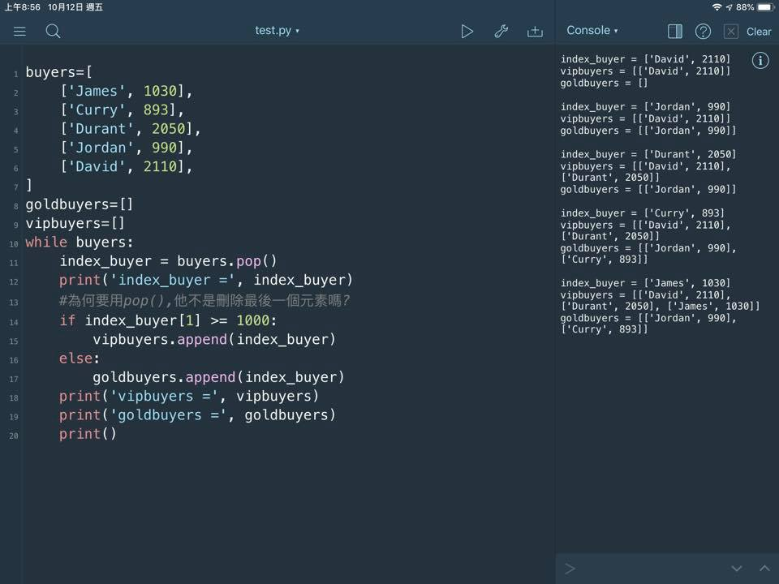

打字來輸入說明。

[參考答案] Exercise-03

def encrypt(word, vowels=('a', 'e', 'i', 'o', 'u')):

find_vowel = False

letters = list(word)

print(letters)

for idx, letter in enumerate(letters):

if letter in vowels:

find_vowel = True

break

elif letter.lower() in vowels:

find_vowel = True

letter = letter.lower()

break

if find_vowel:

word = ''.join(letters[idx:]) + '*' + ''.join(letters[:idx])

return word

[參考答案-1] Exercise-04

ListA = ["I am Sam"]

ListB = ["I am Sam", "Yes me Sam"]

setA = set([word for i in range(len(ListA)) for word in ListA[i].split(' ')])

for i in range(len(ListB)):

for word in ListB[i].split():

if word not in setA:

ListB[i] = ListB[i].replace(word, 'foo')

print(ListB)

[參考答案-2] Exercise-04

ListA = ["I am Sam"]

ListB = ["I am Sam", "Yes me Sam"]

setA = set([word for i in range(len(ListA)) for word in ListA[i].split(' ')])

ListB = [word if word in setA else 'foo' for i in range(len(ListB)) for word in ListB[i].split()]

print(ListB)