Adjustable configuration Graphs. PHP/Mysql Ajax and pchart.(pchart.com)
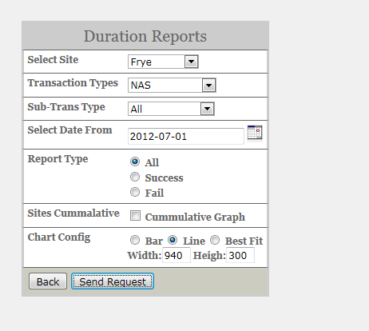

Line Graphs
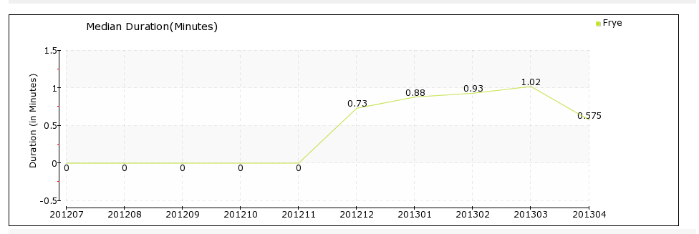

Bar Graphs
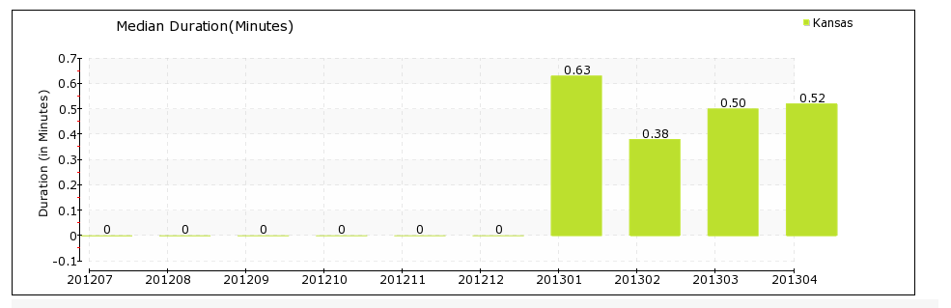

Transaction and Duration Graphs
