Assignment #3

Dong Yan

5944970

April 8, 2021

Part I

Decision table based on business requirement

|  |  |  |  |  |  |  |  |  |  |  |
| --- | --- | --- | --- | --- | --- | --- | --- | --- | --- | --- |
| Stub | Entry | | | | | | | | | |
| 3 or more accidents | T | T | T | T | T | F | F | F | F | F |
| No experience driver | T | F | F | F | F | T | F | F | F | F |
| 1-9 years driving experience | F | T | T | F | F | F | T | T | F | F |
| Over 9 years driving experience | F | F | F | T | T | F | F | F | T | T |
| Driver's age >=30 and driving experience >=2 | F | F | T | F | T | F | F | T | F | T |
| Refuse to provide insurance | X | X | X | X | X |  |  |  |  |  |
| Base rate $4000 annually |  |  |  |  |  | X |  |  |  |  |
| Base rate $2500 annually |  |  |  |  |  |  | X | X |  |  |
| Other base rate $1000 annually |  |  |  |  |  |  |  |  | X | X |
| 24% of discount on base rate |  |  |  |  |  |  |  | X |  | X |

Decision table – Adding Don’t Cares

|  |  |  |  |  |  |  |  |  |  |  |
| --- | --- | --- | --- | --- | --- | --- | --- | --- | --- | --- |
| Stub | Entry | | | | | | | | | |
| Accidents level | 3 or more accidents | | | | | Less than 3 accidents | | | | |
| Driving experience | No experience | 1-9 years | | Others | | No experience | 1-9 years | | Others | |
| Driver's age and driving experience combination | - | - | - | - | - |  | >= 30 years old & >=2 years experience | else | >= 30 years old & >=2 years experience | else |
| Refuse to provide insurance | X | X | X | X | X |  |  |  |  |  |
| Base rate $4000 annually |  |  |  |  |  | X |  |  |  |  |
| Base rate $2500 annually |  |  |  |  |  |  | X | X |  |  |
| Other base rate $1000 annually |  |  |  |  |  |  |  |  | X | X |
| 24% of discount on base rate |  |  |  |  |  |  | X |  | X |  |

Final decision table without redundancies

|  |  |  |  |  |  |  |
| --- | --- | --- | --- | --- | --- | --- |
| Stub | Entry |  |  |  |  |  |
| Accidents level | 3 or more accidents | Less than 3 accidents | | | | |
| Driving experience | - | No experience | 1-9 years | | Others | |
| Driver's age and driving experience combination | - |  | >= 30 years old & >=2 years experience | else | >= 30 years old & >=2 years experience | else |
| Refuse to provide insurance | X |  |  |  |  |  |
| Base rate $4000 annually |  | X |  |  |  |  |
| Base rate $2500 annually |  |  | X | X |  |  |
| Other base rate $1000 annually |  |  |  |  | X | X |
| 24% of discount on base rate |  |  | X |  | X |  |

Test case

|  |  |  |
| --- | --- | --- |
| Test ID | Test Steps | Expected Outcome |
| 1 | As a driver has 3 or more accidents on record, regardless of driving experience | Refuse to provide this drive with insurance. |
| 2 | As a driver has less than 3 accidents on record, with no driving experience | Provide a base rate of $4000 annually. |
| 3 | As a driver has less than 3 accidents on record, with 1 to 9 years of experience | Provide a base rate of $2500 annually. |
| 4 | As a driver has less than 3 accidents on record, with 2 or more years driving experience and at age 30 or older | Provide a 24% discount on the base rate of $2500 annually. |
| 5 | As a driver has less than 3 accidents on record, with over 9 years of experience | Provide a base rate of $1000 annually. |
| 6 | As a driver has less than 3 accidents on record, with over 9 years driving experience and at age 30 or older | Provide a 24% discount on the base rate of $1000 annually. |

Part II

Task 1 Screenshot

Home Page

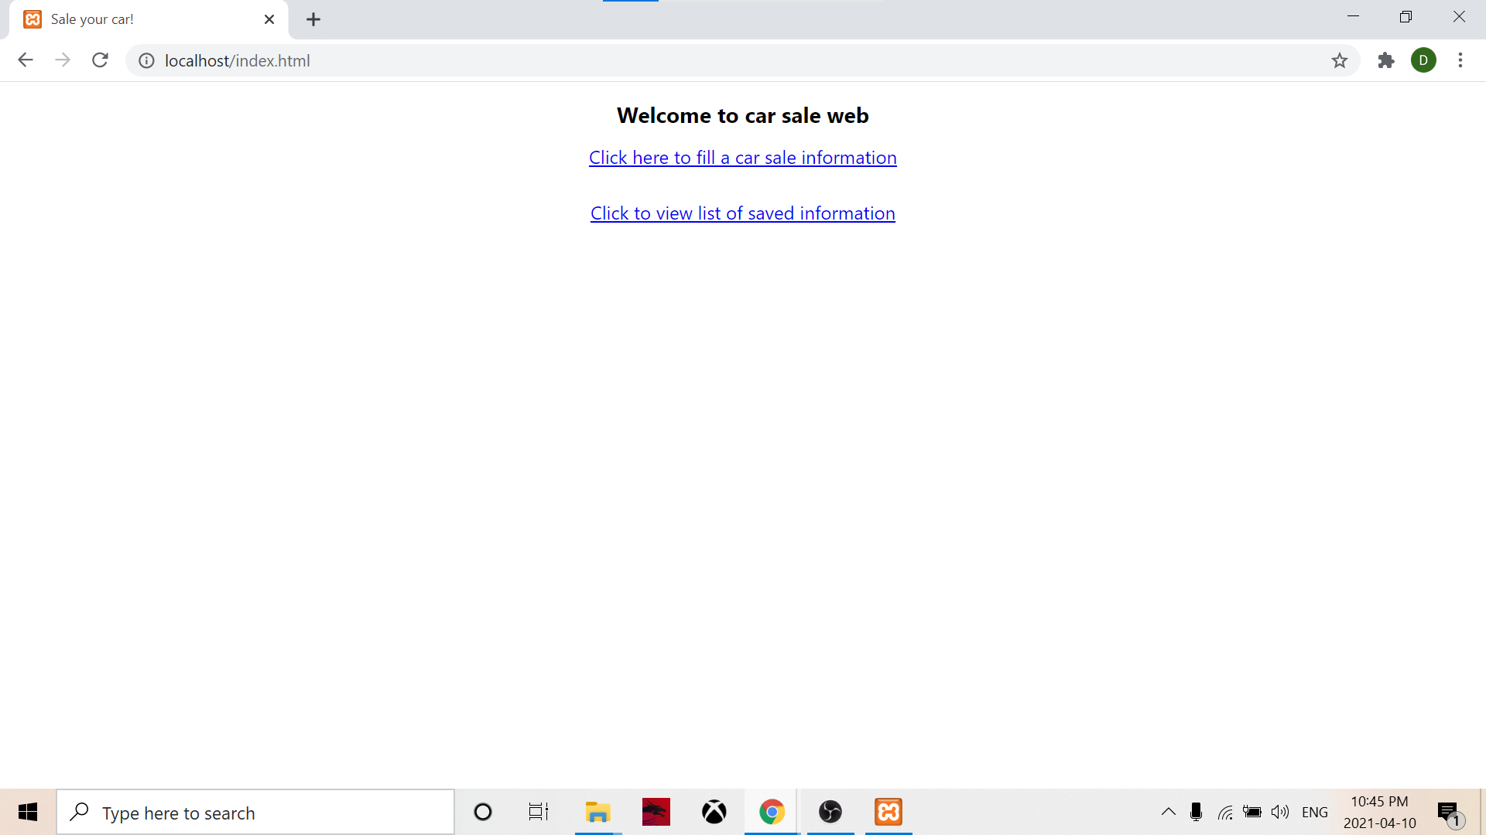

Enter info form

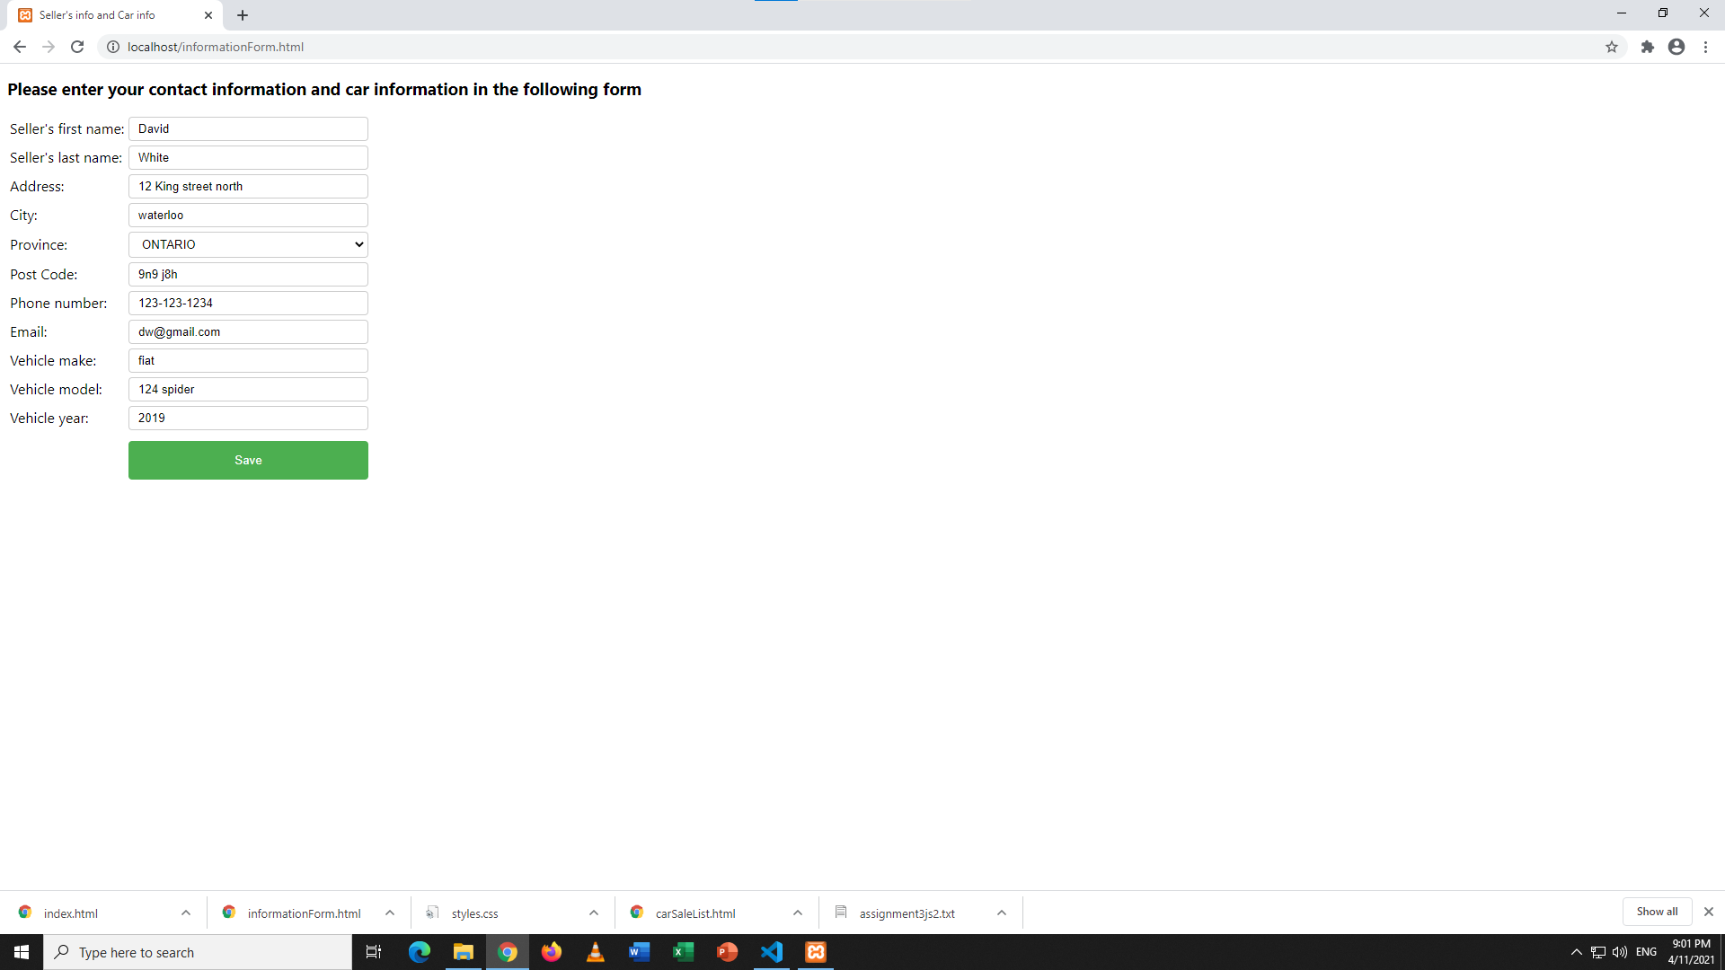

Displayed Entered Info and Link

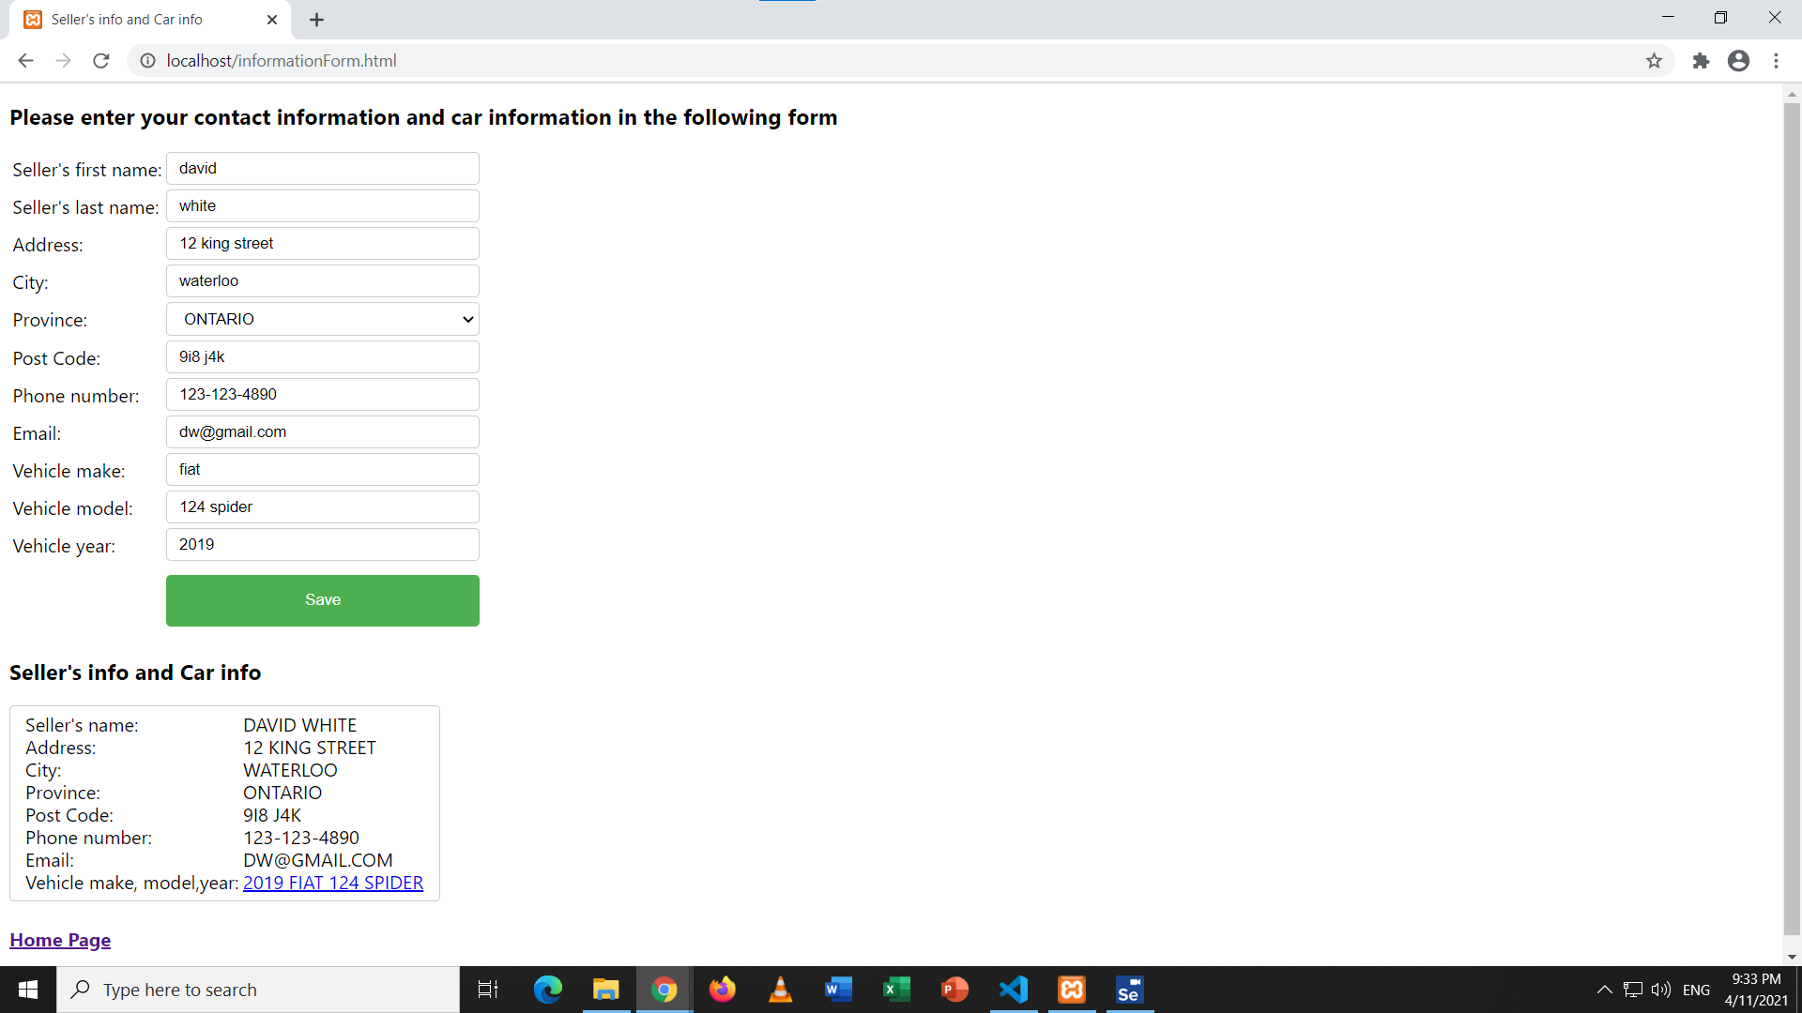

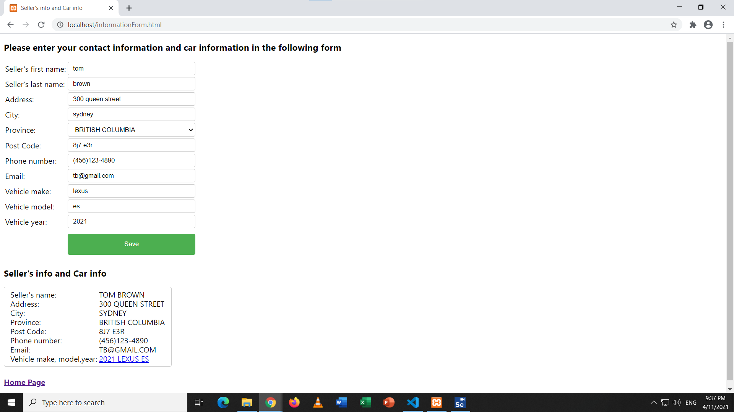

Display List of All Saved Info

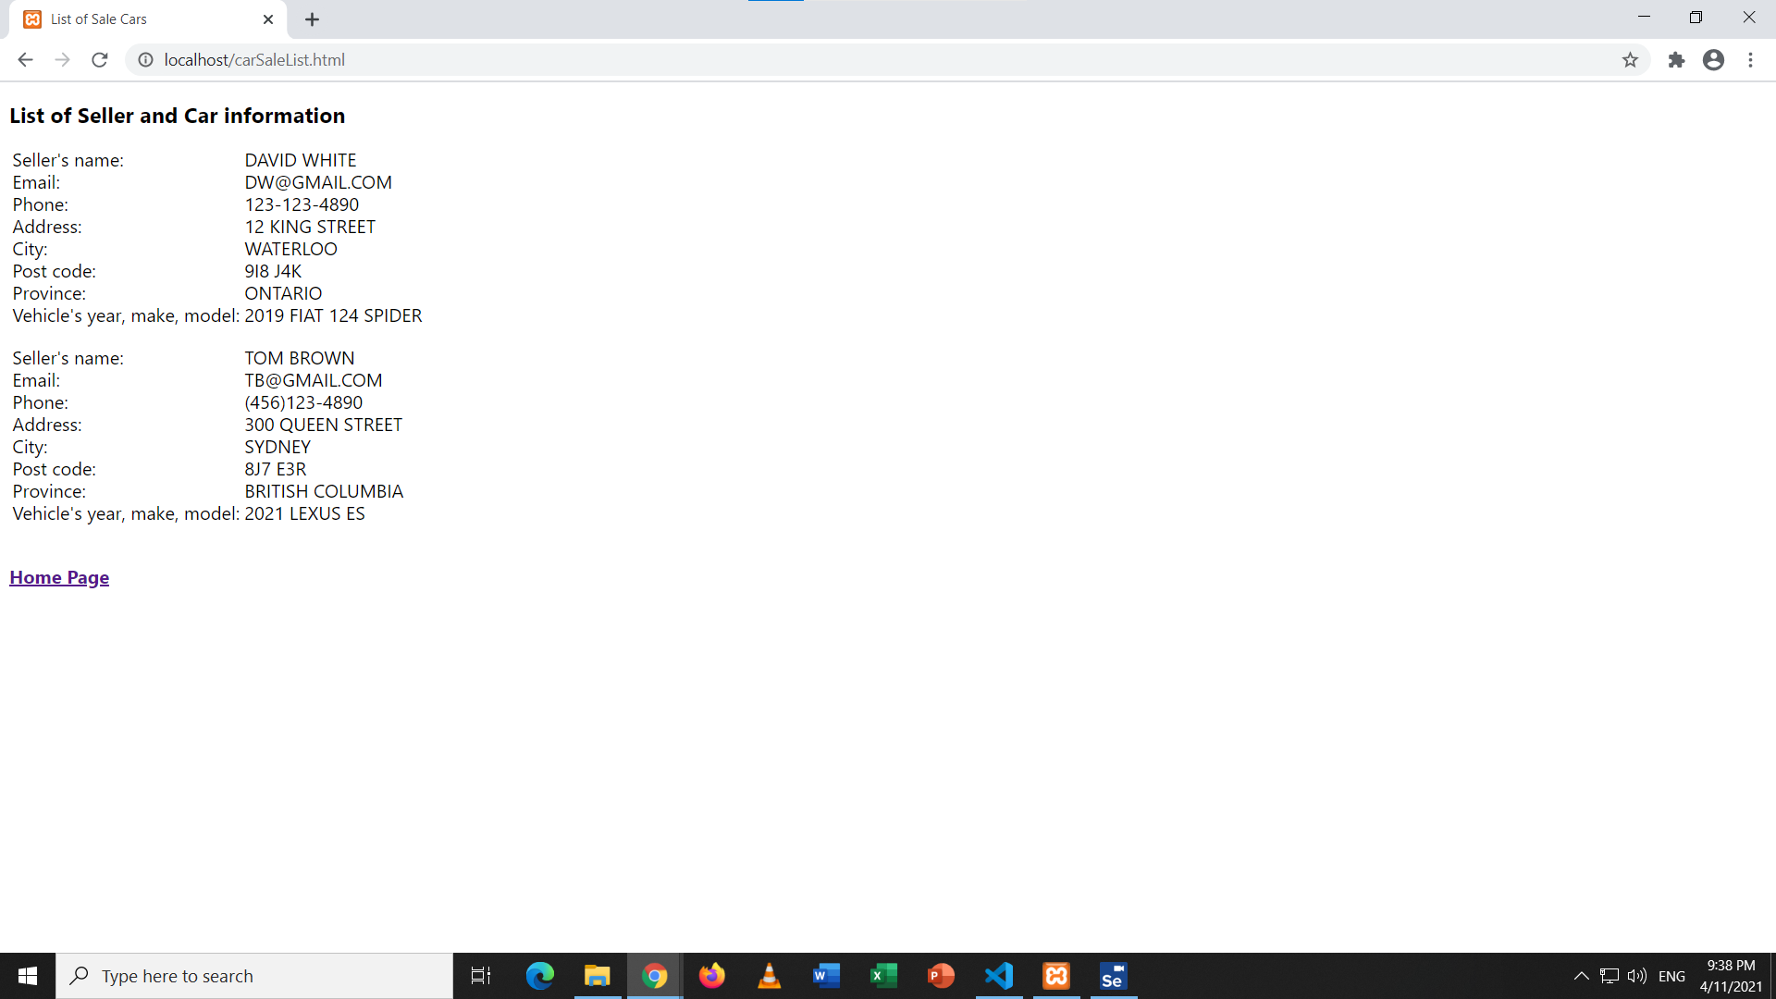

C# code

HTML code