Q.1) Insert and display the documents in the Employee collection.

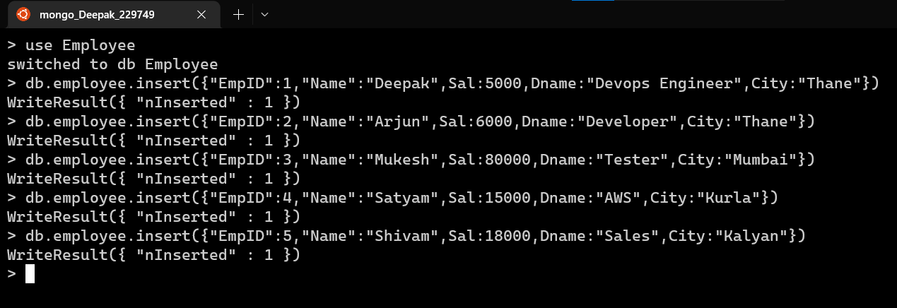

Output:

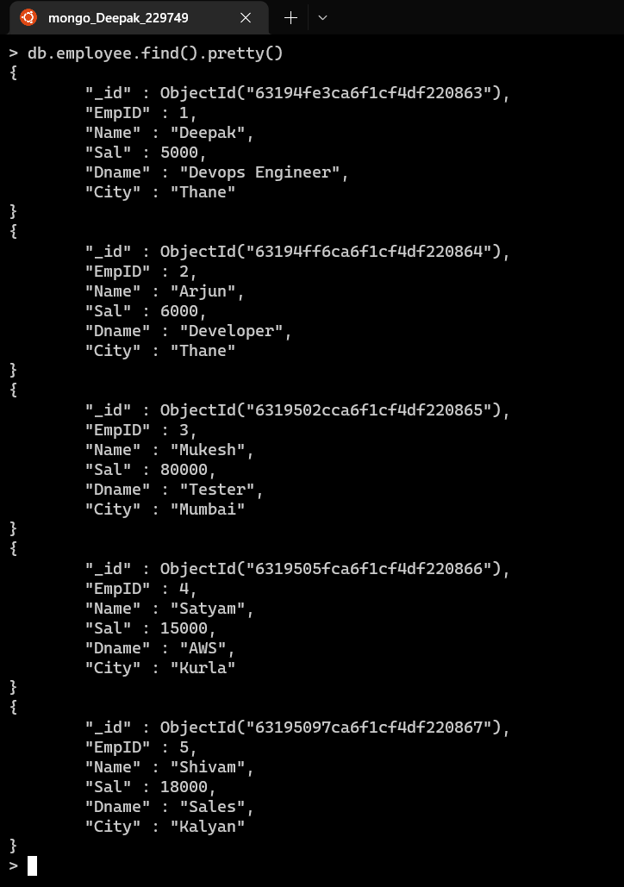

Q.2) Display details of employees who live in Mumbai.

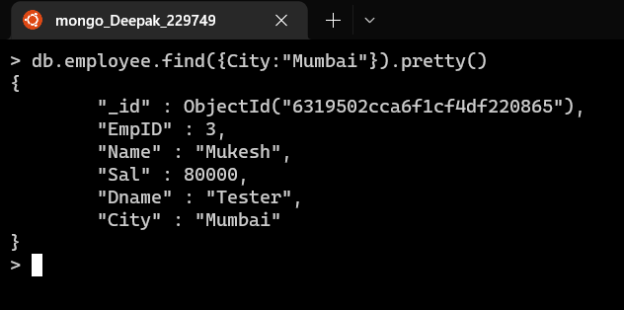

Q.3) Display details of employee staying in Kurla and salary greater than 19000

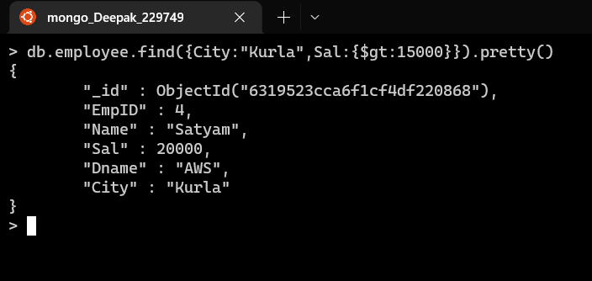

Q.4) Display details of the employee whose salary is greater than equal 10000 but less than 20000.

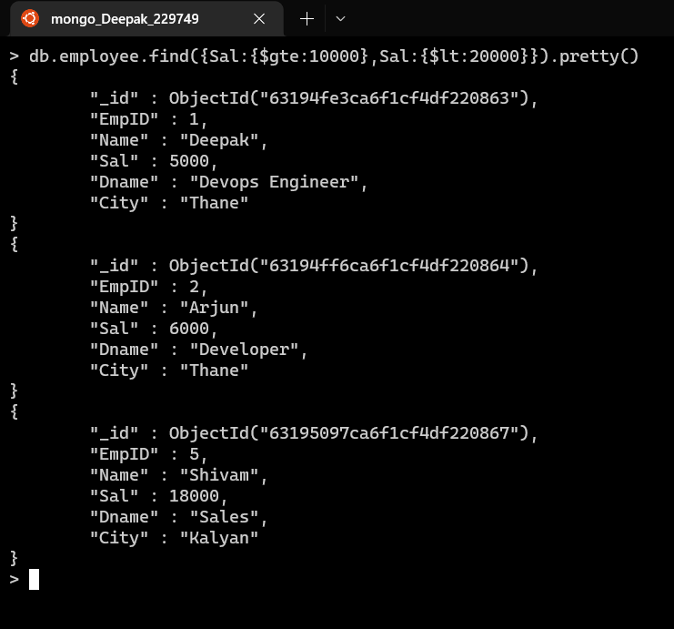

Q.5) Display details of employees staying in either thane or mumbai and salary greater than 25000.

