Information Retrieval (CMSC 476/676)

Homework 4 – Report
Done by – Anushka Dhekne (CMSC VD19739)

The objective of this project is to build a command-line retrieval system on top of the inverted index files created in Project 3. The system must take in queries (list of words and their respective weights) and run these queries through the preprocessing logic and match the query words against the inverted file and finally, give the document IDs and the term weights of the top 10 ranking files as the output. The query must run in a single command and the query may use multiple terms with their respective weights or a single term (with 1 or more than 1 word) with its weight. If there are no files with non-zero scores, the code must print an appropriate message and, in that case, the printing of files must be skipped.
I have used Python programming language to complete this assignment and Visual Studio Code as the code editor. This report discusses the implementation, the working of each function, the algorithm used, explains the output and the files used for input. It also includes screenshots of a few specific queries. This code involves the usage of the ‘dictionary.txt’ and ‘postings.txt’ files which were generated as the output in Project 3.

The first function – ‘reading_index_and_postings’ reads the inverted index and postings from the specified index dictionary.txt file which basically has the the word, the number of documents that contain that word (this should correspond to the number of records that word gets in the postings list) and the location of the first record for that word in the postings file. It also constructs the ‘inverted_index’ dictionary which stores the inverted index. Each term in this inverted index maps to a dictionary containing the number of documents which contain this term as well as the starting position of the postings for that term. This function then returns the inverted index dictionary as well as the path to the postings.txt file.
The second function – ‘reading_postings’ accesses the postings.txt file and reads the postings for a given term. It also creates a dictionary – ‘postings_dict’, which stores the document Ids and its corresponding term weights. The function uses a file pointer and sets it to the starting position of the postings for a given term and reads the specified number of lines. This count of number of lines is equal to the number of documents containing that term. Each line contains a document Id and its weight. The document Id and its weight is separated by a comma. The function then parses each line and stores the document Id and its respective weight in the ‘postings_dict’ which is then returned by the function.
The next function – ‘preprocessing_queries’ is mainly used to preprocess the queries received from the command line prompt and extract the query terms and their respective weights from the dictionary.txt and postings.txt files. It also initializes the lists to store the query terms and the query weights for the queries. This function then iterates through the queries to check if each item in the query is a term or a weight corresponding to it. If the element is a term, it converts it to lowercase and appends it to the ‘query_terms’ list and if it is a weight, it converts the weight into float and appends it to the ‘query_weights’ list. The function then returns both these lists.
The fourth function – ‘doc_retrieval’ retrieves the weights of each of the documents based on the processed queries. It initializes the ‘doc_weights’ dictionary to store the weights of the documents. This function creates a loop which iterates through each of the query terms and retrieves the postings for each term from the inverted index. It then calculates the weighted sum of the term weights and stores it in the ‘doc_weights’ dictionary. It does this for each document in the postings. The dictionary ‘doc_weights’ containing the document IDs and the weighted sum of the term weights is then returned by this function.
The function ‘top_docs’, along with the ‘doc_weights’ dictionary, takes in the argument ‘top’ which is set equal to 10. This function is used to display the top 10 ranked documents based on its term weights (printed in the descending order). It also filters out the documents with zero weights and if there are files having zero score for the term weights, it displays a message – ‘No documents with non-zero scores found for the given query’. Otherwise, it prints the 10 top-ranked document Ids and its weights.
Finally, the main function parses the command-line arguments using the object of the ‘argparse’ library. It reads the inverted index and postings from the specified directory, which contains the dictionary.txt and postings.txt files containing all the important data for all the preprocessing and query retrieval to finally display the 10 top-ranked document Ids and its weights.

Considering all the functions, the overall time complexity of the code is – O(m * num_of_docs). Here, ‘m’ is the number of query terms and ‘num_of_docs’ is the number of documents containing each of the query terms. The space complexity is decided by the size of the inverted index and postings and so, the space complexity of this code is – O(n), where ‘n’ is the maximum number of terms in the dictionary plus the number of documents having a non-zero weights.

The code does support the feature, where it allows giving a command-line query in 2 ways –
- Users can input a single query (which may contain 1 or multiple words as the terms) along with its weight. For example –
- python code.py 0.3 international affairs
- python code 0.5 cat

- Users can input multiple queries with each query having its individual weight. In this, the weights are combined to calculate the final scores for each document Ids. For example –
- python code.py 0.3 international 0.5 affairs

These query terms and its weights influence the relevance and importance of the documents retrieved by the query. Higher the weights, greater is the importance of the term in the given query. Below given are some screenshots of the output queries.

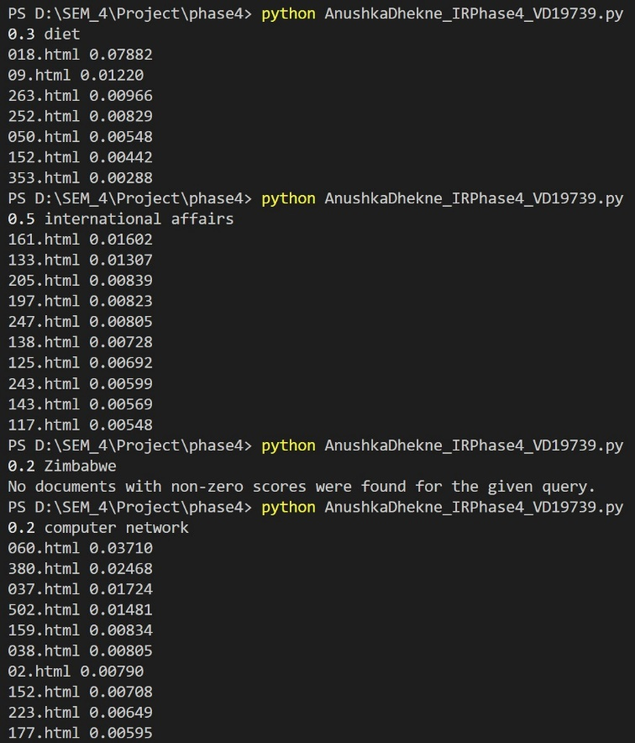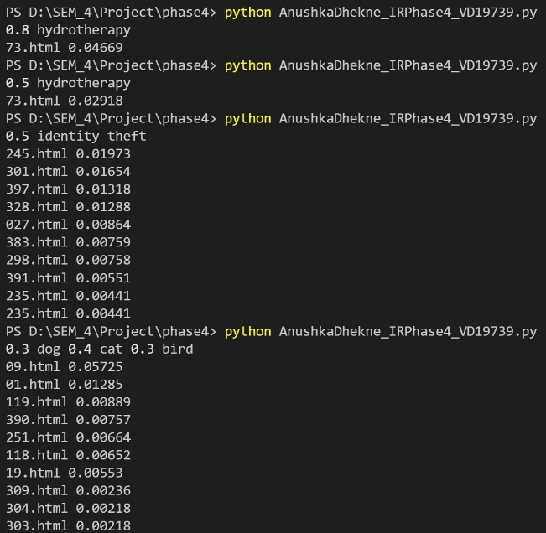
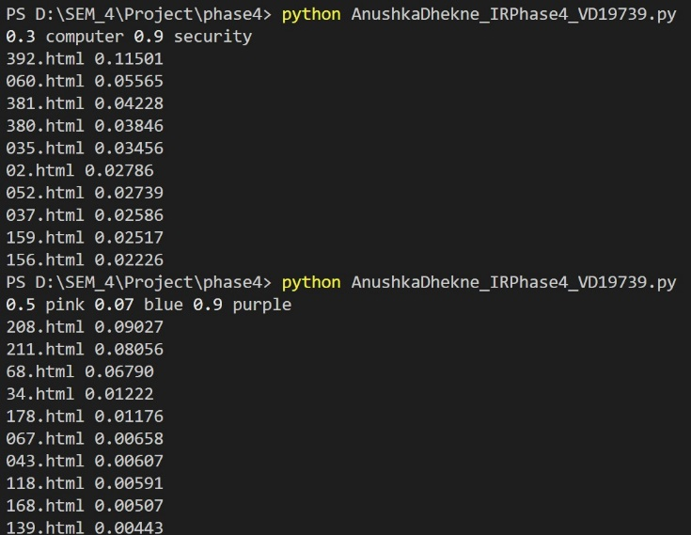
Thus, the given information retrieval engine efficiently retrieves the relevant document IDs based on the given queries by using an inverted index and postings as well as a sorting algorithm and utilizes various data structures like lists, dictionaries and employs I/O file operations to handle individual or multiple terms and its weights. This provides customization to the users to search their queries as they like it. This program thus provides flexibility, scalability, and accuracy in terms of the results achieved.

