Information Retrieval (CMSC 476/676)

Homework 2 – Report
Done by – Anushka Dhekne (CMSC VD19739)

The objective of this assignment is to remove the stopwords and calculate term weights of the tokens that appear in each of the file in the set of documents. The input directory contains the set of tokenized files (from Homework 1) and the output directory contains 1 output file per input file and includes the tokens and their respective weights calculated using tf-idf and bm25. I have used Python programming language to complete this assignment and Visual Studio Code as the code editor. This report also discusses the improvements in implementation while processing the documents from Homework1 to Homework2. It also includes examples of 2 input documents, their respective output files showing the term weights, the graph showing time required to process each set of documents and the efficiency of the overall program.

The first function – ‘preprocessing_text’ is used to convert all text from the input file to lowercase and then remove stopwords from it. The function removes all words given in the list of stopwords, which is hardcoded in the program. Apart from this, it removes all words which are of length 1 and words which appear only once in the entire corpus of documents. The next function calculates the token weights using the TF-IDF and BM25 algorithms. Here, the time calculation for the entire process begins. The system time is started using the ‘time’ Python library. The function iterates over each file in the set of documents provided in the input directory. It extracts the contents of the file which is in the .txt format and tokenizes it using the ‘preprocessing_text’ function . It then computes the document frequencies and calculates document lengths for further calculations related to TF-IDF and BM25.

The TF-IDF scores which are computed for each token are based on the token frequency in the document. The TF (term frequency) is then calculated in each document by dividing the frequency of the token in the document by the document length (number of tokens in the document), and it also calculates Inverse Document Frequency (IDF) values for each token from the corpus. Finally, the TF-IDF scores are calculated by multiplying the value of TF with the value of IDF for that token in the document.
The BM25 algorithm works in a similar way, making use of the IDF values. It also uses term frequency, document length, average document length in the corpus and constants like b and k1. I have taken the values of constant b=0.75 and constant k1=1.5. Thus, BM25 focuses on the document length and term frequency normalization for giving accurate scores on token weights, whereas TF-IDF focuses on frequency of terms which appear frequently in each document, but not in the entire corpus of documents.
The scores calculated using both the algorithms are then stored in the output files along with the token name. These scores or token weights are written to its respective output files, which are saved in the ‘.wts’ format. The file reading and writing operations take place using the ‘os’ library, which allows performing the file operations seamlessly.

Next, we check if the given number of documents have been correctly processed and if the time elapsed to calculate the processing time for each document has been correctly recorded. The time required to process each file (partial time) is recorded and then subsequently, it is appended to the total elapsed time to calculate the time required to process each set of documents. The set of documents contains – 10, 20, 40, 80, 100, 200, 300, 400 and 500 documents. This output is also shown by plotting a graph of ‘Number of Documents Processed’ versus ‘Elapsed Time’. Finally, after all 503 documents’ process time has been appended, the total time documents are recorded to give the output of the code as - ‘Total time for processing all 503 documents.

Homework1 completed the preprocessing using the regex and NLTK libraries to tokenize the words. Homework2 completed the preprocessing by removing the stopwords and unnecessary words, which do not contribute much to the meaning of the text and then, finding the token weights. Thus, the preprocessing step was enhanced in Homework2, which is now giving a more clear, readable, accurate and efficient result. The code was optimized as well by minimizing redundant operations.
The code efficiency was calculated using the ‘time’ Python library. If we consider ‘m’ to be the number of documents, ‘n’ to be the length of the documents and ‘k’ to be the average number of tokens per documents, the time complexity of tokenization is O(m*n), the complexity of the algorithm calculation – TF-IDF and BM25 is O(m*k) and hence, the overall time complexity of the program becomes O(m*(n+k)). Overall, the graph shows that the document processing takes place in linear time and the graph shows a linearly increasing trend.

The graph generated by the program is shown below –
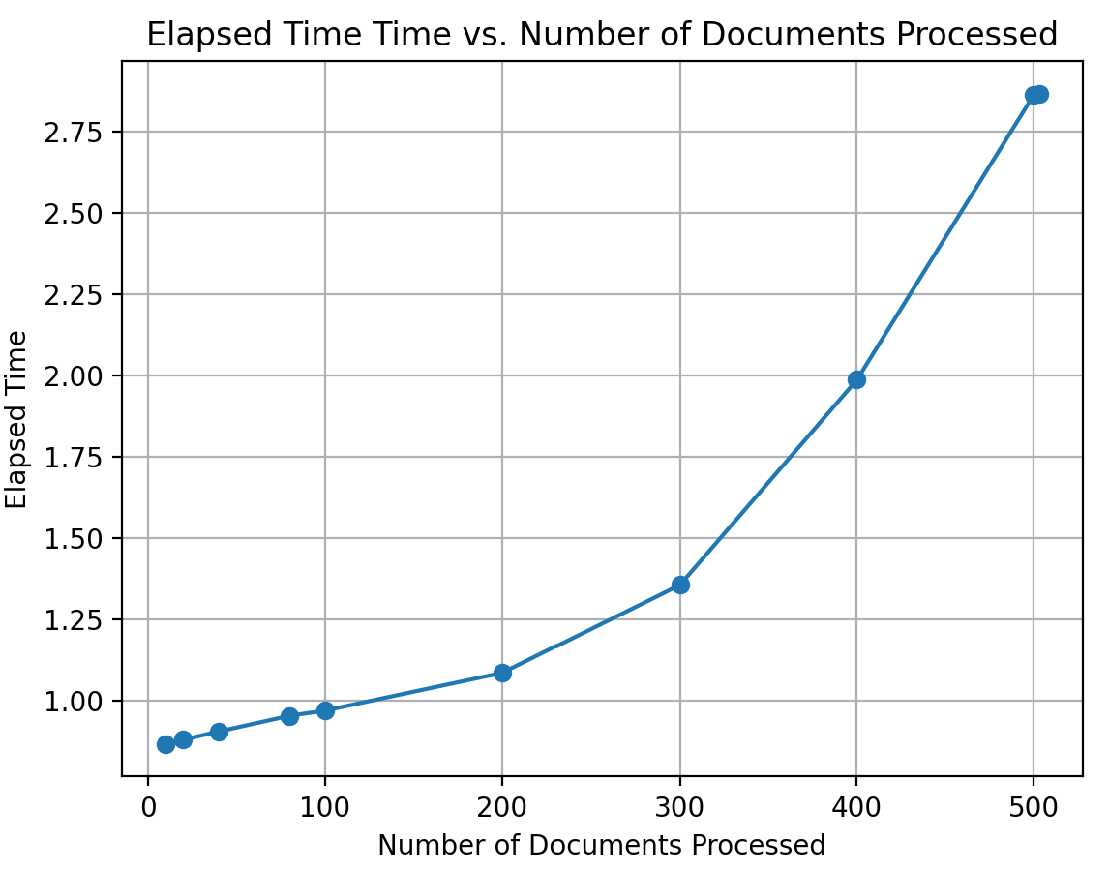
The graph shows the relationship between the Number of Documents Processed against the Elapsed Time to process a set of 10,20,40,80,100,200,300,400,500 and 503 documents. The trend of the graph shows that the algorithm is suitable of handling large files and/or a large corpus of files.
The result of the program which shows the total time required to process 503 documents is given below. Once we close the window of the above graph, we get the result as shown below.

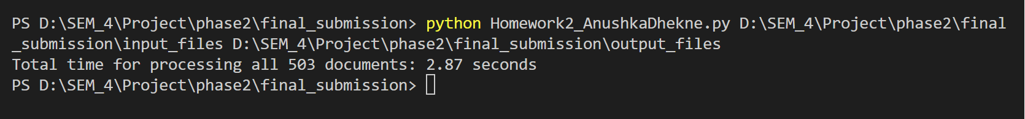

The following images show the input .txt file and the result output file in .wts format.
Input File – 006.txt
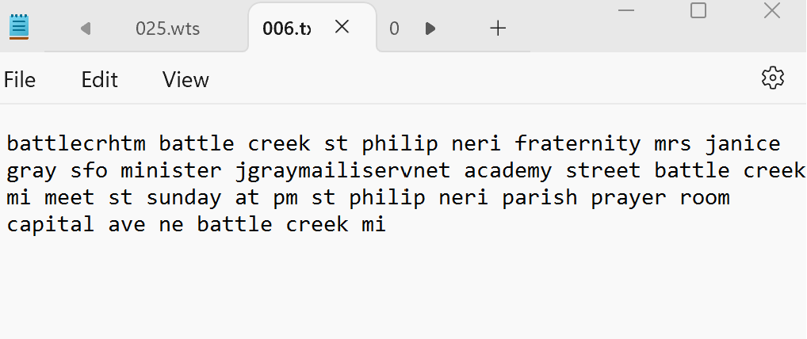
Output File – 006.wts
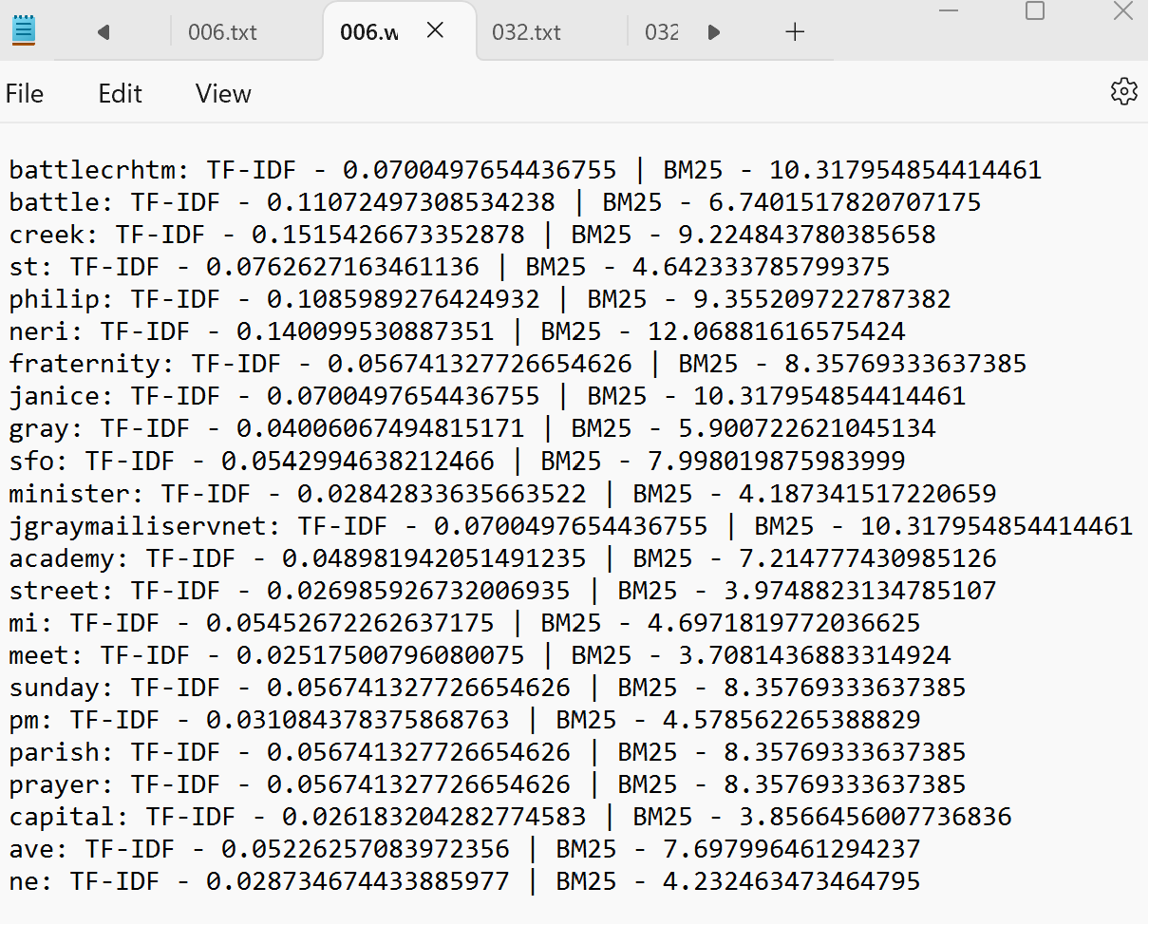

Input File – 032.txt
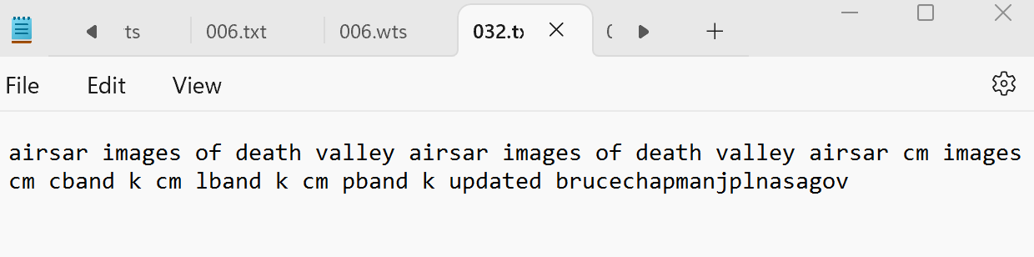
Output File – 032.wts
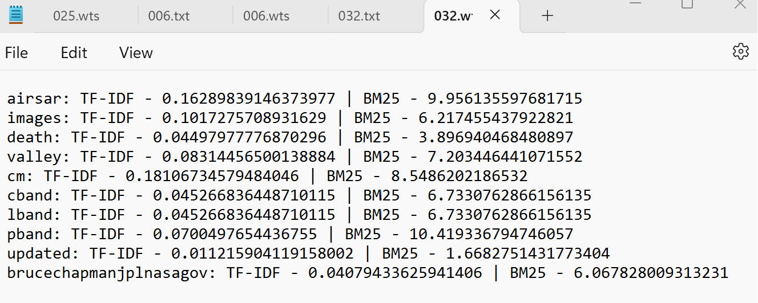

The TF-IDF and BM25 algorithms provide a clean, accurate and reliable solution for data tokenizing, weight calculation and data representation as well. Thus, the preprocessing steps and the efficient algorithm selection has enabled to understand the significance of term weights and has also enhanced the way of document representation.

