Exercise No: 5

Date: 14/10/2020

**Aim:**

To write a python program to check whether an entered string is a pangram or not. If it isn't a pangram then it must print the missing characters to make it a pangram.

**Program:**

def pangram(s):

a2z="abcdefghijklmnopqrstuvwxyz"

a=[pan for pan in a2z if pan in s]

b=[npan for npan in a2z if npan not in s]

if(len(a)==26):

l2s="".join([str(i) for i in a])

return l2s

else:

l2s="".join([str(i) for i in b])

return l2s

st=str(input())

st=st.lower()

p=pangram(st)

print(p)

**Link:**

<http://103.53.53.18/mod/vpl/forms/submissionview.php?id=229&userid=1670>

**Output:**

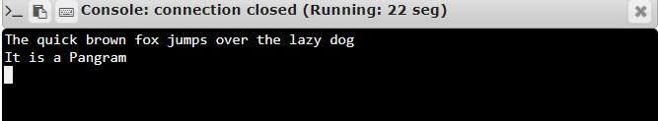

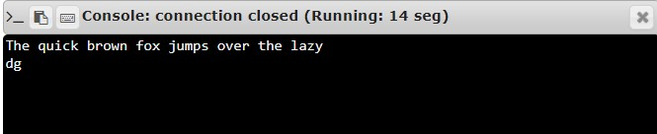

**Result:**

Thus, the program to check the pangram and print the missing letters to complete a string as pangram is executed and required output is obtained.