AUCSC 218: Assignment #1: HTML5 + CSS
Group Work

Instructions
- The goal of this assignment is to demonstrate your mastery of HTML5 and CSS.
- Any submission that violates these instructions will be assigned a zero mark
- Students must work in groups of three to complete this assignment
- Group members will get the same grade unless I received a complaint from any member. In such a case, the student who did not collaborate will receive a lower grade.
- It’s your responsibility to find a group
- Late submissions will be subject to a 50% penalty for the first 24 hours. Submissions that are late more than 24 hours will not be accepted without formal justification.

Submitting
- Put your assignment in one folder named FirstName1_ FirstName2_ FirstName3. Put all resources used by your assignment into this folder. Zip this folder to submit to eClass. I will not mark your assignment If you do not follow these submission instructions.

In the assignment folder, create a PDF file, named output.pdf, that contains the following four sections:

Names of group members (first, last)

the HTML code,

CSS code,

Image that shows the outcome as it appears on the browser

Grading
The grade for this assignment will be broken down as follows:
Layout Accuracy (85/100)
Valid + Appropriately Semantic HTML (15/100)
Note: use HTML and CSS comments to make your code more readable to the instructor

Non-Functional Requirements
All images must be in the subfolder “images”, and CSS file(s) must be in the “CSS” subfolder
You must submit valid HTML5. The CSS files must be valid as well. You can use the W3C validator at http://validator.w3.org to ensure your HTML files are valid. You can use the CSS validator at http://jigsaw.w3.org/css-validator.
You must create the HTML web page shown below. You will be supplied with the necessary images. You must use CSS for formatting; however, other than some floats for either the menu or the action images in the table, CSS positioning will not be necessary. The page does not have to be an exact match; it should however be as close as possible and look the same on the major browsers.
The tabbed menu must be a list with different hover behavior (i.e., underline and different background image). For all links, make the destination URL simply be “#”. The table in the Table Template section should have its column sizes specified using relative percent measures.
There is a file called otcome_screen_capture.png which can be used to find colors. Notice that there are a variety of gradient images used as backgrounds (for table cells, text boxes, etc).

content_top.gif, content_bottom.gif
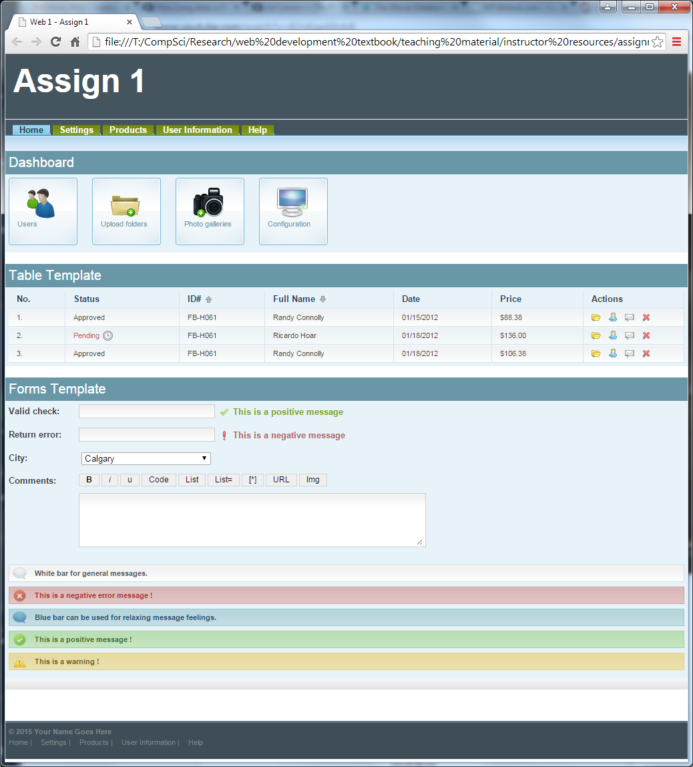
main_menu_li.gif, mm_lk_middle.gif
d1.gif, d2.gif, d3.gif, d4.gif, dashboard_li.gif
action1.gif, etc,
td_bg1.gif, td_bg2.gif, asc.gif, desc.gif, pending.gif
white_ico.png, white_message.gif,
red_ico.png, red_message.gif
blue_ico.png, blue_message.gif,
green_ico.png, green_message.gif
positive.gif, negative.gif, input_text1.gif, input_text2.gif
title_bg.png
Note: this should be an embedded table; each of these four things should be links

