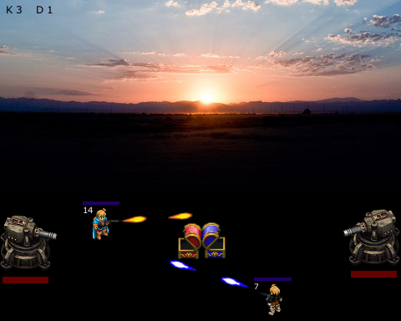FireFight

OVERVIEW

The game is a top down single player battle arena style game in which the player fights another character, trying to destroy their turret before their own turret is destroyed.

BASIC RULES

1. Each character has a predetermined amount of life. When hit by the other player’s projectile, you lose a health point.
2. Limited amount of ammunition requires the character to return to their turret to reload.
3. The chest in the middle of the map provides an opportunity to exchange the current weapon for one with a different and random scalar damage amount. However, ammunition count does not change when switching weapon.
4. The turret takes a predetermined amount of hits to destroy and can only be hit when the other player is killed.
5. After being killed, they will be respawn after a predetermined amount of time, which remains static throughout the game.
6. After completing each level, the opposing character receives a health and damage buff for the next level in single player mode.

FEATURES

1. Weapon Upgrades: In the middle of the map, there will be a chest which will give a randomized power-up which replaces your current weapon with an item which scales your damage output.
2. Scaling Damage: Damage output of the character increases over time.
3. Ammunition Count: Each player has a predetermined amount of ammo to use before having to return to their tower to reload.
4. Turret Protection: If a player gets too close to the opposing person’s turret, they automatically receive damage.

DIFFICULTY

1. Development of AI Character
2. Implementation of status of each character
3. Multiplayer option