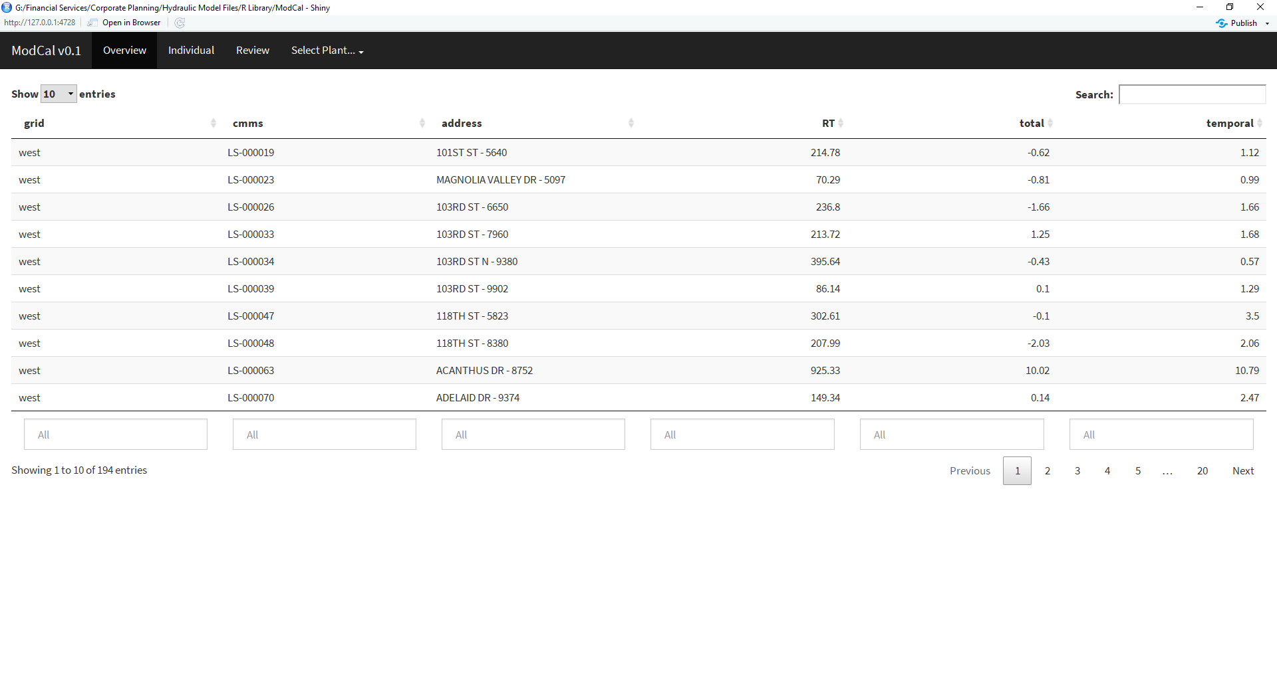

output$omt_overview <- DT::renderDataTable(error

, selection="single"

, rownames=FALSE

, filter="bottom"

)

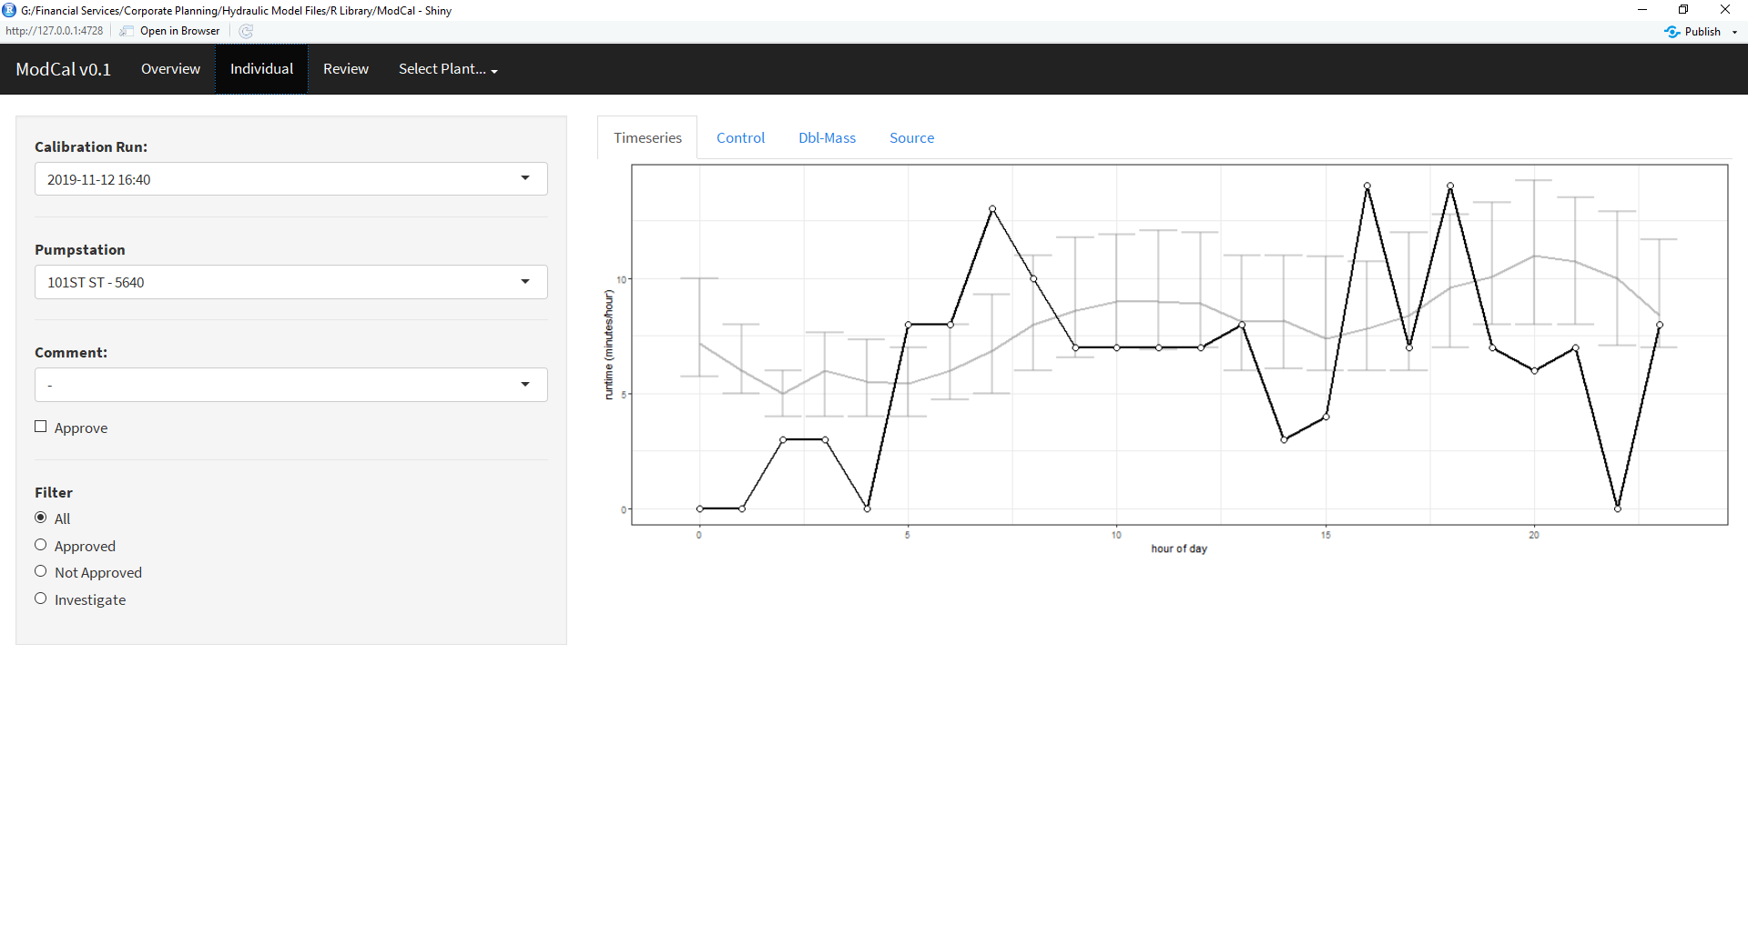

**Dropdown:**

sw$address

sw$approved[ index() ]

sw$comment[ index() ]

**Plots:**

tmp %>% dplyr::filter(cmms==sw$cmms[index()]) %>% …

hrt %>% dplyr::filter(cmms==sw$cmms[index()]) %>% …

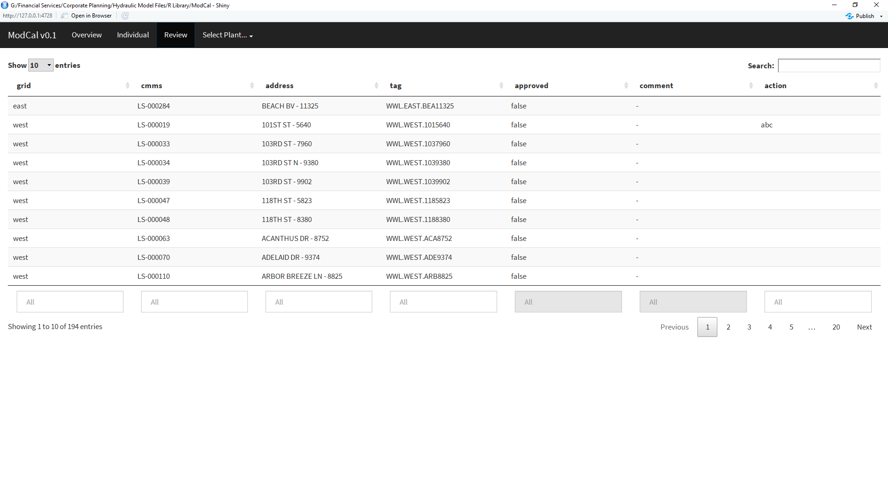

sw