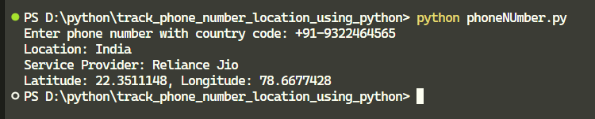

import phonenumbers

from phonenumbers import geocoder as phone_geocoder, carrier

import folium

from opencage.geocoder import OpenCageGeocode

*# OpenCage API key*

Key = "6d6f969fd9024ac8afde957f0c86a5ba"

*def* get_location_from_phone(*number*):

    try:

*# Parse the phone number*

        check_number = phonenumbers.parse(number)

*# Get the location description*

        location_description = phone_geocoder.description_for_number(check_number, "en")

        if not location_description:

            raise *ValueError*("Location description not found.")

*# Get the service provider*

        service_provider = phonenumbers.parse(number)

        provider_name = carrier.name_for_number(service_provider, "en")

        print(*f*"Location: {location_description}")

        print(*f*"Service Provider: {provider_name}")

*# Use OpenCage Geocoding to get coordinates*

        geocoder_service = OpenCageGeocode(Key)

        query = *str*(location_description)

        results = geocoder_service.geocode(query)

        if not results:

            raise *ValueError*("Geocoding did not return any results.")

*# Extract latitude and longitude*

        lat = results[0]['geometry']['lat']

        lng = results[0]['geometry']['lng']

        print(*f*"Latitude: {lat}, Longitude: {lng}")

*# Create a map with a marker*

        map_location = folium.Map(*location*=[lat, lng], *zoom_start*=9)

        folium.Marker([lat, lng], *popup*=location_description).add_to(map_location)

        map_location.save("mylocation.html")

    except phonenumbers.phonenumberutil.NumberParseException as e:

        print(*f*"Error parsing phone number: {e}")

    except *Exception* as e:

        print(*f*"An error occurred: {e}")

*# Get phone number input*

number = input("Enter phone number with country code: ")

get_location_from_phone(number)