Ja-B AIMS
(Java-Based Application Inventory Management System)

This project is developed by a group of students under the guidance of the assigned instructor.
Group Coordinator: Boteros, Vladdimer Jr. E.
Members:
Estrada, Clyde
Tantay, Javi Emmanuel
Vergara, Antonio Miguel
Section: 4-306

PROJECT DESCRIPTION
The Inventory System is a Java-based graphical user interface (GUI) application designed to manage and organize product inventory efficiently. The system allows users to store, update, search, and analyze product data such as name, price, and quantity.
The main purpose of this program is to simplify inventory management by providing an interactive and user-friendly interface. Instead of manually tracking products, users can rely on the system to automatically compute totals, detect low stock items, and generate reports.
Here’s are the key Features of our Ja-B AIMS:
- Add Product: Users can input new product details including name, price, and quantity.
- Update Product: Modify the quantity of existing products.
- Delete Product: Remove selected items from the inventory.
- Search Functionality: Quickly find products using keywords.
- Dashboard Overview: Displays:
  - Total number of items
  - Low stock items
  - Total inventory value
- Low Stock Monitoring: Automatically identifies products with quantity less than 5.
- Report Generation: Saves inventory data into a text file (inventory_report.txt).
- User-Friendly GUI: Built using Java Swing for easy navigation and interaction.
The system is ideal for small-scale inventory management and demonstrates fundamental concepts in Java programming such as object-oriented design, GUI development, file handling, and data processing.

Program Structure
The system is composed of multiple classes, each responsible for a specific function. These classes work together to ensure smooth operation of the program.
The system is composed of multiple classes, each responsible for a specific function. These classes work together to ensure the smooth and efficient operation of the program.
- InventoryGUI (Main Class)
InventoryGUI class serves as the main interface of the system, providing users with a graphical environment to interact with the application. It handles all user interactions such as button clicks, menu selections, and input dialogs. Additionally, it displays data using tables, labels, and lists, and acts as the central component that connects and coordinates all other classes in the system.
- Inventory
Inventory class is responsible for storing and managing all product data within the system. It uses an array structure to hold product objects and maintains the total count of products currently stored. This class provides essential functions such as adding new products, updating product quantities, deleting products, and searching for products based on user input.
- Product
Product class represents a single product in the inventory. It serves as a data model containing the essential attributes of a product, including its name, price, and quantity. Each product object created in the system is an instance of this class.
- InventoryProcessor
InventoryProcessor class is responsible for handling data processing and calculations related to the inventory. It includes functions for computing the total value of all products in the inventory and identifying items that are considered low in stock based on a predefined threshold.
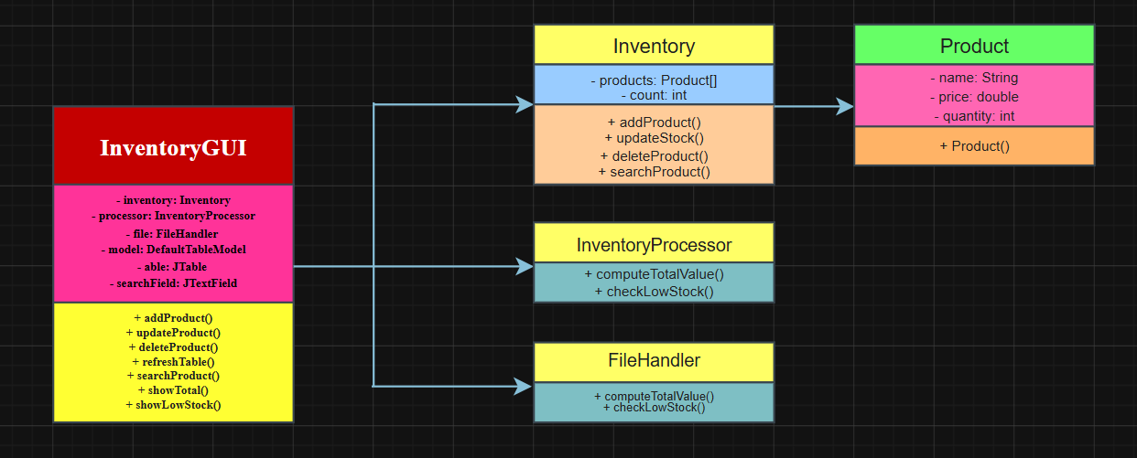
- FileHandler
FileHandler class manages file-related operations within the system. Its primary function is to save inventory data into a formatted text file, allowing users to generate and store reports of their inventory for future reference.

Picture 1. Package and Class Diagram
User Guide (Step-by-Step Instructions)
This section explains how to use the Inventory System.
- Running the Program.
- Compile and run the InventoryGUI class or double-click or run the INVENTORY SYSTEM.exe
- The main window will appear showing:
  - Table (product list)
  - Dashboard (totals and statistics)
  - Buttons (actions)
- Adding a Product,
- Click the ADD button or go to MENU → ADD PRODUCT.
- Enter:
  - Product Name
  - Price
  - Quantity
- Click OK.
- The product will appear in the table.
Note: If the product already exists, the system will: Update its quantity instead of adding a duplicate.

- Viewing Products
- All products are automatically displayed in the table.
- You can also click:
  - MENU → VIEW PRODUCTS

- Updating a Product
- Select a product from the table.
- Click the UPDATE button.
- Enter the new quantity.
- The table will refresh automatically.
- Deleting a Product
- Select a product from the table.
- Click the DELETE button
- The product will be removed

- Searching for a Product
- Enter a keyword in the SEARCH field.
- Click SEARCH.
- Matching products will be displayed in the table.

- Viewing Total Inventory Value
- Click the TOTAL button or MENU → COMPUTE TOTAL
- A message box will show the total value.

- Viewing Low Stock Items
- Click the LOW STOCK button.
- A list of products with quantity less than 5 will appear.

- Saving Inventory Report
- Click the SAVE button or MENU → SAVE OUTPUT.
- The system will create a file named:
  - inventory_report.txt
- The file contains:
  - Product names
  - Prices
  - Quantities

- Dashboard Features
- The dashboard automatically updates and displays:
  - Total Items: Number of products
  - Low Stock: Number of low stock items
  - Total Value: Overall inventory worth
  - Lists:
    - Low stock items
    - Normal stock items

- Exiting the Program
- Click MENU → EXIT or close the window.

Conclusion
The Inventory System is a practical application that demonstrates key programming concepts such as:
- Object-Oriented Programming
- GUI Development using Java Swing
- File Handling
- Data Processing and Validation
The system provides an efficient way to manage inventory and can serve as a foundation for more advanced applications such as database-driven systems or enterprise-level inventory solutions.

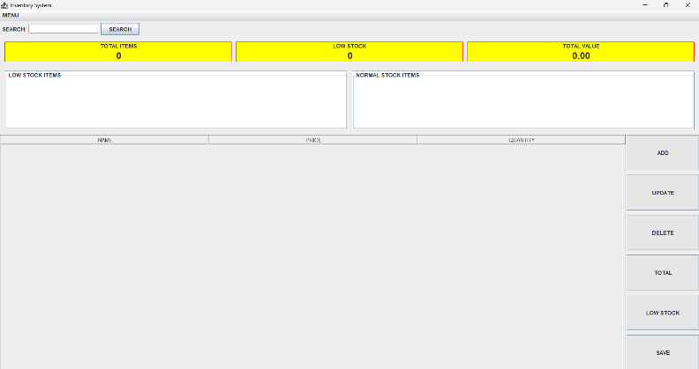
Screen shots
Figure 1. Main Interface of the Inventory System
This screenshot shows the main graphical user interface (GUI) of the Inventory System, including the menu bar, search bar, dashboard statistics, product table, and action buttons.

Figure 2. Dashboard Overview
This figure displays the dashboard section of the system, showing the total number of items, low stock count, and total inventory value.
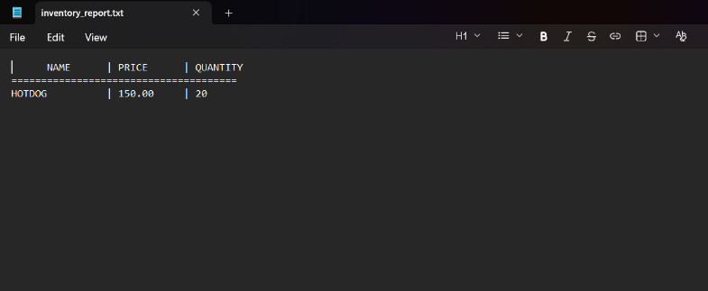
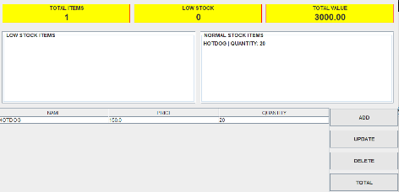
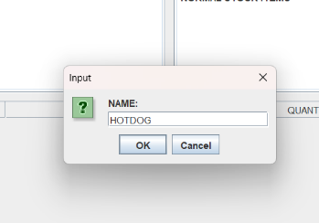
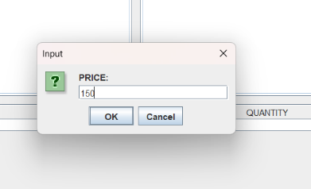
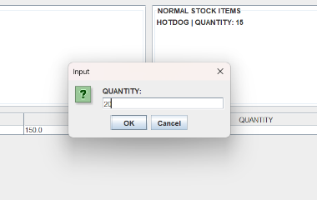
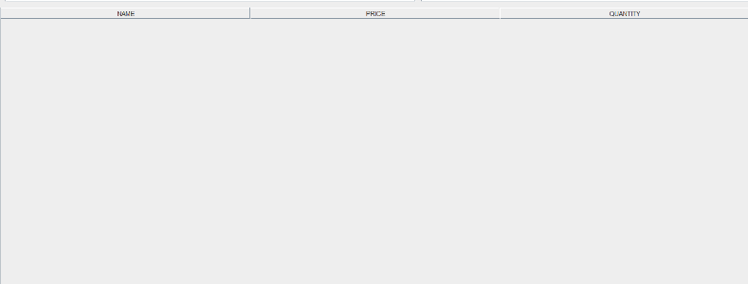
Figure 8. Example Output
Figure 5,6, and 7. Example of Input
Figure 4. Stock Classification Panel
This figure shows the classification of products into low stock and normal stock items, helping users easily monitor inventory levels.
Figure 3. Product Table Display
This screenshot presents the product table where all inventory items are listed with their corresponding name, price, and quantity.

