

**De La Salle University- Manila**

**Gokongwei College of Engineering**

LBYCPA1

Programming Logic and Design Laboratory

Project Proposal

Lizard-Spock RPS

Mark Joseph Carillo

Arhela Maxine Drapiza

Alyssa S. Montemayor

March 26, 2023

**Project Description**

A program and design command-line game in Python allow players to compete against each other in a game of rock, paper, and scissors. With this, our program will be modified into rock-paper-scissors-lizard-Spock. This modified game’s features include a single player vs the computer, two-players, score tracking, and a user input validation which is only limited to rock, paper, scissors, lizard, and Spock. Moreover, ASCII art will be implemented to create additional features in the game. The game will also follow the basic rules of rock-paper-scissors, but with the addition of lizard and Spock as two new options. Furthermore an additional game mode which will involve power ups and HP will be implemented to provide a unique experience for the players. Overall, this program will create an aesthetically pleasing and interactive user interface through the use of Python programming language and ASCII art.

**IPO**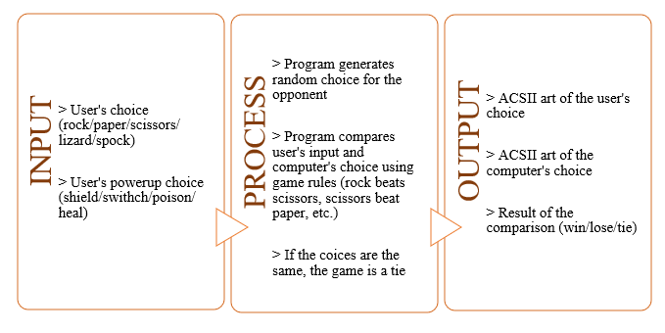

**Methodology**

In this program, the rules dictionary defines the possible choices and their corresponding winning choices. The get_player_choice() function gets the player's choice and checks if it's a valid choice. The get_computer_choice() function chooses a random choice from the rules dictionary. The determine_winner() function determines the winner based on the player's choice and the computer's choice. The main game loop repeatedly gets the player's choice, computer's choice, and determines the winner. It then displays the ASCII art for the choices and the winner. It asks if the player wants to play again, and if not, it breaks out of the loop and ends the game.

**Overall System Flowchart**

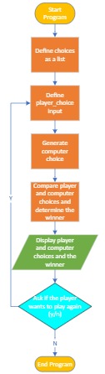

**Game Rules**

1. In the original rock paper scissors game, the following rules apply:
   1. Scissors cuts paper
   2. Paper covers rock
   3. Rock crushes scissors
2. The addition of Lizard and Spock create new rules:
   1. Rock crushes lizard
   2. Lizard poisons spock
   3. Spock smashes scissors
   4. Scissors decapitates lizard
   5. Lizard eats paper
   6. Paper disproves spock
   7. Spock vaporizes rock\
3. Player Vs. Computer Game Mode
   1. In this game mode, the player plays against a computer which generates random moves, the first one to get the highest score (10) wins.
4. Player Vs. Player Game Mode
   1. In this game mode, two players are able to play against each other, the first player to get the highest score (10) wins.
5. Powerup Game Mode
   1. During Powerup Game Mode, the player and computer will have HP points (5), the first one to have 0 HP loses and the remaining player will win.
   2. Every other round, a random powerup will be generated each round and the player will have to choose what powerup to use. Only one powerup can be used per round by each player.
   3. Shield - Allows the player to block their opponent’s next move, giving them a chance to counterattack
   4. Switch - allows the player to change their chosen move after seeing their opponent’s move
   5. Poison - Allows the player to poison the opponent, causing them to lose a certain amount of health each turn.
   6. Heal - restores a certain amount of player’s health.

**Python Concepts Used to Develop Project**

1. Conditional Statements - The game involves multiple conditional statements to determine the winner based on the rules of the game as well detect whether a player has used powerups.
2. Loops - The game uses loops to repeatedly iterate the game until the user chooses to quit and replay whenever they want to.
3. Input/Output - The game requires input from the user and displays the output (result of game) to the console.
4. Random Module - The game utilizes the random module to randomly select the computer’s choice.
5. Data Structures - The game utilizes data structures such as lists or dictionaries used to keep track of scores, powerups, and available choices.
6. Modular Programming - The game will utilize modules in order to break down processes into smaller, more manageable modules that can be independently developed, tested, and maintained.
7. Error Handling - The game will be able to detect if there are errors or invalid user input to make the game more robust.
8. ASCII Art - The game will utilize ascii art to make it visually appealing for users to play in.

**Schedule of Activities**

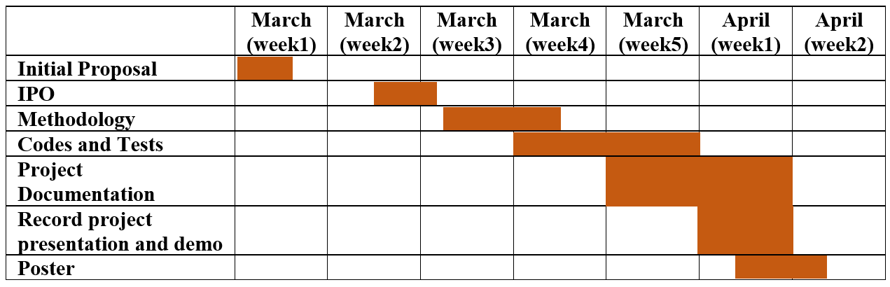

Initial Proposal – All members

IPO – Drapiza and Montemayor

Methodology – Carrillo

Codes and Tests – All members

Project Documentation paper - All members

Record project presentation and demo – Drapiza and Carillo

Poster – Montemayor

**References**

Cite the resources that will be used for the project.

[Rock, Paper, Scissors, Lizard, Spock | The Big Bang Theory Wiki | Fandom](https://bigbangtheory.fandom.com/wiki/Rock,_Paper,_Scissors,_Lizard,_Spock)

[The Official Rules of Rock Paper Scissors - World Rock Paper Scissors Association (wrpsa.com)](https://wrpsa.com/the-official-rules-of-rock-paper-scissors/)