Week 5

**1# Write a C++ program to enter elements in the array and display the array elements.**

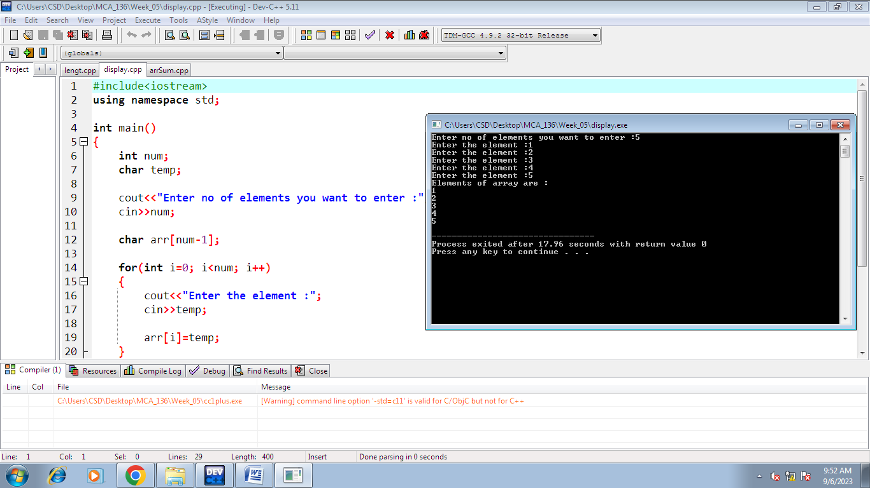

**2# Write a C++ program to find the sum of the all-array element.**

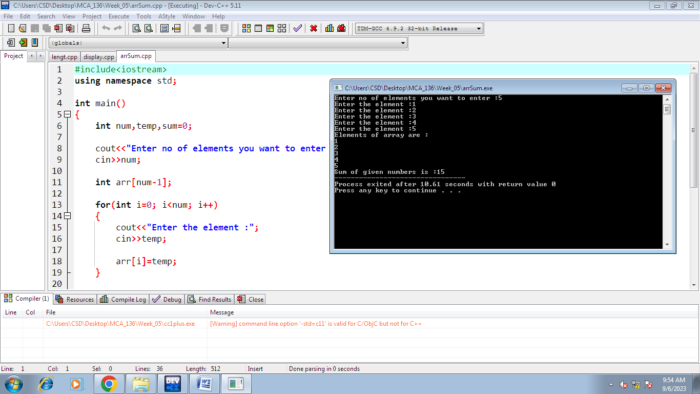

**3# Write a C++ program to find the length of the array.**

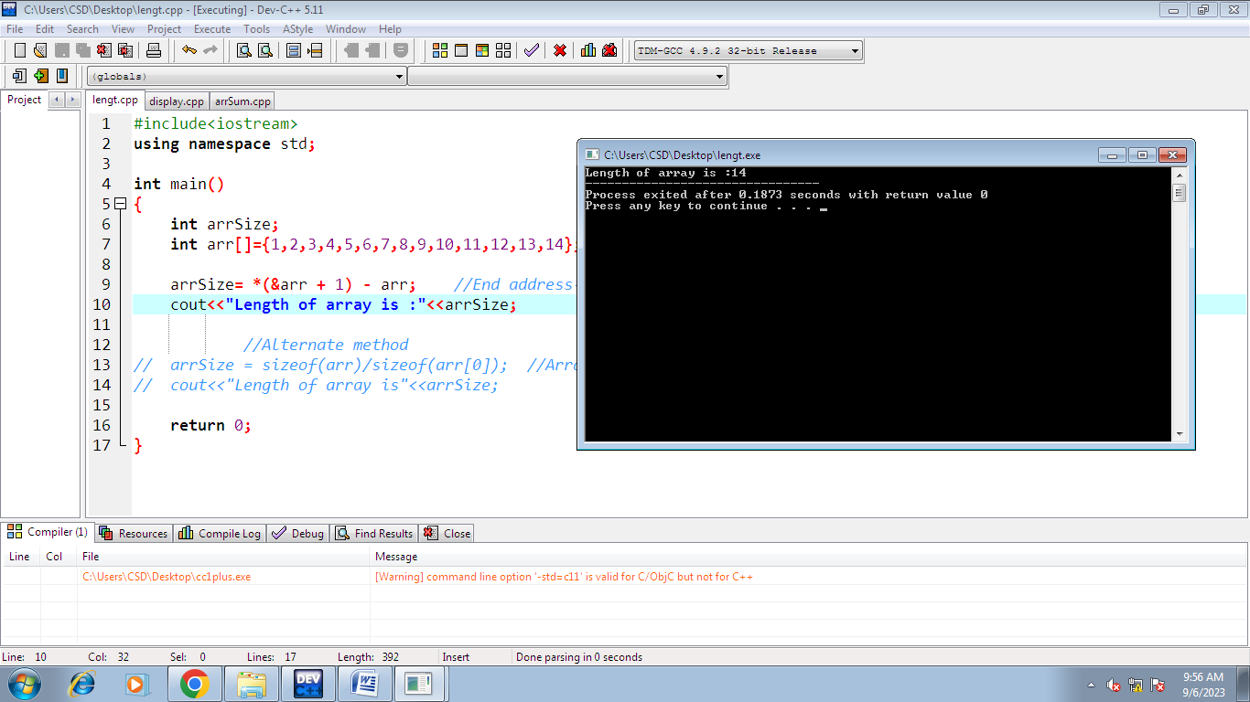

**4# Write a C++ program to find the second-largest integer in a list of integers.**

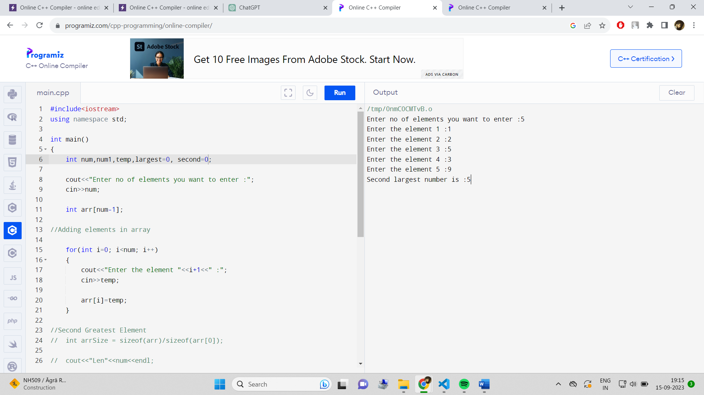

**5# Write a C++ Program to reverse the position of the array element (Hint: First eminent to the last element.)**

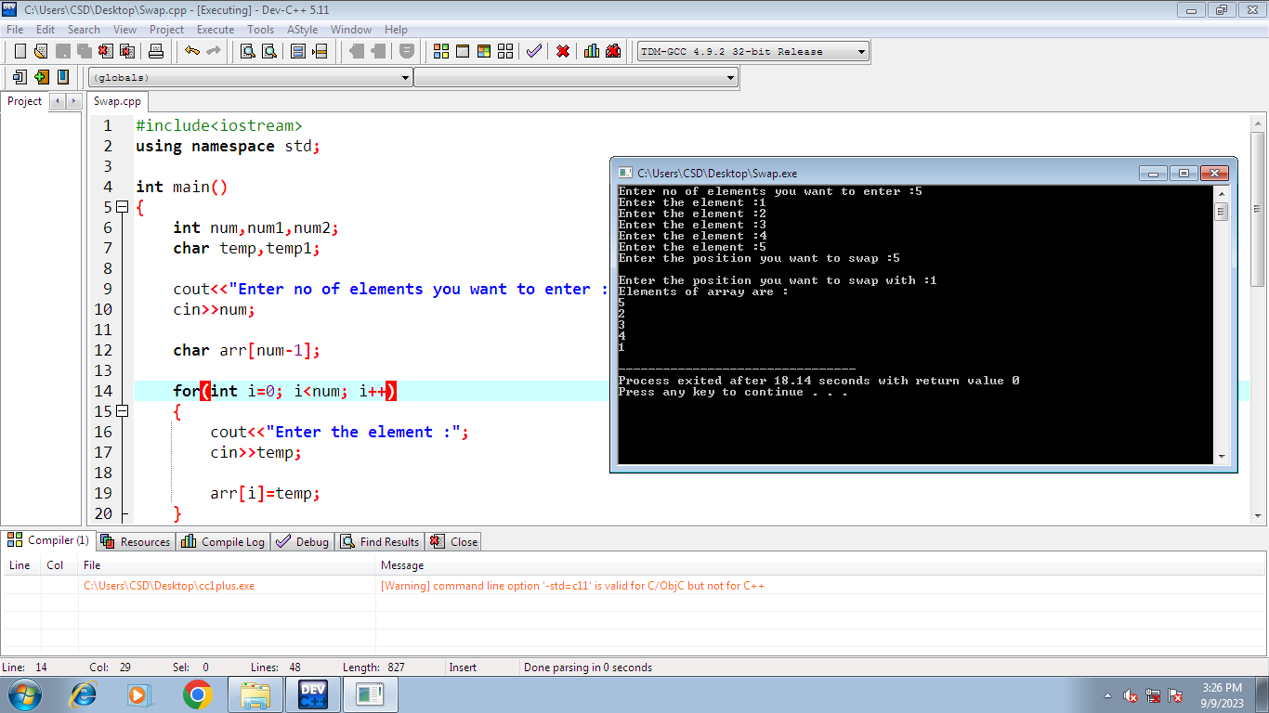

**6# Write a C++ program to perform the following: a. Addition of two matrices b. Multiplication of two matrices**

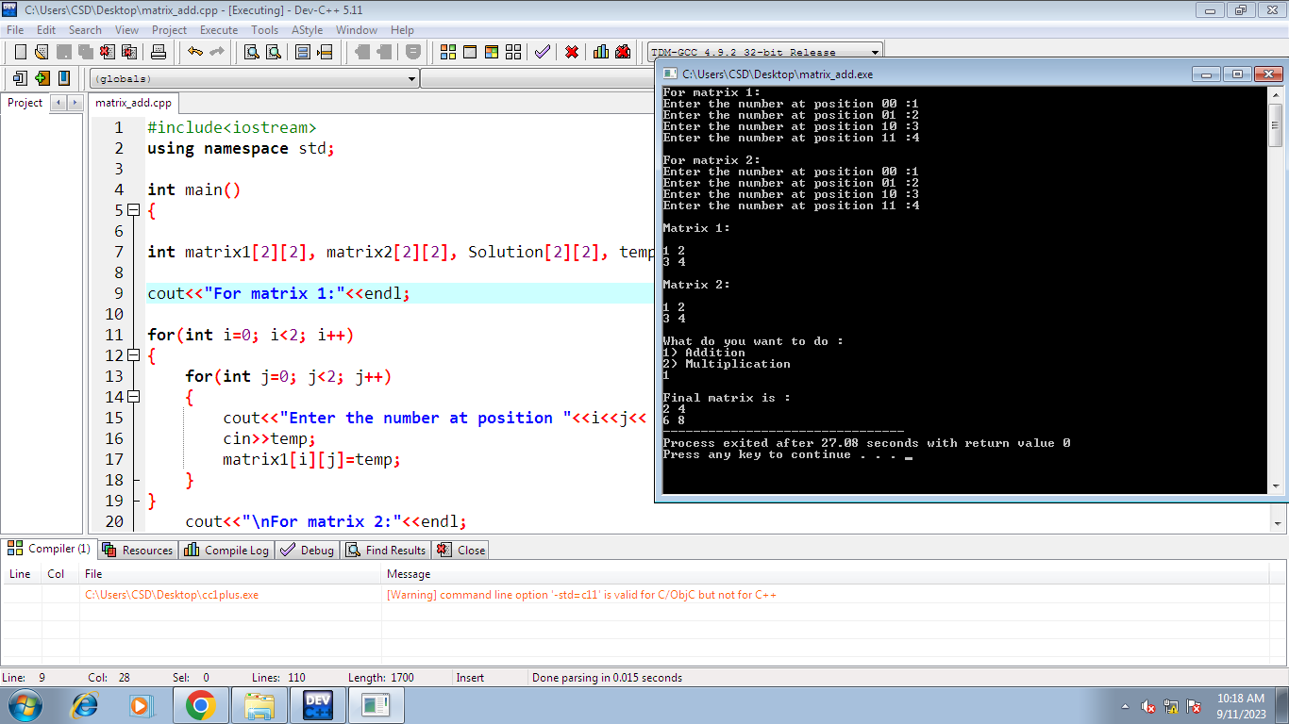

**7# Write a C++ program to count and display positive, negative, odd and even numbers in an array.**

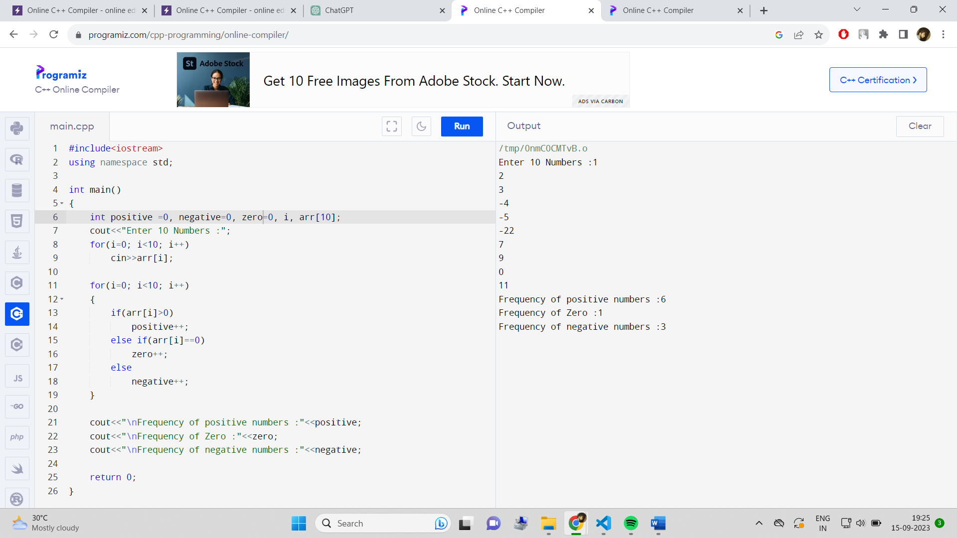

**8# Write a C++ program to merge two sorted arrays into another array in sorted order**.

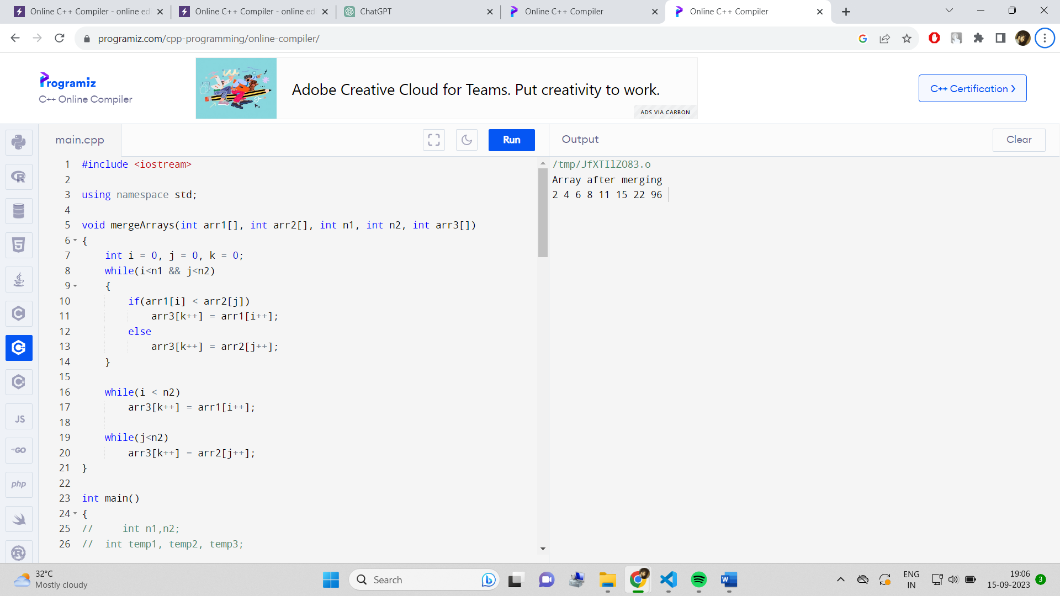

**9# Write a C++ program to find the frequency of a particular number in a list of integers.**

