Data mining 4th Report  
(Student Number: 1651046, Name: Daiki Kubo)

Practice "Decision Tree", "Random Forest" and "Naive Bayes Classifier" using 3 different data and tools of your choice (R or other) and make some reports within maximum 6 pages (3 sheets).

**Answer.**

1. Decision Tree (tool: python, data: iris dataset)

Source Code

----------------------------------------------------------------------------

#coding:utf-8

from sklearn.datasets import load_iris

from sklearn import tree

from graphviz import Digraph

from sklearn.externals.six import StringIO

import pydot

def main():

# iris dataset

iris = load_iris()

# make a model (decision tree)

dtc = tree.DecisionTreeClassifier(max_depth=3)

dtc = dtc.fit(iris.data, iris.target)

# output

dot_data = StringIO()

tree.export_graphviz(dtc, out_file=dot_data,

class_names=iris.target_names,

feature_names=iris.feature_names)

graph = pydot.graph_from_dot_data(dot_data.getvalue())

print graph

# visualization with a graph

graph[0].write_pdf("graph.pdf")

if __name__ == '__main__':

main()

----------------------------------------------------------------------------

Result

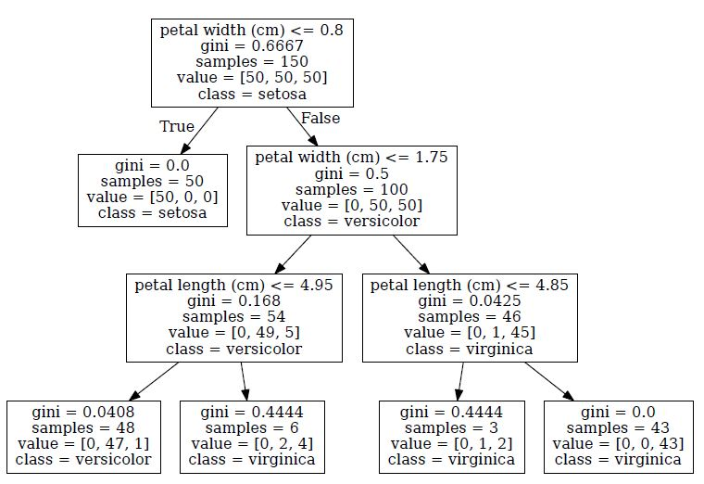

1. Random Forest (tool: python, data: mnist dataset)

Source Code

----------------------------------------------------------------------------

#coding:utf-8

import numpy as np

from sklearn.datasets import fetch_mldata

from sklearn.ensemble import RandomForestClassifier

from sklearn.metrics import classification_report

from sklearn.metrics import accuracy_score

def main():

# load the data

mnist = fetch_mldata('MNIST original')

mnist.data = mnist.data.astype(np.float32)

mnist.data /= 255

mnist.target = mnist.target.astype(np.int32)

N = 60000

x_train, x_test = np.split(mnist.data, [N])

y_train, y_test = np.split(mnist.target, [N])

# learn

rfc = RandomForestClassifier()

rfc.fit(x_train, y_train)

# test

x_test, y_test

pred = rfc.predict(x_test)

print "classification report"

print classification_report(y_test, pred, target_names=map(str, range(10)))

print "accuracy"

print accuracy_score(y_test, pred)

if __name__ == '__main__':

main()

----------------------------------------------------------------------------

Result

classification report

precision recall f1-score support

0 0.95 0.99 0.97 980

1 0.99 0.99 0.99 1135

2 0.92 0.96 0.94 1032

3 0.92 0.93 0.93 1010

4 0.94 0.95 0.95 982

5 0.94 0.93 0.93 892

6 0.97 0.96 0.96 958

7 0.97 0.95 0.96 1028

8 0.94 0.90 0.92 974

9 0.95 0.92 0.93 1009

avg / total 0.95 0.95 0.95 10000

accuracy

0.9482

1. Naive Bayes Classifier (tool: python, data: digits dataset)

Source Code

----------------------------------------------------------------------------

#coding:utf-8

from sklearn import datasets

from sklearn.naive_bayes import GaussianNB

def main():

# load the data

digits = datasets.load_digits()

# make a model

gnb = GaussianNB()

y_pred = gnb.fit(digits.data, digits.target).predict(digits.data)

print("Number of mislabeled points out of a total %d points : %d"

% (digits.data.shape[0],(digits.target != y_pred).sum()))

if __name__ == '__main__':

main()

----------------------------------------------------------------------------

Result  
 Number of mislabeled points out of a total 1797 points : 255