7003SCN Software Project Portfolio Report
Team Members
Name: (full name) / SID: (Your student ID number) (Team member 1)
Name: ADETUNJI MARVELLOUS OLUWAFERANMI / SID: 17181802 (Team member 2)
Name: OPEYEMI CALEB AKOKI / SID: 16980763 (Team member 3)
Name: (full name) / SID: (Your student ID number) (Team member 4)
Name: Ijeoma Chiedozie Desmond / SID: 17365424 (Team member 5)

Declaration of Originality:
As listed in one of the members above, I confirm that the individual components in this report are solely my own work and signed off by myself, in fulfilment of the requirements of my course and the Chartered Management Institute (CMI) Level 7 Certificate award.

Table of Contents
Table of Figures
Table of Tables
Introduction
- Software project leadership and entrepreneurship (group evaluation)
  - Agile approach to project management and leadership, project risks, social, legal, and ethical considerations
1.1.1 Scrum Framework

Scrum is described as a methodology that is fundamentally different from existing approaches:
- Management is led by the “Product Manager”.

- Development Teams are small, cross-functional teams of between three and six people.

- The Sprints phase is an empirical process.

The finality of the deliverable(s) of the “Sprints” phase is explicitly left open. (Remember to reference: Scrum: A Brief History of a Long-Lived Hype)

“Sprints are used to evolve the final product. […] Iterative Sprints, until the product is deemed ready for distribution.” (Remember to reference by Gunther Verheyen, December 2020 ).

In the Scrum framework, there are very important processes that drive Scrum or have driven the methodology to produce the excellent results it has over the years in software development, and they include:

- Scrum Meeting: a short daily team meeting (same time and place). This process involves the Ticket flow team discussing what they have completed, what they will work on next, and anything blocking their progress.

- Sprint: A fixed period in which selected work is completed. For example, the Ticket Flow team chooses some backlog items, such as Login and Event Creation, and spends the Sprint designing, coding, testing, and completing them.

- Backlog: Prioritized list of work that needs to be done: In this case, the Ticket Flow team lists features such as Login, Admin Portal, Event creation, and Reports, then prioritizes them.

- Scrum Master: a team leader who helps Scrum run effectively, helping team members and resolving blocks.

- Scrum Team: a self-organized team structure to produce and effectively build a useful deliverable in a Sprint: Developers, designers, testers, and other necessary specialists collaborate to produce the working software increment of “TicketFlow”.

1.1.2 Evaluation of Agile Approach
1.1.3 Project Risk Analysis
The team of five developers with mixed experience levels faced material risks developing TicketFlow in a fixed 6-week sprint on an unfamiliar stack (MongoDB transactions, Server-Sent Events, cryptographic token handling, and AI-assisted features). Three risk categories emerged: team/collaboration risks, schedule/resource risks, and product/technical risks.

Team & Collaboration Risks
The skill disparity and the communication breakdown were the main risks for the team. Two developers had no experience with MongoDB; none had built real-time systems with SSE; only one had experience with cryptographic operations. This was mitigated through pair programming on critical paths (database transactions, authentication), two 1-week spikes exploring unfamiliar technology before sprint commitment, and a code review standard requiring inline annotations explaining why concurrency-critical code is necessary. Before the merge, all authentication and payment logic was vetted by one dedicated member with more knowledgeable experience.

Schedule & Resource Risks
The core scheduling risk was building five advanced features (concurrent inventory control, real-time dashboards, cryptographic tokens, anomaly detection, and NL query parser) in six weeks with a learning curve on each. This was mitigated through the use of the MoSCoW prioritisation technique: MUST-have features (ticketing, check-in, basic RBAC) were locked in; SHOULD-have features (live dashboard, guest import) were completed; COULD-have features (anomaly detector and NL parser) were built with acknowledged limitations; and WON'T features were ignored. Each feature had a merge deadline to prevent indefinite tweaking, and "Definition of Done" included unit tests, integration tests, and code review sign-off (Wikipedia contributors, 2026).

Product & Technical Risks
Concurrency correctness, security, and audit integrity were the highest-impact risks. Sequence diagrams explicitly modelled the race conditions in oversell and double-admission scenarios before code was written. MongoDB replica set (required for transactions) was enforced in development (docker-compose.yml), so developers tested against production-equivalent infrastructure. Explicit concurrency tests (TC-CONC-01, TC-CONC-02) fired two concurrent operations and verified exactly one succeeded; load testing with k6 simulated 50 concurrent buyers and confirmed no oversell.

Security vulnerabilities (token guessing and fake webhooks) were mitigated through a code review checklist (cryptographic RNG, timing-safe comparison, and no hardcoded secrets) and unit tests verifying timing-side-channel resistance. Audit trail integrity was protected by writing audit logs inside the same transaction as status changes; all-or-nothing semantics ensure every admission/revocation is recorded or the entire operation rolls back. Memory leaks from unbounded SSE listeners were prevented through explicit cleanup on socket close and a memory profile test.

1.1.4 Social, Legal, and Ethical Considerations
The development of TicketFlow was guided by rigorous social, legal, and ethical standards, aligning with the British Computer Society (BCS) Code of Conduct to ensure public interest and data integrity were prioritised (BCS Code of Conduct, n.d.).

Legal Considerations
Strict adherence to the General Data Protection Regulation (GDPR) was fundamental to the platform's architecture. A comprehensive data retention and erasure sweep was implemented, automating the removal of legacy user data to guarantee the "right to be forgotten" (Art. 17 GDPR – Right to Erasure (‘Right to Be Forgotten’) - General Data Protection Regulation (GDPR), 2017). Additionally, financial security was legally safeguarded by offloading card processing to Paystack. By explicitly rejecting client-reported payment statuses and exclusively relying on server-side HMAC-SHA512 webhook verification, the system mathematically guarantees transaction authenticity and protects users from spoofing (ICO, n.d.).

Figure
Paystack HMAC webhook verification function
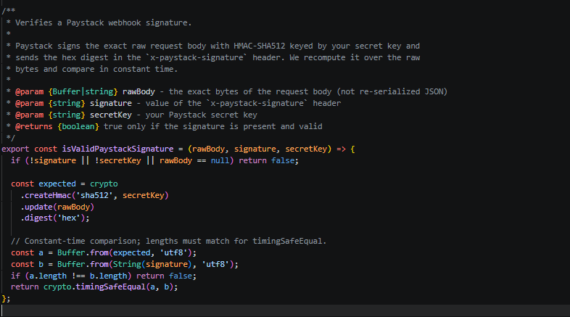

Social Considerations
To fulfil our social obligation of digital inclusivity, the Next.js frontend was subjected to a targeted accessibility audit. New UI components were validated against WCAG 2.2 AA standards. This ensures that users relying on screen readers or keyboard navigation can seamlessly access the event discovery platform and invite-only checkout flows without systemic barriers (Web Content Accessibility Guidelines (WCAG) 2.2, 2024).

Figure
Lighthouse accessibility score
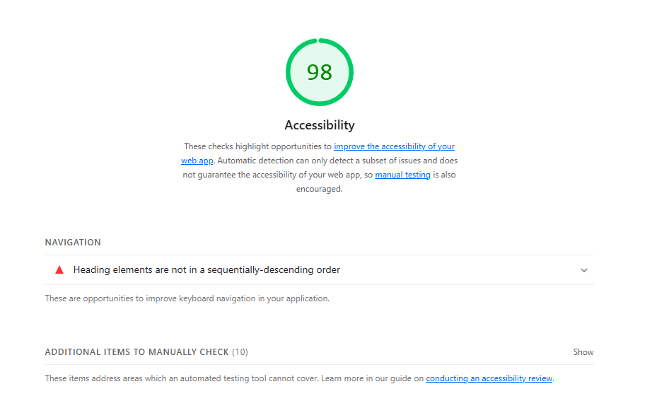

Ethical Considerations
The integration of machine learning—specifically the no-show predictor and scan-anomaly detector—introduces ethical risks regarding algorithmic bias and opaque decision-making. To ensure ethical transparency, the platform utilises an immutable AuditLog collection that records every QR scan outcome (success or rejection). This audit trail feeds the anomaly detector but also ensures human door staff can override AI-flagged anomalies, preventing unfair denial of entry (AI Act, 2026). Furthermore, the performance of the scikit-learn model was rigorously evaluated for precision, recall, and F1 scores to ensure the algorithm does not disproportionately penalise specific user demographics.

Figure
The evaluation report for the ‘no-show prediction’ feature
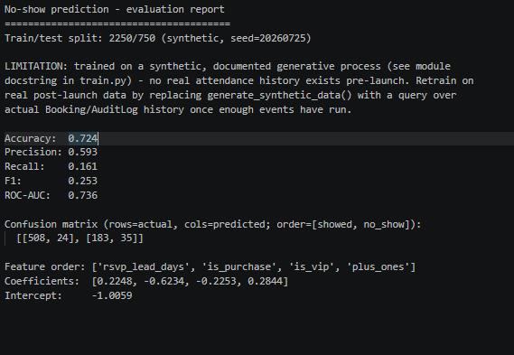

1.1.5 Team Member Contribution

Name | Role | Contributions
Marvellous Adetunji | Frontend Developer | Led the development of the frontend web application. Implemented the client-side secure Paystack payment flow, built the real-time Server-Sent Events (SSE) live arrivals dashboard, managed lightweight custom state stores, and executed UI/theme polishing.
Olasubomi Abiola | UI/UX& Tester | Designed the user interface and experience flows. Ensured the platform components successfully passed the WCAG 2.2 AA accessibility audits and optimized the user journey for the invite-only guest management and ticket discovery features.
Opeyemi Akoki | DevOps Engineer | Engineered the Docker Compose infrastructure, including the critical single-node MongoDB replica set required for transactions. Configured GitHub Actions CI pipelines and Playwright E2E test environments.
Ofejiro Ederhi | Backend Developer | Architected the layered backend and unified Mongoose models. Implemented atomic database transactions for race-proof door check-ins, built the server-side HMAC-SHA512 Paystack webhook verification, and integrated the AI/ML pipelines.
Desmond Ijeoma | Project Manager | Facilitated the agile development approach and phase-by-phase execution. Managed the GDPR retention/erasure sweeps, documented project risks, and ensured feature alignment with the module's entrepreneurship and complexity grading criteria.

1.1.6 Market Research

The UK event ticketing industry presents a massive commercial opportunity, with live music alone recently generating £6.68 billion and 23.1 million ticket sales, a figure that excludes a vastly broader market of sports, conferences, and community gatherings (UK Live Music Industry Statistics | 2026 Edition, n.d.). Despite the presence of established competitors like Eventbrite and Ticketmaster, organisers and attendees continue to face significant friction, including exorbitant booking fees, opaque pricing, ticket fraud, and slow payouts. TicketFlow addresses these critical market gaps by providing a highly reliable and flexible platform for in-person, online, and hybrid events. Competing on simplicity and transparent pricing, the system features seamless event creation, secure QR-code ticket validation, and live attendance analytics. To ensure a trustworthy experience and mitigate inherent industry risks like cybersecurity threats and payment disputes, TicketFlow is fortified with strict GDPR compliance, robust organiser verification, and secure payment processing.

Figure
Competitor comparison: TicketFlow's advantages
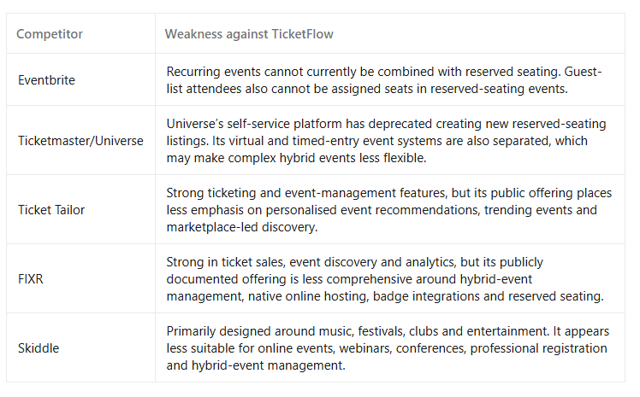

  - Software artefacts
This section reports on the significant work completed by the team across design, implementation, and testing of TicketFlow — an event ticketing platform built with robust guest management capabilities, enabling live door check-in, audit logging, and AI-assisted operations. The system brings together paid ticket sales and invite-only guest admissions under a single unified admission model, supported by real-time event dashboards and anomaly detection for operational security.

Technical Stack: The technical stack comprises Node.js, Express.js, MongoDB, and Mongoose for the backend, and Next.js with TypeScript for the frontend.

    - Design
Architecture Overview
The backend implements a multilayered architecture that enforces separation of concerns at the code level, making business logic testable without HTTP or database dependencies, and preventing the common anti-pattern of mixing persistence, business rules, and HTTP concerns in a single code path.

Figure
TicketFlow’s layered Architecture
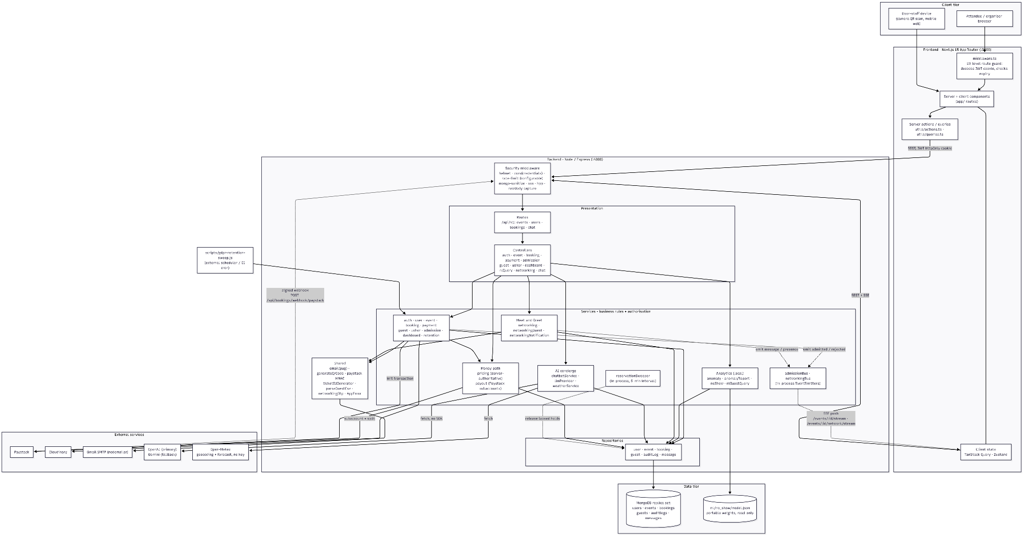

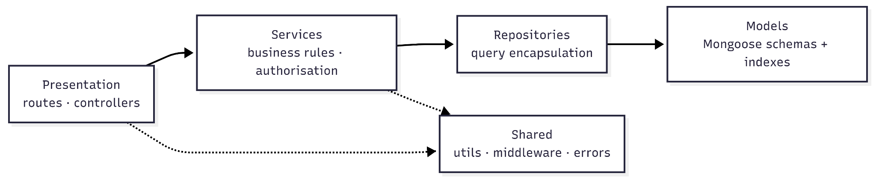

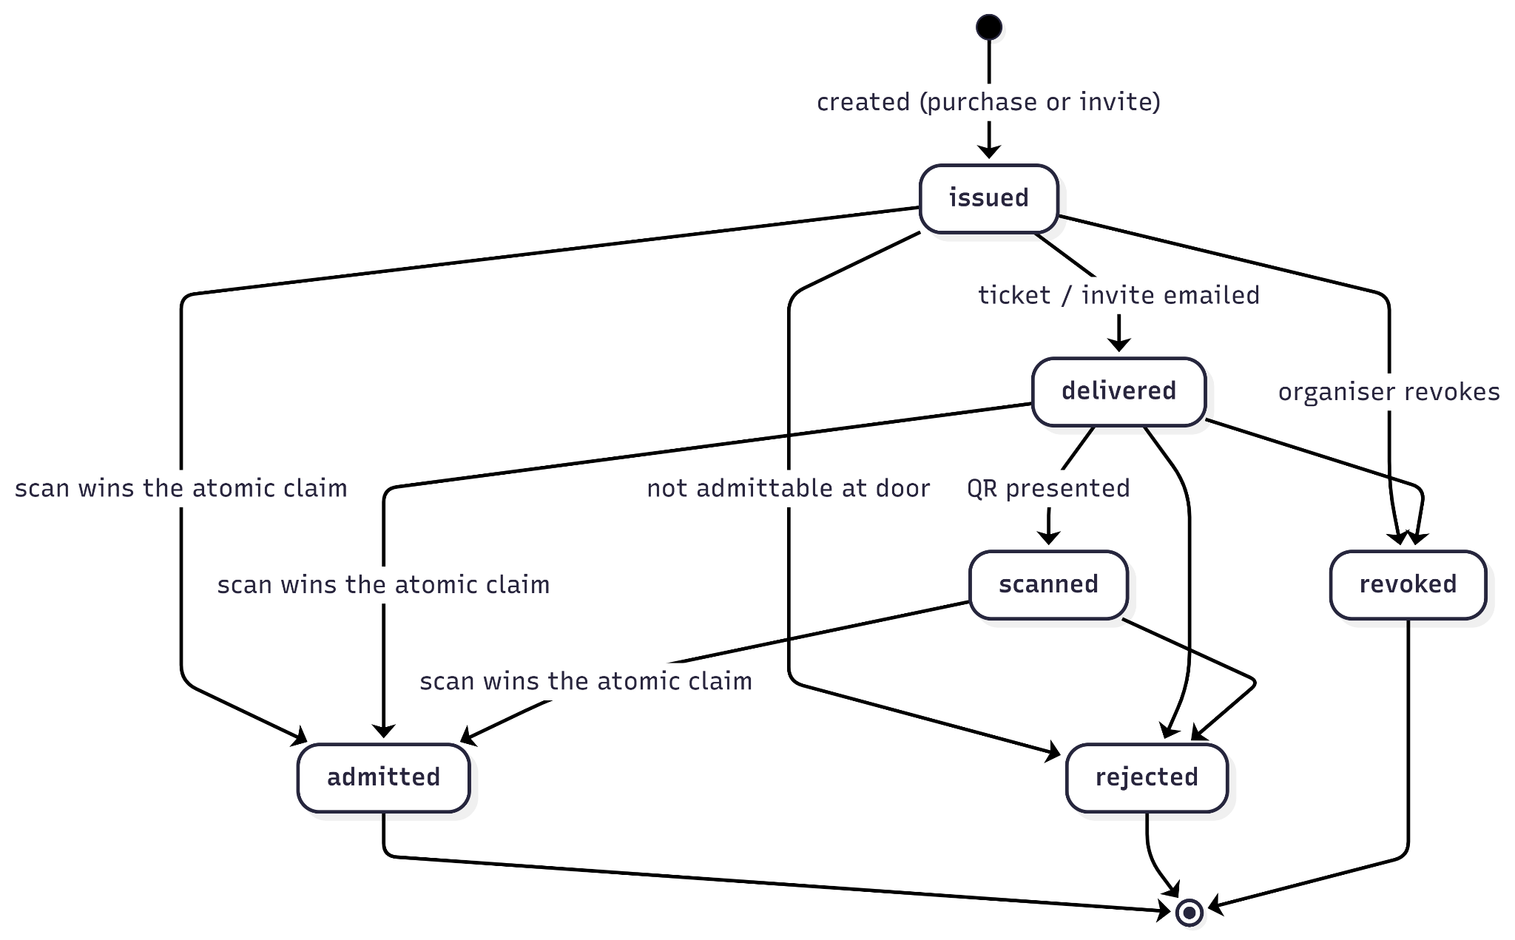

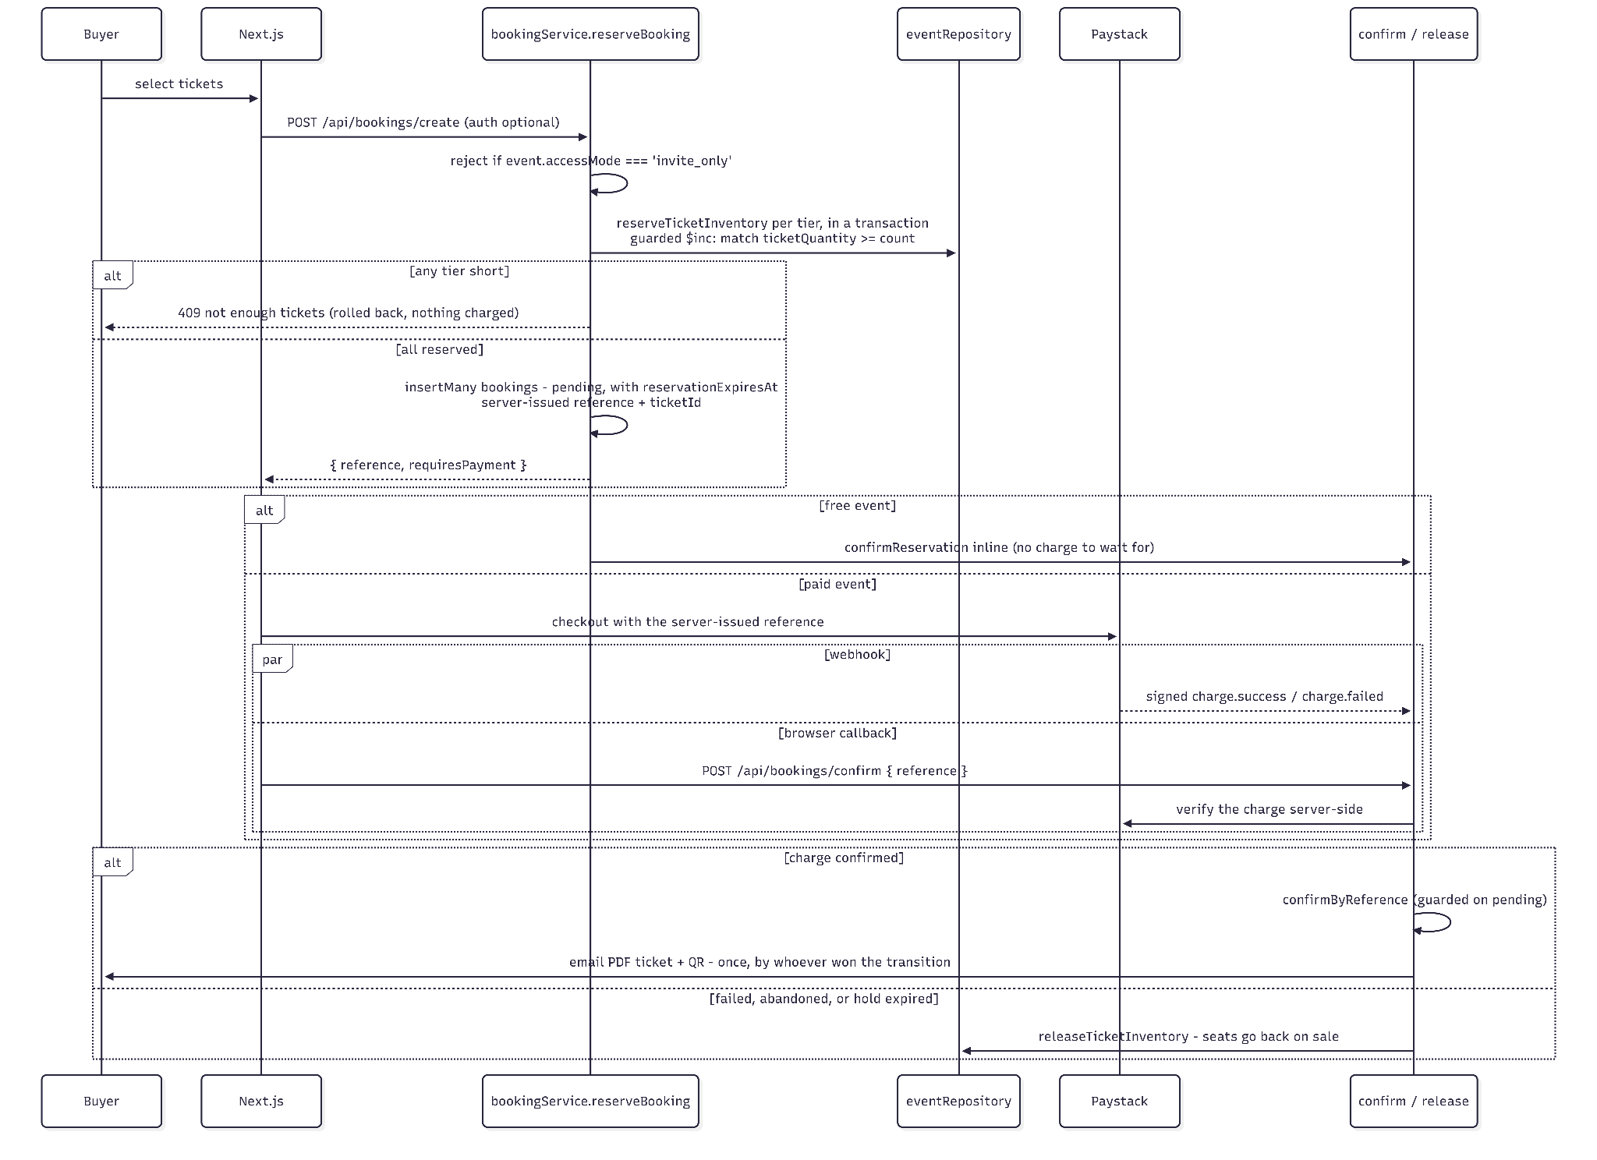

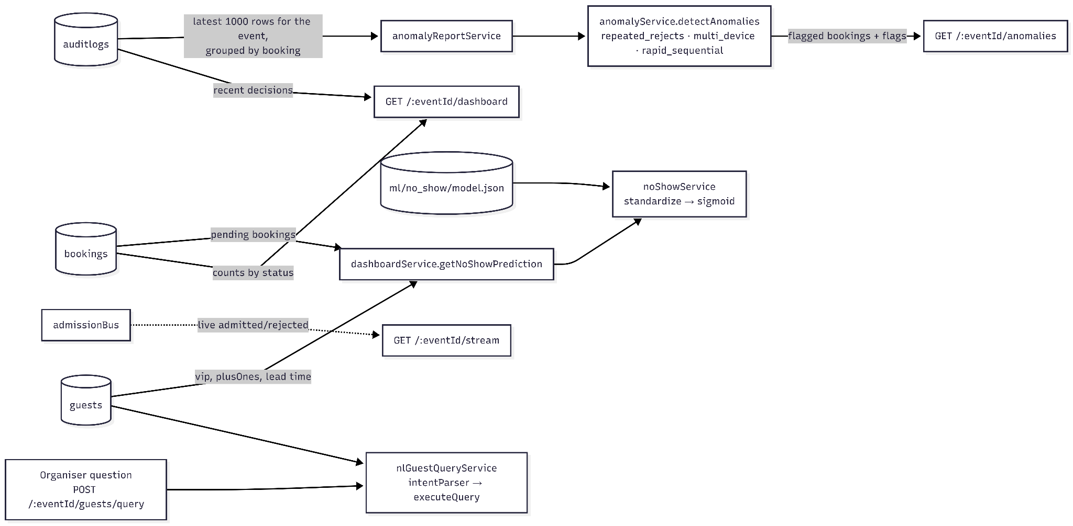

This layering addresses maintainability (modularity and code reusability), reliability (testability without external dependencies), and security (centralised authorisation checks in a single layer, not scattered across controllers).

Data Model

Figure
TicketFlow’s data model
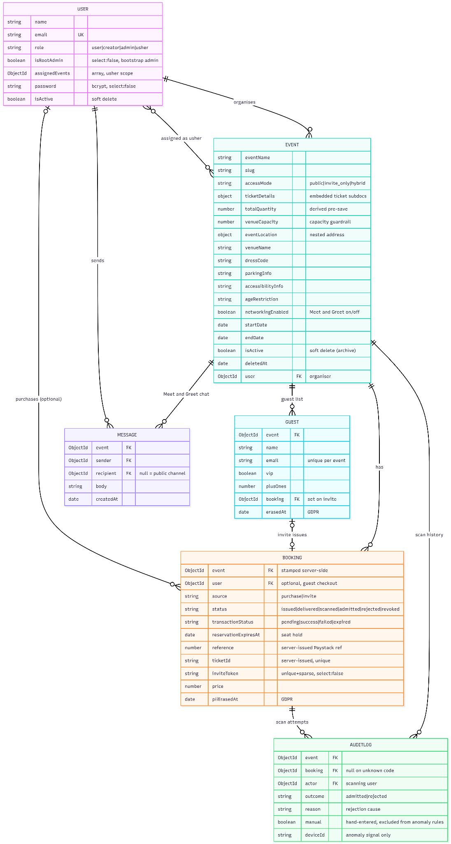

Entity-Relationship Diagram
Figure
TicketFlow’s entity-relationship diagram

Domain Class Model
A UML class diagram showing entities and their relationships at the business-logic level:
Figure
TicketFlow’s domain class model

Use Cases & Actors
Figure
TicketFlow’s use case diagram
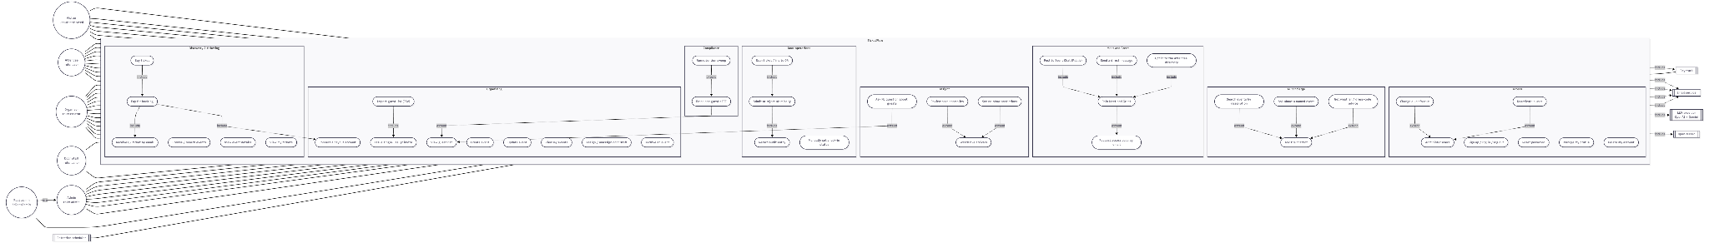

    - Implementation

This section examines the fundamental features that illustrate how TicketFlow was built. Attendees browse events and purchase tickets via a reserve-then-pay-then-confirm flow where inventory is held atomically, ensuring buyers are never charged without a guaranteed ticket. Organisers can choose public ticketed, invite-only, or hybrid access modes, which the system unifies under a single admission model for identical check-in handling at the door. Behind this simplicity, a strict four-layer architecture (Presentation → Service → Repository → Model) is enforced: controllers parse HTTP input for services, services orchestrate business logic inside transactions, repositories encapsulate database queries, and models handle schema validation. This clear separation ensures that business logic remains fully testable without HTTP or database dependencies.

Figure
createBooking() showing HTTP parsing and delegation to service
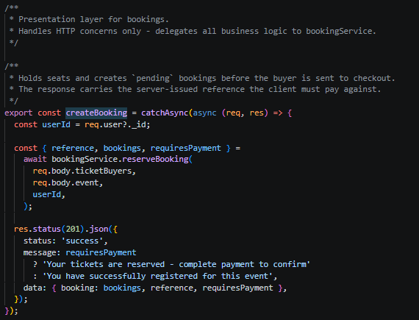

Figure
bookingService.js showing reserve-confirm flow with transaction orchestration
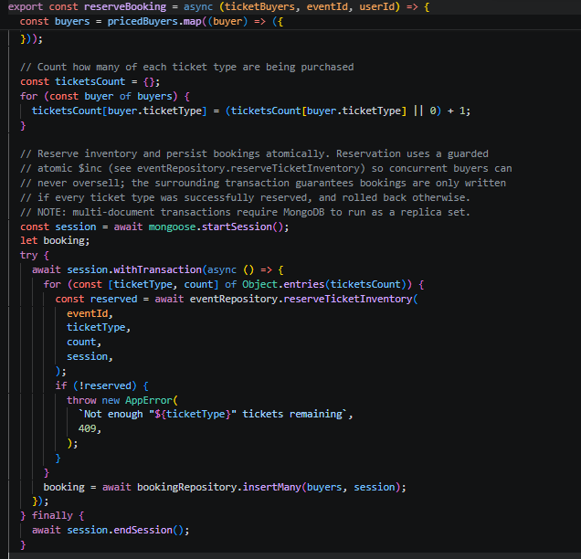

Figure
bookingRepository.js showing clean data-access interface
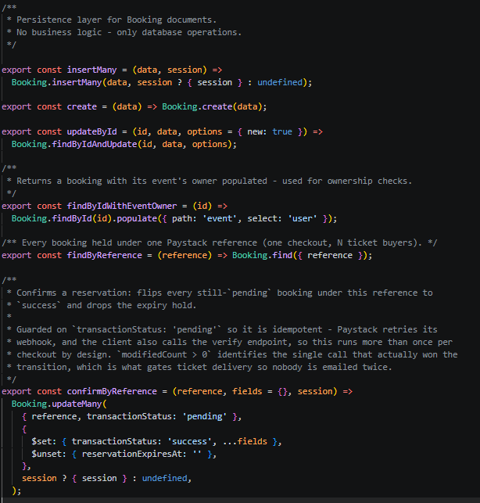

Figure
bookingModel.js showing Event and Booking schemas with conditional validators
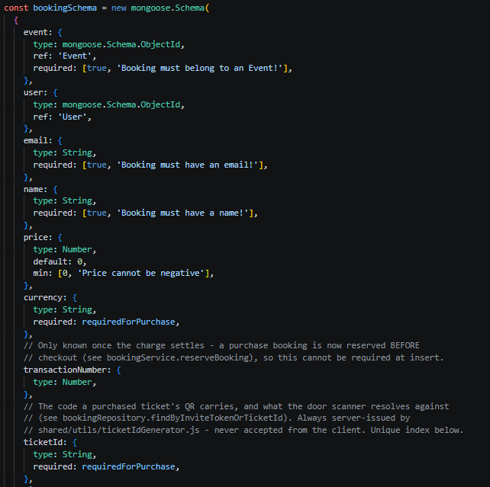

TicketFlow ensures race-free ticket inventory by executing MongoDB guards ($gte) and decrements ($inc) in a single atomic operation, eliminating read-then-write gaps during simultaneous purchases. This guarded atomic update pattern is replicated for single-use door admissions: a booking's status updates from {issued, delivered, scanned} → admitted only if the current state matches. Concurrent scans find the status is already 'admitted' and are rejected with HTTP 409. Concurrency tests simulating simultaneous operations against limited resources prove both patterns are race-free.

Figure
eventRepository.reserveTicketInventory() with $elemMatch guard and $inc
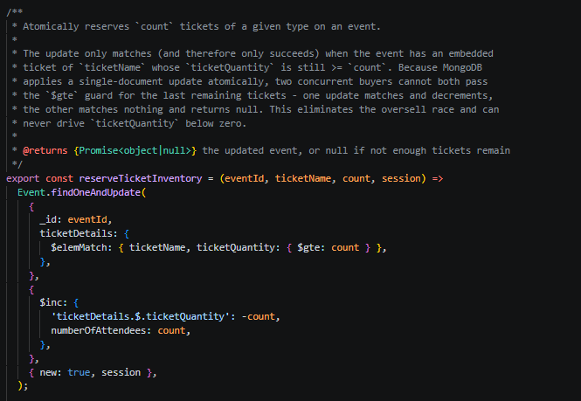

Figure
bookingService.reserveBooking() showing session.withTransaction() wrapper
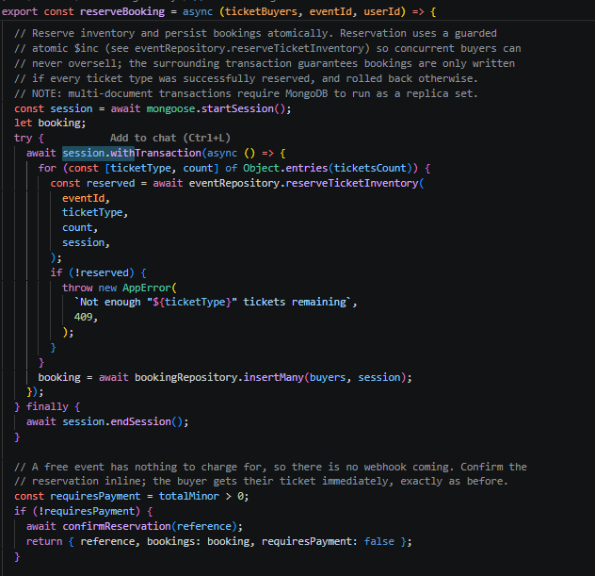

Figure
bookingRepository.admitById() with conditional status guard
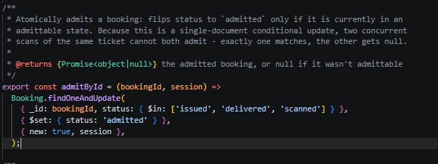

Figure
admissionService.checkInByScan() full transaction scope including audit log write
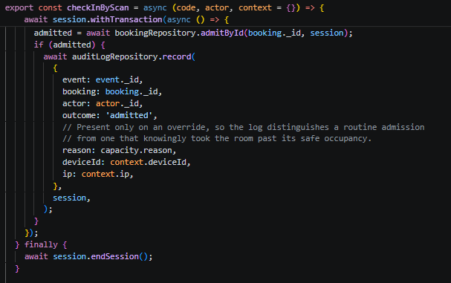

Real-time visibility is delivered through Server-Sent Events (SSE): when door staff admit a guest, admissionService emits an event that reaches only the authorised organiser's dashboard with no page refresh. SSE listeners are cleaned up explicitly when browser connections close (req.on('close') removes the listener and clears the heartbeat interval), preventing a memory leak.

Figure
dashboardController.streamEvent() showing SSE headers, snapshot, listener setup with per-event filter, heartbeat, and cleanup
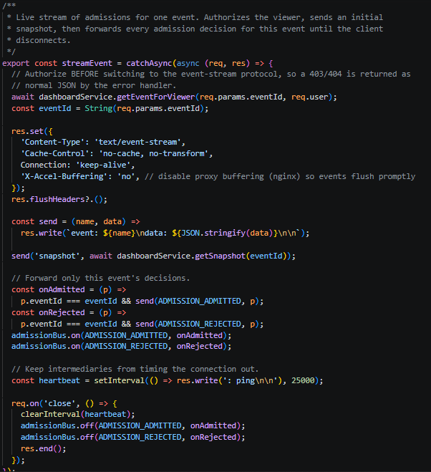

Figure
Dashboard page showing guest data being fetched and updated in real time 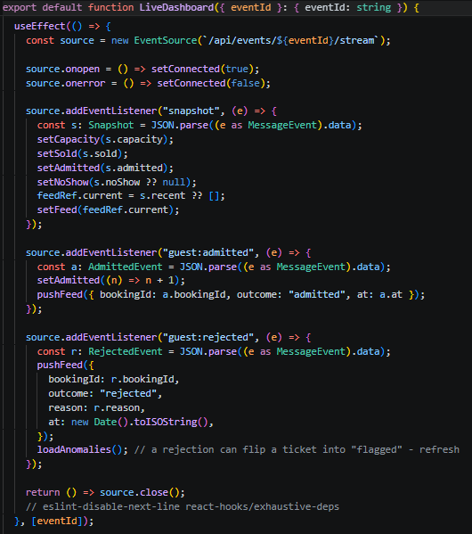

Figure
Memory leak test with heap sampling before/after 20 connections
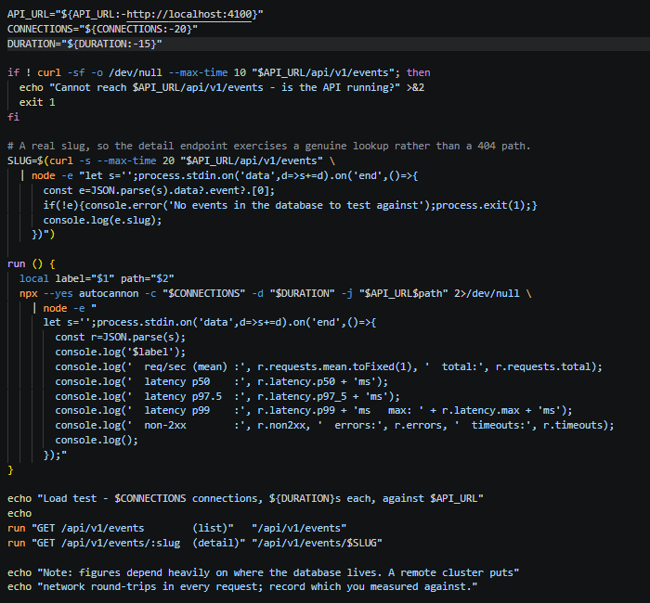

Invite tokens are generated using crypto.randomBytes(24) instead of Math.random(), and Paystack webhooks are verified by recomputing HMAC-SHA512 over the raw request body via crypto.timingSafeEqual() to prevent timing side-channels. Unit tests confirm signature correctness and timing safety across both execution paths.

Figure
inviteToken.js using crypto.randomBytes
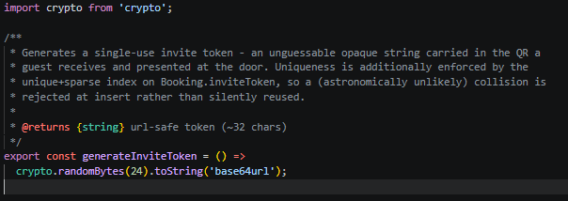

Figure
paystack.js isValidPaystackSignature() with HMAC and timingSafeEqual
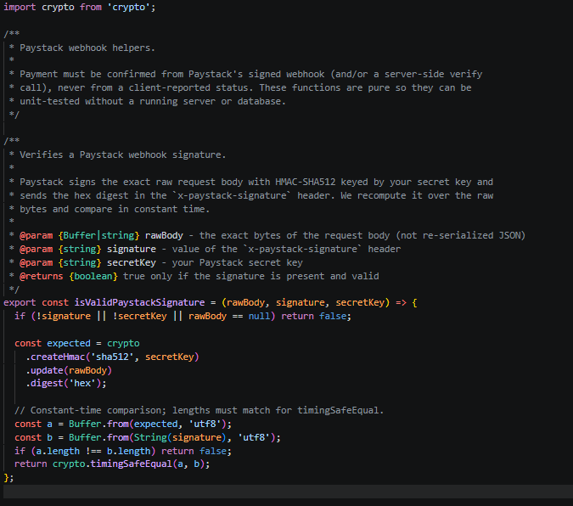

Figure
Timing-safe verification unit test
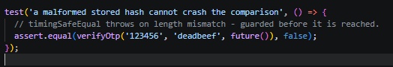

The data model unifies paid purchases and organiser invites under one Booking collection rather than two parallel collections, eliminating dual-write consistency bugs. This normalisation is enforced at the schema level: fields like transactionNumber are mandatory only for purchased bookings (via conditional validator required: [function isPurchase() { return this.source === 'purchase'; }]), and invite-only events cannot be saved with sales dates—making invalid states literally unrepresentable.

Figure
bookingModel.js conditional validator for purchase-only fields
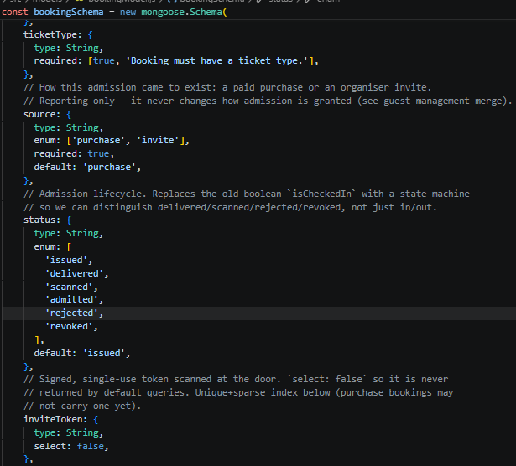

Figure
eventModel.js conditional validator for ticketed events
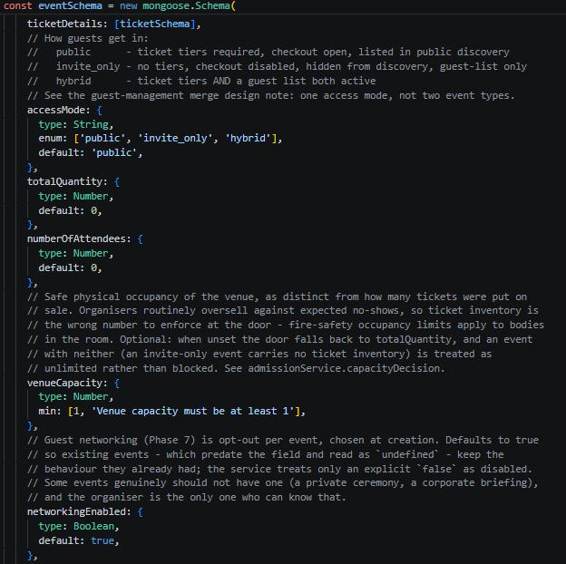

The system utilises comprehensive inline comments, ESLint rules to block direct Mongoose controller calls, unit testing for pure functions, integration testing with real MongoDB for transactions and concurrency, and Playwright end-to-end workflows. Every pattern aligns with ISO 25010 quality attributes: concurrency and schema constraints guarantee Reliability, cryptography guarantees Security, a layered architecture guarantees Maintainability and Testability, and transactional logging guarantees Compliance.

    - Testing
Usability was tested empirically against ISO 9241-11 (effectiveness, efficiency, satisfaction) using five participants — one Attendee, one Organiser, one Door staff — each completing a realistic task on the dev build.

[SCREENSHOTS — task tables; SUS scoring; results summary; defect log; before/after fix]

Satisfaction used the standard SUS instrument (Brooke, 1996) plus per-task SEQ ratings. The highest-severity defect found was fixed and re-tested, closing the ISO 9241-210 design loop. Accessibility (WCAG 2.2 AA) was assessed separately, scoped honestly to the components actually modified.

- Software project leadership and entrepreneurship (individual evaluation)
  - Principles and practice of leadership and people development
(Guideline: The following sub-sections should be completed by each of the team members as an individual and be signed off by the respective individual team members with their full names. You are advised that each member should focus on different aspects to report on in relation to your own project group work, to avoid repetition and plagiarism. The word count guidance for each team member in this section is 1,750 words excluding the appendix A. Please also see the Assessment Marking Criteria in the assignment brief for details. Please remove the redundant sections below, if you have less than 5 members in the team.)
    - The influence of leadership, culture and development on performance
    - The strategies which promote engagement and wellbeing as an enabler of individual and team performance
    - The leadership development strategy which values people whilst optimising team and organisational success
(Guideline: You should include a proposal of leadership development strategy in Appendix A1 which is excluded in the word count.)
By team member 1: (full name)

    - The influence of leadership, culture and development on performance
In traditional hierarchical development models, rigid directive leadership often suppresses developer autonomy, leading to cognitive fatigue and sub-optimal design choices (Northouse, 2021). To optimise engineering throughput during the development of Ticketflow, leadership was carried out through situational leadership rather than a static management style. Situational leadership theory holds that effective leaders vary their approach according to the maturity of those they lead and the demands of the task, rather than applying one style throughout (Greenleaf, 2018).

Figure
The Situational Leadership Model
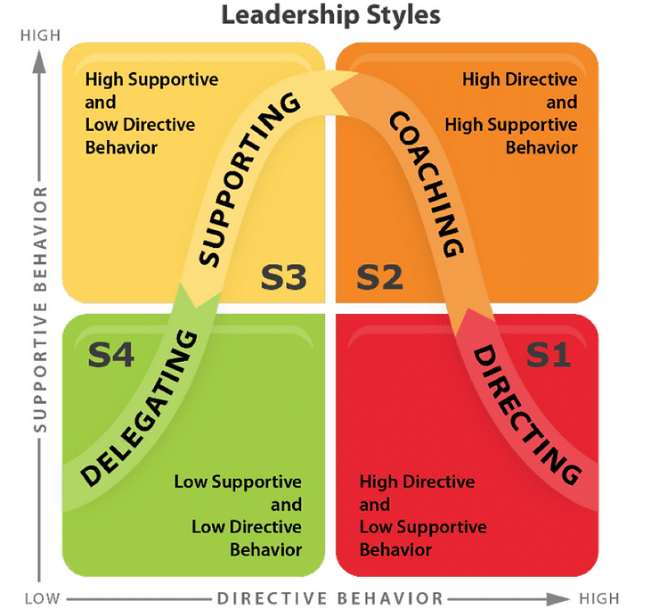
From Parker (2026)

Within our own project, this played out very clearly.

During the initial stages of our development process, when establishing the core monorepo architecture and layered backend pattern, team members exhibited high enthusiasm but low domain-specific knowledge regarding strict architectural constraints. Leadership adopted a highly directive stance, establishing non-negotiable coding conventions and enforcing explicit monorepo directory splits without root ‘package.json’ pollution and mandating raw body capture middleware specifically for HMAC signature verification. This upfront clarity minimised structural technical debt early in the lifecycle.

Implementing the client-side payment system using ‘react-paystack’ met us with several behavioural challenges. The team needed to trigger payment popups successfully without trusting client-side success callbacks, routing the transaction proofs to backend raw-body HMAC endpoints instead. Leadership provided clear structural patterns for asynchronous state transitions while providing continuous feedback during code reviews to build confidence in zero-trust payment workflows

This pattern is not unique to student delivery. CMI's own research into culture and engagement found that communication and a shared sense of belonging were what sustained organisational culture through periods of pressure, with 84% of respondents reporting their culture held up or improved through disruption where these were present (CMI, 2021).

    - The strategies which promote engagement and wellbeing as an enabler of individual and team performance
    - The leadership development strategy which values people whilst optimising team and organisational success
(Guideline: You should include a proposal of leadership development strategy in Appendix A2 which is excluded in the word count.)

By team member 2: Adetunji Marvellous Oluwaferanmi

    - The influence of leadership, culture and development on performance
    - The strategies which promote engagement and wellbeing as an enabler of individual and team performance
    - The leadership development strategy which values people whilst optimising team and organisational success
(Guideline: You should include a proposal of leadership development strategy in Appendix A3 which is excluded in the word count.)

By team member 3: (full name)

    - The influence of leadership, culture and development on performance
    - The strategies which promote engagement and wellbeing as an enabler of individual and team performance
    - The leadership development strategy which values people whilst optimising team and organisational success
(Guideline: You should include a proposal of leadership development strategy in Appendix A4 which is excluded in the word count.)
By team member 4: (full name)

    - The influence of leadership, culture and development on performance
    - The strategies which promote engagement and wellbeing as an enabler of individual and team performance
    - The leadership development strategy which values people whilst optimising team and organisational success
(Guideline: You should include a proposal of leadership development strategy in Appendix A5 which is excluded in the word count.)

By team member 5: (full name)
  - Theoretical concepts and entrepreneurial practice
(Guideline: The following sub-sections should be completed by each of the team members as an individual and be signed off by the respective individual team members with their full names. You should critically evaluate and report on the theoretical concepts and contemporary thinking in entrepreneurial practice of how your idea, from concept to delivery, is developed based on the scenario selected by the team. Consider forms and strategic contexts of entrepreneurial practice and consideration of the following to achieve a successful outcome in this scenario in the target group project scenario. You are advised that each member should focus on different aspects to report on in relation to your own project group work, to avoid repetition and plagiarism. The word count guidance for each team member in this section is 1,750 words excluding the appendix B. Please also see the Assessment Marking Criteria in the assignment brief for details. Please remove the redundant sections below, if you have less than 5 members in the team.)

    - The multi-dimensional issues which impact on entrepreneurial practice
    - Suggestion of ways of overcoming barriers to entrepreneurial practice
(Guideline: This should be related to your group project, using an evidence-based approach. You should include a proposal for a course of action to achieve an entrepreneurial aim in Appendix B1, which is excluded in the word count.)
    - Characteristics and attributes of entrepreneurial leadership for achieving outcomes
By team member 1: (full name)

    - The multi-dimensional issues which impact on entrepreneurial practice
    - Suggestion of ways of overcoming barriers to entrepreneurial practice
(Guideline: This should be related to your group project, using an evidence-based approach. You should include a proposal for a course of action to achieve an entrepreneurial aim in Appendix B2, which is excluded in the word count.)
    - Characteristics and attributes of entrepreneurial leadership for achieving outcomes
By team member 2: Adetunji Marvellous Oluwaferanmi

    - The multi-dimensional issues which impact on entrepreneurial practice
    - Suggestion of ways of overcoming barriers to entrepreneurial practice
(Guideline: This should be related to your group project, using an evidence-based approach. You should include a proposal for a course of action to achieve an entrepreneurial aim in Appendix B3, which is excluded in the word count.)
    - Characteristics and attributes of entrepreneurial leadership for achieving outcomes
By team member 3: (full name)

    - The multi-dimensional issues which impact on entrepreneurial practice
    - Suggestion of ways of overcoming barriers to entrepreneurial practice
(Guideline: This should be related to your group project, using an evidence-based approach. You should include a proposal for a course of action to achieve an entrepreneurial aim in Appendix B4, which is excluded in the word count.)
    - Characteristics and attributes of entrepreneurial leadership for achieving outcomes
By team member 4: (full name)

    - The multi-dimensional issues which impact on entrepreneurial practice
    - Suggestion of ways of overcoming to entrepreneurial practice
(Guideline: This should be related to your group project, using an evidence-based approach. You should include a proposal for a course of action to achieve an entrepreneurial aim in Appendix B5, which is excluded in the word count.)
    - Characteristics and attributes of entrepreneurial leadership for achieving outcomes
By team member 5: (full name)

Conclusion

Appendices
(Guideline for Appendix A: You are advised that each member should focus on different areas when writing a proposal of development strategy in relation to your group project work, to avoid repetition and plagiarism.)
Appendix A1: The leadership development strategy proposal (team member 1)
(Guideline: The proposal should be included here for Section 2.1 subsections completed by team member 1. The leadership development strategy which values people whilst optimising team and organisational success. The proposal is excluded from the word count.)
By team member 1: (full name)
Appendix A2: The leadership development strategy proposal (team member 2)
(Guideline: The proposal should be included here for Section 2.1 subsections completed by team member 2. The leadership development strategy which values people whilst optimising team and organisational success. The proposal is excluded from the word count.)
By team member 2: Adetunji Marvellous Oluwafernami
Appendix A3: The leadership development strategy proposal (team member 3)
(Guideline: The proposal should be included here for Section 2.1 subsections completed by team member 3. The leadership development strategy which values people whilst optimising team and organisational success. The proposal is excluded from the word count.)
By team member 3: (full name)
Appendix A4: The leadership development strategy proposal (team member 4)
(Guideline: The proposal should be included here for Section 2.1 subsections completed by team member 4. The leadership development strategy which values people whilst optimising team and organisational success. The proposal is excluded from the word count.)
By team member 4: (full name)
Appendix A5: The leadership development strategy proposal (team member 5)
(Guideline: The proposal should be included here for Section 2.1 subsections completed by team member 5. The leadership development strategy which values people whilst optimising team and organisational success. The proposal is excluded from the word count.)
By team member 5: (full name)

(Guideline for Appendix B: You are advised that each member should focus on different areas when proposing an action plan in relation to your group project work, to avoid repetition and plagiarism.)
Appendix B1: The proposal for a course of action to an entrepreneurial aim (team member 1)
(Guideline: The proposal should be included here for Section 2.2 subsections completed by team member 1 for ‘Suggesting ways of overcoming barriers to entrepreneurial practice, using an evidence-based approach including proposing a course of action to achieve an entrepreneurial aim. The proposal is excluded from the word count.)
By team member 1: (full name)
Appendix B2: The proposal for a course of action to an entrepreneurial aim (team member 2)
(Guideline: The proposal should be included here for Section 2.2 subsections completed by team member 2 for ‘Suggesting ways of overcoming barriers to entrepreneurial practice, using an evidence-based approach including proposing a course of action to achieve an entrepreneurial aim. The proposal is excluded from the word count.)
By team member 2: Adetunji Marvellous Oluwaferanmi
Appendix B3: The proposal for a course of action to an entrepreneurial aim (team member 3)
(Guideline: The proposal should be included here for Section 2.2 subsections completed by team member 3 for ‘Suggesting ways of overcoming barriers to entrepreneurial practice, using an evidence-based approach including proposing a course of action to achieve an entrepreneurial aim. The proposal is excluded from the word count.)
By team member 3: (full name)
Appendix B4: The proposal for a course of action to an entrepreneurial aim (team member 4)
(Guideline: The proposal should be included here for Section 2.2 subsections completed by team member 4 for ‘Suggesting ways of overcoming barriers to entrepreneurial practice, using an evidence-based approach including proposing a course of action to achieve an entrepreneurial aim. The proposal is excluded from the word count.)
By team member 4: (full name)

Appendix B5: The proposal for a course of action to an entrepreneurial aim (team member 5)
(Guideline: The proposal should be included here for Section 2.2 subsections completed by team member 5 for ‘Suggesting ways of overcoming barriers to entrepreneurial practice, using an evidence-based approach including proposing a course of action to achieve an entrepreneurial aim. The proposal is excluded from the word count.)
By team member 5: (full name)

References
(Guideline: The above report sections should be supported by appropriate in-text citations in the CU APA referencing style.)
Team member 1 (full name)
(Guideline: Your references are given here.)
Team member 2: Adetunji Marvellous Oluwaferanmi
Wikipedia contributors. (2026, July 8). MoSCoW method. Wikipedia, The Free Encyclopedia. https://en.wikipedia.org/w/index.php?title=MoSCoW_method&oldid=1363138458
Art. 17 GDPR – Right to erasure (‘right to be forgotten’) - General Data Protection Regulation (GDPR). (2017, June 12). General Data Protection Regulation (GDPR). https://gdpr-info.eu/art-17-gdpr/
ICO. (n.d.). What is personal data? https://ico.org.uk/for-organisations/uk-gdpr-guidance-and-resources/personal-information-what-is-it/what-is-personal-data/what-is-personal-data/
Web Content Accessibility Guidelines (WCAG) 2.2. (2024, December 12). https://www.w3.org/TR/WCAG22/
AI Act. (2026, July 31). Shaping Europe’s Digital Future. https://digital-strategy.ec.europa.eu/en/policies/regulatory-framework-ai#1720699867912-0
UK Live Music Industry Statistics | 2026 Edition. (n.d.). https://worldmetrics.org/uk-live-music-industry-statistics/
Brooke, J. (1996). Sus: a “quick and dirty’usability. Usability evaluation in industry, 189(3), 189-194.

Team member 3 (full name)
(Guideline: Your references are given here.)
Team member 4 (full name)
(Guideline: Your references are given here.)
Team member 5 (full name)
(Guideline: Your references are given here.)

[CMI Resources]
(Guideline: You are advised to have a sub-section to include a list of references for the CMI Resources from LeadershipDirect in your report to support your evaluation in the CU APA referencing style.)
Team member 1 (full name)
(Guideline: Your references are given here.)
Team member 2: Adetunji Marvellous Oluwaferanmi
Culture and Employee Engagement - CMI. (2021, May 18). CMI. https://www.managers.org.uk/knowledge-and-insights/research-thought-leadership/management-transformed/culture-and-employee-engagement/
Parker, A. (2026, May 7). Situational Leadership | ISEO Blue. Iseo Blue. https://iseoblue.com/post/situational-leadership/

Team member 3 (full name)
(Guideline: Your references are given here.)
Team member 4 (full name)
(Guideline: Your references are given here.)
Team member 5 (full name)
(Guideline: Your references are given here.)

Word Count
(Guideline: You should state your word count at the end of written work. The work count will exclude the appendices and references. If you exceed the word limit by more than 10% (i.e. if you exceed 2,000 [+/- 10%], i.e., 2,200 for Section 1 or 3,500 [+/- 10%], i.e., 3,800 for Section 2, then your work will only be read up to the allocated limit.)
[Section 1] word count: (Guideline: Group report word count here)
[Section 2]
Team member 1 (full name) – word count: (Guideline: Individual report word count here)
Team member 2 (full name) – word count: (Guideline: Individual report word count here)
Team member 3 (full name) – word count: (Guideline: Individual report word count here)
Team member 4 (full name) – word count: (Guideline: Individual report word count here)
Team member 5 (full name) – word count: (Guideline: Individual report word count here)

