MagNet Challenge 2025 Concept Proposal Template

First A. Author, Student Member, IEEE, Second B. Author, and Third C. Author, Jr., Fellow, IEEE

Abstract- These instructions give you basic guidelines for preparing Transactions-styled papers for IEEE Transactions on Power Electronics. Abstracts are limited to 200 words and cannot contain equations, figures, or tables. Please do not cite any references in the abstract.

I. Introduction

Your goal is to simulate, as closely as possible, the usual appearance of papers in IEEE Transactions on Power Electronics.

A. Preparing your Electronic Paper
Prepare your paper in full-size format, on US letter paper (8.5 x 11 inches). For A4 paper, use the A4 settings. IEEE TPEL has no page limit for regular papers, but accepted papers of 9 pages and above will be subject to overlength page charges. Please note, however, IEEE Transactions on Power Electronics Letters submissions do have a page limit. Letters manuscripts with more than 4 pages will be rejected immediately. Please note, the focus of IEEE Power Electronics Letters is new ideas and specific contributions. While a Letter is expected to include a literature review and to provide sufficient results to prove the validity of the proposed concept, works that require extensive literature review, detailed and long analytical and theoretical steps, and/or extensive experimental verification and validation should be submitted as regular papers to IEEE Transactions.
Type Sizes and Typefaces: Follow the type sizes specified in Table I. As an aid in gauging type size, 1 point is about 0.35 mm. Times New Roman is the preferred font.
1) In formatting your original (8.5 x 11 inch) page, set top margin to 0.75 inch and bottom margin to 1 inch, and left and right margins to 0.625 inch. The column width is 3.5 inches. The space between the two columns is 0.25 inch.
2) A4 Margins: set top margin to 19mm and bottom margin to 43mm, and left and right margins to 13mm. The column width is 88mm. The space between the two columns is 4mm.
Paragraph indentation is 3.5 mm (0.14 in). Left- and right-justify the columns. On the last page of the paper, adjust the lengths of the columns to make them equal. Use automatic hyphenation and spell checking. Digitize or paste down figures.

TABLE I
TYPE SIZES FOR PAPERS

Type  Size  (pts.) | Appearance
Type  Size  (pts.) | Regular | Bold | Italic
6  8  9  10  11  24 | Table captions,ª table superscripts
6  8  9  10  11  24 | Section titles,ª references, tables, table names,ª first letters in table captions,ª figure captions, footnotes, text subscripts, and superscripts
6  8  9  10  11  24 |  | Abstract
6  8  9  10  11  24 | Authors’ affiliations, main text, equations |  | Subheading
6  8  9  10  11  24 | Authors’ names
6  8  9  10  11  24 | Paper title
ªUppercase

II. Additional Requirements

A. Figures and Tables
Position figures and tables at the tops and bottoms of columns. Avoid placing them in the middle of columns. Large figures and tables may span across both columns. Figure captions should be align left below the figures; table captions should be centered above. Avoid placing figures and tables before their first mention in the text. Use the abbreviation “Fig. 1,” even at the beginning of a sentence.
Figure axis labels are often a source of confusion. Use words rather than symbols. For example, write “Current,” or “Current (A)” not just “A”. Put units in parentheses. Do not label axes only with units. In the example, write “Magnetization (A/m)” or “Magnetization (A·m¹).” Do not label axes with a ratio of quantities and units. For example, write “Current (A),” not “Current/A.”
Multipliers can be especially confusing. Write “Magnetization (kA/m)” or “Magnetization (10³ A/m).” Figures labels should be legible, about 10-point type.
B. References
Number reference citations consecutively in square brackets [1]. The sentence punctuation follows the bracket [2]. Refer simply to the reference number, as in [3]. Use “Ref. [1]” or “Reference [1]” at the beginning of a sentence.
Number footnotes separately in superscripts. Place the actual footnote at the bottom of the column in which it is cited. Do not put footnotes in the reference list. Use letters for table footnotes (see Table I). IEEE Transactions no longer use a journal prefix before the volume number. For example, use “IEEE Trans. Magn., vol. 25,” not “vol. MAG-25.”
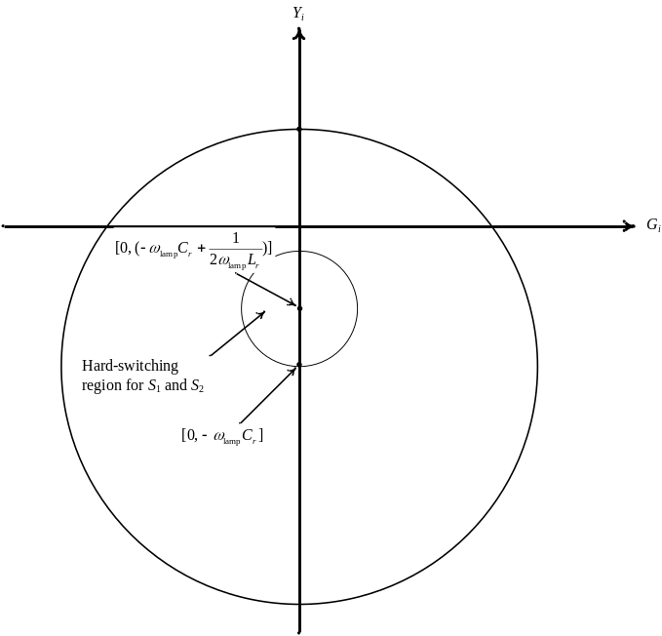
Fig. 1 Hard-switching region. (align left). Captions should be placed in text boxes. Note that “Fig.” is abbreviated and there is a period after the figure number followed by two spaces. It is good practice to explain the significance of the figure in the caption.
Give all authors’ names; use “et al.” if there are six authors or more. Papers that have not been published, even if they have been submitted for publication, should be cited as “unpublished.” Papers that have been accepted for publication should be cited as “in press.” In a paper title, capitalize the first word and all other words except for conjunctions, prepositions less than seven letters, and prepositional phrases.
For papers published in translated journals, first give the English citation, then the original foreign-language citation.

C. Abbreviations and Acronyms
Define abbreviations and acronyms the first time they are used in the text, even if they have been defined in the abstract. Abbreviations such as IEEE, SI, MKS, CGS, ac, dc, and rms do not have to be defined. Do not use abbreviations in the title unless they are unavoidable.

D. Equations
Number equations consecutively with equation numbers in parentheses flush with the right margin, as in (1). To make your equations more compact, you may use the solidus ( / ), the exp function, or appropriate exponents. Italicize Roman symbols for quantities and variables, but not Greek symbols. Use an en dash (–) rather than a hyphen for a minus sign. Use parentheses to avoid ambiguities in denominators. Punctuate equations with commas or periods when they are part of a sentence, as in
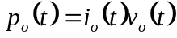. (1)

Symbols in your equation should be defined before the equation appears or immediately following. Use “(1),” DO NOT use “Eq. (1)” or “equation (1),” except at the beginning of a sentence: “Equation (1) is …”

E. Other Recommendations
The Roman numerals used to number the section headings are optional. If you do use them do not number ACKNOWLEDGMENT and REFERENCES, and begin Subheadings with letters. Use two spaces after periods (full stops). Hyphenate complex modifiers: “zero-field-cooled magnetization.” Avoid dangling participles, such as, “Using (1), the potential was calculated.” Write instead, “The potential was calculated using (1).”
Use a zero before decimal points: “0.25,” not “.25.” Use “cm³,” not “cc.” Do not mix complete spellings and abbreviations of units: “Wb/m²” or “webers per square meter,” not “webers/m².” Spell units when they appear in the text: “…a few henries,” not “…a few H.” If your native language is not English, try to get a native English-speaking colleague to proofread your paper.

III. Units

Metric units are preferred for use in IEEE publications. British units may be used as secondary units (in parentheses). An exception would be the use of British units as identifiers in trade, such as “3.5-inch disk drive.”
Avoid combining SI and CGS units, such as current in amperes and magnetic field in oersteds. This often leads to confusion because equations do not balance dimensionally. If you must use mixed units, clearly state the units for each quantity that you use in an equation.

Appendix

Appendixes, if needed, appear before the acknowledgment.

Acknowledgment
The preferred spelling of the word “acknowledgment” in American English is without an “e” after the “g.” Use the singular heading even if you have many acknowledgments. Avoid expressions such as “One of us (S.B.A.) would like to thank . . . ” Instead, write “F. A. Author thanks . . . .” In most cases, sponsor and financial support acknowledgments are placed in the unnumbered footnote on the first page, not here.

References

[1] G. Dawson and I. N. Chan, “A modified zero-voltage-switching flyback converter,” IEEE Trans. Power Electron., vol. 9, no. 2, pp. 129-135, Apr 1994.
[2] Y. Zhi, T. Kaynak, and W. Zhang, “Modified maximum power point tracking technique for wind energy application,” IEEE Trans. Power Electron., vol. 27, no. 7, pp. 3023-3027, Jul 2012.
[3] F. Zhang, “A new high power factor AC-AC inverter,” IEEE Power Electron. Lett., vol. 1, no. 5, pp. 10–13, Mar. 2000.

A footnote should indicate whether the paper is an extension of a conference paper, the title of the conference paper, the conference the paper was presented in, year, etc. A footnote may also indicate the sponsor and financial support acknowledgment. A footnote may also indicate the affiliation of the authors and the participating teams.

