Intrusion Detection and Directory Traversal Attack Monitoring Using Snort IDS

Project Title | Intrusion Detection and Directory Traversal Attack Monitoring Using Snort IDS
Domain | ADCD
Submitted By | D. SHOBIJA
Date | July 11, 2026
Environment | VirtualBox Lab – Ubuntu Server & Kali Linux 2025.3
Tools & Technologies | Snort IDS 2.9.20, Apache2, Kali Linux, Ubuntu Server

1. Abstract
This project demonstrates the design, deployment, and validation of a network-based Intrusion Detection System (IDS) using Snort, aimed at detecting directory traversal attacks against a web server. A two-machine virtual lab was built using Oracle VirtualBox, consisting of an Ubuntu Server hosting an Apache2 web application (the target) and a Kali Linux workstation acting as the attacker. Snort was installed and configured on the target host, and a custom detection rule was written to identify directory traversal patterns in incoming HTTP traffic. An attack was then simulated from the attacker machine using a crafted HTTP request, and the IDS successfully detected and logged the intrusion attempt in real time. The project provides hands-on experience in IDS deployment, rule writing, and SOC-style detection validation.

2. Objectives
- To set up a two-node isolated virtual lab environment for offensive/defensive security practice.
- To deploy and configure a web server (Apache2) as a monitored target.
- To install and configure the Snort IDS on the target host for network traffic inspection.
- To author a custom Snort rule capable of detecting directory traversal attack patterns.
- To simulate a real-world directory traversal attack from an attacker machine.
- To validate that the IDS accurately detects and logs the simulated attack in real time.
- To document the exercise as a reusable, repeatable methodology for future detection-engineering practice.

3. Tools & Technologies Used
Virtualization Platform | Oracle VirtualBox
Target OS | Ubuntu Server (Linux)
Attacker OS | Kali Linux 2025.3
Web Server | Apache2 2.4.58
IDS Engine | Snort 2.9.20 GRE (Build 82)
Attack Tool | curl (HTTP request crafting)
Editor | GNU nano (rule authoring)
Networking | VirtualBox NAT network, ip / systemctl / apt CLI utilities

4. System Architecture / Lab Topology
The lab consists of two virtual machines connected over an isolated VirtualBox network. The Ubuntu Server (10.0.2.10) hosts the Apache2 web service and runs the Snort IDS, monitoring all inbound traffic on interface enp0s3. The Kali Linux machine (10.0.2.11) acts as the attacker, sending crafted HTTP requests toward the target over interface eth0. This topology mirrors a simplified real-world scenario in which a SOC analyst monitors a web-facing server for malicious inbound traffic.
Target Host | Ubuntu Server – IP 10.0.2.10 (enp0s3)
Attacker Host | Kali Linux – IP 10.0.2.11 (eth0)
Monitored Service | Apache2 HTTP – Port 80
Detection Point | Snort IDS, inline on target's network interface

5. Methodology / Implementation

5.1 Network Configuration Verification
The IP configuration of both virtual machines was verified using the ip a command to confirm connectivity before proceeding with service deployment.
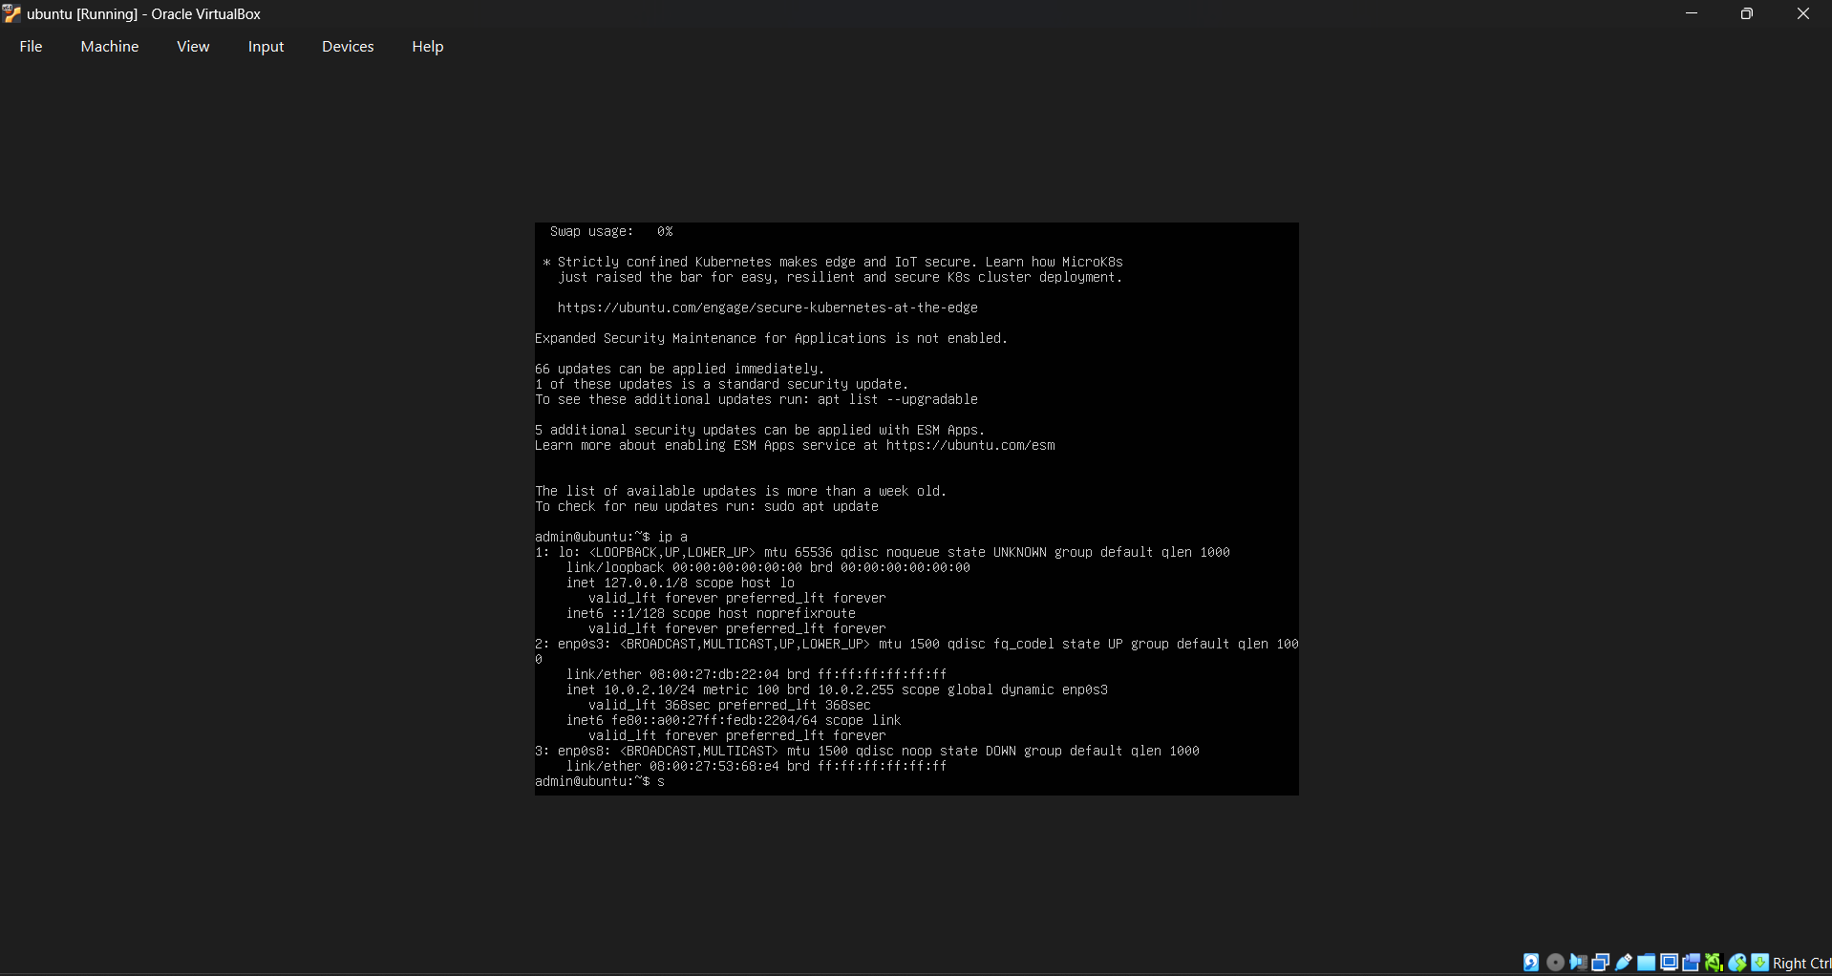
Figure 1: Ubuntu server network configuration – IP 10.0.2.10
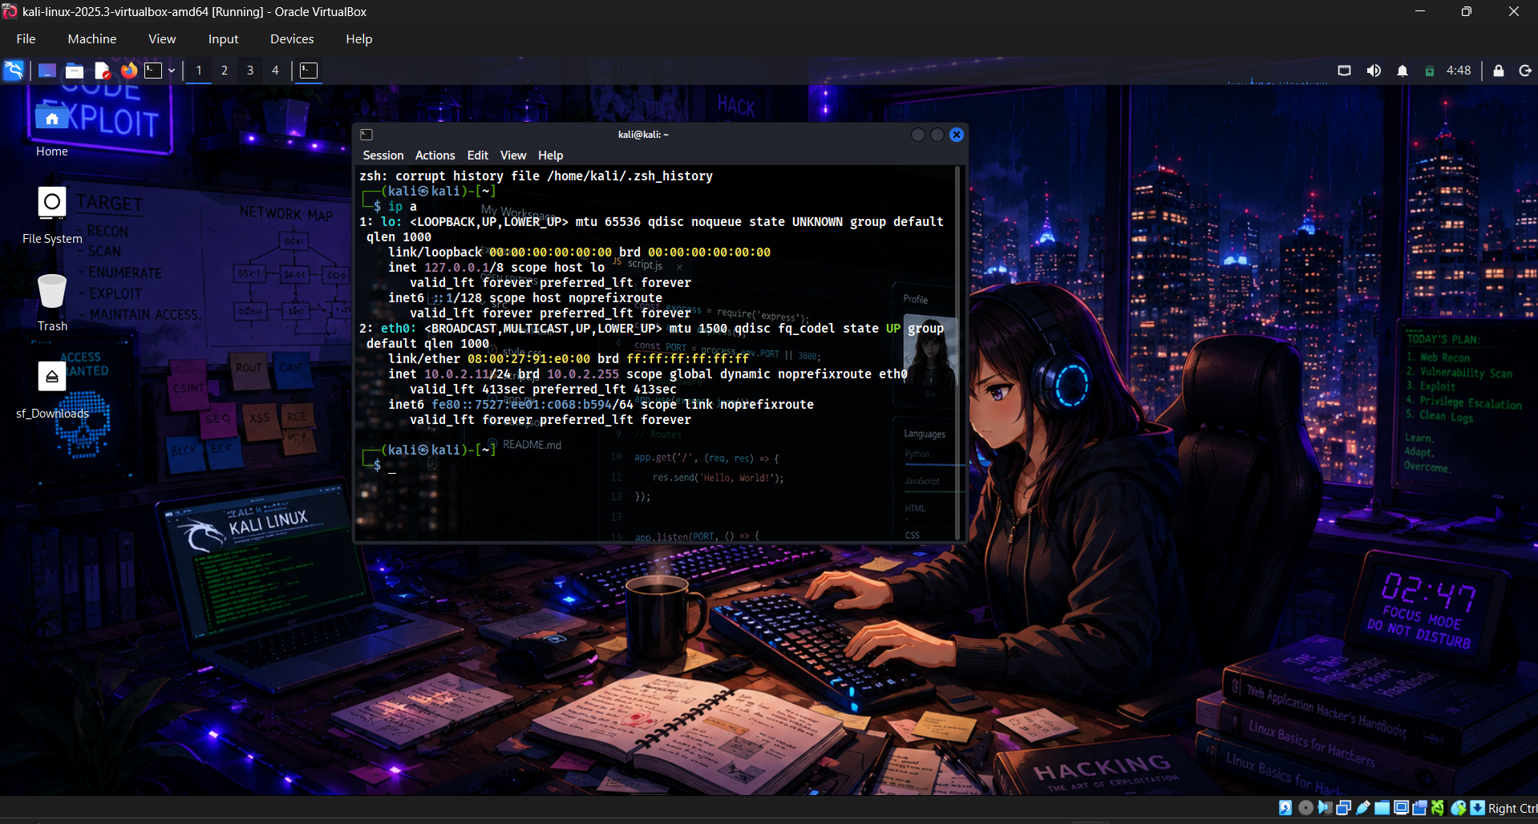
Figure 2: Kali Linux attacker network configuration – IP 10.0.2.11

5.2 System Update
The Ubuntu server's package repository was updated using sudo apt update to ensure the system was current before installing new services.
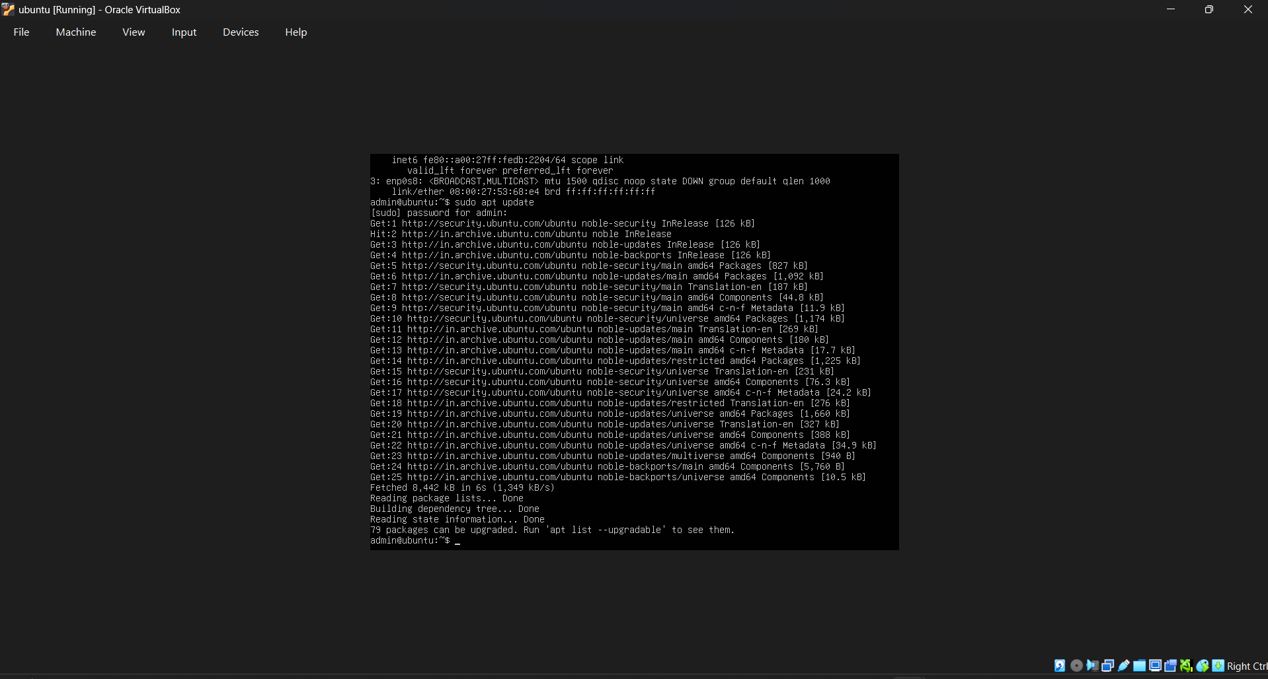
Figure 3: Package repository update on the Ubuntu server

5.3 Apache2 Web Server Installation
Apache2 was installed and configured as the target web application, serving as the resource that the simulated attack would be directed against.
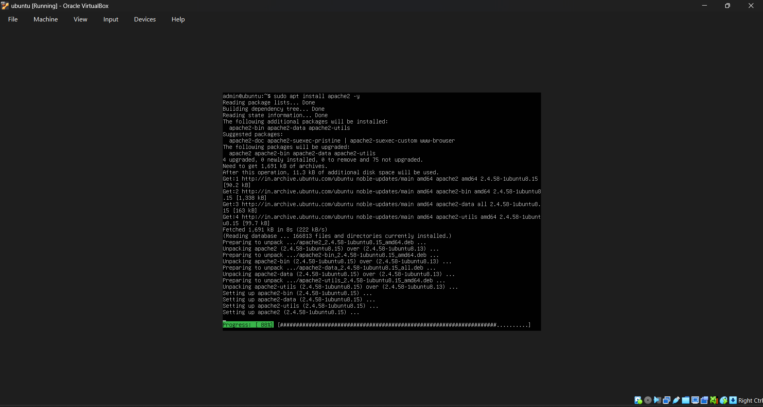
Figure 4: Apache2 installation in progress
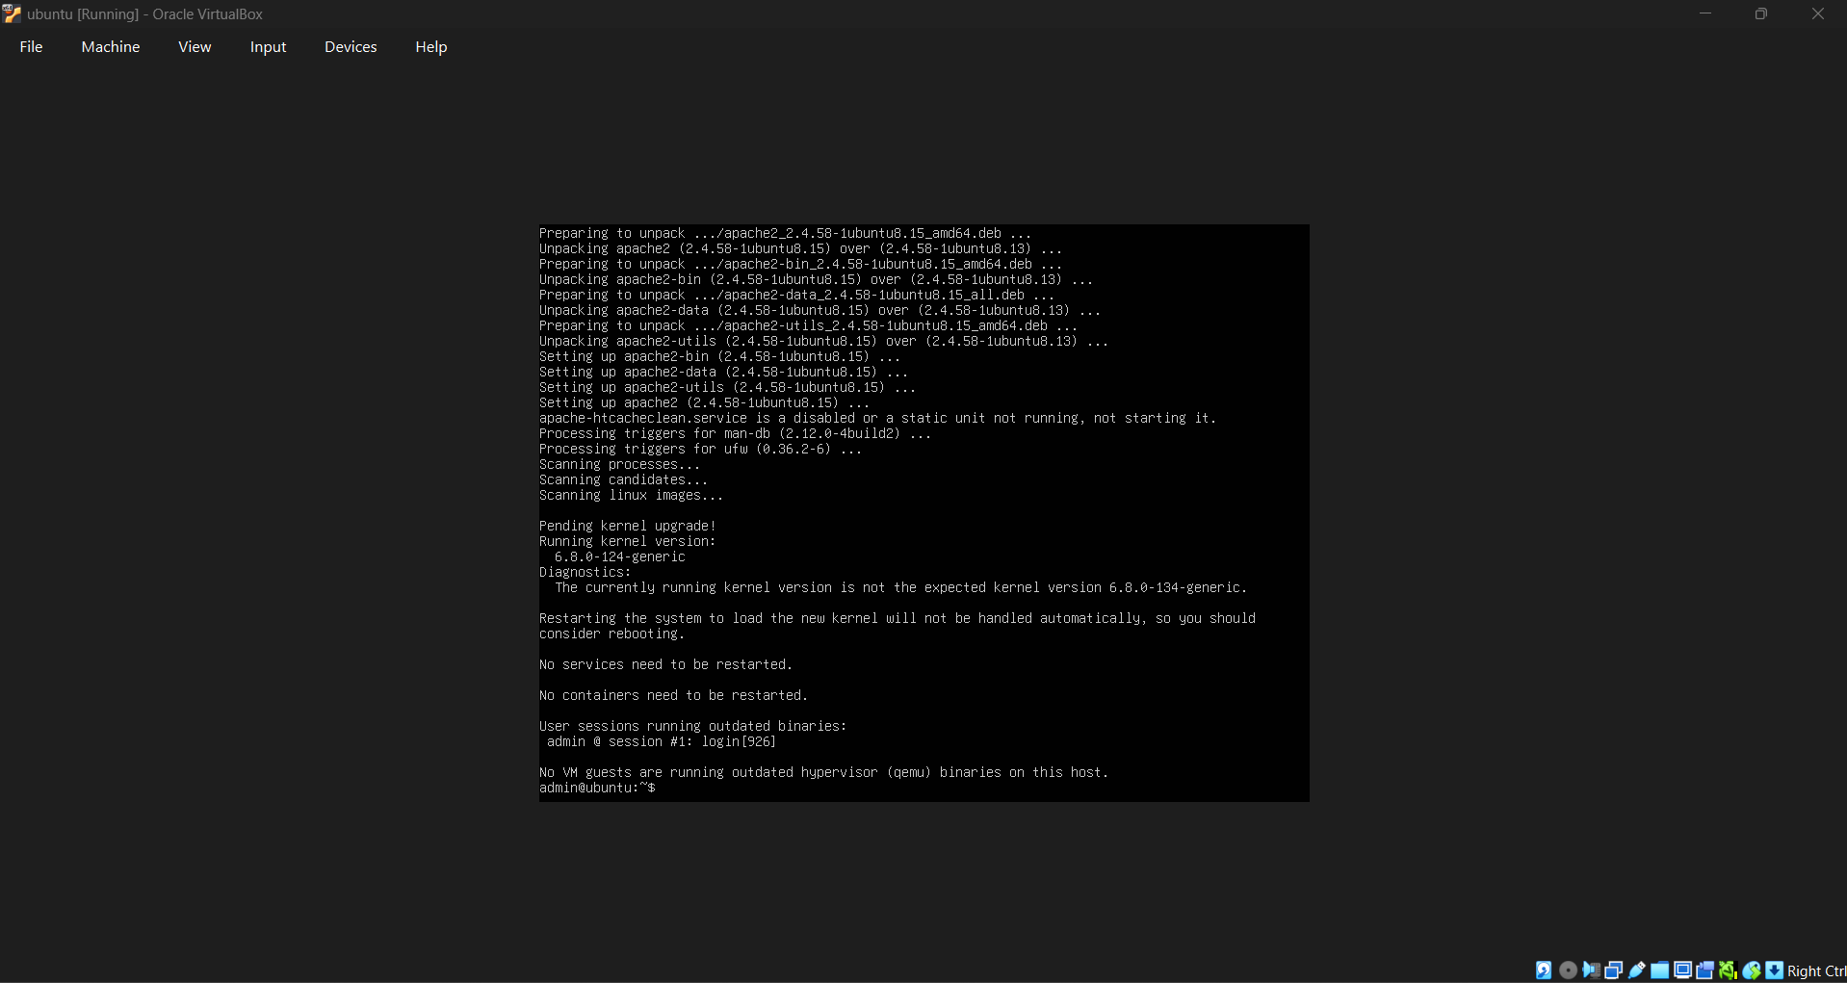
Figure 5: Apache2 installation completed
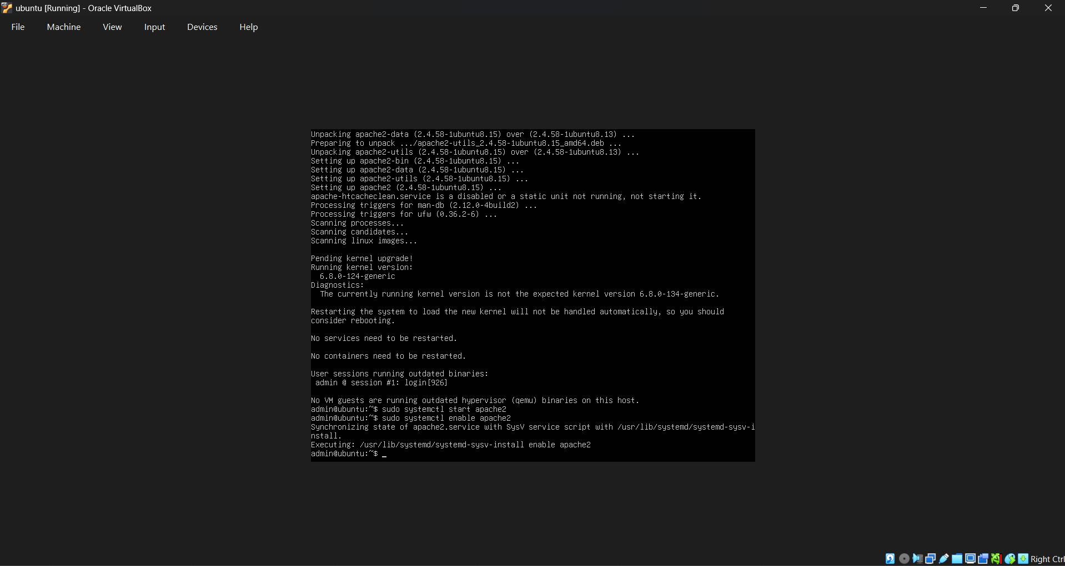
Figure 6: Apache2 service started and enabled via systemctl
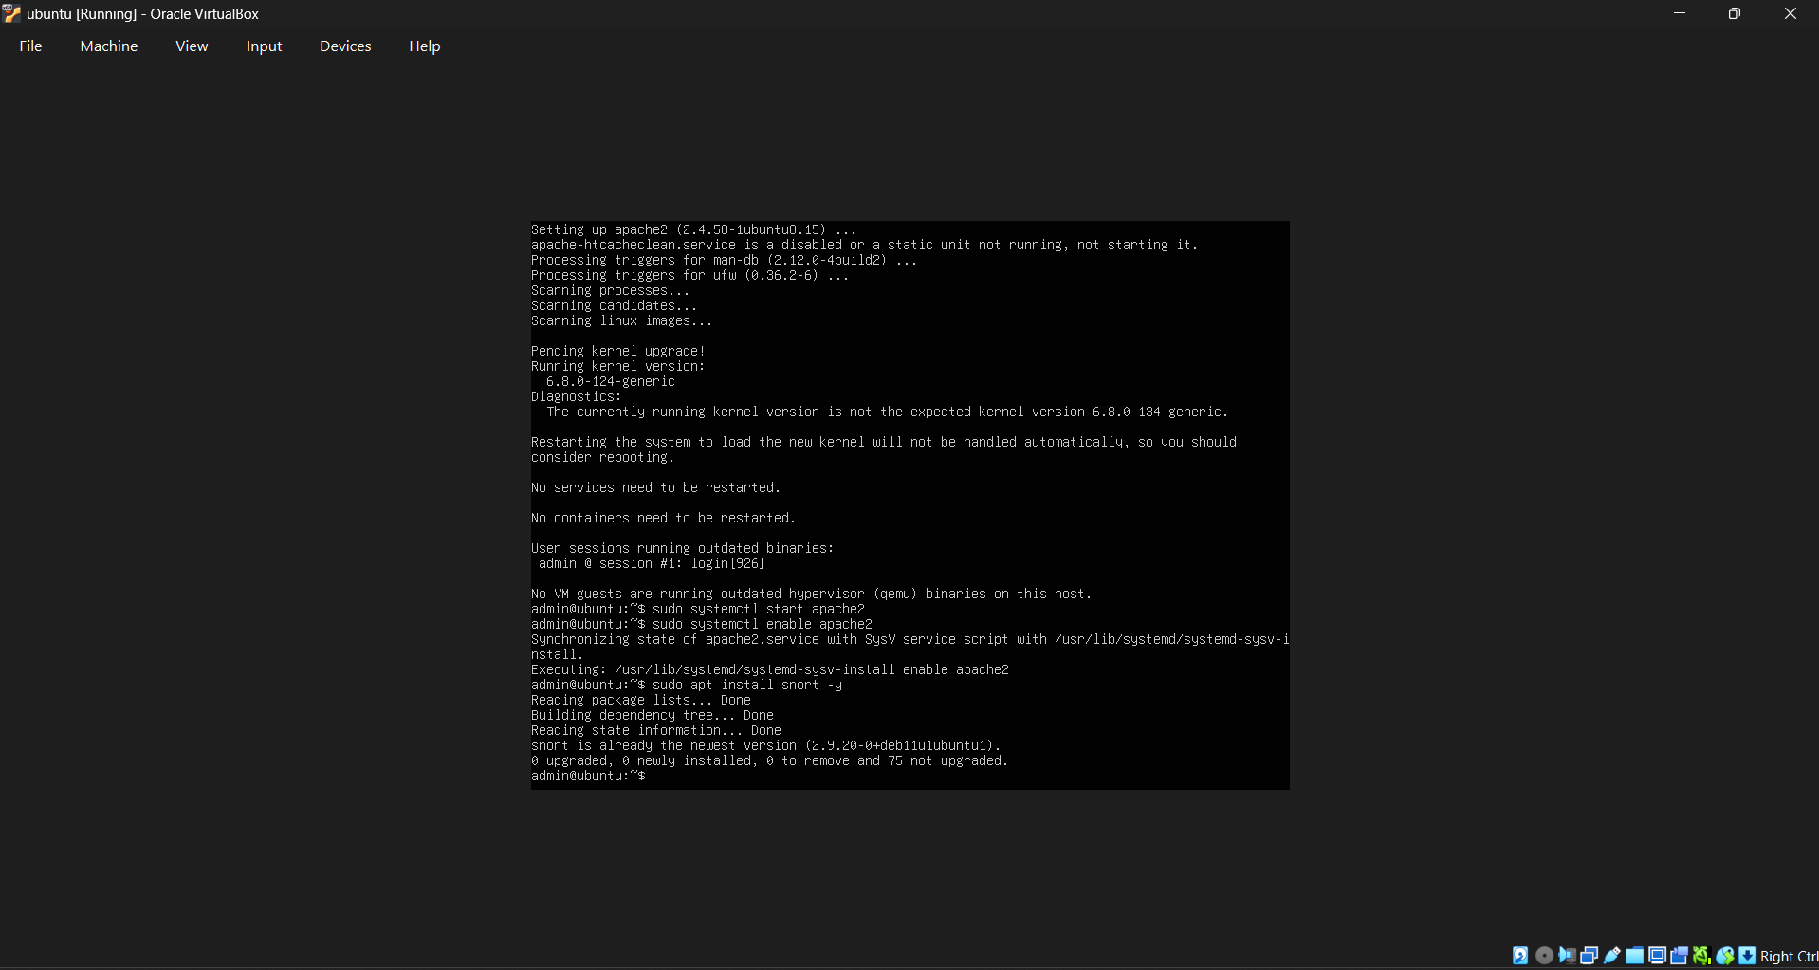
Figure 7: Apache2 default page confirmed reachable at http://10.0.2.10

5.4 Snort IDS Installation & Verification
Snort was installed on the Ubuntu server and its version verified to confirm a successful, functional installation.
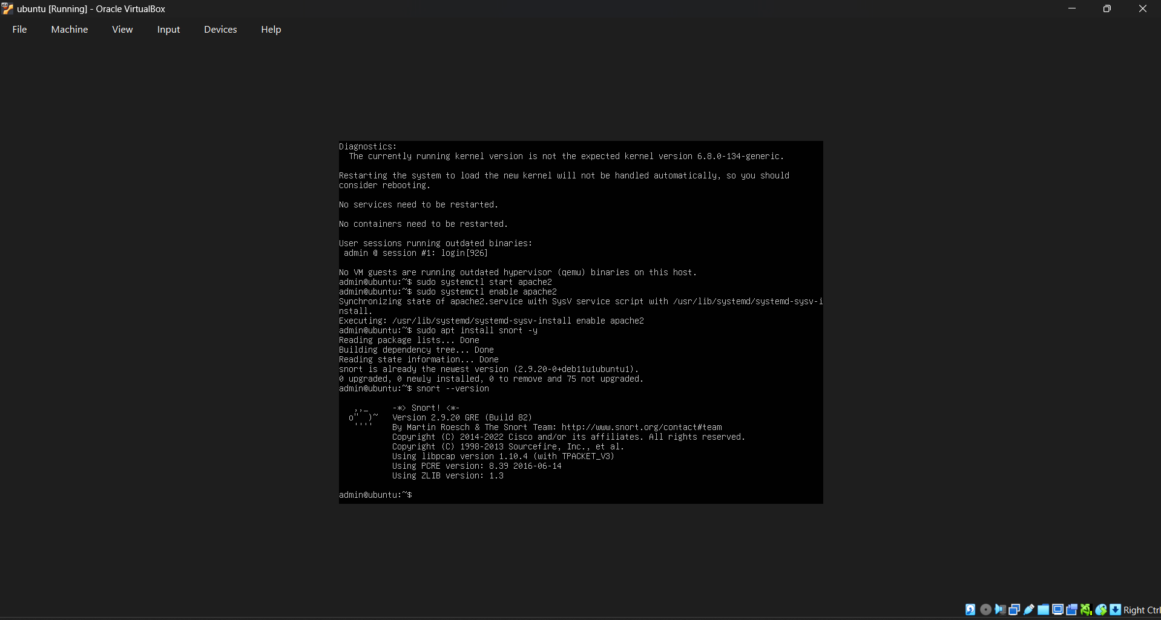
Figure 8: Snort IDS installation
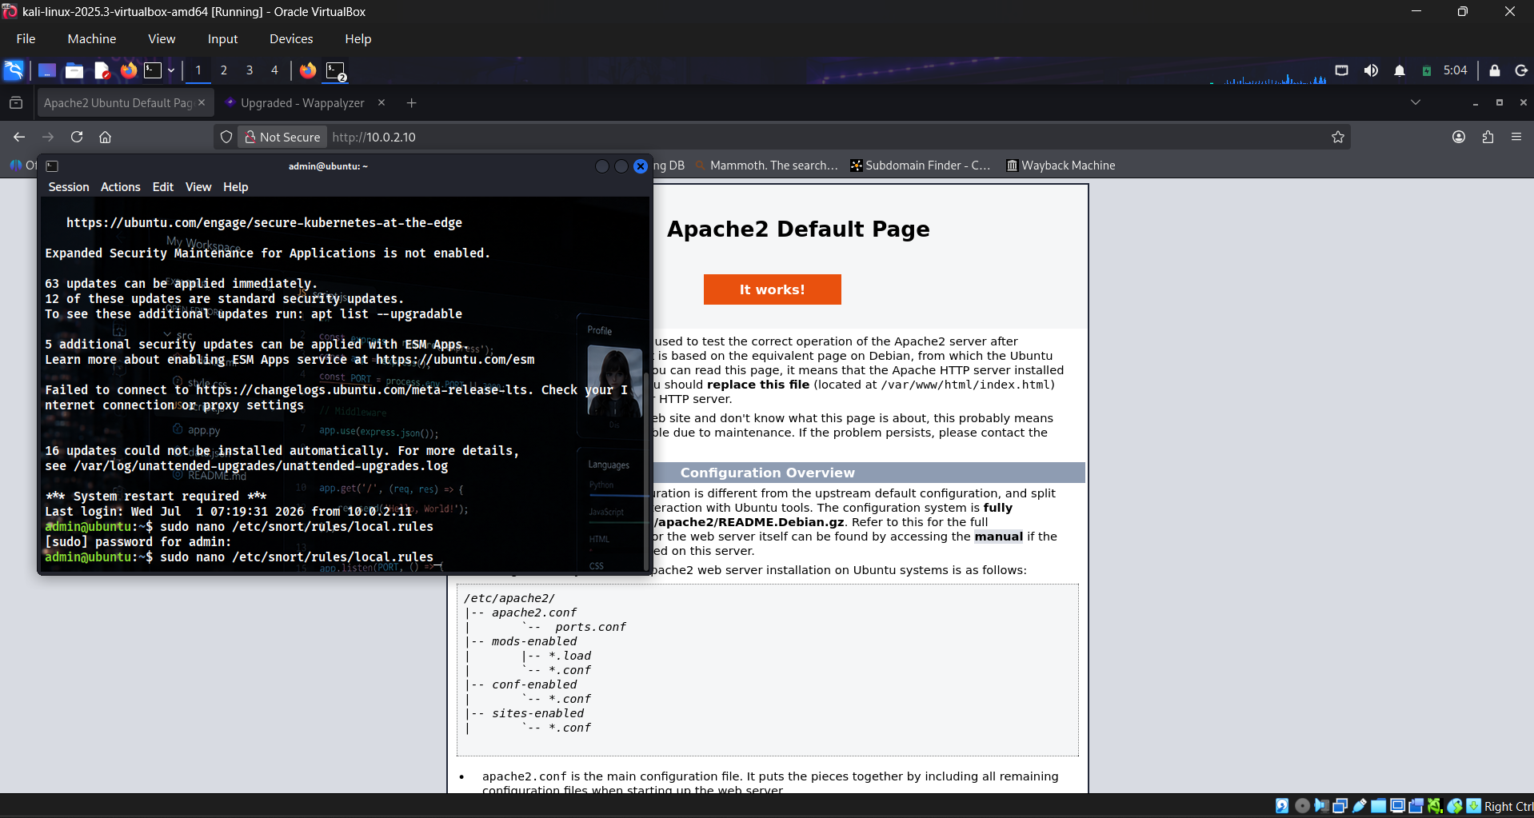
Figure 9: Snort version verification – Snort 2.9.20 GRE (Build 82)

5.5 Custom Rule Development
A custom detection rule was written in /etc/snort/rules/local.rules to identify directory traversal attempts. The rule inspects TCP traffic destined for port 80 and triggers an alert whenever the traversal pattern “../” is present in the payload.
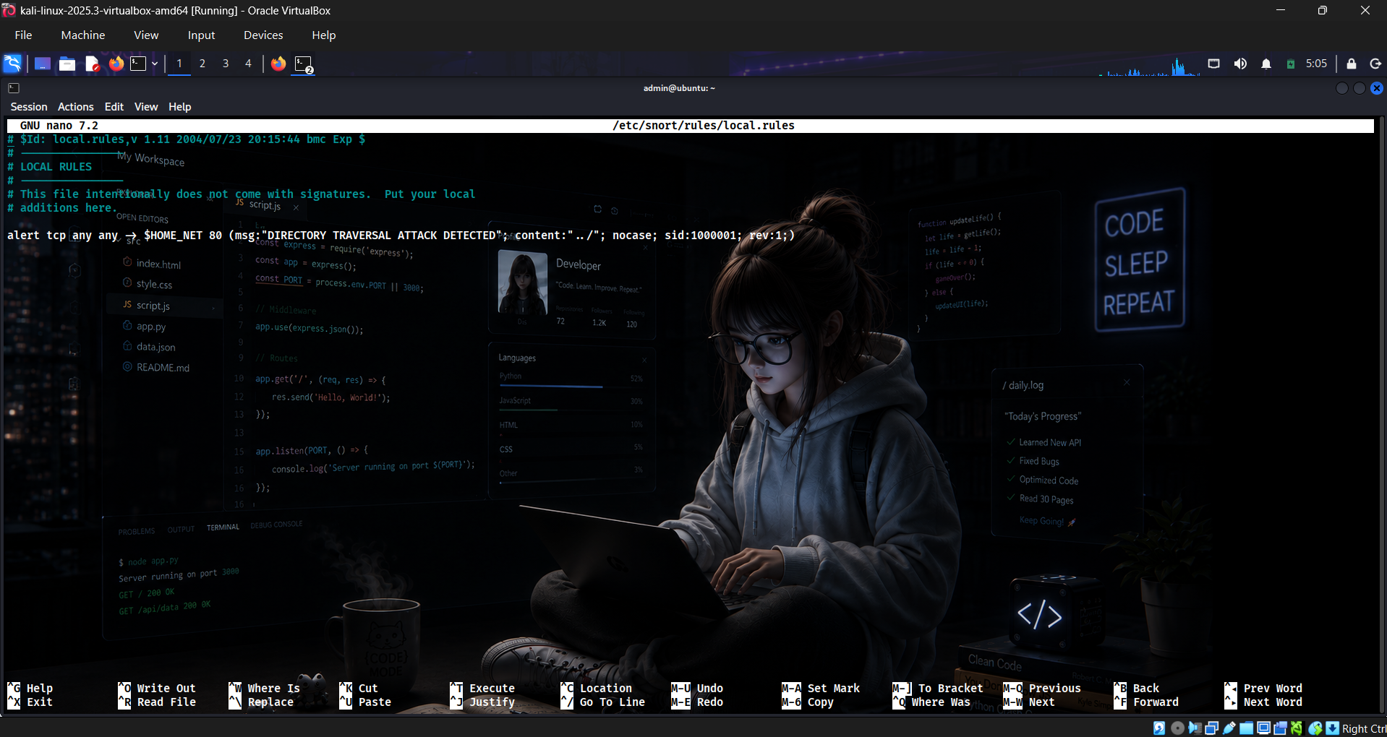
Figure 10: Editing local. Rules using nano
alert tcp any any -> $HOME_NET 80 (msg:"DIRECTORY TRAVERSAL ATTACK DETECTED";
content:"../"; nocase; sid:1000001; rev:1;)
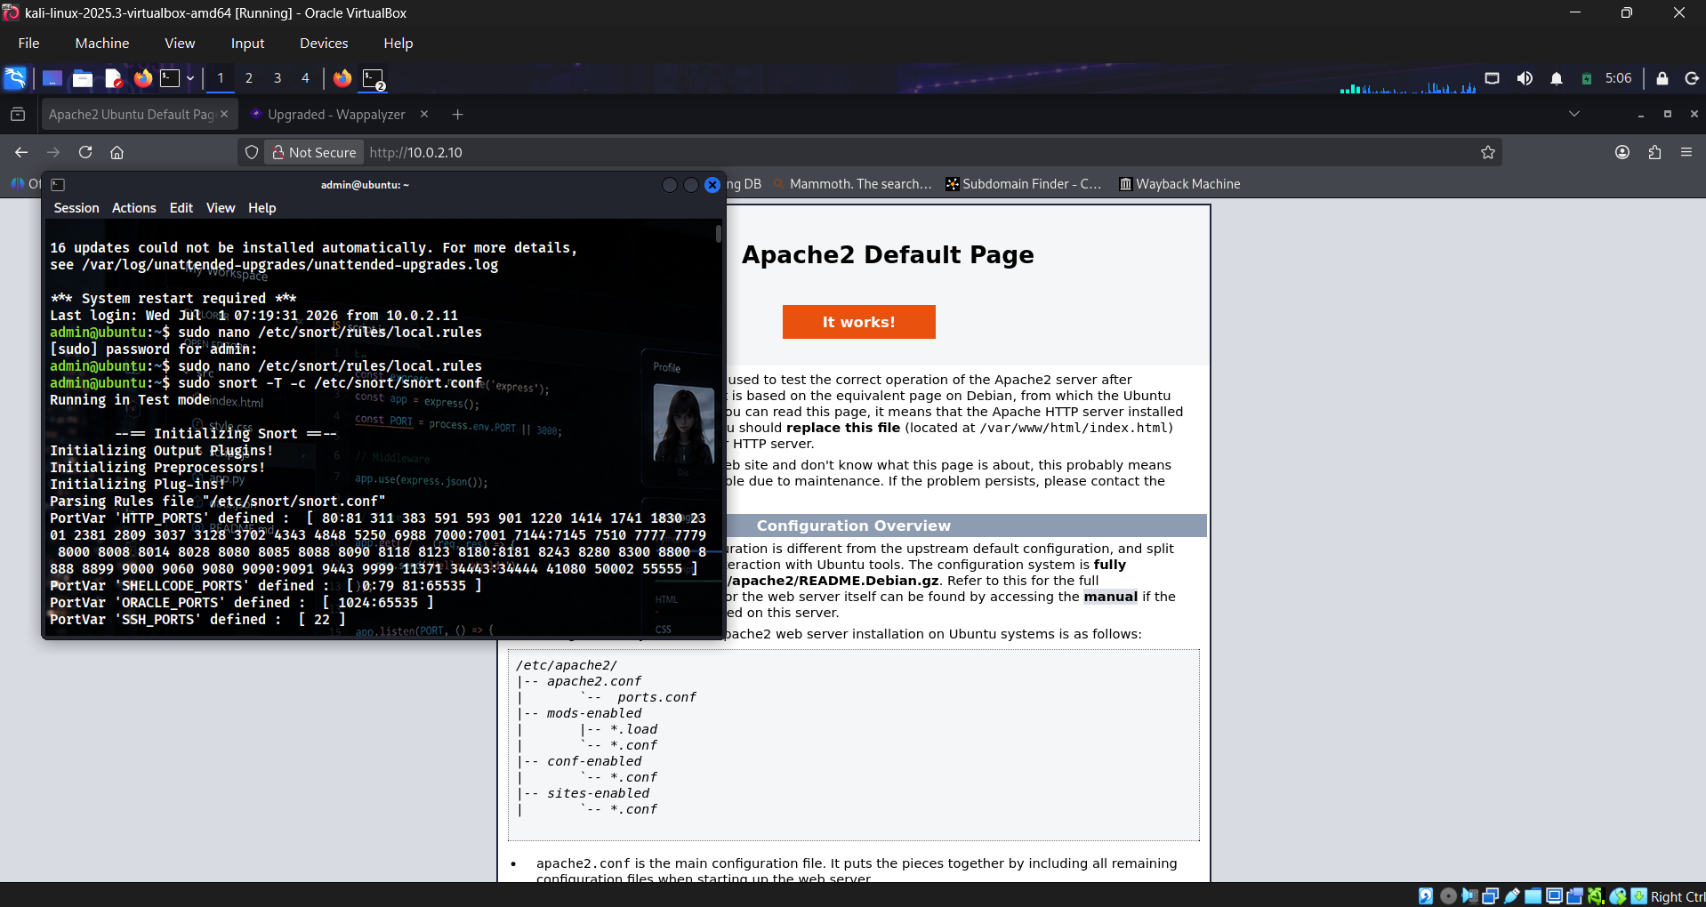
Figure 11: Custom rule (SID 1000001) added to local.rules

5.6 Configuration Testing
Before going live, the Snort configuration was validated using test mode to ensure the rule set and preprocessors loaded correctly and without error.
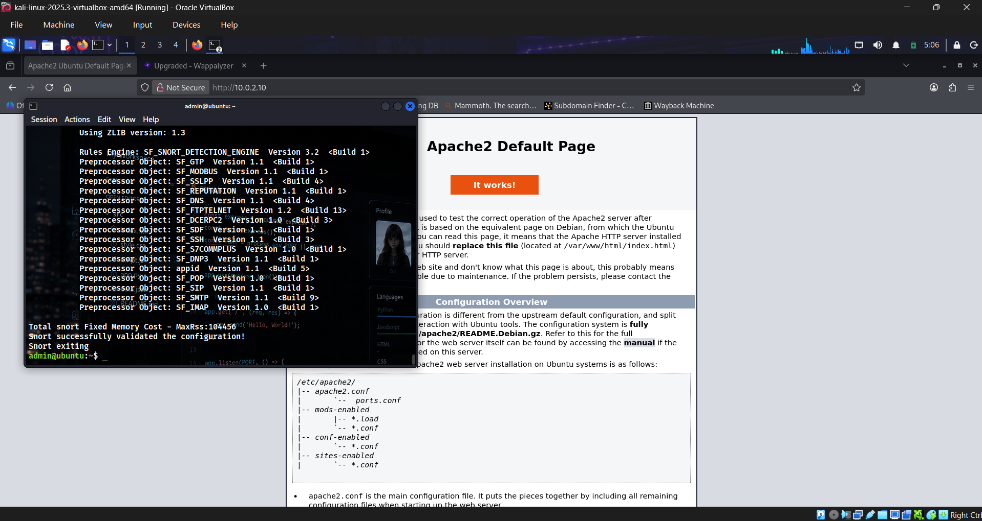
Figure 12: Snort test-mode initialization
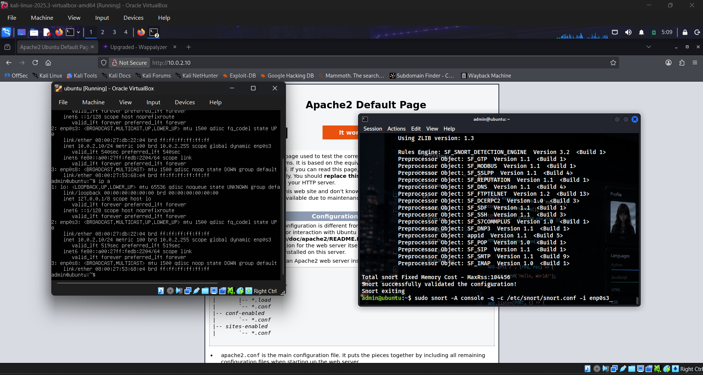
Figure 13: Snort configuration validated successfully

5.7 Live Monitoring Deployment
Snort was launched in live console alert mode, actively monitoring the target server's network interface (enp0s3) for matches against the configured rule set.
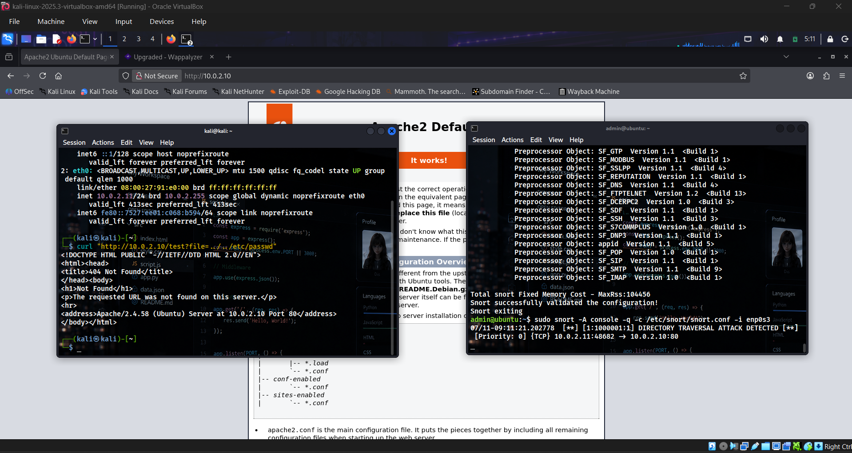
Figure 14: Snort running in live console monitoring mode

6. Results
To test the detection capability, a directory traversal attack was simulated from the Kali Linux machine using the following crafted HTTP request, attempting to access the system's /etc/passwd file:
curl "http://10.0.2.10/test?file=../../../etc/passwd"
While Apache2 correctly returned a 404 Not Found response (confirming no application-layer vulnerability was exploited), Snort successfully detected the traversal pattern in the network traffic and generated a real-time alert:
Alert Signature | DIRECTORY TRAVERSAL ATTACK DETECTED
Signature ID (SID) | 1000001
Source IP | 10.0.2.11 (Kali Linux attacker)
Destination IP | 10.0.2.10 (Ubuntu Server)
Destination Port | 80/TCP (HTTP)
Alert Timestamp | 07/11 – 09:11:21.202778


Figure 15: Snort alert confirming successful detection of the simulated attack
This confirms that the custom rule and Snort deployment functioned correctly, successfully detecting the simulated attack in real time and logging all relevant details (source, destination, port, and timestamp) required for incident analysis.

7. Conclusion
This project successfully demonstrated the complete lifecycle of deploying a network intrusion detection capability from lab setup and web service configuration to custom rule authoring, configuration validation, and live attack detection. The Snort IDS was able to correctly identify a simulated directory traversal attack, validating both the underlying detection logic and the overall monitoring workflow. This exercise strengthened practical skills in IDS configuration, Snort rule syntax, and SOC-style detection validation, and lays the groundwork for future detection-engineering and network security projects.

8. Future Scope
- Extend the rule set to detect additional attack classes such as SQL injection, XSS, and brute-force login attempts.
- Integrate Snort's alert output with a centralized dashboard for automated, AI-assisted triage of detected events.
- Add support for encoded traversal payloads (URL-encoding, double-encoding) to reduce evasion opportunities.
- Migrate from console/test mode to Snort inline IPS mode for active blocking of malicious traffic.
- Incorporate automated alert correlation and reporting using the Claude API-powered triage layer.

