**The Pathway for Transforming Regional Health**

## The Pathway helps leaders and teams better assess and drive progress toward a healthy health system—one where collaborative efforts help individuals, families, and businesses thrive and multi–sector approaches assure that high-quality, affordable care is available when and where we need it. Built on well-grounded complex system change principles that characterize common limits to growth and success, the Pathway offers insights into five stages of development. It focuses on those conditions that can contribute to momentum, and the forces that can disrupt progress. These tend to cluster around three areas:

1. Level of demand for change by those involved,
2. Capacity—human, financial, and organizational—for continued action, and
3. Alignment among individual interests and the success of the effort.

As a core tool for ReThink Health, the Pathway helps leaders and teams see that both success and problems can be within their control, and understand how progress often breeds the next level of challenges. Points of transition are critical moments of opportunity to foster greater momentum and tackle emergent challenges.

The ReThink Health Pathway begins when leaders step outside of their own organizational boundaries to work more collaboratively with others. The first phase is typically a single focused campaign. Yet absent a long-term and broad-scope vision for system redesign, campaigns alone rarely lead to wider systemic change. Moving through the five phases, leaders typically experience cycles within and between phases, and may find that different parts of a regional effort are in different phases at the same time. The Pathway helps leaders understand what’s involved in the long journey to system redesign, and see the critical roles of stewardship, strategy, investment, and financing along the way.

The Pathway presents the definitions, characteristics, the typical pitfalls of each phase, as well as the approaches and processes that will sustain momentum and collaboration toward the vision of a healthy health system.

*This brief was developed with support from the Robert Wood Johnson Foundation.*

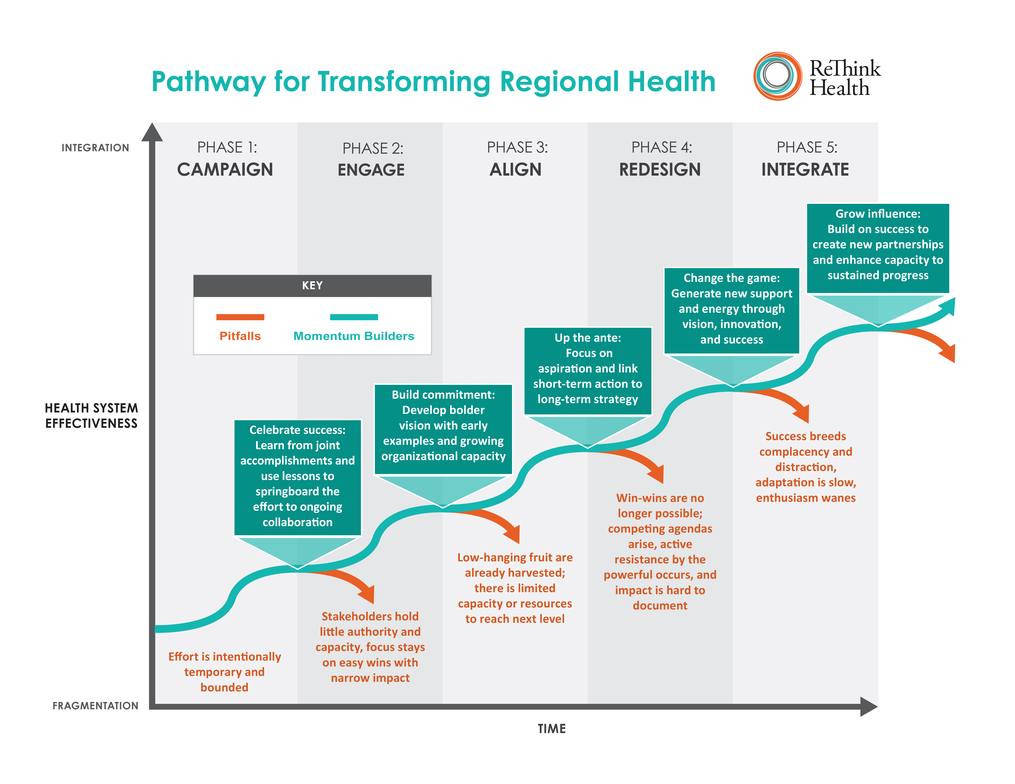

|  |  |  |  |  |  |  |  |  |  |  |  |
| --- | --- | --- | --- | --- | --- | --- | --- | --- | --- | --- | --- |
|  | | Phase 1: Campaign | | Phase 2: Engage | | Phase 3: Align | | | Phase 4: Redesign | | Phase 5: Integrate |
| **Features of Reform Efforts** | | | | | | | | | | | |
| **Definition** | | Focused, time-limited effort to align resources or take action on a specific issue or crisis. | | A diverse set of stakeholders is engaged in an on-going dialogue focused on building understanding and coordination, is conducting small-scale experiments that create capacity and trust across sectors, and is generating support of the infrastructure for collaboration. | | Alignment of efforts around shared goals for greatest impact with widespread engagement, targeted initiatives, and growing infrastructure and coordination. | | | Seeding and spreading collaborative, cross-organizational efforts and disruptive or high-impact innovations that will bring the targeted strategy to life; redesigning key processes, with clear system goals and measures and pooled resources. | | Multi-stakeholder governance structure(s) with influence and authority-setting system goals, that shape and monitor policies, influence and direct allocation of resources, and adjudicate breakdowns. Structures facilitate learning and rethinking, and guide transparency and impact evaluation. |
| **Characteristics** | | * High energy * Excitement * Goal focused * Well-resourced | | * Strong leadership and growing relationships * Peers encourage on-going engagement * Collective action on a relatively low level * Diverse activities and focus * Innovations within institutions * Occasional shared activation on crisis topics or focused campaigns * Win-win results | | * Enhanced relationships and collaboration * Reinforcement of shared values * New array of funders for community efforts * Growing community engagement and coordination * Health system and care bridging * Growing system orientation * Growing orientation to using and sharing measures | | | * Recognition of the potential synergy * Excitement through rapid innovation cycles and prototyping * Pooled and new resources and new allocation strategies * Experimentation grows to focus on scaling in place * Greater coordination and co-dependence among organizations * Increased policy protection for innovation * Investment for long-term, distributed leadership | | * Legitimacy of governance * Broad and active engagement strategy * Long-term system vision and targeted goals * Clear strategy * Diverse institutional agendas respected * Mechanisms for shared risk in place * Continuous performance improvement * Sustainable investment and financial strategy |
| **Pitfalls** | | * Time limited * Resource limited * Sense of completion or burn out * Not sustainable * Limited system wide impact | | * Participants are advocates with limited authority * Controversial subjects are avoided * Discussion does not result in collaborative action * Resources limited for coordination * Trust breaks down due to external forces * Low hanging fruit is harvested | | * Safe topics are exhausted * Tendency to turn to next new things as opposed to sustain effort of real impact * Delayed impact challenges perceptions of progress, weakens funding streams * Coordinating infrastructure lags * Easy funding and low-hanging fruit is exhausted * Pressure to return to status quo * Win-win becomes more challenging * Early members drift away | | | * Choices need to be made – may be winners and losers * Impact is long term and progress is elusive * Powerful stakeholders resist change, and refocus on institutional priorities * Innovation models not replicable or cause unmanageable challenges * Innovators hired by others * Leaders less interested in spread and sustainability * Key leadership changes | | * Strategies fail * External conditions change * Adaption is slow * Breakdowns not easily addressed * Progress is hard to measure * Over reliance on key leaders * Strong backbone causes stakeholders to disengage * Success leads to complacency * No longer as exciting or fun |
|  | Phase 1: Campaign | | Phase 2: Engage | | Phase 3: Align | | | Phase 4: Redesign | | | Phase 5: Integrate |
| **Avoiding Pitfalls and Building Momentum** | | | | | | | | | | | |
| **Stewardship** | * Provoke commitment to change * Surface dissatisfaction and build urgency * Build network of relationships * Acknowledge accomplishments * Capture lessons * Use success to inspire ongoing collaboration | | * Share stories and build values-based relationships * Explore synergy among participants * Build capacity to discuss tough issues * Celebrate and expand cross-sector leadership engagement * Surface potential conflicts between key institutions * Initiate collaborative norms of conduct | | * Reinforce alignment around shared values * Continue to energize teams with feedback and new events – seed enthusiasm * Add new members and new energy while reinforcing shared aspirations * Learn with peers in other contexts to maintain rethinking and sustain commitment * Spotlight successes | | * Recruit new champions of a future system * Engage wider partnerships to move innovations to scale * Hold members accountable to norms * Engage in joint decision-making about priorities | | | * Celebrate success * Develop next generation of leaders * Establish long-term governance * Leverage success to work on other factors affecting the system * Develop new partners * Refresh goals and vision | |
| **Strategy** | * Diagnose needs, resources and gaps * Build system understanding * Frame system wide goals that connect to aspirational vision * Understand the health and finance networks * Assess approach and impact to improve strategy | | * Learn from others * Agree on high impact activities and strategy * Initiate early wins * Build innovation capacity * Create visible measures and reporting | | * Organize collective efforts that can lead to greater system impacts * Build capacity for innovation and rapid cycle experiments * Engage in complex joint experiments across organizations * Embrace continuous learning and idea generation * Partake in visible and transparent measurement | | * Engage in rapid prototyping of new system designs * Stabilize and spread successes * Continue to drive innovation in a changing environment * Monitor impact and adjust strategy * Add new initiatives to complement successes | | | * Expand scope and build on success * Address context and policy issues * Review and refine strategy based on outcomes, changing policies, and regional conditions * Broaden scaling efforts and add new initiatives to heighten and sustain impact * Continue to spark innovation and experimentation | |
| **Financing** | * Secure in-kind and local support * Form long-term financing group * Assess community assets for health and care | | * Structure and leverage foundation and member funds and in-kind resources * Refocus Community Benefit resources * Build relationships and strategy for long-term financing including policy | | * Develop and align community funders * Shift organizational funding priorities * Explore and cultivate develop new funding mechanisms (payment reform, shared savings, policy efforts, purchasing processes, etc.) * Develop approaches for initiatives and for organization * Examine policy and earned revenue opportunities | | * Implement new financing strategies and harvest investments * Leverage relationship and scale – and resulting savings – to stabilize funding * Take advantage of aligned incentives through payment reform * Develop agreements with partners and beneficiaries * Pursue stable tax or other assessed funding structures | | | * Renew old funders and attract new ones with innovations and scaling opportunities * Engage with government, major stakeholders and beneficiaries to establish long term financing strategies * Leverage refreshed leadership and stakeholders to expand opportunities * Explore partnerships that create win-wins in the community | |