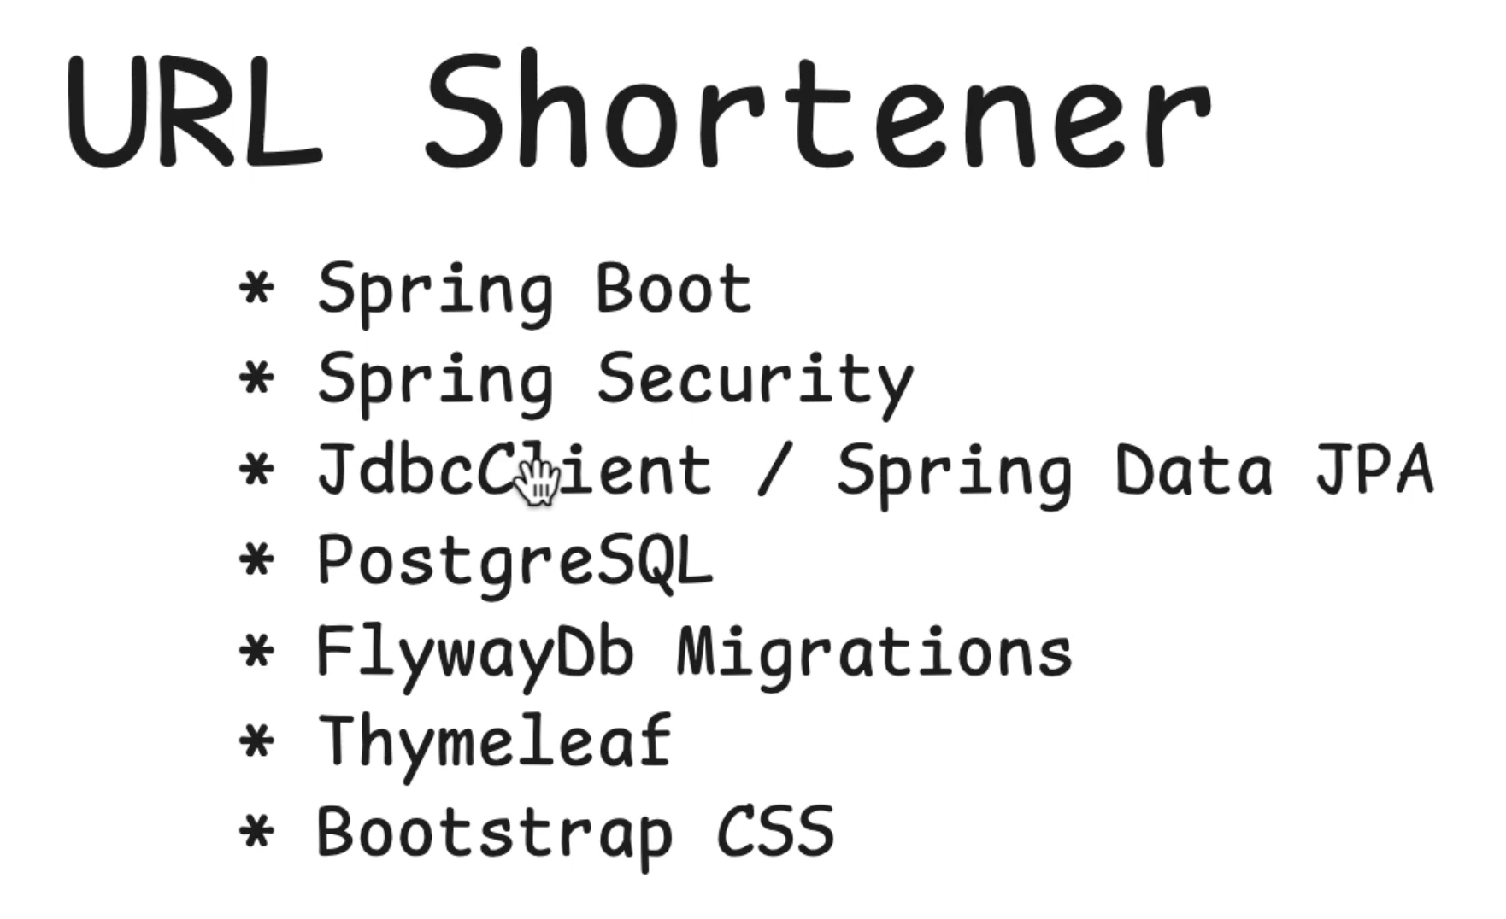
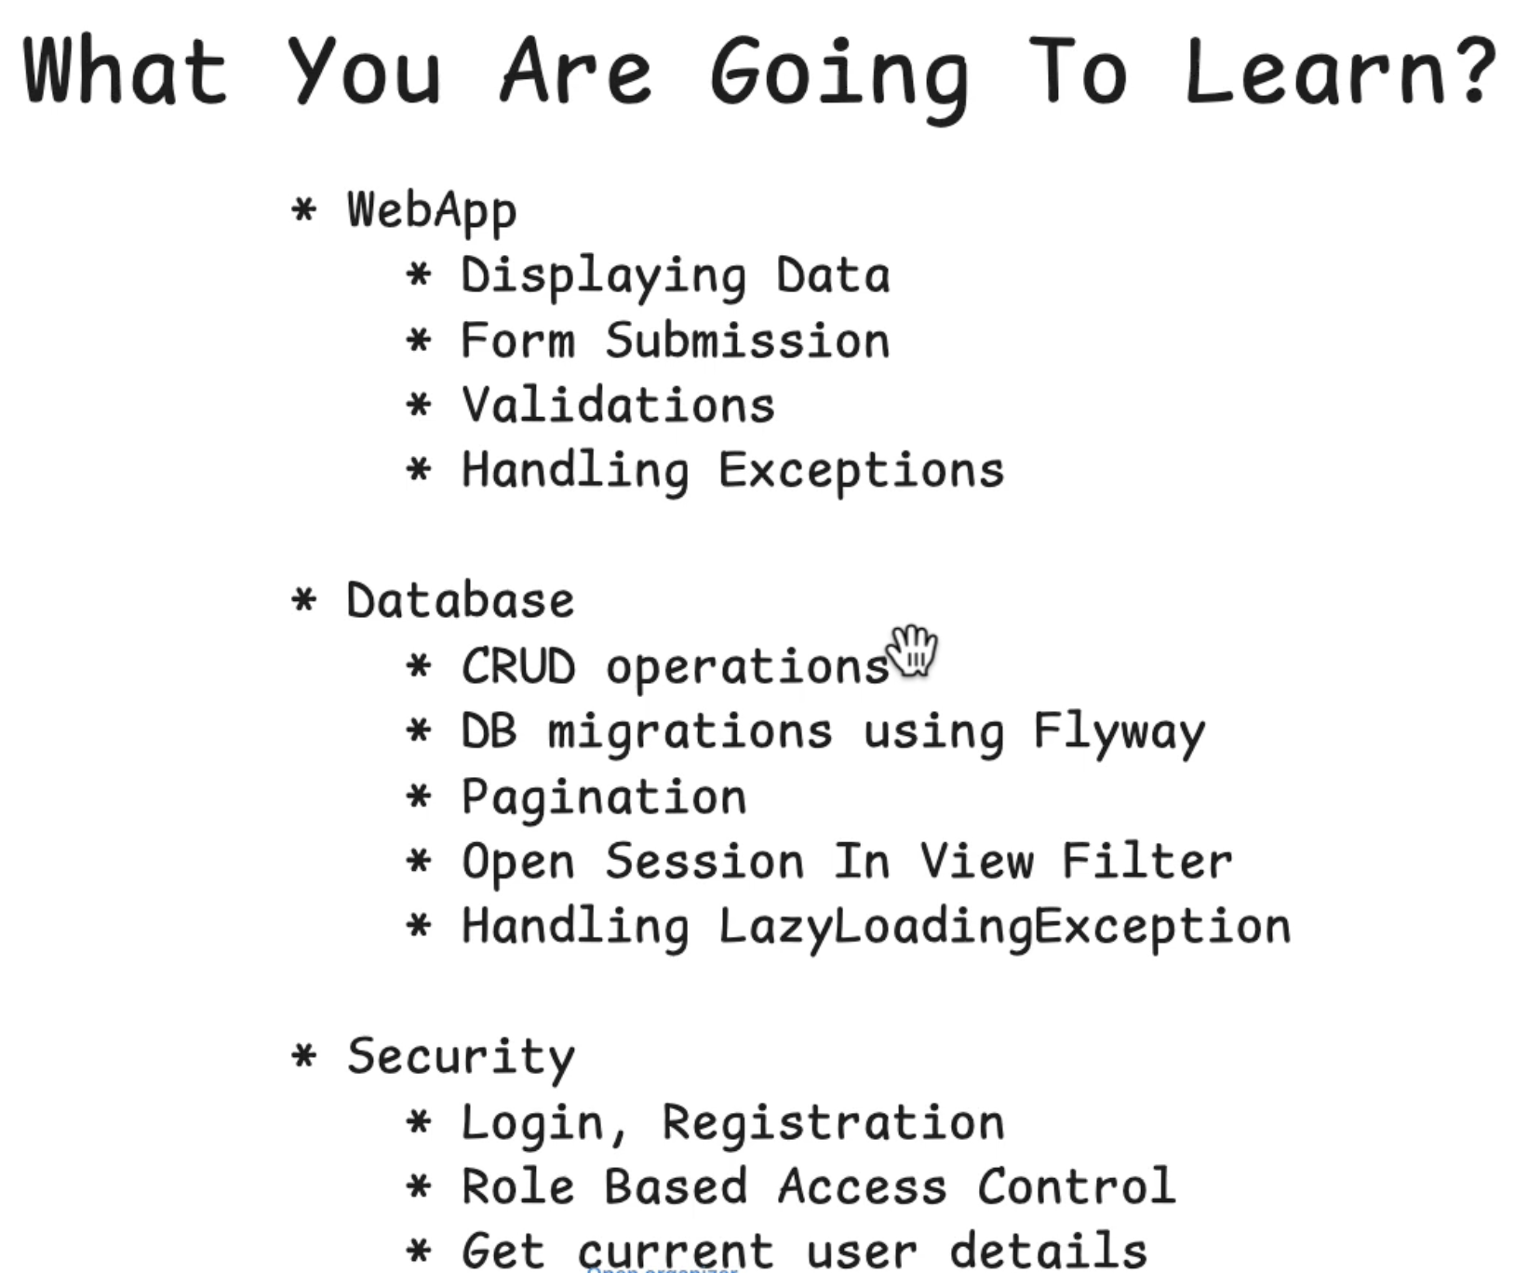

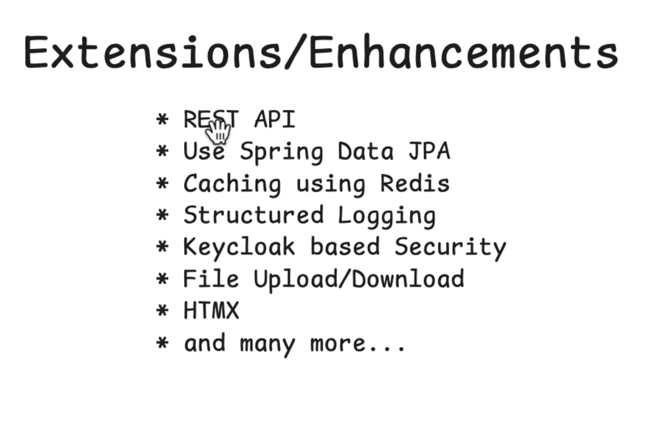
Artifact name follows deliverable service name Eg: Lower-kebabe-case
Package name is always without hyphens

The @SpringBootApplication is the entry point for our application so every subpackage or the .java files that we create has to be under the package name of the main java class or else the SpringBootApplication will not be able to scan it

Using Thymleaf we can render some dynamic data that can be used for our application and by default springboot serves static data which is in the static data table.

Class level declaration and method level declaration- two types of declarations, both of them have their use cases

So Eg: @RestController replacement for @Controller and @ResponseBody
Also whenever we are using thymleaf dependency we need to change two things:
- The base index.html is to be expected in templates and not static
- We do not need the .html in the return statement of our controller
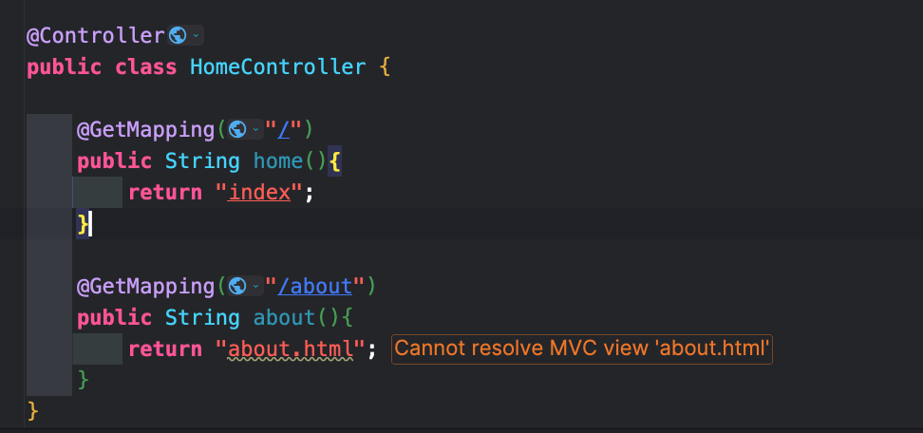

We can see we only need the baseclass name here and nothing else
A quick guide to see: https://github.com/sivaprasadreddy/spring-boot-self-learning-guide

What is Spring Data JPA:
Java does provide JDBC api to interact with databases with their dialects
but it is a very low level API and we need a lot of boiler plate code
Eg: connection, auto-commit, with try catch and then connection and releaseing the connection
there is a lot of boiler plate code for infrastructure management so it takes a lot of time like Eg: releasing and doing the connections

To have a higher level abstraction we have ORM frameworks like Hibernate and Data JPA
We also have
- Plain JPA
- Spring Data JPA
Here we will work only with objects and Orm will take care of data storage and all
Spring Data JPA is built on top of JPA
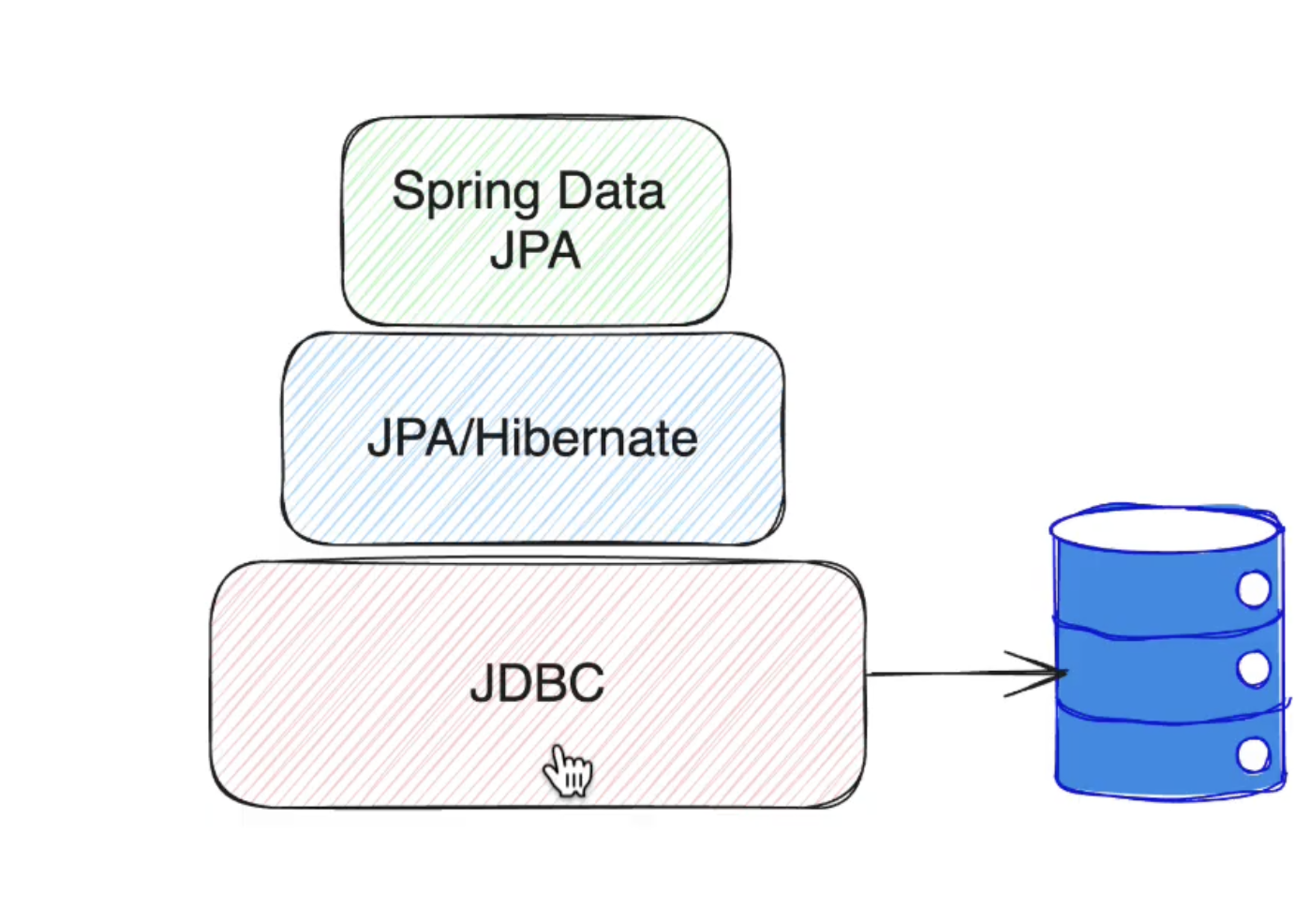
Spring Data JPA provides:
- ﻿﻿Repository abstraction with CRUD operations
- ﻿﻿Derived Query Methods
- ﻿﻿Custom Query Methods
- ﻿﻿Pagination and Sorting
- ﻿﻿Projections
- Auditing

Open-In-View (also known as Open Session in View or OSIV) is a pattern in Spring Boot that keeps the database connection (the JPA EntityManager) open for the entire duration of an HTTP request, including during the HTML template rendering phase.

How OSIV Works & Why It's Enabled
By default, Spring Boot sets spring.jpa.open-in-view=true.
- The Benefit: It prevents LazyInitializationException. If a Thymeleaf template accesses a lazily-loaded relationship (like shortUrl.getCreatedBy().getDesignation()), Hibernate can lazily fetch that extra data from PostgreSQL on the fly because the DB session is still open.
- The Drawback (The "Anti-Pattern"): Database connections are held open much longer than necessary. Instead of releasing the connection back to the HikariCP pool immediately after the @Service layer finishes, the connection remains tied up while Tomcat renders the view. Under heavy traffic, this can exhaust your database connection pool and cause performance bottlenecks.

Best Practice
In production-grade enterprise applications, OSIV is usually turned off. Instead, any data needed by the view or API response is explicitly fetched within the @Transactional service layer using JOIN FETCH queries or DTO projections.
To turn off OSIV and remove the warning log, add this line to your application.properties:
So there are two ways to create the table DDL and run it;
- Create Data.sql and schema.sql and in resources and in application.properties we write –

#enable the data load and table ddl, Eg: always, embed, never
spring.sql.init.mode=always

Option 02) Using flywayDB migration where we create a db/migration folder structure and in it we have two .sql files which are used to create and update the data

For using option 02) we will remove the application.properties configurations and also delete the data.sql and schema.sql

Remember: Once a flyway migration is successfully applied we should not change it not even a space in the .sql file because in the flyway_schema_history we have a checksum table that would be altered and won’t match and we the autoconfiguration will again need to reload and execute the migration script

In our application we have used JDBC client for User related operations and ShortUrl operations we will be using SpringDataJPA, both of them are mutually exclusive and we can use each one of them individually

So with our original findAll() method of getting all the URLs is not useable and not production friendly as we only want to return the URLs who are public only. So we will create SpringDataJPA way of URLs that can automatically fetch and use the Spring Data JPA derived methods
Eg: FindByLongUrl

On the other hand we can also use JPQL for our data querying

We are going to follow controller, service and repository interactions and we will centralize all the business logic in service layer and leave repository only for DB interactions

In spring initializer we have docker-compose dependency which is very useful and really great to create the docker-compose.yaml file based on the dependencies that we have added and this could be of great help if you are doing your local developments

