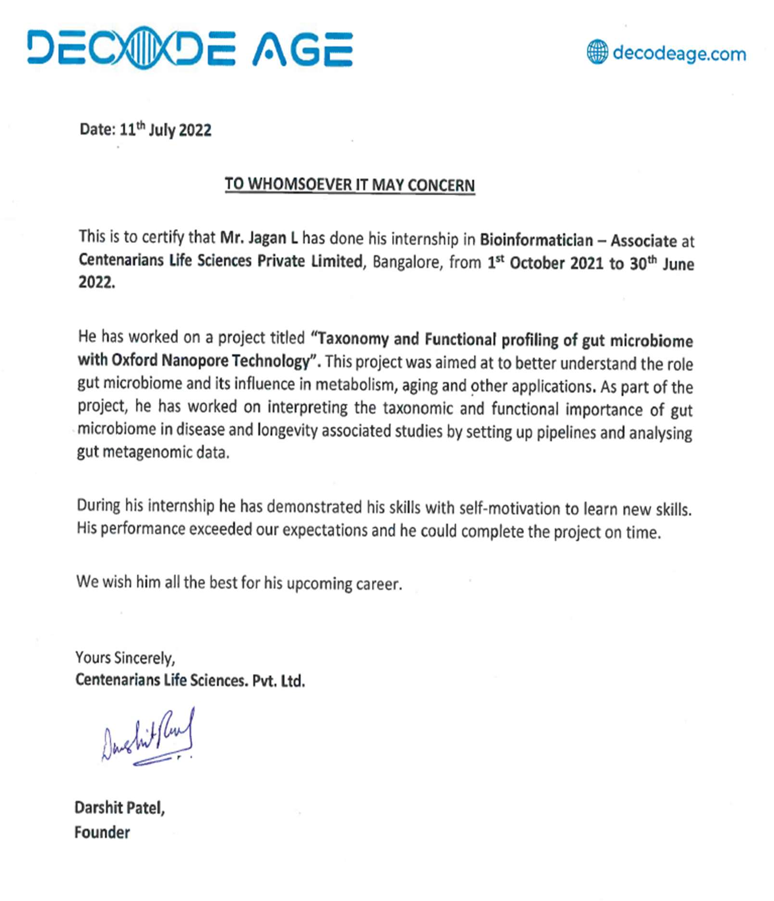

Title: Database management for an efficient storage model of 16S metagenomics data

Internship duration: 29th November 2022 to 29th may 2023