LAB REPORT

OBJECT-ORIENTED PROGRAM

The Very First Java Programs

2.2.1 Write, compile the first Java application:

Result:

2.2.2 Write, compile the first dialog Java program

Result:

2.2.3 Write, compile the first input dialog Java application:

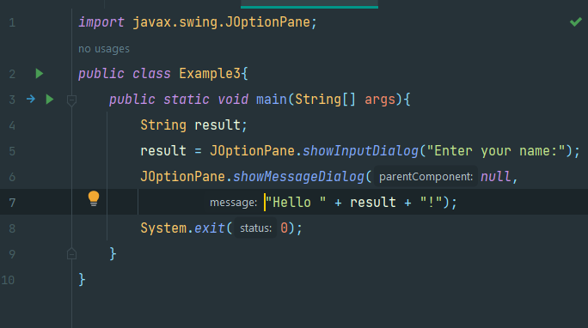

Result:

2.2.4 Write, compile, and run the example:

2.2.5 Write a calculator program:

Result:

2.2.6 Solve equations:

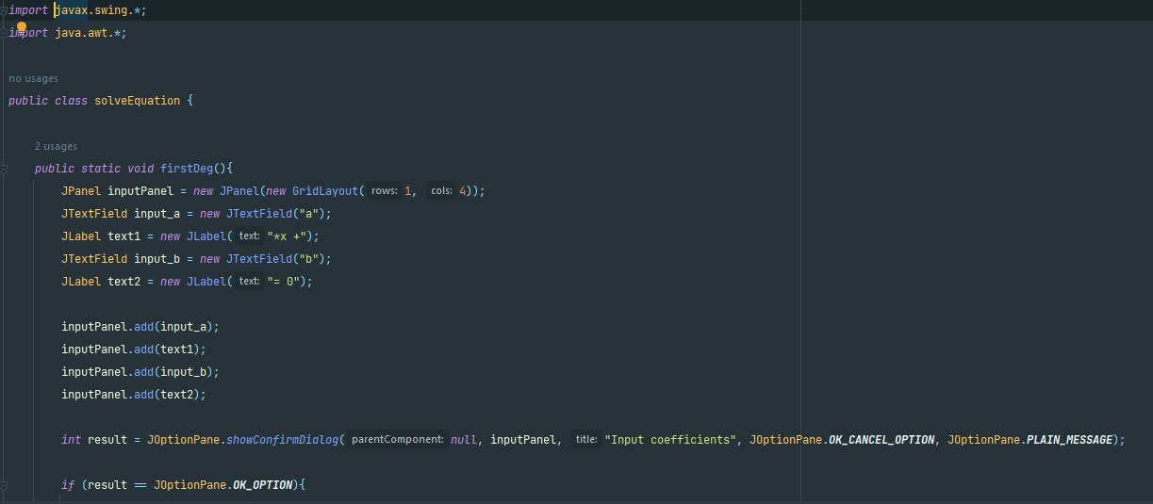

Result:

6.1 *Write, compile and run the ChoosingOption program:*

6.2 *Write a program for input/output from keyboard:*

Result:

6.3 *Write a program to display a triangle with a height of n stars (\*), n is entered by users.:*

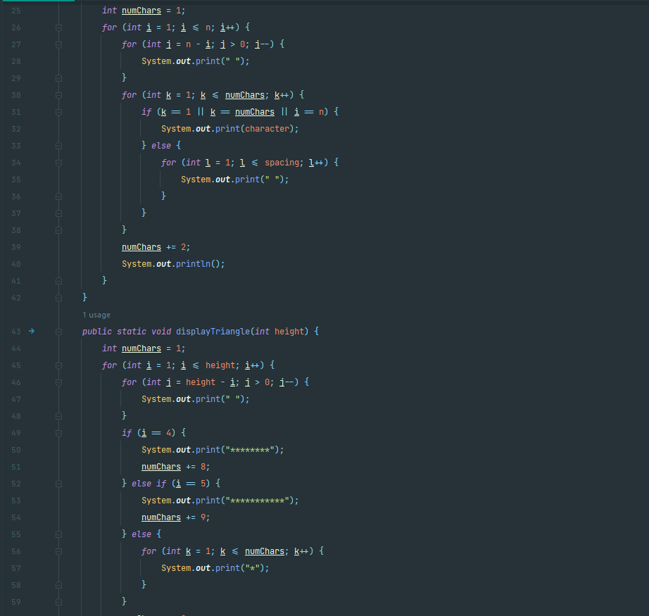

Result:

6.4 Write a program to display the number of days of a month:

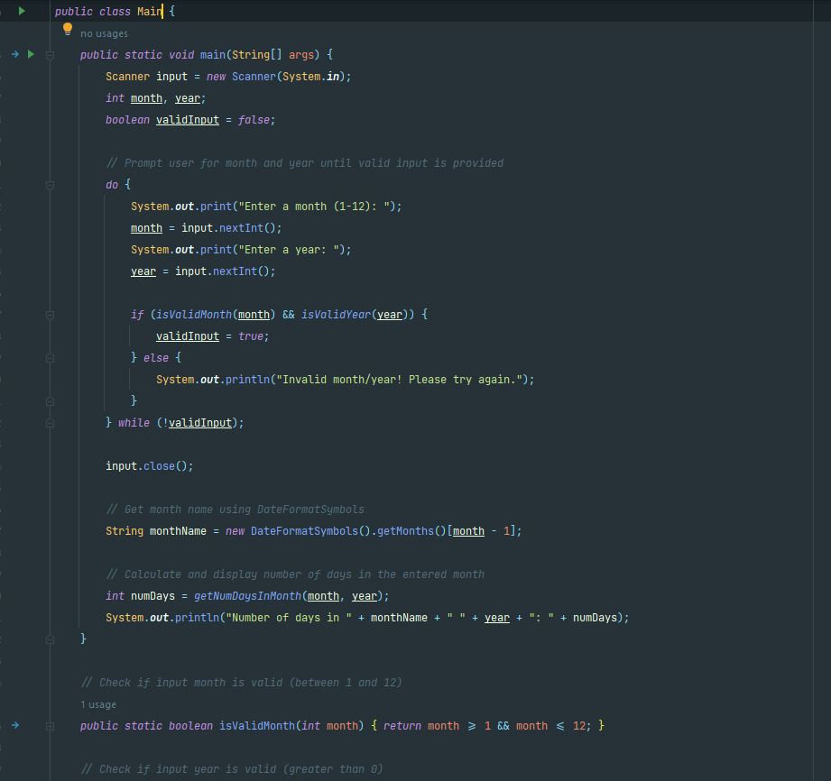

Result:

6.5 *Write a Java program to sort a numeric array, and calculate the sum and average value of array* *elements:*

Result:

6.6 *Write a Java program to add two matrices of the same size:*

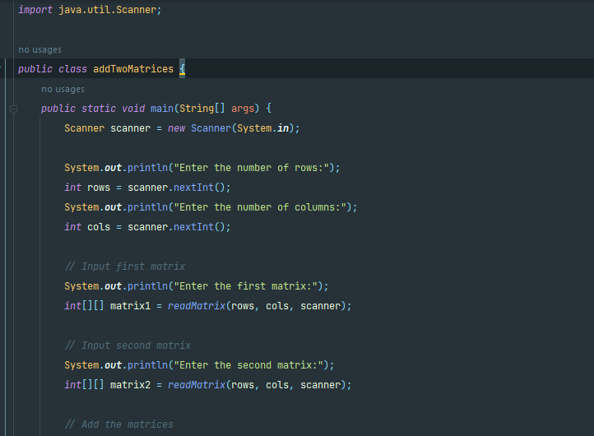

Result:

