LAB REPORT

Vu Duc An – 20215174

1. Branch repository: A screenshot of a computer

   Description automatically generated
2. Working with method overloading
   1. Overloading by differing types of parameter: A screen shot of a computer code

      Description automatically generated with low confidence
   2. Overloading by differing the number of parameters:

1. Passing parameter:

- Question: Is JAVA a Pass by Value or a Pass by Reference programming language?

-Answer: JAVA is a Pass by Value language.

1. Use debug run:
   1. Debugging Java in Eclipse
   2. Example of debug run for the swap method of TestPassingParameter:

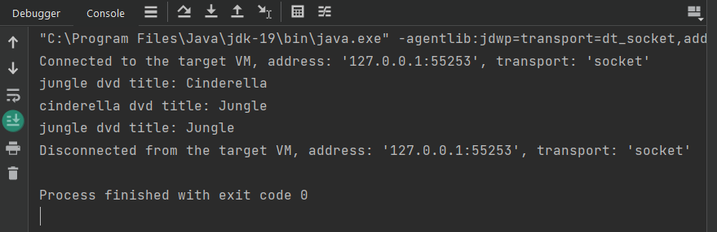

* + 1. Setting, deleting & deactivate breakpoints:

* + 1. Run in Debug mode:
    2. Step Into, Step Over, Step Return, Resume:
    3. Investigate value of variables:

* + 1. Change value of variables:

1. Classifier Member and Instance Member
2. Open the Cart class
3. Implement the Store class
4. Re-organize your projects
5. String, StringBuilder and StringBuffer
6. Release flow demonstration
   1. Hypothesis
   2. Demonstration