LAB REPORT

Vu Duc An – 20215174

1. Import the existing project into the workspace of Eclipse
2. Additional requirements of AIMS
3. Creating the Book class:

1. Creating the abstract Media class

1. Creating the CompactDisc class

* 1. Create the Disc class extending the Media class

* 1. Create the Track class which models a track on a compact disc and will store information incuding the title and length of the track

* 1. Open the CompactDisc class

1. Create the Playable interface

1. Update the Cart class to work with Media

1. Update the Store class to work with Media

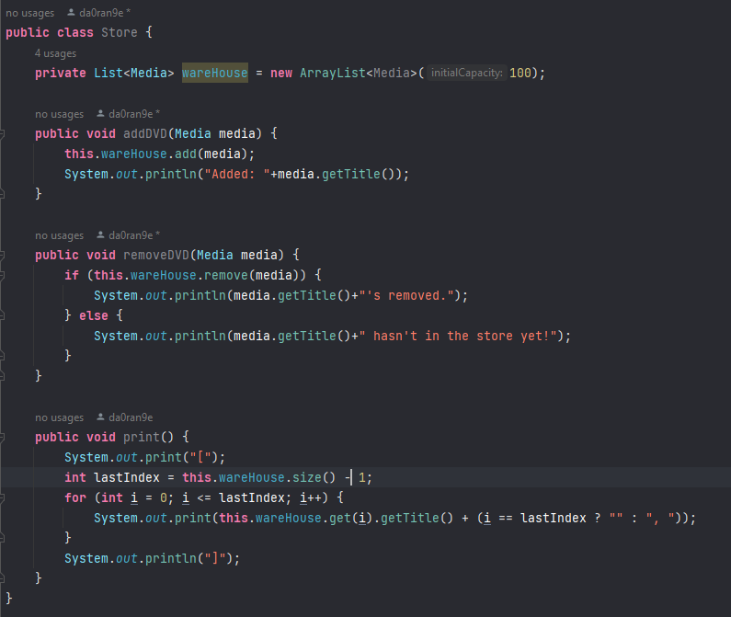

1. Constructors of whole classes and parent classes

1. Unique item in a list
2. Polymorphism with toString() method
3. Sort media in the cart
4. Create a complete console application in the Aims class