LAB REPORT

VuDucAn – 20215174

1. UML & Astah:

Try to create some diagrams

Class diagram:

Activity diagram:

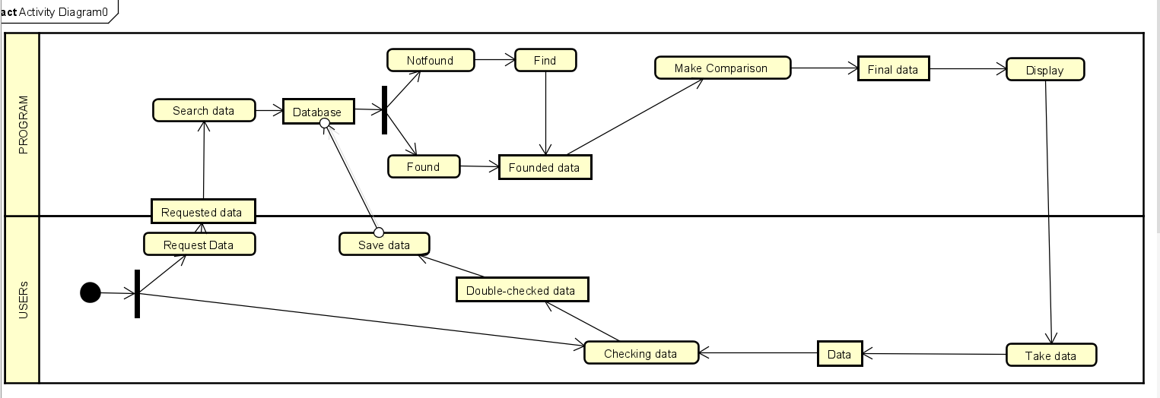

1. Problem Statement of AIMS Project
2. Use case diagram

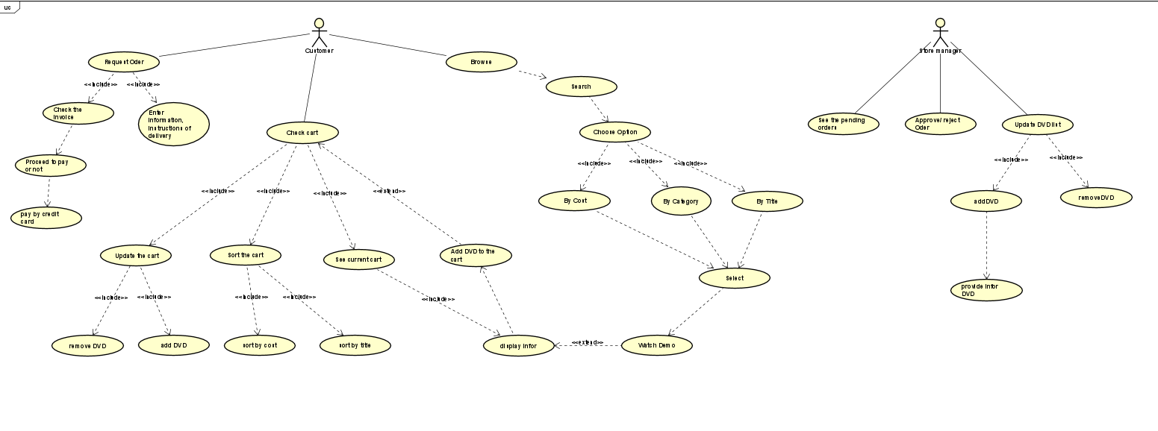

1. UML Class Diagram for use cases related to cart management

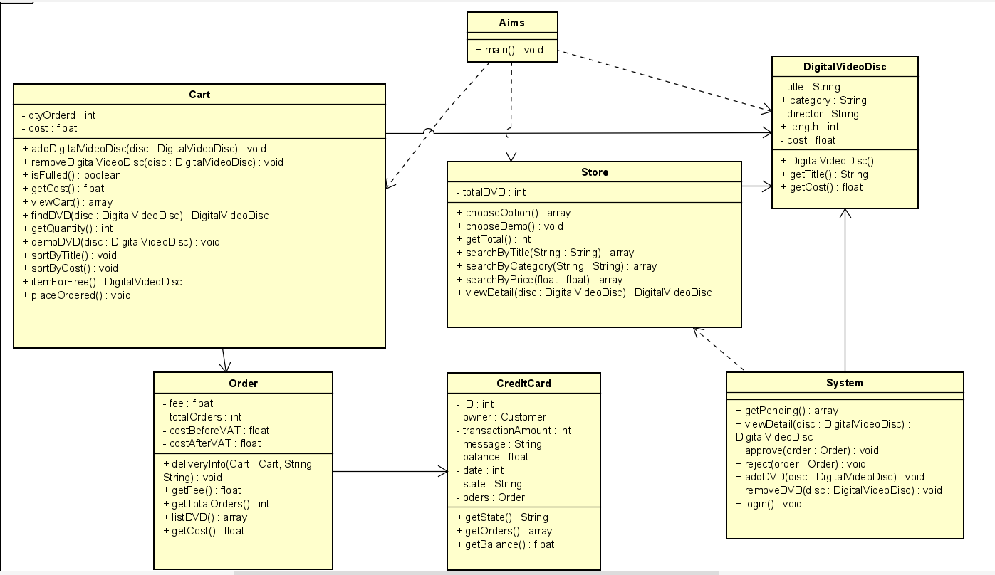

1. Create Aims class

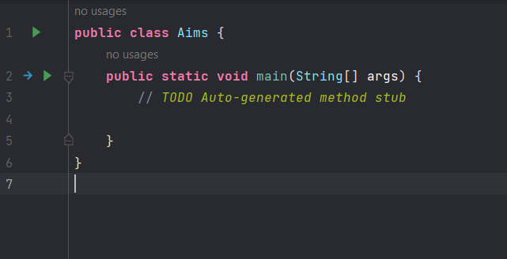

1. Create the DigitalVideoDisc class and its attributes

1. Create accessors and mutators for the class DigitalVideoDisc

1. Create Constructor method

**Question:**- If you create a constructor method to build a **DVD** by title then create a constructor method to build  
a **DVD** by category. Does JAVA allow you to do this?

**Answer:**

-No, because the title parameter already was a String

9. Create the Cart class to work with DigitalVideoDisc

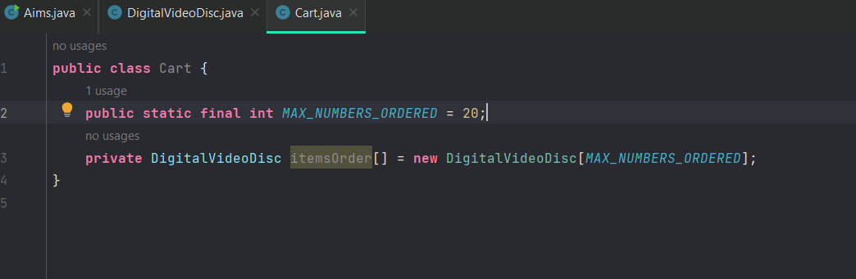

1. Create Carts of DigitalVideoDiscs:

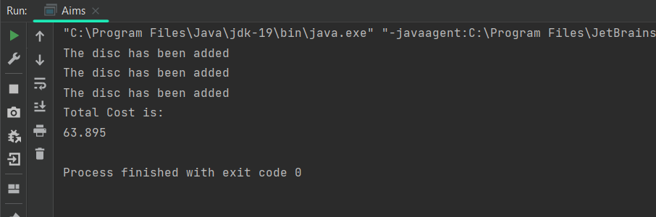

1. Removing items from the cart

