Lesson 102 – Mesh Shapes
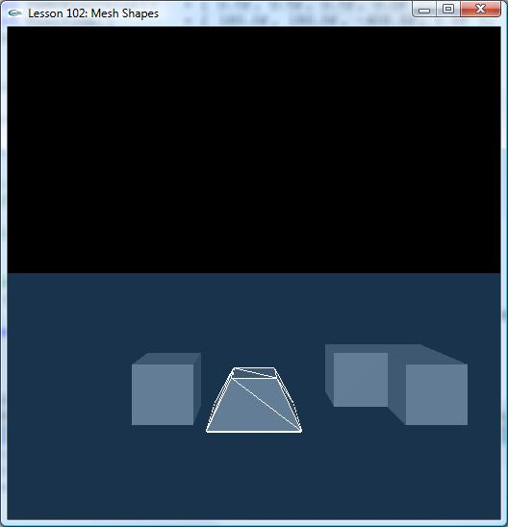

Introduction
In this lesson, we learn how to create convex mesh and triangle mesh shapes. Generally,
Convex mesh is used to create dynamic and static actors; triangle mesh is used to create
static actor. The initialization process is the same as Lesson 101. Here, we mainly illustrate the two functions: CreateConvexMesh() and CreateTriangleMesh()

Creating Convex Mesh
Convex mesh is meant to satisfy the need of using shapes that are more complex than primary shape, yet simpler and more efficient than the general mesh-mesh collision models. The maximum number of polygons for a convex mesh is limited to 256.

NxActor* CreateConvexMesh()
{
NxActorDesc actorDesc;
NxBodyDesc bodyDesc;

NxVec3 boxDim(1.5,0.75,1.5);
// Pyramid
NxVec3 verts[8] =
{ NxVec3(boxDim.x, -boxDim.y, -boxDim.z),
NxVec3(-boxDim.x, -boxDim.y, -boxDim.z),
NxVec3(-boxDim.x, -boxDim.y, boxDim.z),
NxVec3(boxDim.x, -boxDim.y, boxDim.z),
NxVec3(boxDim.x*0.5, boxDim.y, -boxDim.z*0.5),
NxVec3(-boxDim.x*0.5, boxDim.y, -boxDim.z*0.5),
NxVec3(-boxDim.x*0.5, boxDim.y, boxDim.z*0.5),
NxVec3(boxDim.x*0.5, boxDim.y, boxDim.z*0.5)
};

// Create descriptor for convex mesh
if (!convexDesc)
{
convexDesc = new NxConvexMeshDesc();
assert(convexDesc);
}
convexDesc->numVertices = 8;
convexDesc->pointStrideBytes = sizeof(NxVec3);
convexDesc->points = verts;
convexDesc->flags = NX_CF_COMPUTE_CONVEX;

NxConvexShapeDesc convexShapeDesc;
convexShapeDesc.localPose.t = NxVec3(0,boxDim.y,0);
convexShapeDesc.userData = convexDesc;

// Two ways on cooking mesh: 1. Saved in memory, 2. Saved in file
NxInitCooking();
// Cooking from memory
MemoryWriteBuffer buf;
bool status = NxCookConvexMesh(*convexDesc, buf);
//
// Please note about the created Convex Mesh, user needs to release it when no //one uses it to save memory. It can be detected
// by API "meshData->getReferenceCount() == 0". And, the release API is //"gPhysicsSDK->releaseConvexMesh(*convexShapeDesc.meshData);"

NxConvexMesh *pMesh = gPhysicsSDK->createConvexMesh(MemoryReadBuffer(buf.data));
assert(pMesh);
convexShapeDesc.meshData = pMesh;
NxCloseCooking();

if (pMesh)
{
// Save mesh in userData for drawing.
pMesh->saveToDesc(*convexDesc);
//
NxActorDesc actorDesc;
assert(convexShapeDesc.isValid());
actorDesc.shapes.pushBack(&convexShapeDesc);
actorDesc.body = &bodyDesc;
actorDesc.density = 1.0f;

actorDesc.globalPose.t = NxVec3(0.0f, 0.0f, 0.0f);
assert(actorDesc.isValid());
NxActor* actor = gScene->createActor(actorDesc);
assert(actor);
return actor;
}

return NULL;
}

Creating Triangle Mesh
A triangle mesh is helpful in creating more complex shapes such as terrain etc. When creating triangle mesh, there are 2 notes to be paid more attention. One is that triangles’ normal is not passed explicitly and is assumed to be (v1-v0) x (v2-v0). We make sure that we define face normal in the direction we expect Collision detection will only work correctly. The other is that we mustn’t duplicate identical vertices. If we create two copies of the vertex, the collision detection code won’t know that it is actually the same vertex which leads to decrease performance and unreliable results.

NxActor* CreateTriangleMesh()
{
NxVec3 boxDim(1.0f, 1.0f, 1.0f);
// Supply hull

NxVec3 verts[8] =
{ NxVec3(-boxDim.x, -boxDim.y, -boxDim.z),
NxVec3(boxDim.x, -boxDim.y, -boxDim.z),
NxVec3(-boxDim.x, boxDim.y, -boxDim.z),
NxVec3(boxDim.x, boxDim.y, -boxDim.z),
NxVec3(-boxDim.x, -boxDim.y, boxDim.z),
NxVec3(boxDim.x, -boxDim.y, boxDim.z),
NxVec3(-boxDim.x, boxDim.y, boxDim.z),
NxVec3(boxDim.x, boxDim.y, boxDim.z),
};

// Triangles is 12*3
NxU32 indices[12*3] =
{ 1,2,3,
0,2,1,
5,4,1,
1,4,0,
1,3,5,
3,7,5,
3,2,7,
2,6,7,
2,0,6,
4,6,0,
7,4,5,
7,6,4
};

NxU16 indices16[12*3] =
{ 1,2,3,
0,2,1,
5,4,1,
1,4,0,
1,3,5,
3,7,5,
3,2,7,
2,6,7,
2,0,6,
4,6,0,
7,4,5,
7,6,4
};

// Create descriptor for triangle mesh
if (!triangleMeshDesc)
{
triangleMeshDesc = new NxTriangleMeshDesc();
assert(triangleMeshDesc);
}
triangleMeshDesc->numVertices = 8;
triangleMeshDesc->pointStrideBytes = sizeof(NxVec3);
triangleMeshDesc->points = verts;
triangleMeshDesc->numTriangles = 12;
triangleMeshDesc->flags = 0;
triangleMeshDesc->triangles = indices;
triangleMeshDesc->triangleStrideBytes = 3 * sizeof(NxU32);

//Alternative: see NxMeshFlags
//triangleMeshDesc->flags = NX_MF_16_BIT_INDICES
//triangleMeshDesc->triangles = indices16;
//triangleMeshDesc->triangleStrideBytes = 3 * sizeof(NxU16);

// The actor has one shape, a triangle mesh
NxInitCooking();
MemoryWriteBuffer buf;

bool status = NxCookTriangleMesh(*triangleMeshDesc, buf);
NxTriangleMesh* pMesh;
if (status)
{
pMesh = gPhysicsSDK->createTriangleMesh(MemoryReadBuffer(buf.data));
}
else
{
assert(false);
pMesh = NULL;
}
NxCloseCooking();
// Create TriangleMesh above code segment.

NxTriangleMeshShapeDesc tmsd;
tmsd.meshData = pMesh;
tmsd.userData = triangleMeshDesc;
tmsd.localPose.t = NxVec3(0, boxDim.y, 0);
tmsd.meshPagingMode = NX_MESH_PAGING_AUTO;

NxActorDesc actorDesc;
NxBodyDesc bodyDesc;

assert(tmsd.isValid());
actorDesc.shapes.pushBack(&tmsd);
//Dynamic triangle mesh don't be supported anymore. So body = NULL
actorDesc.body = NULL;
actorDesc.globalPose.t = NxVec3(3.0f, 0.0f, 0.0f);

if (pMesh)
{
// Save mesh in userData for drawing
pMesh->saveToDesc(*triangleMeshDesc);
//
assert(actorDesc.isValid());
NxActor *actor = gScene->createActor(actorDesc);
assert(actor);

return actor;
}

return NULL;
}

Conclusion
We should now know how to create Convex mesh and Triangle mesh.

Related Classes, Functions, and Parameters
NxTriangleMeshDesc
NxConvexMeshDesc
NxTriangleMeshShapeDesc
NxConvexShapeDesc
NxInitCooking
NxCookConvexMesh
NxCookTriangleMesh
createConvexMesh
createTriangleMesh
NxCloseCooking

