Lesson 103 – Compound

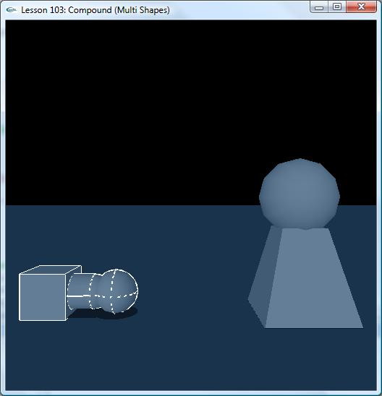

Introduction
The SDK is initialized with the same parameters as the previous two lessons. The scene is initialized with the same default material and ground plane. InitNx() now creates two actors which are composed of multi shapes. Refer to two main functions:
CreatePrimaryMultiShape() and CreateMeshMultiShape().

CreatePrimaryMultiShape() & CreateMeshMultiShape()
Actually, compound is such an actor that multi different shapes or same shapes are assembled together and each shape still remains its own characteristic.

NxActor* CreatePrimaryMultiShape()
{
// Create an actor which is composed of Box, Capsule and Sphere.
NxActorDesc actorDesc;
NxBodyDesc bodyDesc;

//Box Shape
NxBoxShapeDesc boxShape;
boxShape.dimensions = NxVec3(1.0f, 1.0f, 1.0f);
boxShape.localPose.t = NxVec3(1.5f, 0.0f, 0.0f);
assert(boxShape.isValid());
actorDesc.shapes.pushBack(&boxShape);

//Capsule Shape
NxCapsuleShapeDesc capsuleDesc;
capsuleDesc.radius = 0.8f;
capsuleDesc.height = 1.0f;
capsuleDesc.localPose.t = NxVec3(0.0f, 0.0f, 0.0f);
//Rotate capsule 90 degree around z axis
NxQuat quat(90.0f, NxVec3(0, 0, 1));
NxMat33 m;
m.id();
m.fromQuat(quat);
capsuleDesc.localPose.M = m;
assert(capsuleDesc.isValid());
actorDesc.shapes.pushBack(&capsuleDesc);

//Sphere Shape
NxSphereShapeDesc sphereDesc;
sphereDesc.radius = 1.0f;
sphereDesc.localPose.t = NxVec3(-1.5f, 0.0f, 0.0f);
assert(sphereDesc.isValid());
actorDesc.shapes.pushBack(&sphereDesc);

actorDesc.body = &bodyDesc;
actorDesc.density = 1.0f;
actorDesc.globalPose.t = NxVec3(5.0f, 0.0f, 0.0f);
assert(actorDesc.isValid());
NxActor *pActor = gScene->createActor(actorDesc);
assert(pActor);
return pActor;
}

NxActor* CreateMeshMultiShape()
{
// Create an actor which is composed of Convex and Sphere.

NxActorDesc actorDesc;
NxBodyDesc bodyDesc;

//Convex Shape
NxVec3 boxDim(2.0f, 2.0f, 2.0f);

NxVec3 verts[8] =
{ NxVec3(boxDim.x, -boxDim.y, -boxDim.z),
NxVec3(-boxDim.x, -boxDim.y, -boxDim.z),
NxVec3(-boxDim.x, -boxDim.y, boxDim.z),
NxVec3(boxDim.x, -boxDim.y, boxDim.z),
NxVec3(boxDim.x*0.5, boxDim.y, -boxDim.z*0.5),
NxVec3(-boxDim.x*0.5, boxDim.y, -boxDim.z*0.5),
NxVec3(-boxDim.x*0.5, boxDim.y, boxDim.z*0.5),
NxVec3(boxDim.x*0.5, boxDim.y, boxDim.z*0.5)
};

// Create descriptor for convex mesh
if (!convexDesc)
convexDesc = new NxConvexMeshDesc();
assert(convexDesc);
convexDesc->numVertices = 8;
convexDesc->pointStrideBytes = sizeof(NxVec3);
convexDesc->points = verts;
convexDesc->flags = NX_CF_COMPUTE_CONVEX;

NxConvexShapeDesc convexShapeDesc;
convexShapeDesc.localPose.t = NxVec3(0,boxDim.y,0);
convexShapeDesc.userData = convexDesc;

NxInitCooking();
// Cooking from memory
MemoryWriteBuffer buf;
bool status = NxCookConvexMesh(*convexDesc, buf);
//
// Please note about the created Convex Mesh, user needs to release it when no //one uses it to save memory. It can be detected
// by API "meshData->getReferenceCount() == 0". And, the release API is //"gPhysicsSDK->releaseConvexMesh(*convexShapeDesc.meshData);"
//
NxConvexMesh *pMesh = gPhysicsSDK->createConvexMesh(MemoryReadBuffer(buf.data));
assert(pMesh);
convexShapeDesc.meshData = pMesh;
NxCloseCooking();

if (pMesh)
{
// Save mesh in userData for drawing.
pMesh->saveToDesc(*convexDesc);
//
assert(convexShapeDesc.isValid());
actorDesc.shapes.pushBack(&convexShapeDesc);
}

//Sphere Shape
NxSphereShapeDesc sphereDesc;
sphereDesc.radius = 1.8f;
sphereDesc.localPose.t = NxVec3(0.0f, 5.4f, 0.0f);
assert(sphereDesc.isValid());
actorDesc.shapes.pushBack(&sphereDesc);

actorDesc.body = &bodyDesc;
actorDesc.density = 1.0f;
actorDesc.globalPose.t = NxVec3(-5.0f, 0.0f, 0.0f);
assert(actorDesc.isValid());
NxActor *pActor = gScene->createActor(actorDesc);
assert(pActor);

return pActor;
}

Conclusion
We should now know how to create compound.

Related Classes, Functions, and Parameters
NxCapsuleShapeDesc
height
radius
localPose

NxBoxShapeDesc
dimensions
localPose

NxSphereShapeDesc
radius
localPose

NxConvexMeshDesc

NxConvexShapeDesc

NxActor
globalPose

