Lesson 104 – Actors

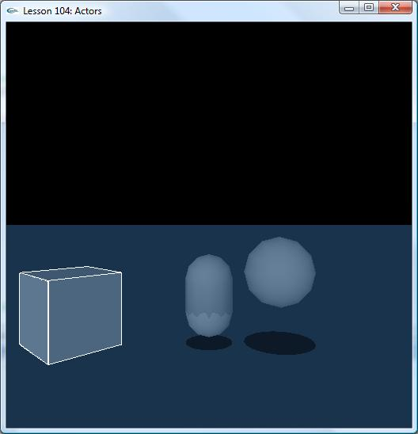

Introduction
In this lesson, we learn how to create three types of actors: dynamic, kinematic and static.

Dynamic, Kinematic & Static
Dynamic and kinematic actors both belong to dynamic actors. Kinematic actor can only be transferred from one position to another position and can’t be moved by applying force to it.
Create a static actor by setting the body member to NULL in the actor descriptor. Once static actor is created, do not do anything with it. i.e. changing position, adding more shapes and deleting etc.

NxActor* CreateDynamicActor()
{
NxActorDesc actorDesc;
NxBodyDesc bodyDesc;

//
NxBoxShapeDesc boxDesc;
boxDesc.dimensions = NxVec3(1.5f, 1.5f, 1.5f);
actorDesc.shapes.pushBack(&boxDesc);

actorDesc.density = 1.0f;
actorDesc.body = &bodyDesc;
actorDesc.globalPose.t = NxVec3(3.0f, 0.0f, 0.0f);

NxActor *pActor = gScene->createActor(actorDesc);
assert(pActor);

return pActor;
}

NxActor* CreateKinematicActor()
{
NxActorDesc actorDesc;
NxBodyDesc bodyDesc;
bodyDesc.flags |= NX_BF_KINEMATIC;
//
NxCapsuleShapeDesc capsuleDesc;
capsuleDesc.radius = 1.0f;
capsuleDesc.height = 1.5f;
actorDesc.shapes.pushBack(&capsuleDesc);

actorDesc.density = 1.0f;
actorDesc.body = &bodyDesc;
actorDesc.globalPose.t = NxVec3(0.0f, 2.0f, 0.0f);

NxActor *pActor = gScene->createActor(actorDesc);
assert(pActor);
//pActor->raiseBodyFlag(NX_BF_KINEMATIC);

return pActor;
}

NxActor* CreateStaticActor()
{
NxActorDesc actorDesc;
NxBodyDesc bodyDesc;

//
NxSphereShapeDesc sphereDesc;
sphereDesc.radius = 1.5f;
actorDesc.shapes.pushBack(&sphereDesc);

actorDesc.body = NULL;
actorDesc.globalPose.t = NxVec3(-3.0f, 3.0f, 0.0f);

NxActor *pActor = gScene->createActor(actorDesc);
assert(pActor);

return pActor;
}

Conclusion
We should now know how to create different actors.

Related Classes, Functions, and Parameters
NxBodyFlag
NX_BF_KINEMATIC

