Lesson 107 – Rigidbody Properties

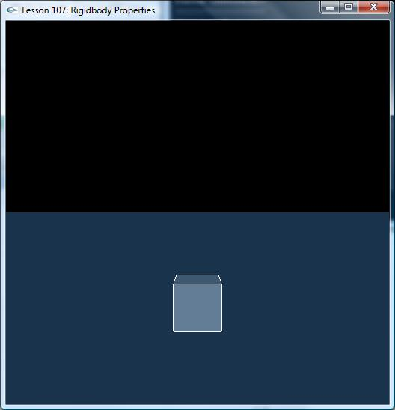

Introduction
Dynamic actors have a set of special properties that are used for rigid body simulation.
In this lesson, we learn how to apply these properties to rigid body.

Rigidbody Properties
All rigid body properties have a linear and angular version. The linear version is used in computations involving rectilinear motion along a path, and the angular version is used when the body is rotating. Most movement is a combination of both.

Initial settings for these properties may be assigned to NxBodyDesc * NxActorDesc::body, as well as queried and changed using appropriate methods of NxActor.

Linear Quantity | Angular Quantity
mass (scalar) | inertia (3-vector) - The mass distribution of the body along its three dimensions.
position (3-vector) - The position of the body's center of mass relative to the actor's frame. | orientation (quaternion or 3x3-matrix) - The orientation of the principal moments relative to the actor's frame.
velocity (3-vector) - Linear velocity. | angular velocity (3-vector) - Represented as an axis of rotation with a length equal to the magnitude of the angular velocity.
force (3-vector) - The amount of force that is being exerted on this body. | torque (3-vector) - The amount of angular force that is being exerted on this body. Represented as an axis of rotation with a length equal to the magnitude of the angular velocity.

void KeyboardCallback(unsigned char key, int x, int y)
{
gKeys[key] = true;

switch (key)
{
case 'r':
{
SelectNextActor();
break;
}
case 'e':
{
if (gSelectedActor)
{
gSelectedActor->setGlobalPosition(NxVec3(3.0f, 5.0f, 3.0f));
}
break;
}
case 'c':
{
if (gSelectedActor)
{
gSelectedActor->setLinearVelocity(NxVec3(10.0f, 0, 100));
}
break;
}
case 'v':
{
if (gSelectedActor)
{
gSelectedActor->setAngularVelocity(NxVec3(0, 1000.0f, 0));
}
break;
}
default: { break; }
}
}

void ProcessForceKeys()
{
if (!gSelectedActor) return;

// Process force keys
for (int i = 0; i < MAX_KEYS; i++)
{
if (!gKeys[i]) { continue; }

switch (i)
{
// Force controls
case 'i': { gForceVec = ApplyForceToActor(gSelectedActor,NxVec3(0,0,1),gForceStrength,bForceMode); break; }
case 'k': { gForceVec = ApplyForceToActor(gSelectedActor,NxVec3(0,0,-1),gForceStrength,bForceMode); break; }
case 'j': { gForceVec = ApplyForceToActor(gSelectedActor,NxVec3(1,0,0),gForceStrength,bForceMode); break; }
case 'l': { gForceVec = ApplyForceToActor(gSelectedActor,NxVec3(-1,0,0),gForceStrength,bForceMode); break; }
case 'u': { gForceVec = ApplyForceToActor(gSelectedActor,NxVec3(0,1,0),gForceStrength,bForceMode); break; }
case 'm': { gForceVec = ApplyForceToActor(gSelectedActor,NxVec3(0,-1,0),gForceStrength,bForceMode); break; }

// Return focus actor to (0,5,0)
case 't':
{
gSelectedActor->setGlobalPosition(NxVec3(0,5,0));
gScene->flushCaches();
break;
}
}
}
}

Conclusion
New things you should have learned: how to build a static actor, how to turn a dynamic actor into a kinematic one and back to a dynamic actor again, how to use moveGlobalPosition(), and how to use setGlobalPosition().

Related Classes, Functions, and Parameters
NxActor
setGlobalPosition()
moveGlobalPosition()
readBodyFlag()
raiseBodyFlag()
clearBodyFlag()
setLinearVelocity()
setAngularVelocity()
addForce()
addTorque()

