Lesson 109 – Collision Groups

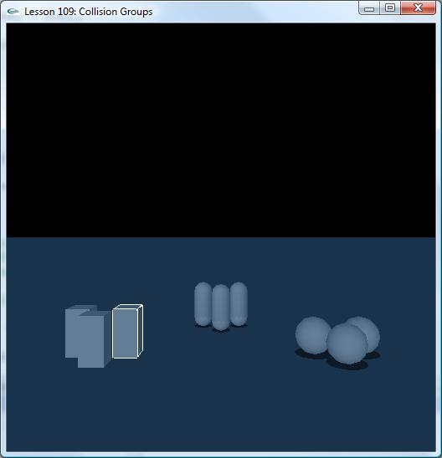

Introduction
This training program teaches you about collision groups. A collision group is used to mark collections of shapes in the scene as collidable with none, some, or all other collision groups. All shapes start out in collision group 0 by default.

Collision groups are useful for turning collision off for groups of shapes you don’t want colliding with other groups of shapes. You can also use collision groups to turn off certain groups of shapes you want to ignore when casting a ray through the scene.

Collision Groups
We create 3 sets of objects (3 boxes, 3 capsules, and 3 spheres) and place them on the ground.

// Actor globals
NxActor* groundPlane = NULL;
NxActor* box1 = NULL;
NxActor* box2 = NULL;
NxActor* box3 = NULL;
NxActor* sphere1 = NULL;
NxActor* sphere2 = NULL;
NxActor* sphere3 = NULL;
NxActor* capsule1 = NULL;
NxActor* capsule2 = NULL;
NxActor* capsule3 = NULL;
…
void InitNx()
{
…
// Create the objects in the scene
groundPlane = CreateGroundPlane();

box1 = CreateBox(NxVec3(6,0,1), NxVec3(0.5,1,0.5), 20);
box2 = CreateBox(NxVec3(5,0,0.25), NxVec3(0.5,1,0.5), 20);
box3 = CreateBox(NxVec3(4,0,1), NxVec3(0.5,1,0.5), 20);

capsule1 = CreateCapsule(NxVec3(1,0,6), 1.5, 0.5, 20);
capsule2 = CreateCapsule(NxVec3(0,0,5), 1.5, 0.5, 20);
capsule3 = CreateCapsule(NxVec3(-1,0,6), 1.5, 0.5, 20);

sphere1 = CreateSphere(NxVec3(-6,0,1), 0.8, 20);
sphere2 = CreateSphere(NxVec3(-5,0,-0.25), 0.8, 20);
sphere3 = CreateSphere(NxVec3(-4,0,1), 0.8, 20);

InitActorCollisionGroups();
InitContactReportsPerPair();
...
gSelectedActor = box3;
…
}

We then call InitActorCollisionGroups().

void SetActorCollisionGroup(NxActor *actor, NxCollisionGroup group)
{
NxU32 nbShapes = actor->getNbShapes();
NxShape*const* shapes = actor->getShapes();

while (nbShapes--)
{
shapes[nbShapes]->setGroup(group);
}
}

void InitActorCollisionGroups()
{
SetActorCollisionGroup(box1, 1);
SetActorCollisionGroup(box2, 1);
SetActorCollisionGroup(box3, 1);

SetActorCollisionGroup(capsule1, 2);
SetActorCollisionGroup(capsule2, 2);
SetActorCollisionGroup(capsule3, 2);

SetActorCollisionGroup(sphere1, 3);
SetActorCollisionGroup(sphere2, 3);
SetActorCollisionGroup(sphere3, 3);

gScene->setGroupCollisionFlag(1,2,true);
gScene->setGroupCollisionFlag(2,3,true);
gScene->setGroupCollisionFlag(1,3,false);
}

Collision groups are assigned to shapes, so we must get the shapes from each actor and set each of them separately.

Notice the boxes are assigned to collision group 1, the capsules are assigned to collision group 2, and the spheres are assigned to collision group 3. Note also, the ground plane shape is assigned to collision group 0, by default.

Setting up groups like this does nothing without setting the collision group flags, which get set in the last lines of the function.

gScene->setGroupCollisionFlag(1,2,true);
gScene->setGroupCollisionFlag(2,3,true);
gScene->setGroupCollisionFlag(1,3,false);

So group 1 (the boxes) is set to collide with group 2 (the capsules). Group 2 (the capsules) is set to collide with group 3 (the spheres). Group 1 (the boxes) is then set not to collide with group 3 (the spheres).

Try playing the demo. Notice everything collides as usual, except the boxes do not collide with the spheres. Try setting the capsules not to collide with the ground plane (collision group 0).

gPhysicsSDK->setGroupCollisionFlag(0,2,false);

The capsules immediately fall through the floor once the simulation begins. They are still affected by gravity and have nothing to hold them up once they are set not to collide with the floor. If you want to keep them above ground, you need to disable gravity.

Contact Pairs and Collision Groups
We have attached a contact report to the SDK (c.f. “Lesson 302: Contacts”) and set up each box and each sphere as a contact pair. Set a breakpoint on the first “y = 0” in CheckContacts(), run the demo, and push a box into a sphere.

void CheckContacts()
{
NxU32 nbActors = gScene->getNbActors();
NxActor** actors = gScene->getActors();
while (nbActors--)
{
NxActor* actor = *actors++;

// Get our object back
GameObject* Object = (GameObject*)actor->userData;
if(!Object) continue;

if (Object->events != 0)
{
NxU32 y;
y = 0;
}
…
}
…
}

The contact between the box and the sphere does not get reported. If two objects are set not to collide, even if they are set up as contact pairs, their collision will not be reported as in actuality no contact between them has occurred.

This is the distinction between collision groups and contact pairs. Collision groups are collections of shapes marked to collide or not to collide with other collections of shapes. Use them to enable or disable collision between groups of shapes. Contact pairs are pairs of actors designated by the user to send back collision and contact information when they are in contact with one another. Use them to determine the points of contact in a collision between two actors.

There is a lone actor flag called NX_AF_DISABLE_COLLISION. It is independent of collision groups and can be set to disable collision between an actor and the rest of the world.

NxActor* box = NULL;
…
box->raiseActorFlag(NX_AF_DISABLE_COLLISION);

The disables collision between the world and all collision shapes within the actor.

Uses for Collision Groups
Collision groups are used when the user wants one group of objects to be unaffected by another through collision for whatever reason. Often groups are marked as uncollidable with other groups for performance. The two groups of shapes are never checked against each other. Computation to determine collision between the two groups of shapes is never performed.

Sometimes groups are marked as uncollidable for a particular effect, like a character wading through a morass of goo or debris. It might look strange for certain debris to bounce off the character like a rigid body does. It may be possible to tune the behaviour of the debris, but this tuning can be time consuming. In effect, you are saying the character has negligible effect on these objects when walking through them, they mostly are crushed underfoot and close up behind him as if he were walking through water or over a thick carpet. Just turning collisions off between the character and the debris with collision groups will achieve what you want.

Collision groups can be used to keep dynamics from interfering with gameplay. Sometimes you want to turn dynamics off if the results have a negligible or even negative impact on gameplay. If you’re having trouble with actors sticking or colliding in an unseemly fashion in certain special cases, you may want to mark them as uncollidable and let them pass through each other if there is little visible result or if the visible result of a non-collision is desired.

There are certain gameplay functions like pathfinding or raycasting, where collisions are unwanted. If an AI is trying to avoid obstacles using collision detection in a cluttered scene, you may want to mark some objects as obstacles and ignore the rest. The AI might be able to ignore most objects, it will walk right over rocks and light debris, but will want to avoid other objects, like a boulder or table.

For line-of-sight raycasts, you may want to put all transparent or semi-transparent objects into a single collision group: they will collide with each other and other non-transparent objects, but will not obstruct a line-of-sight raycast.

Conclusion
New things you should have learned: what collision groups are, how to assign different shapes to different collision groups, how to enable and disable collisions between collision groups, how to disable collision between an actor and the world, and uses for collision groups.

Related Classes, Functions, and Parameters
NxCollisionGroup

NxPhysicsSDK
setCollisonGroupFlag()

NxShape
setGroup()

NxActorFlag
NX_AF_DISABLE_COLLISION

