Lesson 111 – Dynamic CCD

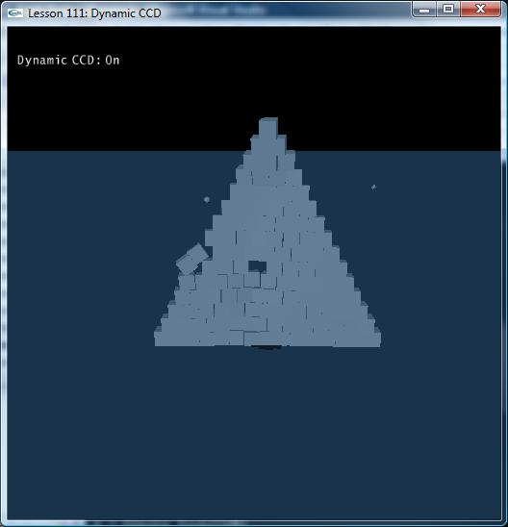

Introduction
Continuous collision detection is required to prevent fast-moving objects from tunneling through other objects. PhysX does a broad phase collision sweep that catches most collisions, though small, high-speed objects will still pass through undetected. To remedy this, you can turn on continuous collision detection. In the current version of the SDK, CCD is supported for dynamic vs. dynamic objects and dynamic vs. static objects.

Continuous Collision Detection
This effect is known as tunneling. Imagine a bullet traveling towards a thin metal plate, in the first time step it would be on one side and in the next it would be on the other. The SDK would never detect a collision and hence not constrain the motion of the bullet. To deal with this problem, CCD tests an extruded volume which represents the object's motion during the whole time step. If a collision is detected, the time of impact can be computed and the object's motion constrained appropriately

To enable CCD computations for the scene, the NX_CONTINUOUS_CD must be set. Turn on continuous collision detection in InitNx().

// CCD globals
bool bCCDEnabled = true;
...
void InitNx()
{
......
// Turn on continuous collision detection for dynamic objects
gPhysicsSDK->setParameter(NX_CONTINUOUS_CD, bCCDEnabled);
gPhysicsSDK->setParameter(NX_CCD_EPSILON, 0.01);
......
}

NxParameter::NX_CCD_EPSILON is a constant used to avoid numerical imprecision, so it should be set to a small value.

Dynamic-dynamic CCD
Hit “1”, “2”, or “3” to create a small pyramid of boxes, a large pyramid of boxes, or a tower of boxes.

void SpecialKeys(unsigned char key, int x, int y)
{
switch(key)
{
case '1': CreateStack(10); break;
case '2': CreateStack(15); break;
case '3': CreateTower(10); break;
...
}

Look at CreateStack().

void CreateStack(int size)
{
const float cubeSize = 0.2f;
const float spacing = 0;
NxVec3 pos(0,0,0);
float offset = -size * (cubeSize * 2.0f + spacing) * 0.5f;
while(size)
{
for(int i=0;i<size;i++)
{
pos.x = offset + (float)i * (cubeSize * 2.0f + spacing);
CreateCCDBox(pos, NxVec3(cubeSize, cubeSize, cubeSize), 10, false);
}

offset += cubeSize;
pos.y += (cubeSize * 2.0f + spacing);
size--;
}
}

CreateStack() calls CreateCCDBox() to generate the boxes that make the stack.

NxActor* CreateCCDBox(const NxVec3& pos, const NxVec3& boxDim, const NxReal density, bool doDynamicCCD)
{
// Add a single-shape actor to the scene
NxActorDesc actorDesc;
NxBodyDesc bodyDesc;

// The actor has one shape, a box
NxBoxShapeDesc boxDesc;
boxDesc.dimensions.set(boxDim.x,boxDim.y,boxDim.z);
boxDesc.localPose.t = NxVec3(0,boxDim.y,0);

// Set box up with CCD skeleton
boxDesc.ccdSkeleton = CreateCCDSkeleton(boxDim.x*0.8f);
if (doDynamicCCD) boxDesc.shapeFlags |= NX_SF_DYNAMIC_DYNAMIC_CCD; // Activate dynamic-dynamic CCD for this body

actorDesc.shapes.pushBack(&boxDesc);

if (density)
{
actorDesc.body = &bodyDesc;
actorDesc.density = density;
}
else
{
actorDesc.body = NULL;
}
actorDesc.globalPose.t = pos;
return gScene->createActor(actorDesc);
}

CreateCCDBox() creates a box actor from a box shape, just like our usual CreateBox() function, only with the addition that we build a CCD skeleton for the box shape.

// Set box up with CCD skeleton
boxDesc.ccdSkeleton = CreateCCDSkeleton(boxDim.x*0.8f);

This CCD skeleton is a convex mesh that conforms to the box.

NxCCDSkeleton* CreateCCDSkeleton(float size)
{
NxU32 triangles[3 * 12] = {
0,1,3,
0,3,2,
3,7,6,
3,6,2,
1,5,7,
1,7,3,
4,6,7,
4,7,5,
1,0,4,
5,1,4,
4,0,2,
4,2,6
};

NxVec3 points[8];

// Static mesh
points[0].set( size, -size, -size);
points[1].set( size, -size, size);
points[2].set( size, size, -size);
points[3].set( size, size, size);

points[4].set(-size, -size, -size);
points[5].set(-size, -size, size);
points[6].set(-size, size, -size);
points[7].set(-size, size, size);

NxSimpleTriangleMesh stm;
stm.numVertices = 8;
stm.numTriangles = 6*2;
stm.pointStrideBytes = sizeof(NxVec3);
stm.triangleStrideBytes = sizeof(NxU32)*3;

stm.points = points;
stm.triangles = triangles;
stm.flags |= NX_MF_FLIPNORMALS;
return gPhysicsSDK->createCCDSkeleton(stm);
}

Hit space to fire a small, fast box at your stack of boxes.

bool bFireCCDBox = false;
...
void SpecialKeys(unsigned char key, int x, int y)
{
switch(key)
{
...
case ' ':
{
bFireCCDBox = true;
}
break;
}
}

void ProcessInputs()
{
...
if (bFireCCDBox)
{
bFireCCDBox = false;
NxActor* ccdBox = CreateCCDBox(gCameraPos, NxVec3(0.1,0.1,0.1), 10, true);
NxVec3 vel = gCameraForward;
vel.normalize();
vel *= 344;
ccdBox->setLinearVelocity(vel);
}

We call CreateCCDBox() again, to make our projectile box, but this time we flag doDynamicCCD as true.

// Set box up with CCD skeleton
boxDesc.ccdSkeleton = CreateCCDSkeleton(boxDim.x*0.8f);
if (doDynamicCCD) boxDesc.shapeFlags |= NX_SF_DYNAMIC_DYNAMIC_CCD; // Activate dynamic-dynamic CCD for this body

NxShapeFlag::NX_SF_DYNAMIC_DYNAMIC_CCD activates dynamic CCD for the box we are firing. It will get special attention from the solver to make sure that it collides with other shapes that are fitted with continuous collision detection skeletons.
The speed of your box is 344 meters/sec, yet it will still collide with the stack of boxes you create.

Hit “c” to turn off continuous collision detection.

// CCD globals
bool bCCDEnabled = true;
bool bToggleCCDEnabled = false;

void SpecialKeys(unsigned char key, int x, int y)
{
switch(key)
{
case 'c':
{
bToggleCCDEnabled = true;
}
}
}
void ProcessInputs()
{
ProcessForceKeys();

if (bToggleCCDEnabled)
{
bToggleCCDEnabled = false;
bCCDEnabled = !bCCDEnabled;
gPhysicsSDK->setParameter(NX_CONTINUOUS_CD, bCCDEnabled);
RefreshDisplayString();
}
...
}

When you fire boxes with “v”, they will now pass right through your stacks as they are moving too fast to collide with Continuous collision detection removed.

CCD is performed with a skeleton mesh embedded within the object, which is simpler than the geometry used for discrete collision detection. The skeleton stops the object flying through other objects.To create a CCD skeleton, use createCCDSkeleton() function.
When CCD becomes active (see below for further information about this) it stops ALL motion for the actor, including lateral sliding motion, which may not be desirable. In order to stop this from happening too often, you want to make the CCD skeleton smaller than the actual shape (minus the skin width), so that the CCD skeleton only comes in contact with other objects when it is in deeper than normal penetration.

Conclusion
You should now know how to enable continuous collision detection for your scene, set your objects up with Continuous collision skeletons, and enable select objects for dynamic-dynamic continuous collision detection with objects fitted with these skeletons.

Related Classes, Functions, and Parameters
NxParameter
NX_CONTINUOUS_CD
NX_CCD_EPSILON

NxShapeFlag
NX_SF_DYNAMIC_DYNAMIC_CCD

NxSimpleTriangleMesh

NxPhysicsSDK
createCCDSkeleton()

NxActor
setLinearVelocity()

