Lesson 112 – Overlap

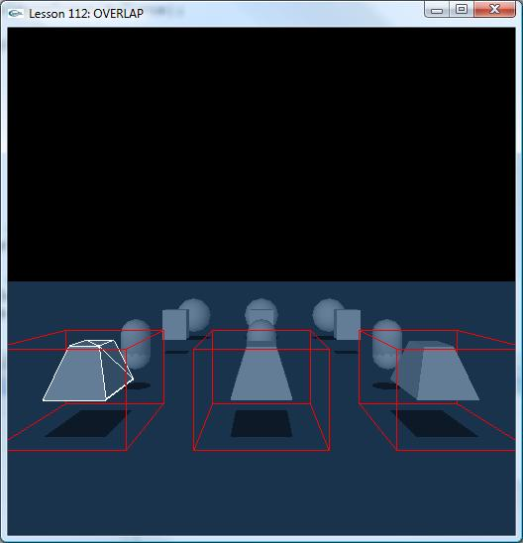

Introduction
In addition to providing Raycast and Trigger support, PhysX SDK provides a set of general methods for testing collision primitive directly against shapes. These are useful when the other collision methods do not fit the user's needs. In this lesson, we learn this kind of method of efficiently testing collision: overlap.

Overlap
Overlap provided by NxScene allows efficiently testing against the entire collision database, while methods of NxShape test against specific objects.
void Update()
{
……

int i = 0;
for (i = 0; i < 3; ++ i)
{
if (i == 0)
{
nbShapes = nbDynamicShapes;
type = NX_DYNAMIC_SHAPES;
switch(gOverlapType)
{
case OVERLAP_AABB:
case OVERLAP_CHECK_AABB:
worldBounds.set(gMIN, gMAX);
break;
case OVERLAP_OBB:
case OVERLAP_CHECK_OBB:
worldBox.center = gBoxCenter;
break;
case OVERLAP_CAPSULE:
case OVERLAP_CHECK_CAPSULE:
worldCapsule = NxCapsule(gCapsuleSegment, gCapsuleRadius);
break;
case OVERLAP_SPHERE:
case OVERLAP_CHECK_SPHERE:
worldSphere = NxSphere(gSphereCenter, gSphereRadius);
break;
}
}
else if (i == 1)
{
nbShapes = nbStaticShapes;
type = NX_STATIC_SHAPES;
switch(gOverlapType)
{
case OVERLAP_AABB:
case OVERLAP_CHECK_AABB:
worldBounds.set(gMIN+NxVec3(-6.0f,0,0),gMAX+NxVec3(-6.0f,0,0));
break;
case OVERLAP_OBB:
case OVERLAP_CHECK_OBB:
worldBox.center = gBoxCenter+NxVec3(-6,0,0);
break;
case OVERLAP_CAPSULE:
case OVERLAP_CHECK_CAPSULE:
worldCapsule.p0.x = gCapsuleSegment.p0.x - 6.0f;
worldCapsule.p1.x = gCapsuleSegment.p1.x - 6.0f;
break;
case OVERLAP_SPHERE:
case OVERLAP_CHECK_SPHERE:
worldSphere = NxSphere(gSphereCenter + NxVec3(-6,0,0), gSphereRadius);
break;
}
}
else if (i == 2)
{
nbShapes = nbStaticShapes + nbDynamicShapes;
type = NX_ALL_SHAPES;
switch(gOverlapType)
{
case OVERLAP_AABB:
case OVERLAP_CHECK_AABB: worldBounds.set(gMIN+NxVec3(6.0f,0,0),gMAX+NxVec3(6.0f,0,0));
break;
case OVERLAP_OBB:
case OVERLAP_CHECK_OBB:
worldBox.center = gBoxCenter+NxVec3(6,0,0);
break;
case OVERLAP_CAPSULE:
case OVERLAP_CHECK_CAPSULE:
worldCapsule.p0.x = gCapsuleSegment.p0.x + 6.0f;
worldCapsule.p1.x = gCapsuleSegment.p1.x + 6.0f;
break;
case OVERLAP_SPHERE:
case OVERLAP_CHECK_SPHERE:
worldSphere = NxSphere(gSphereCenter + NxVec3(6,0,0), gSphereRadius);
break;
}
}
}
}

The user can test against static, dynamic, or all shapes by setting the shapeType parameter to NX_STATIC_SHAPES, NX_DYNAMIC_SHAPES or NX_ALL_SHAPES respectively.
The user has two options for retrieving the overlapping shapes, detailed below:
- Provide a buffer large enough to hold all the overlapping shapes using the shapes and nbShapes parameters. If this buffer is insufficient in size, then only the first nbShapes are returned.
- Provide an NxUserEntityReport callback which directs the SDK to call the callback with sets of shapes as they are detected. A small buffer is allocated on the stack to return shapes, unless a buffer is provided using the shapes parameter, in which case the SDK uses this temporarily.

NxScene::overlapSphereShapes()
This method tests a sphere (in the global frame) against shapes in the scene

NxScene::overlapAABBShapes()
This method tests an axis aligned bound box (in global frame) against shapes in
the scene.

NxScene::overlapOBBShapes()
This method tests an oriented bounding box (in global frame) against shapes in
the scene.

NxScene::overlapCapsuleShapes()
This method tests a world space capsule (in global frame) against shapes in the scene.

NxScene::cullShapes()
This method tests all shapes in the collision database against a set of planes. It tests objects against the planes and returns them if they are in the plane's negative half space (i.e., on the side which the normal points away from). A limitation of this function is that the number of planes should not exceed 32.

NxScene::checkOverlapSphere()
This method tests the sphere against shapes in the collision database.

NxScene::checkOverlapAABB()
This method tests the specified AABB against shapes in the collision database

NxScene::checkOverlapCapsule()
This method tests the capsule against shapes in the collision database

NxScene::checkOverlapOBB()
This method tests the OBB against shapes in the collision database.

NxShape::checkOverlapSphere()
This method tests the sphere against only a single shape.

NxShape::checkOverlapAABB()
This method tests the specified AABB against only a single shape.

NxShape::checkOverlapOBB()
This method tests the OBB against only a shape.

NxTriangleMeshShape::overlapAABBTriangles() and NxHeightFieldShape::overlapAABBTriangles()
This method tests an AABB against a triangle mesh shape and retrieves a list of
triangles which intersect the AABB. The user entity report(callback) is called with
batches of triangle indices.

Conclusion
We should now know how to use overlap to efficiently detect collision.

Related Classes, Functions, and Parameters
NxScene::overlapSphereShapes()
NxScene::overlapAABBShapes()
NxScene::overlapCapsuleShapes()
NxScene::cullShapes()
NxScene::checkOverlapSphere()
NxScene::checkOverlapAABB()
NxScene::checkOverlapCapsule()

NxShape::checkOverlapSphere()
NxShape::checkOverlapAABB()
NxShape::checkOverlapOBB()
NxTriangleMeshShape::overlapAABBTriangles() NxHeightFieldShape::overlapAABBTriangles()

