Lesson 113 – Rigidbody and Cloth

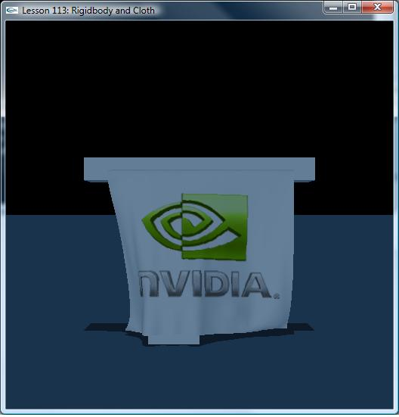

Introduction
In this lesson, we demonstrate interaction between Cloth and Rigid body.

Cloth
Cloth allows for simulation of such items as flags, clothing, etc. There are two way of interaction with Rigid body. One is called one-way that Rigid body applies force to cloth
and Rigid body isn’t affected. The other is called two-way that Rigid body and cloth interact each other. When Rigid body applies force to cloth, cloth also applies force to
Rigid body at the same time.

void SetupCurtainScene()
{
// sprintf(gTitleString, "Cloth and Shape Interaction Sample");
……

NxClothDesc clothDesc;
clothDesc.globalPose.t = NxVec3(4,7,0);
clothDesc.thickness = 0.2;
//clothDesc.density = 1;
clothDesc.bendingStiffness = 0.5;
clothDesc.stretchingStiffness = 1;
//clothDesc.dampingCoefficient = 0.5;
clothDesc.friction = 0.5;
//clothDesc.collisionResponseCoefficient = 1;
//clothDesc.attachmentResponseCoefficient = 1;
//clothDesc.solverIterations = 5;
//clothDesc.flags |= NX_CLF_STATIC;
//clothDesc.flags |= NX_CLF_DISABLE_COLLISION;
//clothDesc.flags |= NX_CLF_VISUALIZATION;
//clothDesc.flags |= NX_CLF_GRAVITY;
clothDesc.flags |= NX_CLF_BENDING;
//clothDesc.flags |= NX_CLF_BENDING_ORTHO;
//clothDesc.flags |= NX_CLF_DAMPING;
//clothDesc.flags |= NX_CLF_COMDAMPING;
clothDesc.flags |= NX_CLF_COLLISION_TWOWAY;

clothDesc.flags &= ~NX_CLF_HARDWARE;

MyCloth *regularCloth = new MyCloth(gScene, clothDesc, 8, 7, 0.15, "nvidia.bmp");
gCloths.push_back(regularCloth);

regularCloth->getNxCloth()->attachToShape(*box2->getShapes(), NX_CLOTH_ATTACHMENT_TWOWAY);
}

2.1 Creating Cloth Mesh
A cloth is defined using a mesh which specifies cloth particle positions (vertices) and the constraints between them (edges). Similarly to a triangle mesh, it is necessary to cook a cloth mesh into a suitable format for simulation.To do so, fill in an NxClothMeshDesc structure and pass it to NxCookingInterface::NxCookClothMesh().This function returns a stream of bytes that can either be saved and reused or fed to NxScene::createClothMesh()

void MyCloth::generateRegularMeshDesc(NxClothMeshDesc &desc, NxReal w, NxReal h, NxReal d, bool texCoords, bool tearLines)
{
int numX = (int)(w / d) + 1;
int numY = (int)(h / d) + 1;

desc.numVertices = (numX+1) * (numY+1);
desc.numTriangles = numX*numY*2;
desc.pointStrideBytes = sizeof(NxVec3);
desc.triangleStrideBytes = 3*sizeof(NxU32);
desc.vertexMassStrideBytes = sizeof(NxReal);
desc.vertexFlagStrideBytes = sizeof(NxU32);
desc.points = (NxVec3*)malloc(sizeof(NxVec3)*desc.numVertices);
desc.triangles = (NxU32*)malloc(sizeof(NxU32)*desc.numTriangles*3);
desc.vertexMasses = 0;
desc.vertexFlags = 0;
desc.flags = 0;

int i,j;
NxVec3 *p = (NxVec3*)desc.points;
for (i = 0; i <= numY; i++)
{
for (j = 0; j <= numX; j++)
{
p->set(-d*j, 0.0f, -d*i);
p++;
}
}

……

NxU32 *id = (NxU32*)desc.triangles;
for (i = 0; i < numY; i++) {
for (j = 0; j < numX; j++) {
NxU32 i0 = i * (numX+1) + j;
NxU32 i1 = i0 + 1;
NxU32 i2 = i0 + (numX+1);
NxU32 i3 = i2 + 1;
if ((j+i)%2) {
*id++ = i0; *id++ = i2; *id++ = i1;
*id++ = i1; *id++ = i2; *id++ = i3;
}
else {
*id++ = i0; *id++ = i2; *id++ = i3;
*id++ = i0; *id++ = i3; *id++ = i1;
}
}
}
…..
}

2.2 Collision flag between shape and cloth
There are 3 collision flags between shape and cloth:
NX_SF_CLOTH_DRAIN:
NX_SF_CLOTH_TWOWAY:
NX_SF_CLOTH_DISABLE_COLLISION:
You may use these flags like this:
pActor->getShapes()[0]->setFlag(NX_SF_CLOTH_DRAIN, true);

Conclusion
We should now know how to create cloth and how Rigid body applies force to cloth.

Related Classes, Functions, and Parameters
NxClothMeshDesc
NxClothDesc
NxCookClothMesh()

