Lesson 114 – Rigidbody and Fluid

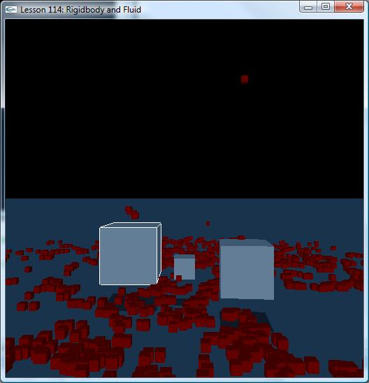

Introduction
In this lesson, we demonstrate interaction between Fluid and Rigidbody.

Fluid
Fluids allow the simulation of liquids and gases using a particle system and emitters.
When a particle collides with a rigid body, a collision impulse is applied to the particle. By default, collisions with static and dynamic shapes are both considered. To enable them separately, the user can specify the NX_F_STATIC and the NX_F_DYNAMIC flags in the NxFluidDesc::collisionMethod member; this can also be adjusted during simulation using NxFluid::setCollisionMethod. It is possible to allow fluids to influence rigid bodies as they are introduced

NxFluid* CreateFluid(const NxVec3& pos, NxU32 sideNum, NxReal distance, NxScene* scene)
{
// Create a set of particles
gParticleBufferNum = 0;
NxReal rad = sideNum*distance*0.5f;
for (NxU32 i=0; i<sideNum; i++)
{
for (NxU32 j=0; j<sideNum; j++)
{
for (NxU32 k=0; k<sideNum; k++)
{
NxVec3 p = NxVec3(i*distance,j*distance,k*distance);
if (p.distance(NxVec3(rad,rad,rad)) < rad)
{
p += pos - NxVec3(rad,rad,rad);
gParticleBuffer[gParticleBufferNum++] = p;
}
}
}
}

// Set structure to pass particles, and receive them after every simulation step
NxParticleData particles;
//particles.maxParticles = gParticleBufferCap;
particles.numParticlesPtr = &gParticleBufferNum;
particles.bufferPos = &gParticleBuffer[0].x;
particles.bufferPosByteStride = sizeof(NxVec3);

// Create a fluid descriptor
NxFluidDesc fluidDesc;
fluidDesc.maxParticles = gParticleBufferCap;
fluidDesc.kernelRadiusMultiplier = KERNEL_RADIUS_MULTIPLIER;
fluidDesc.restParticlesPerMeter = REST_PARTICLES_PER_METER;
fluidDesc.motionLimitMultiplier = MOTION_LIMIT_MULTIPLIER;
fluidDesc.packetSizeMultiplier = PACKET_SIZE_MULTIPLIER;
fluidDesc.stiffness = 50;
fluidDesc.viscosity = 22;
fluidDesc.restDensity = 1000;
fluidDesc.damping = 0;
fluidDesc.restitutionForStaticShapes = 0.4;
fluidDesc.dynamicFrictionForStaticShapes= 0.3;
fluidDesc.collisionResponseCoefficient = 0.5f;
fluidDesc.collisionDistanceMultiplier = 0.1f;
fluidDesc.simulationMethod = NX_F_SPH; //NX_F_NO_PARTICLE_INTERACTION;

fluidDesc.initialParticleData = particles;
fluidDesc.particlesWriteData = particles;
fluidDesc.flags &= ~NX_FF_HARDWARE;
fluidDesc.flags |= NX_FF_COLLISION_TWOWAY;

NxFluid* fl = gScene->createFluid(fluidDesc);
assert(fl != NULL);
return fl;
}

To enable 2-way interaction between Rigidbody and Fluids, both corresponding shape flag as well as fluid flag must be set:
fluidDesc.flags |= NxFluidFlag::NX_FF_COLLISION_TWOWAY;
shapeDesc.flags |= NxShapeFlag::NX_SF_FLUID_TWOWAY;

The collision Response Coefficient defines which fraction of the collision impulse actually gets applied to the colliding rigid body:
fluidDesc.collisionResponseCoefficient = 0.5f;

Conclusion
We should now know how to create Fluid and how Fluid collides with Rigidbody.

Related Classes, Functions, and Parameters
NxParticleData
NxFluidDesc

