Lesson 115 – Rigidbody and Softbody

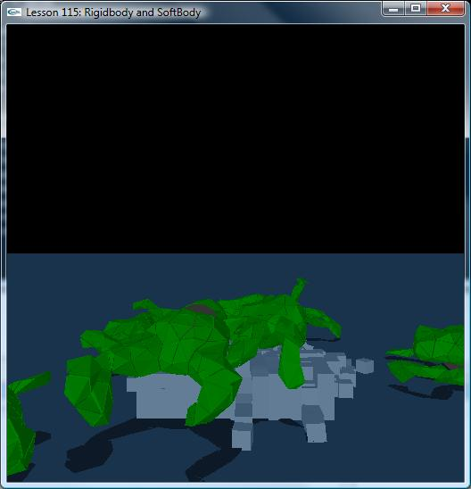

Introduction
In this lesson, we create SoftBody which collides with Rigidbody.

SoftBody
SoftBody is a deformable object. It may be used to simulate complex geometry like
a tree with many branches and leaves. In such game scene, there’s always collision between SoftBody and Rigidbody.

void SetupAnimalScene()
{
// Create the objects in the scene

NxSoftBodyDesc softBodyDesc;
softBodyDesc.globalPose.t = NxVec3(0.0f, 3.0f, 0.0f);
softBodyDesc.particleRadius = 0.2f;
softBodyDesc.volumeStiffness = 0.5f;
softBodyDesc.stretchingStiffness = 1.0f;
softBodyDesc.friction = 1.0f;
softBodyDesc.attachmentResponseCoefficient = 0.1f;
softBodyDesc.solverIterations = 5;

char *fileName = "froggyNormalized";

char tetFileName[256], objFileName[256], s[256];
sprintf(tetFileName, "%s.tet", fileName);
sprintf(objFileName, "%s.obj", fileName);

ObjMesh *objMesh = new ObjMesh();
objMesh->loadFromObjFile(FindMediaFile(objFileName, s));
gObjMeshes.push_back(objMesh);

NxMat33 rot;
rot.rotX(NxHalfPiF32); //Rotate 90 degrees about X axis;
for (int i = 0; i < 10; i++)
{
softBodyDesc.globalPose.t = NxVec3(0,3+i*3,0);
MySoftBody *softBody = new MySoftBody(gScene, softBodyDesc, FindMediaFile(tetFileName,s), objMesh);
assert(softBody);
if (!softBody->getNxSoftBody())
{
printf("Error: Unable to create the SoftBody for the current scene.\n");
delete softBody;
}
else
{
gSoftBodies.push_back(softBody);
NxActor *caps= CreateCapsule(NxVec3(0.0f, 3.0f + i*3.0f, -0.3f), 1.0f, 0.73f, 1.0f);
caps->userData= (void*)&gInvisible;
caps->setGlobalOrientation(rot);
softBody->getNxSoftBody()->attachToShape(caps->getShapes()[0], NX_SOFTBODY_ATTACHMENT_TWOWAY);
}
}
}

  - Creating SoftBody Mesh
A soft body is defined using a mesh which specifies the soft body's vertices and the constraints between them. Each constraint is associated with one tetrahedral volume element and is defined by specifying the 4 vertex indices of the tetrahedron's corner vertices. Similarly to how triangle meshes are handled in the cloth API, it is necessary to cook a soft body mesh into a suitable format for simulation. To do so, we need to fill in an NxSoftBodyMeshDesc structure and pass it to NxCookSoftBodyMesh(). This function returns a stream of bytes that can either be saved and reused later or fed to NxScene::createSoftBodyMesh().

bool MySoftBody::generateTetMeshDesc(NxSoftBodyMeshDesc &desc, char *filename, NxReal scale)
{
static const NxU16 MESH_STRING_LEN = 256;
char s[MESH_STRING_LEN];
int i0,i1,i2,i3;
NxVec3 v;

FILE *f = fopen(filename, "r");
if (!f) return false;

NxArray<NxVec3> tempVertices;
NxArray<NxU32> tempIndices;
NxBounds3 bounds;
bounds.setEmpty();

while (!feof(f)) {
if (fgets(s, MESH_STRING_LEN, f) == NULL) break;

if (strncmp(s, "v ", 2) == 0) { // vertex
sscanf(s, "v %f %f %f", &v.x, &v.y, &v.z);
tempVertices.push_back(v);
bounds.include(v);
}
else if (strncmp(s, "t ", 2) == 0) { // tetra
sscanf(s, "t %i %i %i %i", &i0,&i1,&i2,&i3);
tempIndices.push_back(i0);
tempIndices.push_back(i1);
tempIndices.push_back(i2);
tempIndices.push_back(i3);
}
}

if(tempVertices.size() == 0) return false;

desc.numVertices = tempVertices.size();
desc.numTetrahedra = tempIndices.size() / 4;
desc.vertexStrideBytes = sizeof(NxVec3);
desc.tetrahedronStrideBytes = 4*sizeof(NxU32);
desc.vertexMassStrideBytes = sizeof(NxReal);
desc.vertexFlagStrideBytes = sizeof(NxU32);
desc.vertices = (NxVec3*)malloc(sizeof(NxVec3)*desc.numVertices);
desc.tetrahedra= (NxU32*)malloc(sizeof(NxU32)*desc.numTetrahedra*4);
desc.vertexMasses = 0;
desc.vertexFlags = 0;
desc.flags = 0;

NxReal diag = bounds.min.distance(bounds.max);
mOffset = (bounds.min + bounds.max) * 0.5f;

NxVec3 *vSrc = (NxVec3*)tempVertices.begin();
NxVec3 *vDest = (NxVec3*)desc.vertices;
for (NxU32 i = 0; i < desc.numVertices; i++, vDest++, vSrc++)
*vDest = ((*vSrc) - mOffset)*scale;
memcpy((NxU32*)desc.tetrahedra, tempIndices.begin(), sizeof(NxU32)*desc.numTetrahedra*4);

return true;
}

  - Collision flag between shape and SoftBody
There are 3 collision flags between shape and cloth:
NX_SF_SOFTBODY_DRAIN:
NX_SF_ SOFTBODY _TWOWAY:
NX_SF_ SOFTBODY _DISABLE_COLLISION:
You may use these flags like this:
pActor->getShapes()[0]->setFlag(NX_SF_ SOFTBODY _DRAIN, true);

Conclusion
You should now know how to create SoftBody and how SoftBody collides with Rigidbody.

Related Classes, Functions, and Parameters
NxSoftBodyMeshDesc
NxSoftBodyDesc
NxCookSoftBodyMesh()
createSoftBodyMesh()

