Lesson 116 – Rigidbody and ForceField

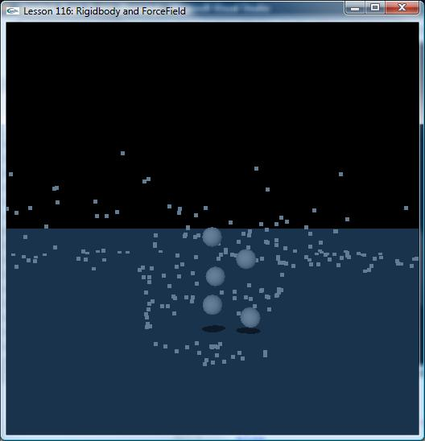

Introduction
In this lesson, we create a ForceField which applies force to Rigidbody. In order to show
ForceField’s track clearly, ForceField’s path is full of particles.

ForceField
ForceField has two important geometrical properties: one is volume of activity, which is defined by groups of shapes (similar to actors), and the other is force field kernel function, which defines the strength of the field throughout the volume of activity.
When an actor enters the volume of ForceField’s activity, force is applied to the actor.
To create a force field, you fill out a descriptor (NxForceFieldDesc) with the desired parameters and then call NxScene::createForceField:
void SampleVortex::createVortexForceField(const NxVec3& pos, NxActor* actor, NxScene* scene)
{
assert(scene);
NxForceFieldDesc ffDesc;
NxForceFieldLinearKernelDesc lKernelDesc;
NxForceFieldLinearKernel* linearKernel;

ffDesc.coordinates = NX_FFC_CYLINDRICAL;
ffDesc.actor = actor;
m_forceFieldTransform.id();
ffDesc.pose = m_forceFieldTransform;
lKernelDesc.constant = NxVec3(-30, 4.0f, 0);
lKernelDesc.positionTarget = NxVec3(3,0,0);

NxMat33 m;
m.zero();
m(0,0) = 10;
m(0,1) = -5;
m(0,2) = 0;
lKernelDesc.positionMultiplier = m;
lKernelDesc.noise = NxVec3(5,5,5);
lKernelDesc.velocityTarget = NxVec3(0,0,30);
m.diagonal(NxVec3(1,1,1));
lKernelDesc.velocityMultiplier = m;

lKernelDesc.falloffLinear = NxVec3(5.0f, 0, 0);
lKernelDesc.falloffQuadratic = NxVec3(5.0f, 0, 0);
linearKernel = scene->createForceFieldLinearKernel(lKernelDesc);
ffDesc.kernel = linearKernel;
ffDesc.flags = 0;

m_forceField = scene->createForceField(ffDesc);
assert(m_forceField);

NxForceFieldShape* s = NULL;
NxBoxForceFieldShapeDesc b;
b.dimensions = NxVec3(5, 7, 5);
b.pose.t = NxVec3(0, 3.5f, 0);
s = m_forceField->getIncludeShapeGroup().createShape(b);

NxForceFieldShapeGroupDesc sgDesc;
sgDesc.flags = NX_FFSG_EXCLUDE_GROUP;
m_excludeGroup = scene->createForceFieldShapeGroup(sgDesc);

NxBoxForceFieldShapeDesc exclude;
exclude.dimensions = NxVec3(2.25f, 1.5f, 1.75f);
exclude.pose.t = NxVec3(8.85f, 1.5f, -10.3f);
m_excludeShape = m_excludeGroup->createShape(exclude);

m_forceField->addShapeGroup(*m_excludeGroup);
}

To create a force field, you fill out a descriptor (NxForceFieldDesc) with the desired parameters and then call NxScene::createForceField:
- Attach forcefield in an actor (which we use for moving the field around in the world)
- Attach the force field at the center of the actor
- Constant force of 30 towards the center (which is then counter-acted by radial forces specified below). constant force of 4 upwards (creating a constant lift on the objects)
- The target where we want the objects to end up is at radius 3 from the center. We use Y=0 as the target in along the y-axis together with the m(0,1)=-5 to create a force directed outwards from the center of forcefield when objects are floating towards the top of forcefield.
- Setup radial forces, depending on where the objects are positioned
- Set target velocity along the tangent of the vortex to 30 (the other directions to 0)
- You can try some fall-off forces if you e.g. want the vortex to lose power along the radial direction when the distance from its center increases:

Next step is to define the volume where the force field is active. This volume is represented by force field shapes which are created inside a group.
- Attach an include shape, we position this so that it covers the vortex specified above

- Create an exclude shape, positioned around the shed

Conclusion
You now know how to create ForceField and how ForceField affects Rigidbody.

Related Classes, Functions, and Parameters
NxForceFieldLinearKernelDesc
NxForceFieldLinearKernel
NxForceFieldDesc
NxForceField
NxBoxForceFieldShapeDesc

